Version No | Content Modified | Date of Modification | Modified by | Approved by
1.0 | Original version | 11/07/19 | Lerina Tong | /

I. Introduction 2
II. Owners 2
III. General Principles of BSC 2
IV. BSC Structure 3
V. Application of BSC Result 4
VI. Attachments 4
6.1 4.2-1 BSC Sheet of OPPO APAC&SEA Regional Hub_Template 4
6.2 4.2-2 Questionnaire_QA 4
6.3 4.2-3 Questionnaire_TL 4
6.4 4.2-4 Questionnaires_Trainer & SME 4

Introduction
BSC, short term for Business Scorecard, is evaluation of performance for all Contact Center related roles through breaking down the performance metrics of the site into the roles.
All Contact Center Roles, including agents (for various channels), Team Leaders (for various channels/accounts), QA (Quality Analyst), SME (Smart Master Expert) etc, have their own BSCs as per their service scope, main business target etc.

Owners
Operation Manager of Contact Centers are responsible for BSC of all related roles as internal management

General Principles of BSC
- All service channels/scope of the role shall be covered in BSC, like inbound, outbound survey, Email, Chat and other social media channels.
- Should there be more than 1 region covered by the role, KPI metrics shall vary among regions as per the current performance level of each.
- BSC is not set once for all, which should be reviewed and revised, when necessary, at least every half a year to meet the operation level of the site/team.

BSC Structure

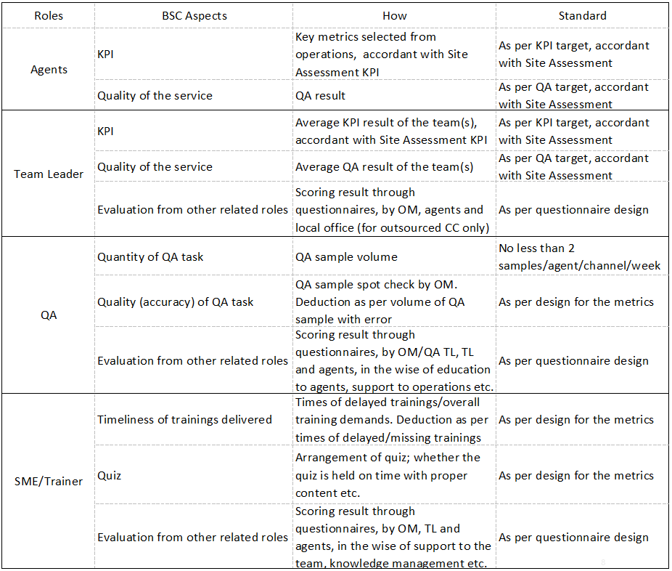

Overall weight: 100%; Weight for each aspect can be designed as per actual considerations.

Application of BSC Result
Bonus/penalty can be connected with BSC result as agents’ performance assessment, based on local salary policies.

Attachments

4.2-1 BSC Sheet of OPPO APAC&SEA Regional Hub_Template

6.2 4.2-2 Questionnaire_QA

6.3 4.2-3 Questionnaire_TL

6.4 4.2-4 Questionnaires_Trainer & SME

