OPPO Find X3 Pro Service Manual -V1.0

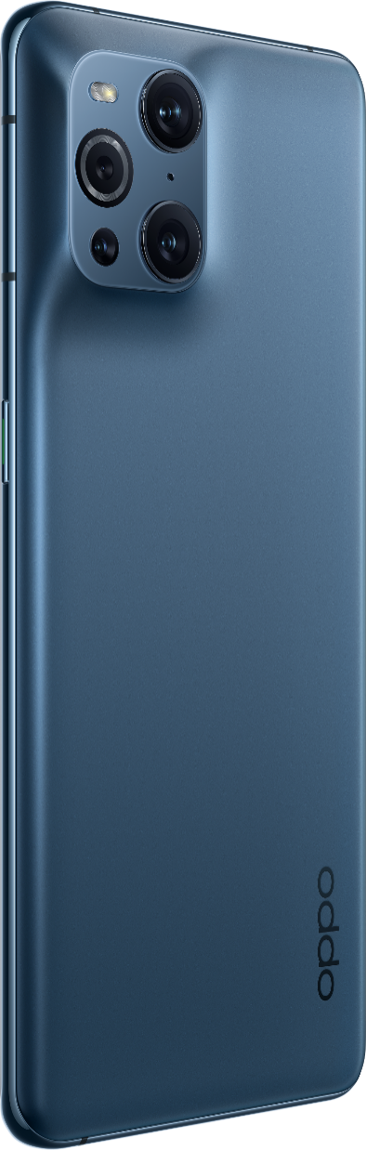

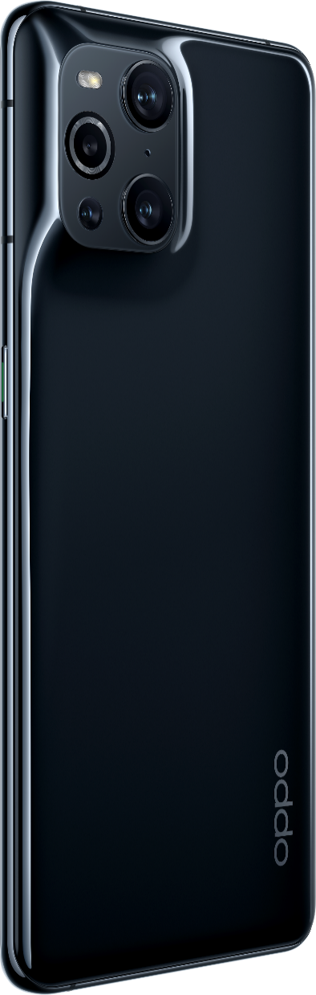

Confidential

Content

1. Guidance 3
1.1 Warnings 3
1.2 Cautions 3
2. General Repair Information 4
3. Phone Structure Diagram 5
3.1 Product Appearance 5
3.2 Phone Structure Explosive View 5
3.3 Explosive Map BOM 6
4. Disassembly Steps 9
4.1 Disassembly Tools 9
4.2 Preparation 9
4.3 Disassembly Steps 9
5. Assembly Steps 13
5.1 Bill of Must-Be-Replaced Materials 13
5.2 Assembly Steps 13
6. After-sale calibration 16
6.1 Leak Calibration 16
6.1.1 Calibration Scenario 16
6.1.2 Calibration Tool 16
6.1.3 Calibration Method 16
6.2 Fingerprint optical calibration 17
6.2.1 Calibration Scenario 17
6.2.2 Calibration Tool 17
6.2.3 Calibration Method 17
6.3 Dual Camera Calibration 17
6.3.1 Calibration Scenario 17
6.3.2 Calibration Tool 17
6.3.3 Calibration Method 17
7. Function Test 19
7.1 Test Path 20
7.2 Test Requirements 22
8. General Cautions 25

Guidance
The purpose of this document is only to guide OPPO technicians to carry out maintenance service to OPPO products. The content shall be keep in confidential, only avail be able to OPPO authorized service centers, and cannot be provided to third parties without authorization. Please follow the regulations and the guidance for maintenance service. For any problems, please contact China HQ in time.

1.1 Warnings
1. Care must be taken on installation in vehicles fitted with electronic engine management systems and ABS (Anti–skid Braking Systems). Under certain fault conditions, emitted RF energy can affect their operation. If necessary, consult the vehicle dealer/manufacturer to determine the immunity of vehicle electronic systems to RF energy.
2. Phones must not be operated in areas likely to contain potentially explosive atmospheres, e.g. petrol stations (service stations), blasting areas etc.
3. Operation of any radio transmitting equipment, including cellular telephones, may interfere with the functionality of inadequately protected medical devices. Consult a physician or the manufacturer of the medical device if you have any questions. Other electronic equipment may also be subject to interference

1.2 Cautions
1. Repair services and calibrations must be undertaken by qualified personnel only.
2. Use only approved components as specified in the parts list.
3. Ensure all components, modules screws and insulators are correctly re-fitted after servicing and alignment.
4. Electrostatic discharge is the main cause of damage to sensitive components of electronic products. Service centers must operate in accordance with OPPO's requirements for ESD protection. Ensure all work is carried out at an ESD workstation and that an ESD wristband is worn.

General Repair Information
- Ensure all work is carried out at an ESD workstation and that an ESD wristband is worn before starting maintenance.
- Wear ESD gloves to avoid oil stains and fingerprints.
- Use protective films to protect the display, camera, camera lens to prevent dust and scratches.
- Use a clean cloth, ESD brush and alcohol (Concentration above 95%) for appearance cleaning. Do not use other items (such as an eraser) for cleaning to prevent the protective layer from being scratched, which may lead to oxidation and corrosion.
- Faulty welded mechanical parts (except shield cover and shield frame parts) can only be replaced and not repairable.
- Use accessories provided by OPPO.
- Check the contacts or solder joints of devices that may cause simple faults (e.g. soldered interfaces or switches). Re-weld if necessary (only for service centers where lead-free soldering is available) and clean the flux remaining after soldering.
- Use the equipment provided by OPPO to test the phone (e.g. When the charging function of the device is abnormal, do use the original OPPO adapter to test to ensure the accuracy of the test results).
- Fill in the fault phenomenon code and fault reason code according to the actual situation, and accurately enter the replacement material code in the CRM system.
- For more information about products,
Mainland China please visit:
http://172.16.41.122:8888/kbaseui-dev/main.do
Regions except for Mainland China please visit:
ftp://ftpex.oppo.com:919/ or
https://oppo knowledge.custhelp.com/app/home/loc/zh_CN

3. Phone Structure Diagram

3.1 Product Appearance
As shown in Figure 3-1-1
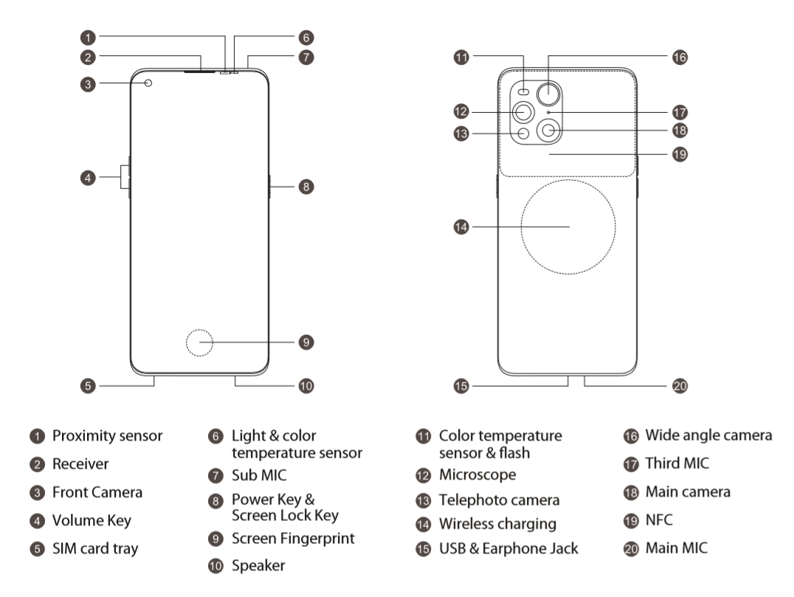 Figure 3-2-1

3.2 Phone Structure Explosive View
As shown in Figure 3-2-1 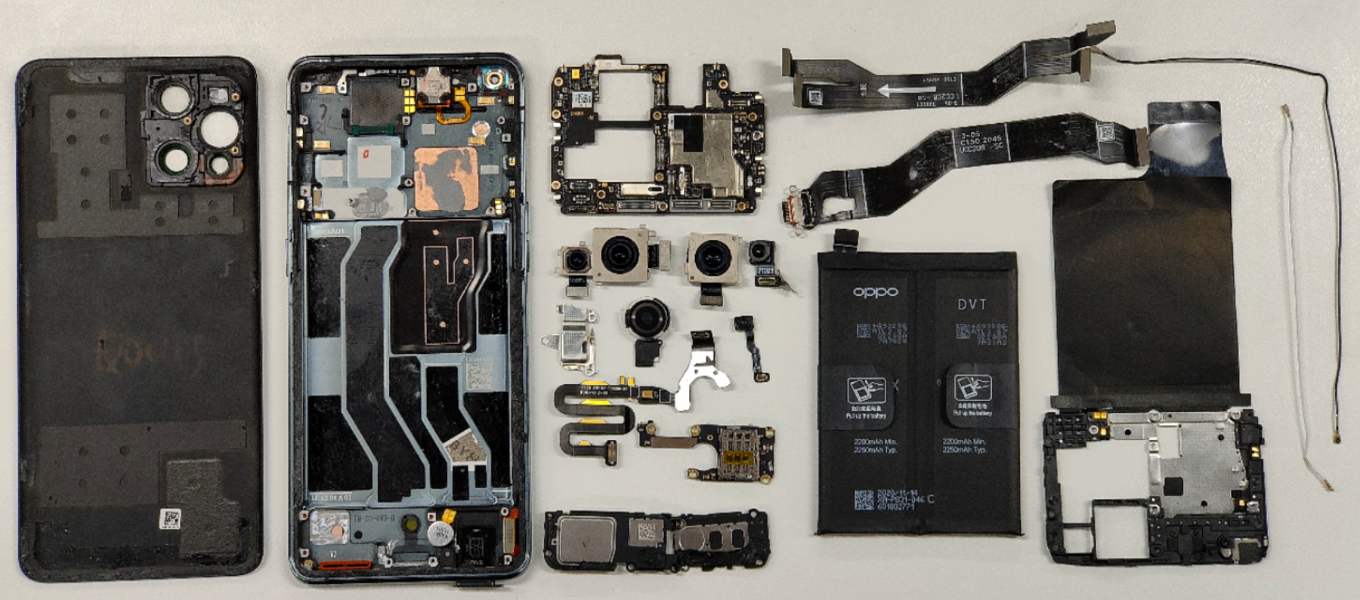 Figure 3-2-1

3.3 Explosive Map BOM
NO | Material Name | Picture | Sub-Category | QTY | Unit
1 | Screen | 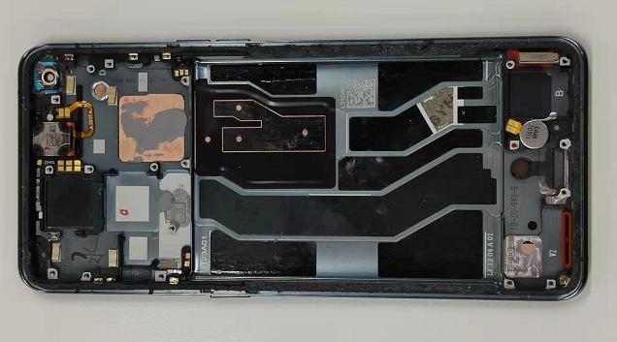 | LCD | 1 | PCS
1 | Screen |  | Front camera bracket | 1 | PCS
1 | Screen |  | Double side tape of front camera | 1 | PCS
1 | Screen |  | Protect film of screen | 1 | PCS
1 | Screen |  | LCD FPC through hole silicone plug | 1 | PCS
1 | Screen |  | BTB Silicone Case for Display | 1 | PCS
1 | Screen |  | Front camera sealing tape | 1 | PCS
2 | Mainboard | 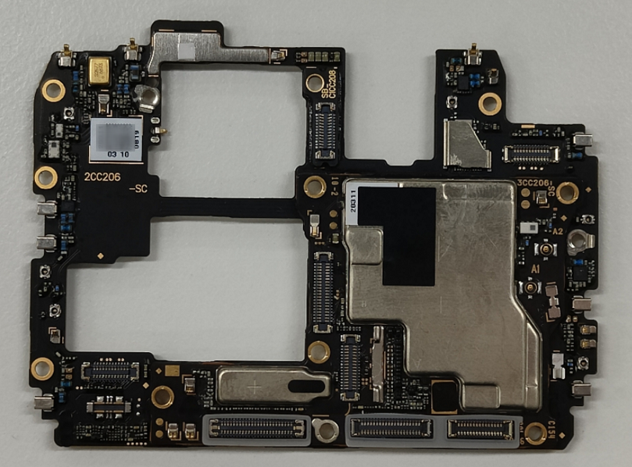 | PCB | 1 | PCS
2 | Mainboard |  | Waterproof sticker | 1 | PCS
2 | Mainboard |  | Test point PET sheet | 2 | PCS
3 | Antenna board | 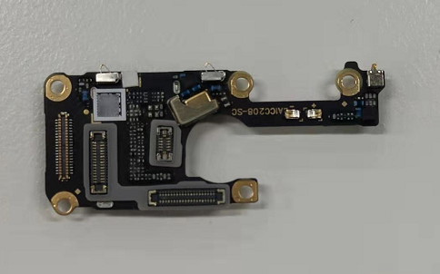 | Antenna board | 1 | PCS
3 | Antenna board |  | Waterproof sticker | 1 | PCS
4 | Mainboard bracket | 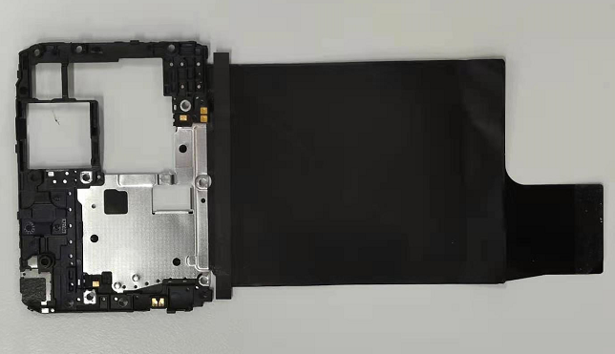 | Mainboard bracket | 1 | PCS
5 | Back cover | 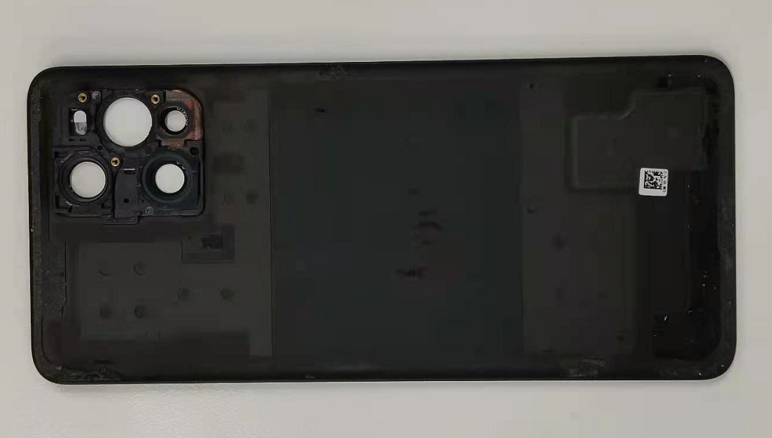 | Back cover | 1 | PCS
6 | Front camera | 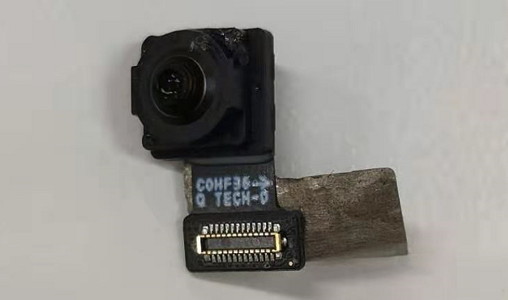 | Copper Foil Graphite Sheet of front camera | 1 | PCS
6 | Front camera |  | Front camera | 1 | PCS
7 | Rear cameras | 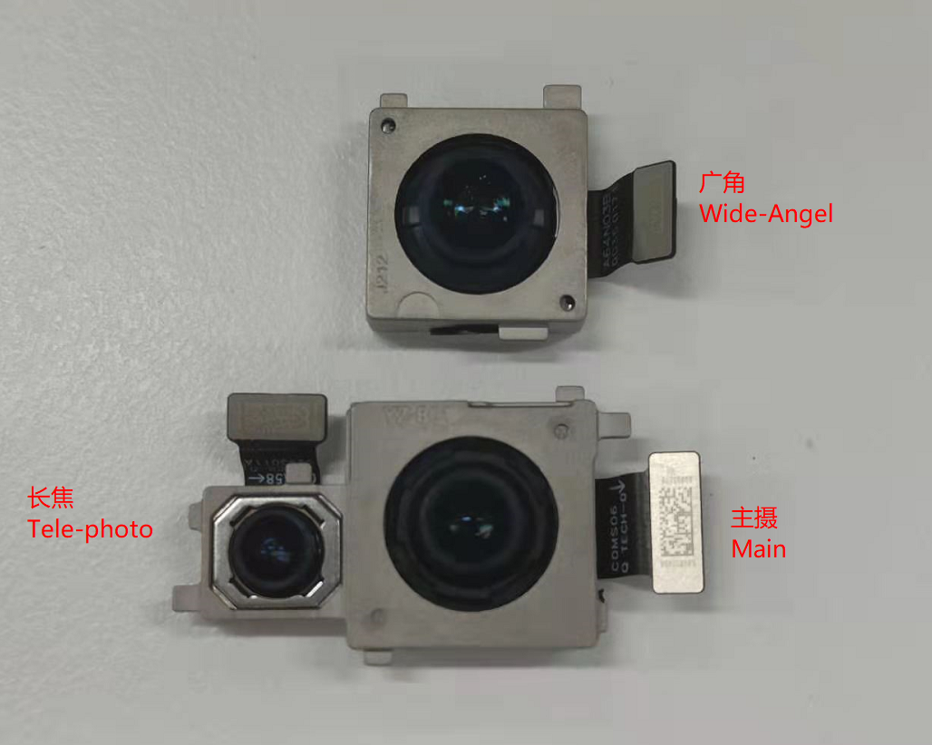 | Rear main camera | 1 | PCS
7 | Rear cameras |  | Rear wide-angle camera | 1 | PCS
7 | Rear cameras |  | Rear telephoto camera | 1 | PCS
8 | Light sensor PCB | 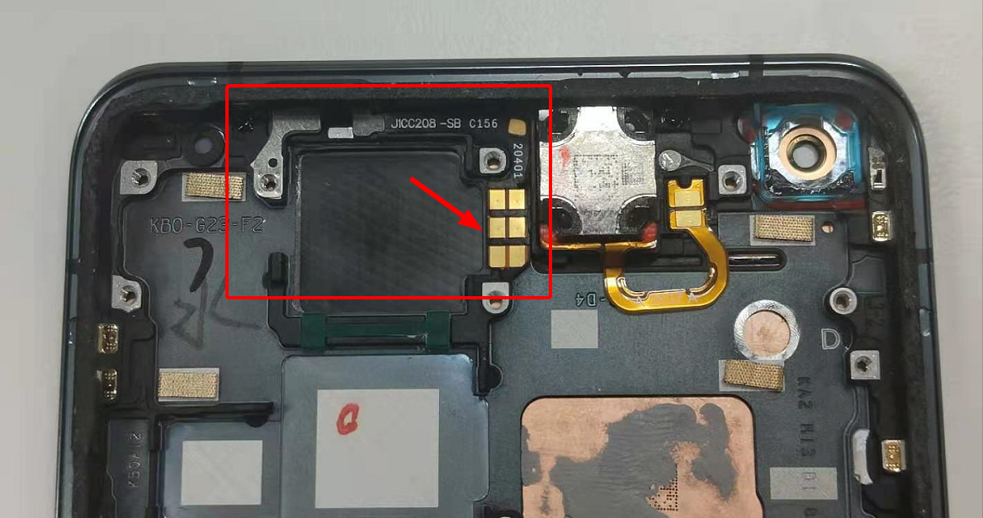 | Light sensor PCB | 1 | PCS
9 | Fingerprint sensor | 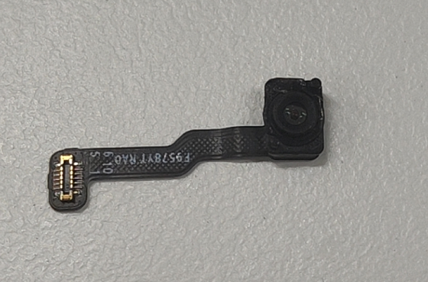 | Fingerprint sensor | 1 | PCS
10 | Speaker BOX | 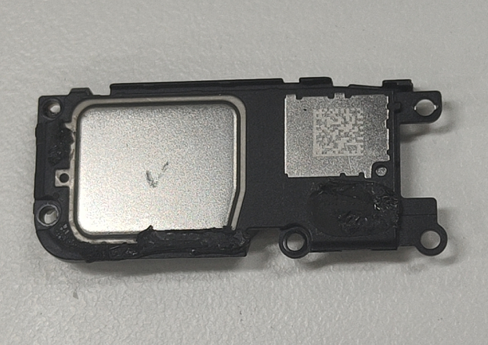 | Speaker BOX | 1 | PCS
11 | USB FPC | 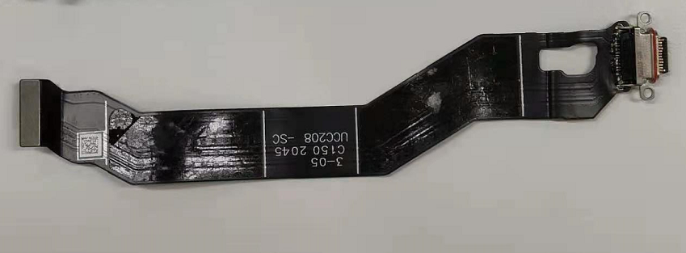 | USB FPC | 1 | PCS
12 | LCD-FPC | 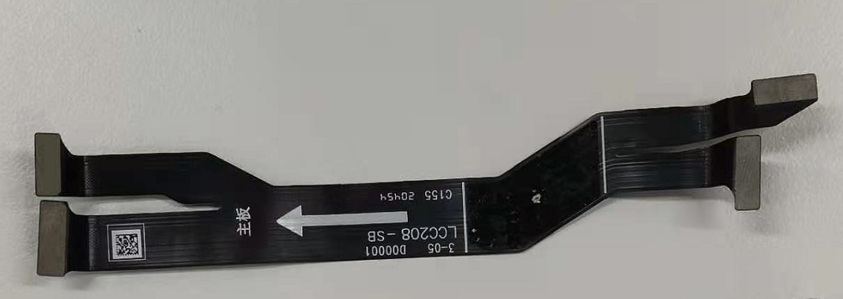 | LCD-FPC | 1 | PCS
13 | RF cables | 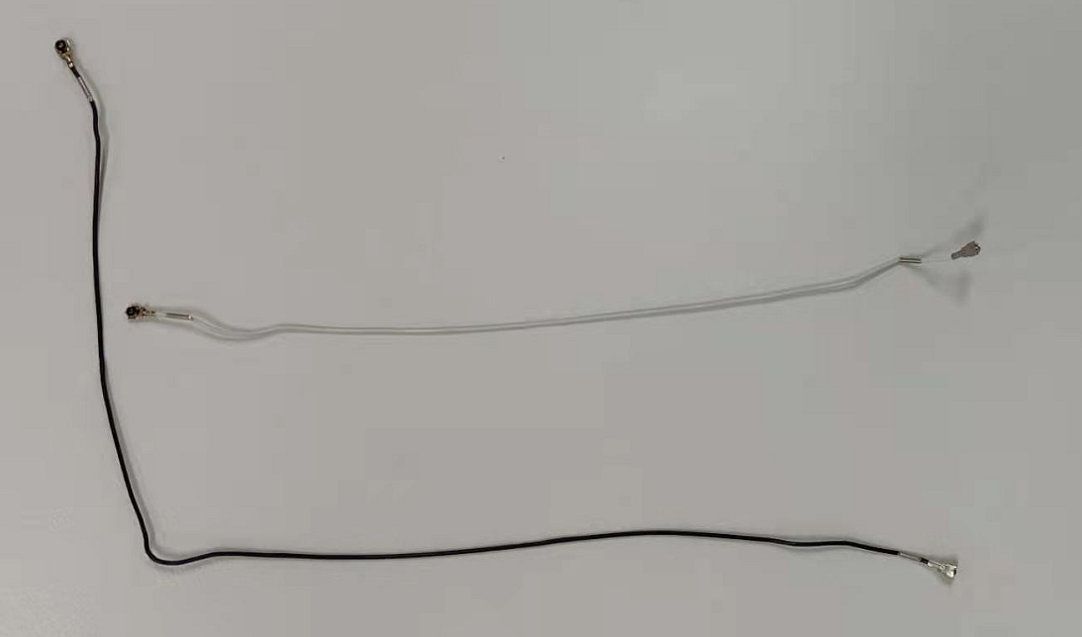 | RF cables | 2 | PCS
14 | Vibration motor | 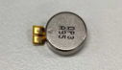 | Vibration motor | 1 | PCS
15 | Battery | 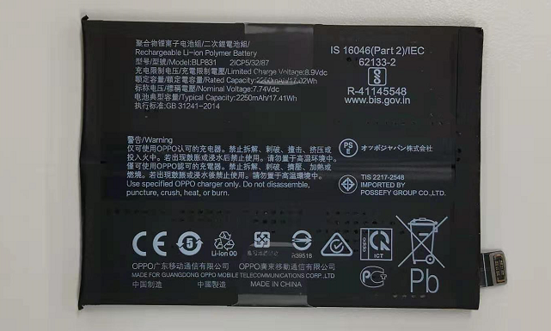 | Battery | 1 | PCS
16 | SIM card tray | 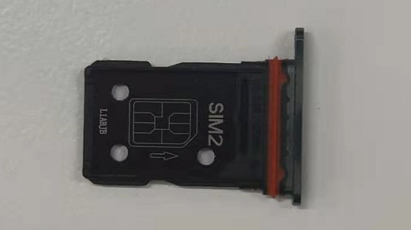 | SIM card tray | 1 | PCS
17 | Receiver | 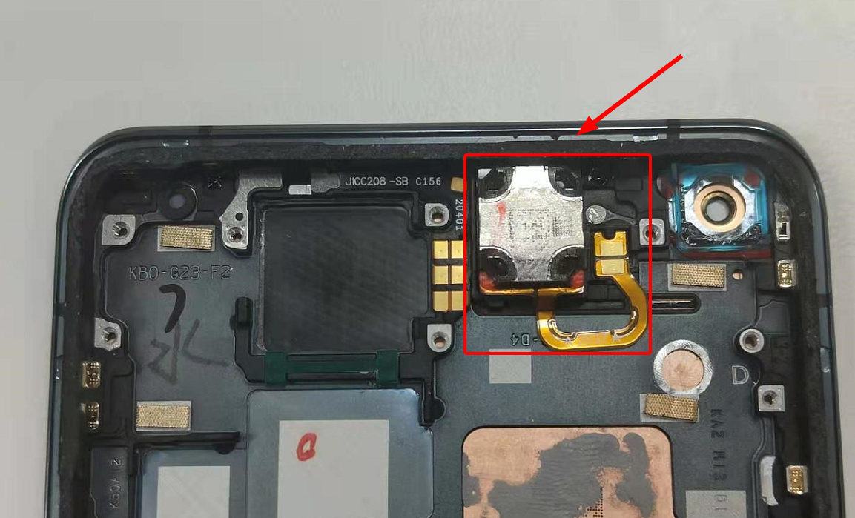 | Receiver | 1 | PCS
18 | Microscope camera | 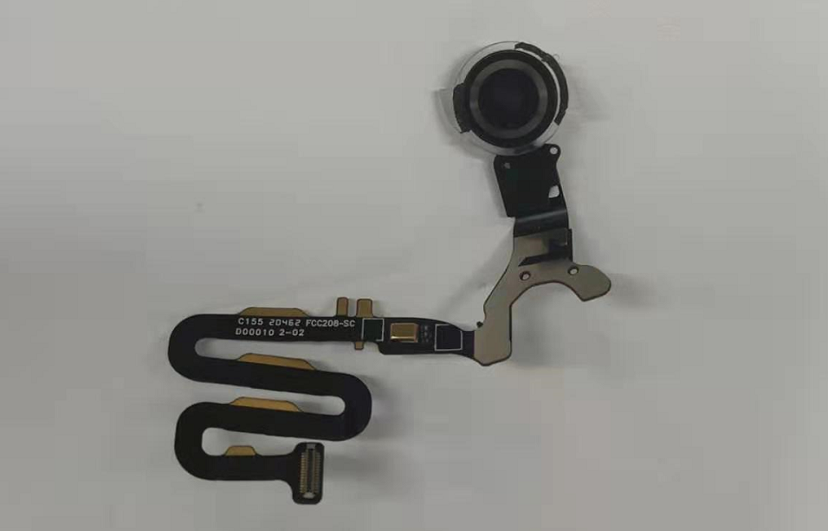 | Microscope camera | 1 | PCS
19 | Camera fastening bracket | 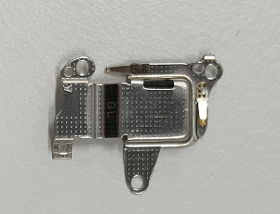 | Camera fastening bracket | 1 | PCS
20 | Small board bracket | 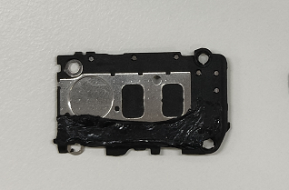 | Small board bracket | 1 | PCS

Note：This table is used only for the name of the annotation but not for the preparation of materials. Please refer to the Price List of OPPO Mobile Phone Original Accessories (for Mainland China)/Price List of Commonly-Used Materials and Accessories (Regions except for Mainland China) for the preparation.

4. Disassembly Steps

4.1 Disassembly Tools
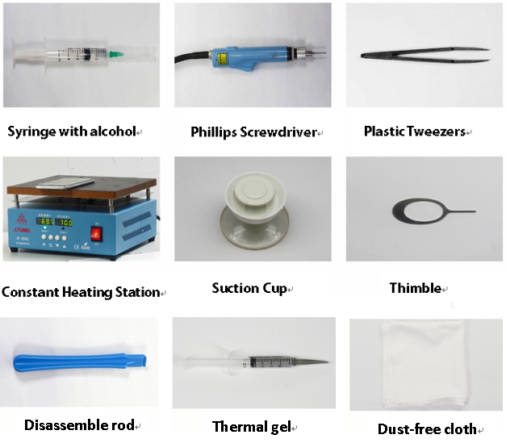

4.2 Preparation
1. The phone must be powered off before disassembly.
2. Way to Power Off:
System Power Off: Press the power key then slide to power off.
Forced Power Off: Long press the volume “+” key and power key for about 8 seconds until the display is off.

4.3 Disassembly Steps

Steps | Details | Picture | Cautions
1 | Take out the sim card tray | 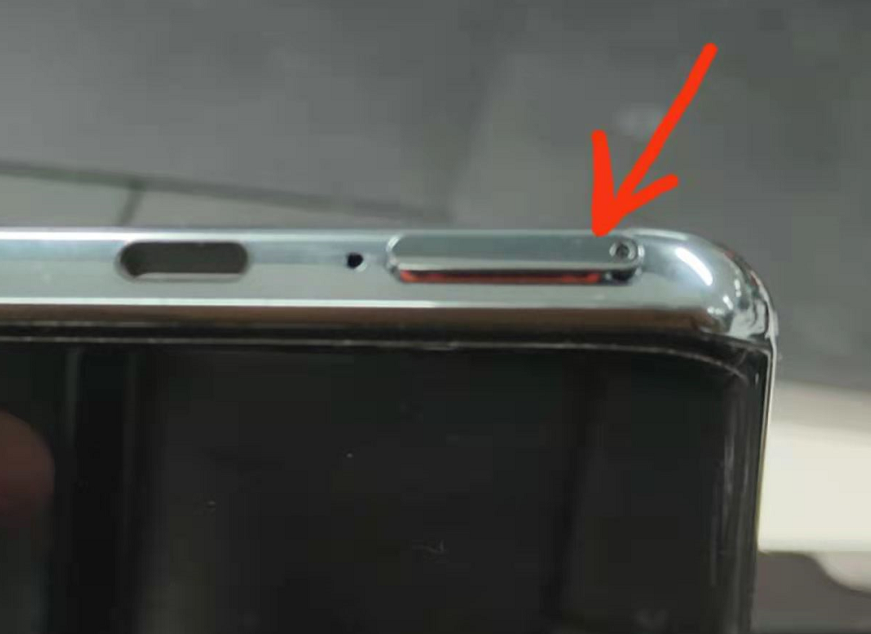 | Sim card hole is the right one
2 | Disassemble back cover | 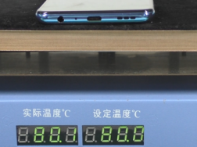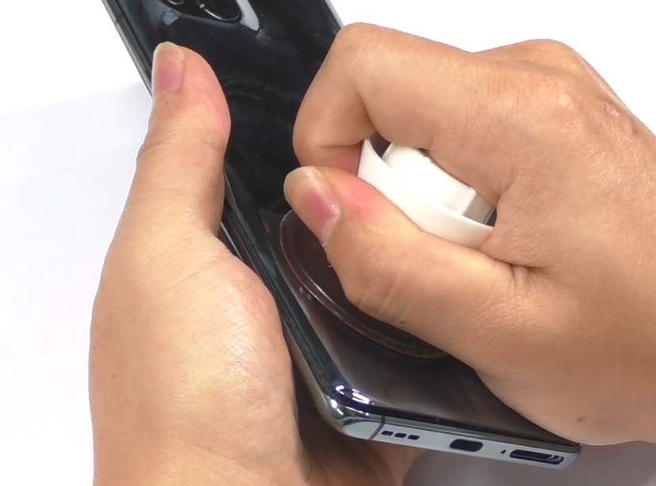 | - Do not use a disassembly stick or other hard objects to removed the battery cover,prevent from painted or scratched.  2. When it's too hard cleaning the battery cover glue, try heat again.
3 | Disassemble the bracket of flash FPC | 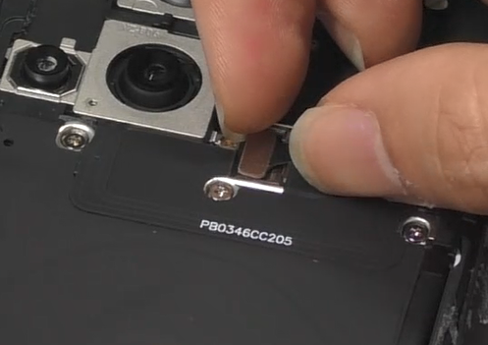  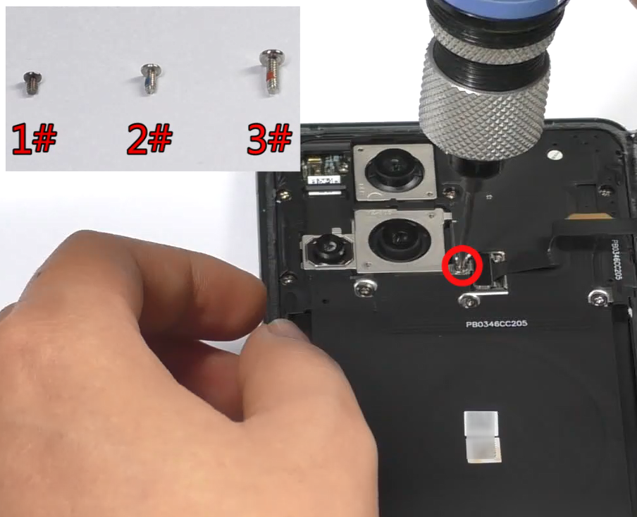 | 3#，1pcs
4 | Clean the double side tape of back cover | 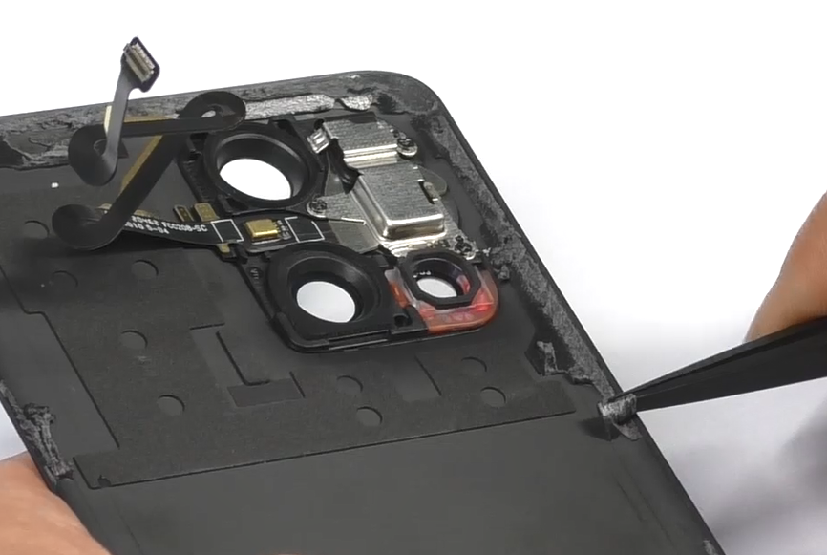 | /
5 | Disassemble microscope camera | 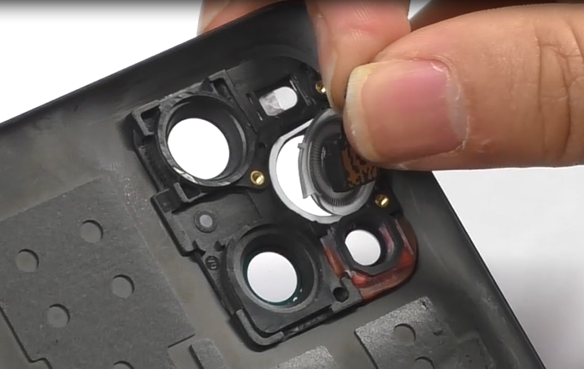  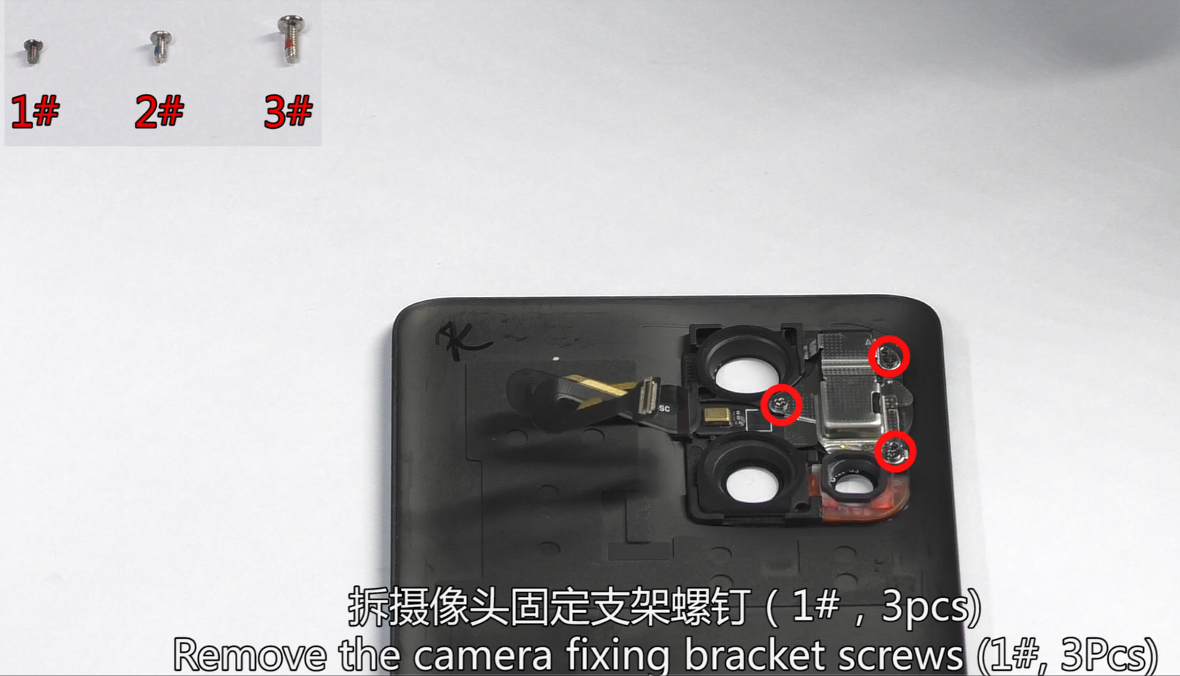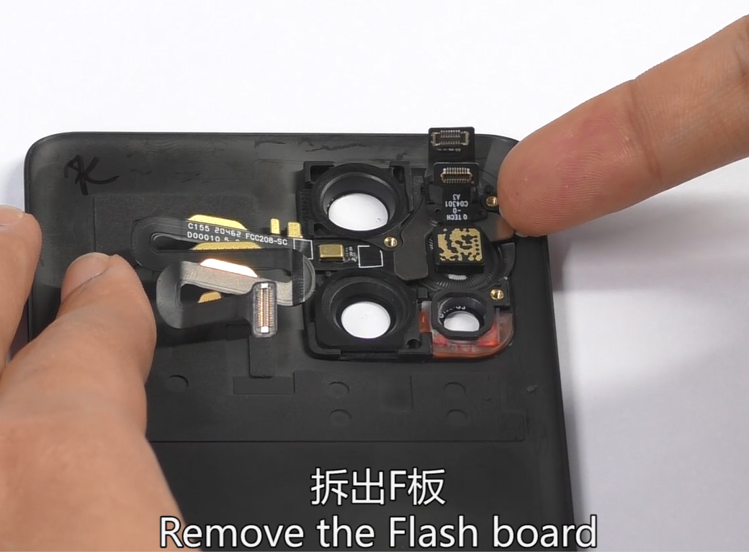 | 1#，3pcs
6 | Disassemble the mainboard bracket | 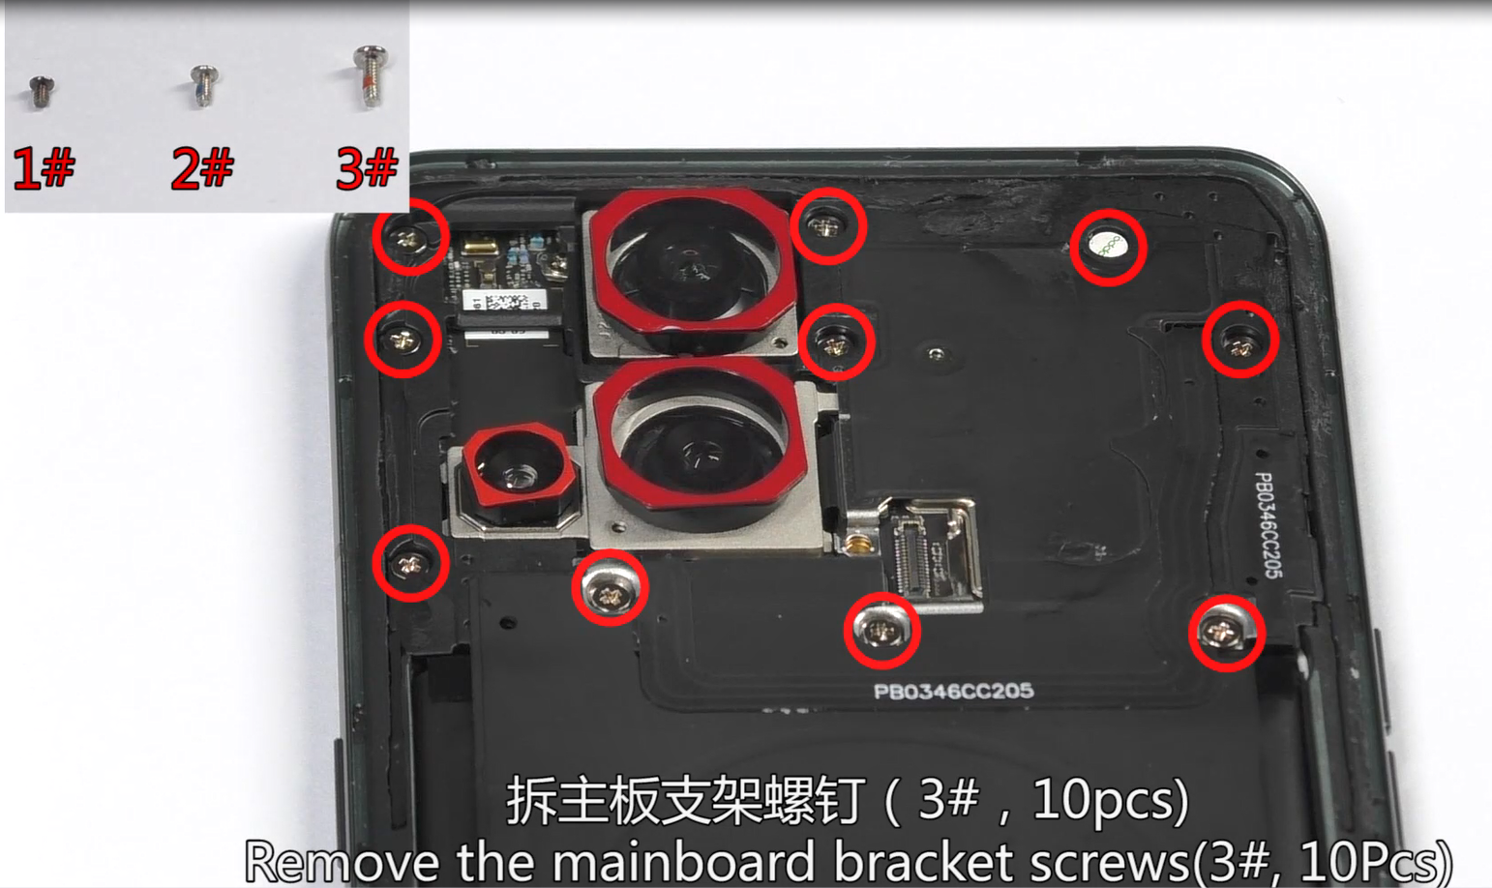  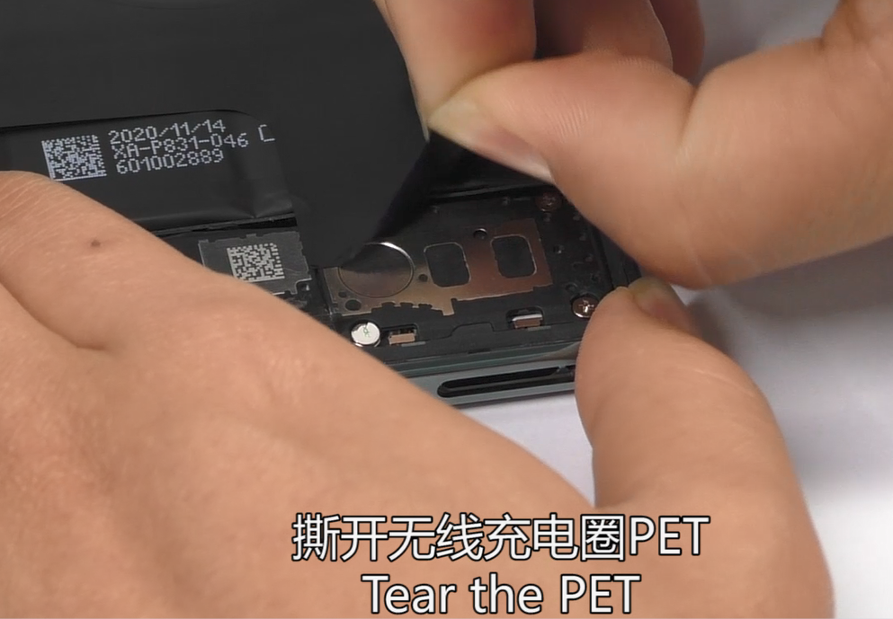 | Take care of the NFC coil
7 | Disassemble the battery | 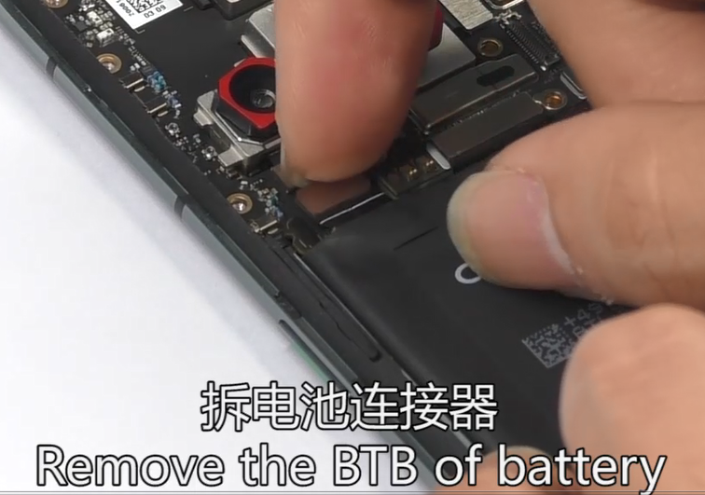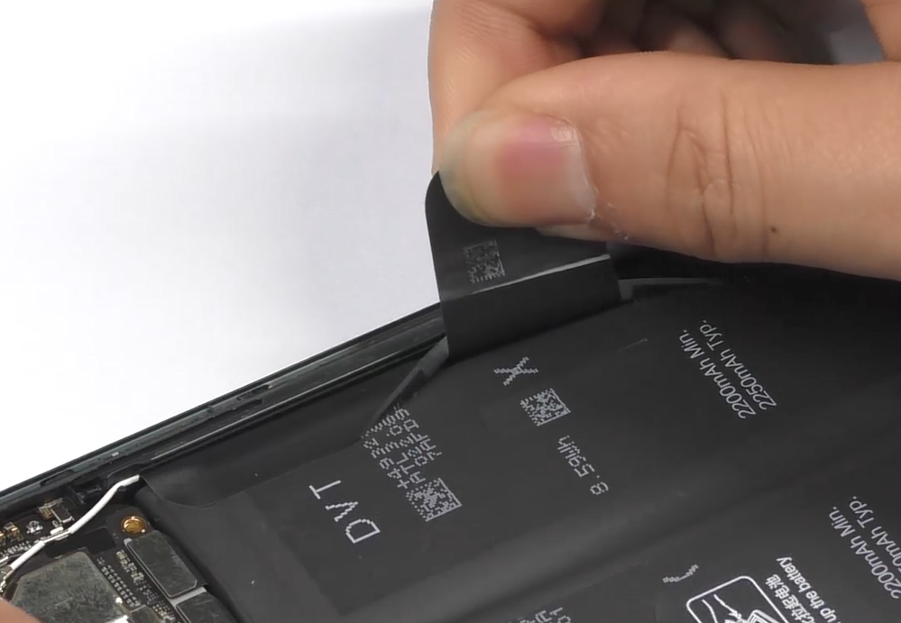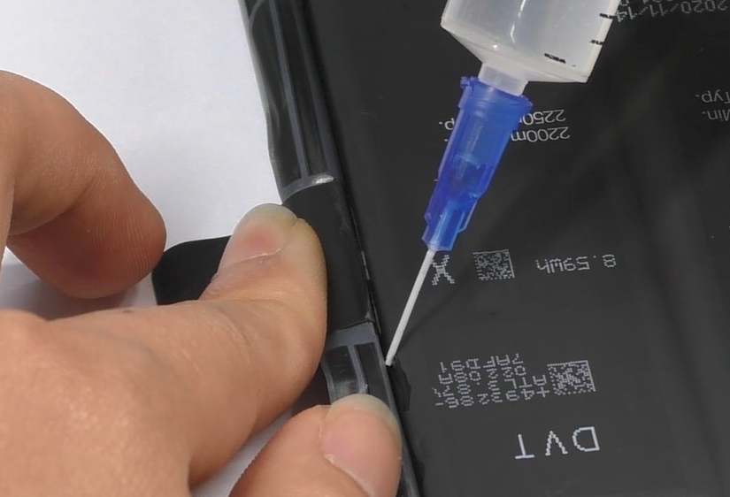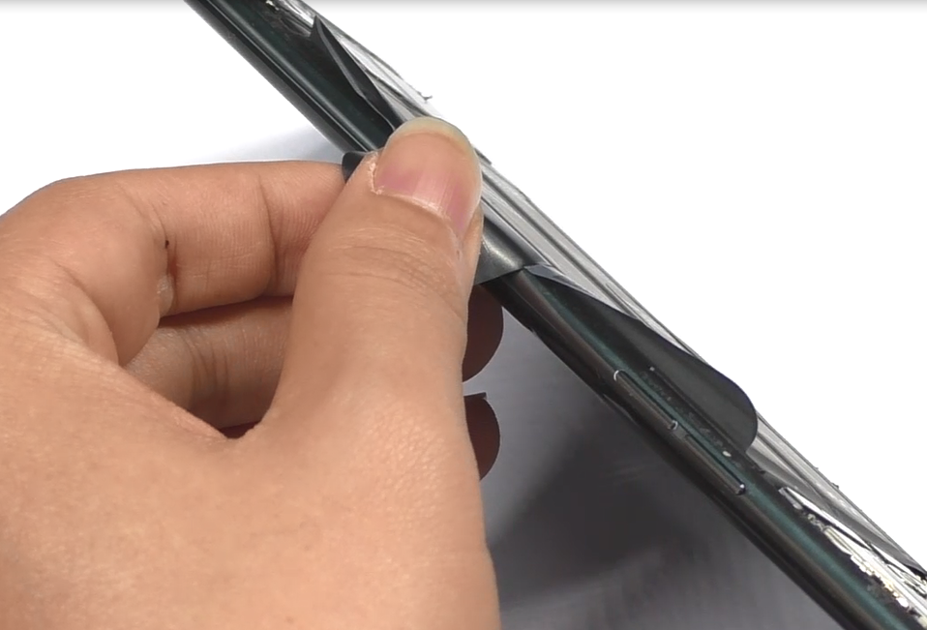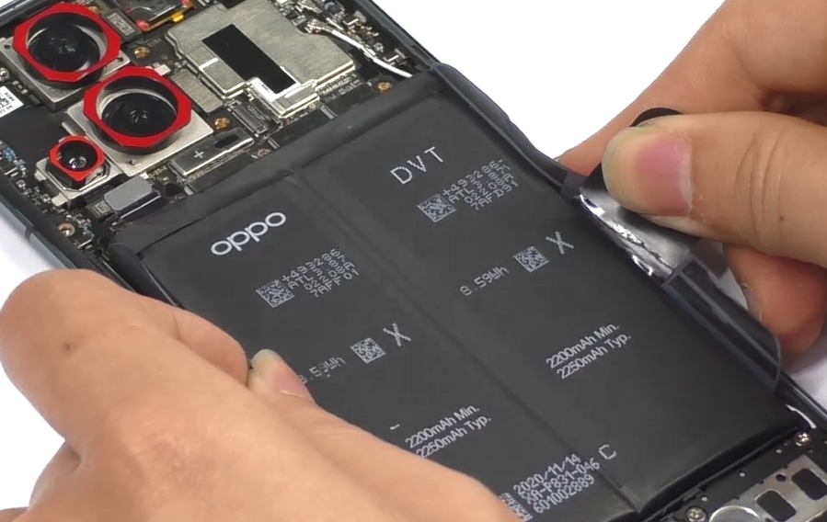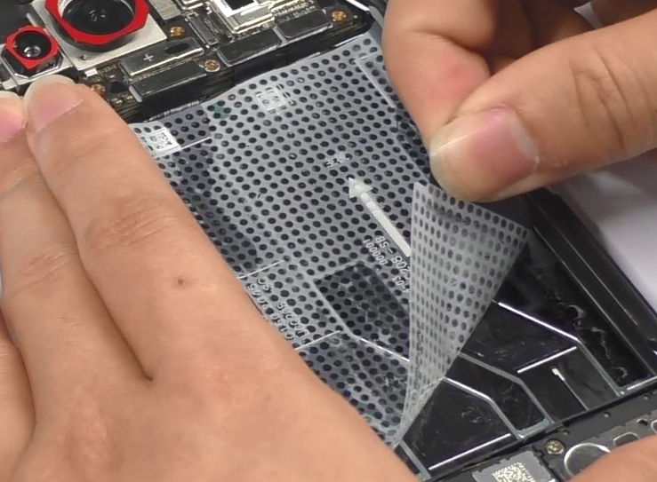 | /
8 | Disassemble L-FPC、RF cable | 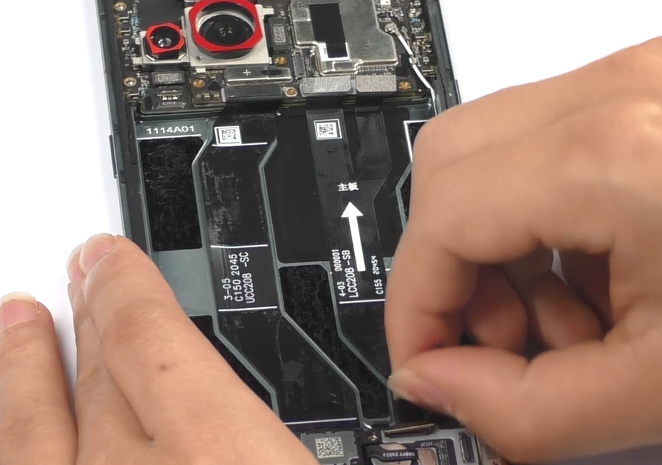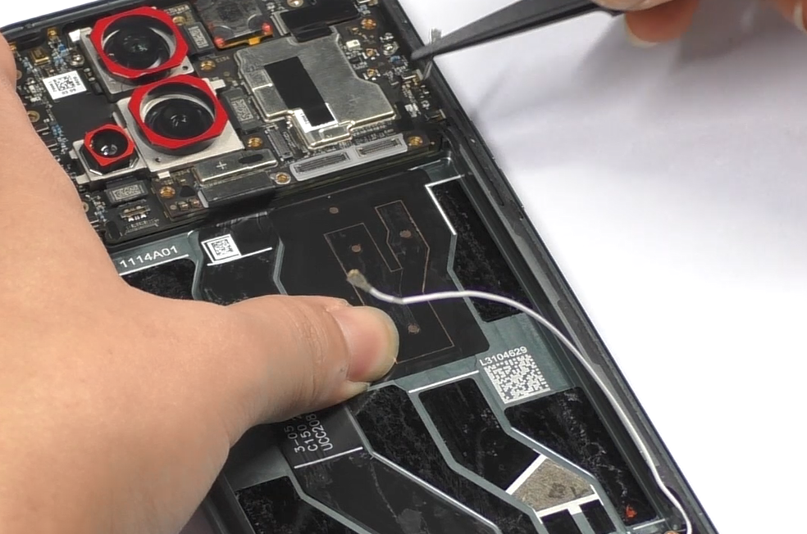 | /
9 | Disassemble speaker、fingerprint sensor | 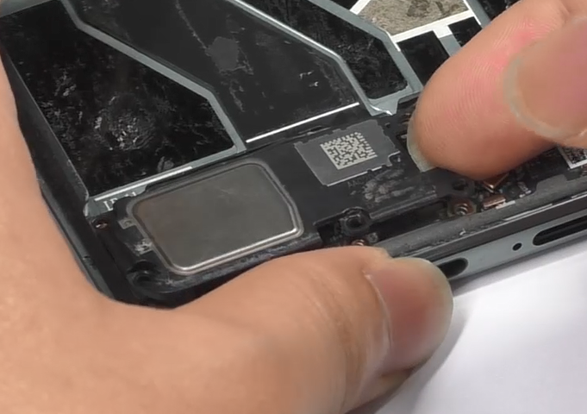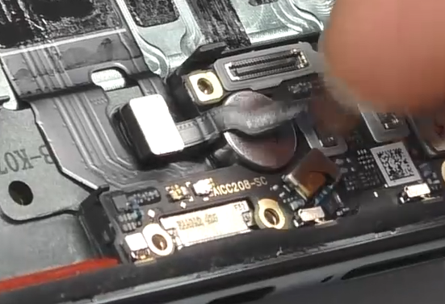 | /
10 | DisassembleUSB、antenna board | 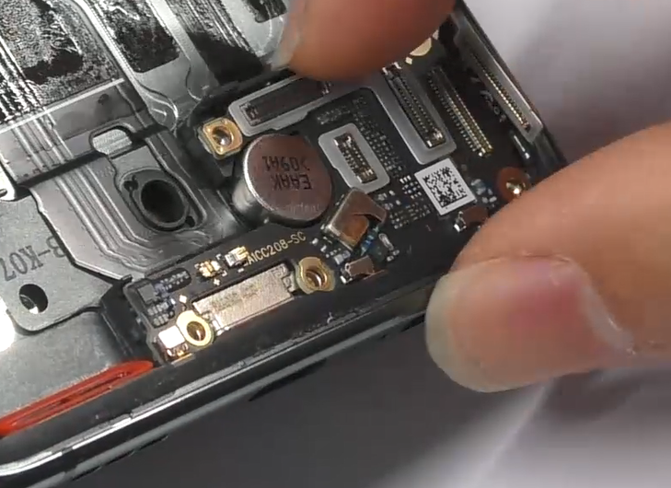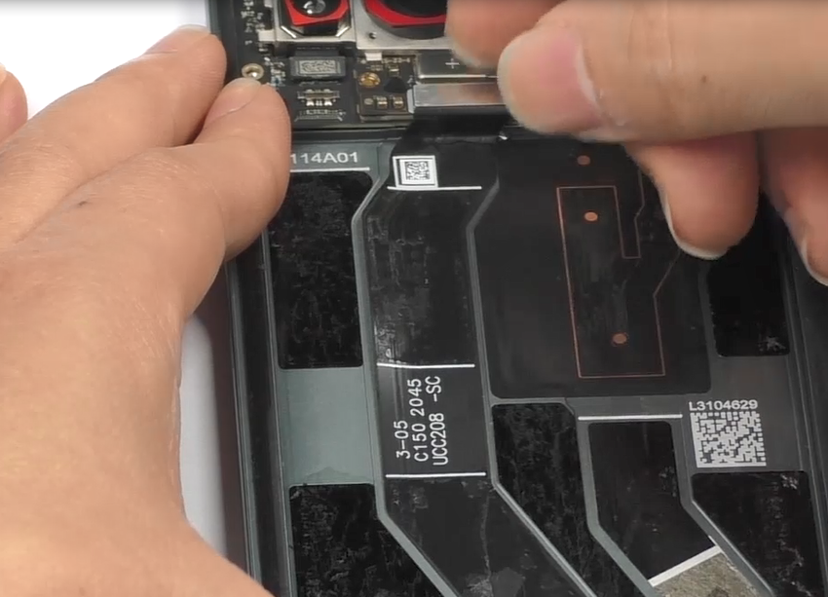 | /
11 | Disassemble front camera | 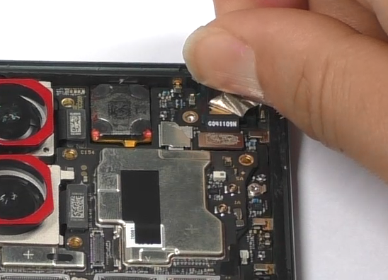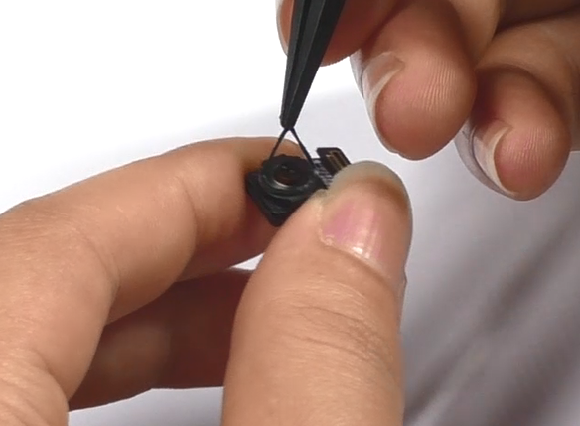 | /
12 | Disassemble rears cameras | 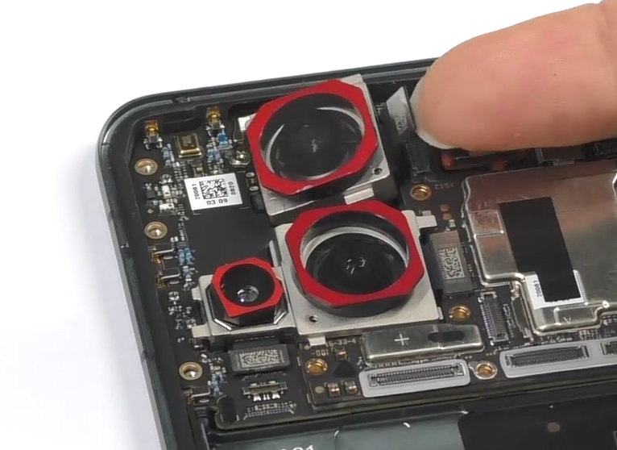 | /
13 | Disassemble mainboard | 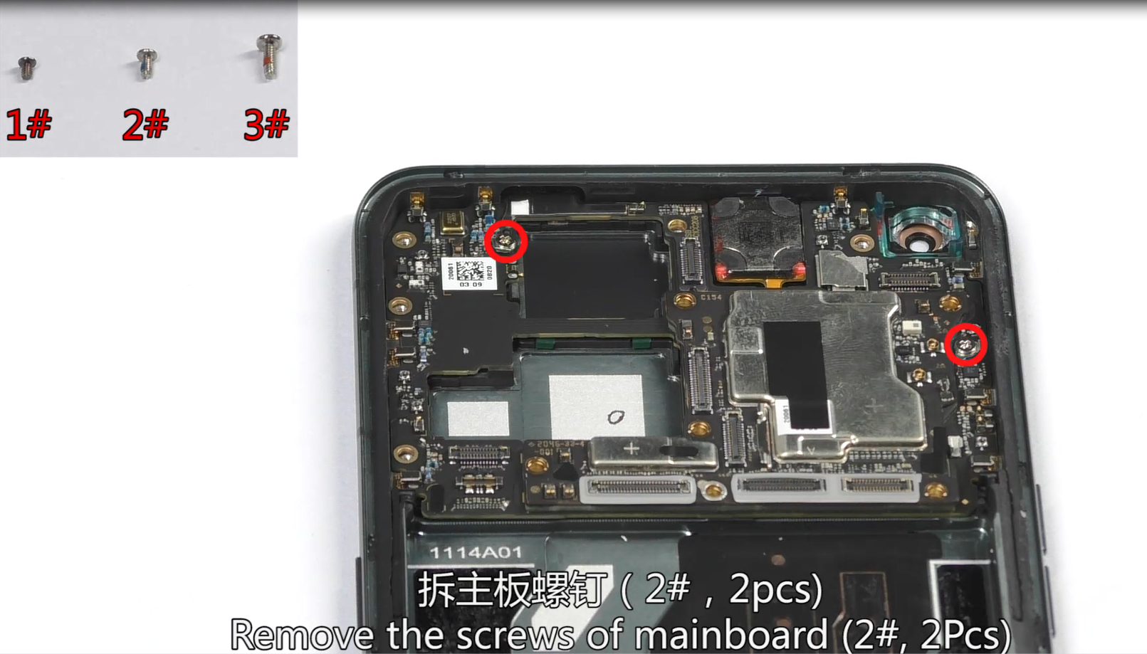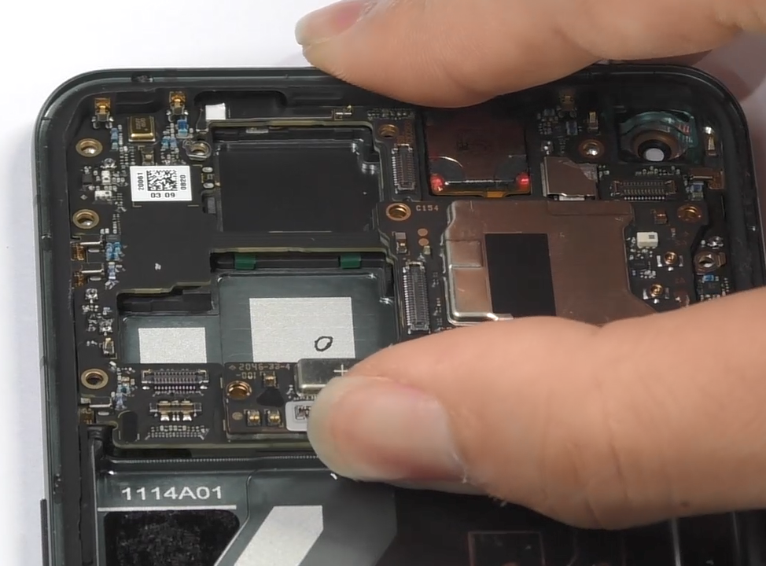  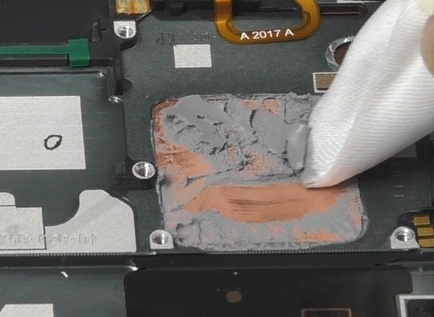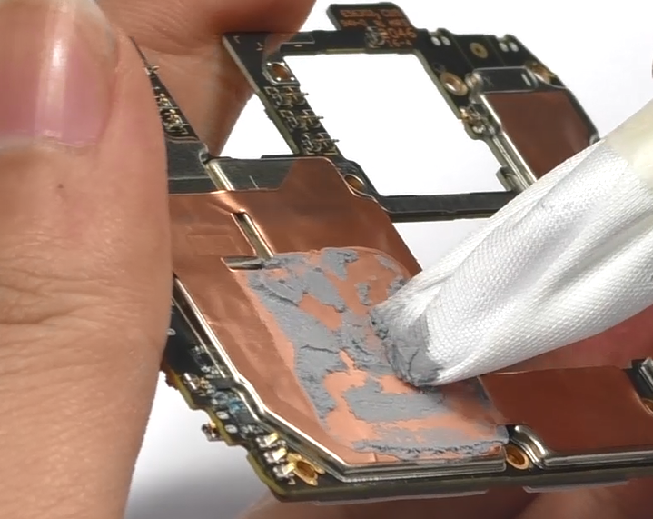 | 2#，2pcs, and the thermal gel
14 | Remove receiver、vibration motor | 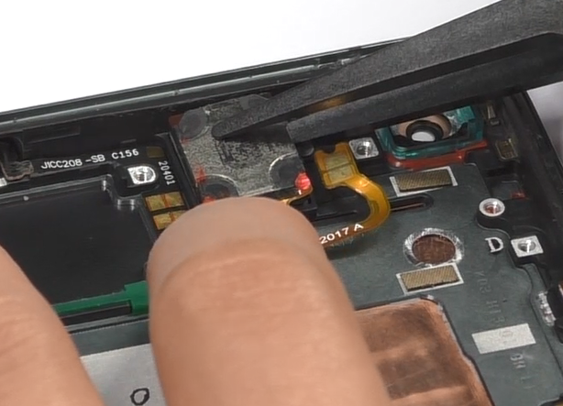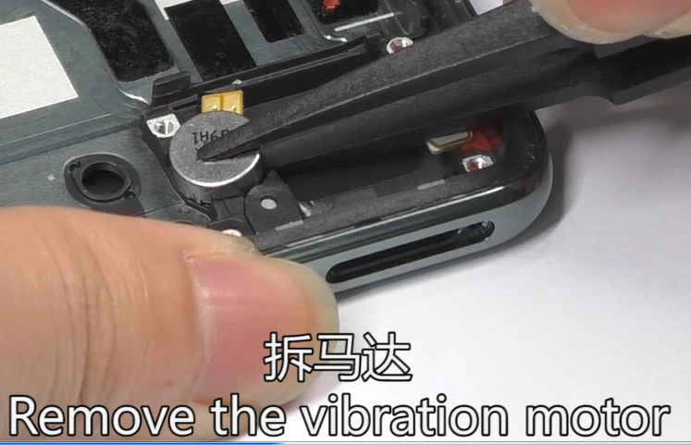 | /

5. Assembly Steps

5.1 Bill of Must-Be-Replaced Materials
NO. | Material code | Material name | Picture | QTY | Notice
1 | 4884752 | Front camera fixed double-sided adhesive | 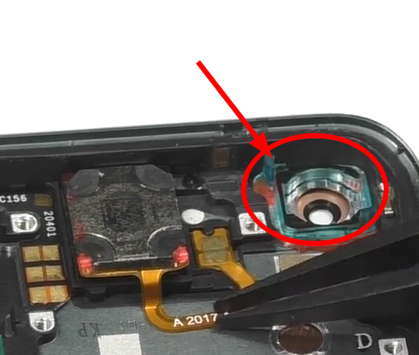 | 1 | Must change when disassemble front camera
2 | 4884821 | Front camera graphite sheet | 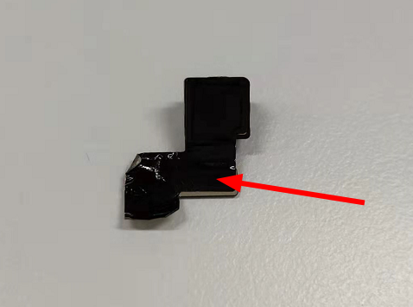 | 1 | Must change when disassemble front camera
3 | 5181951 |  | 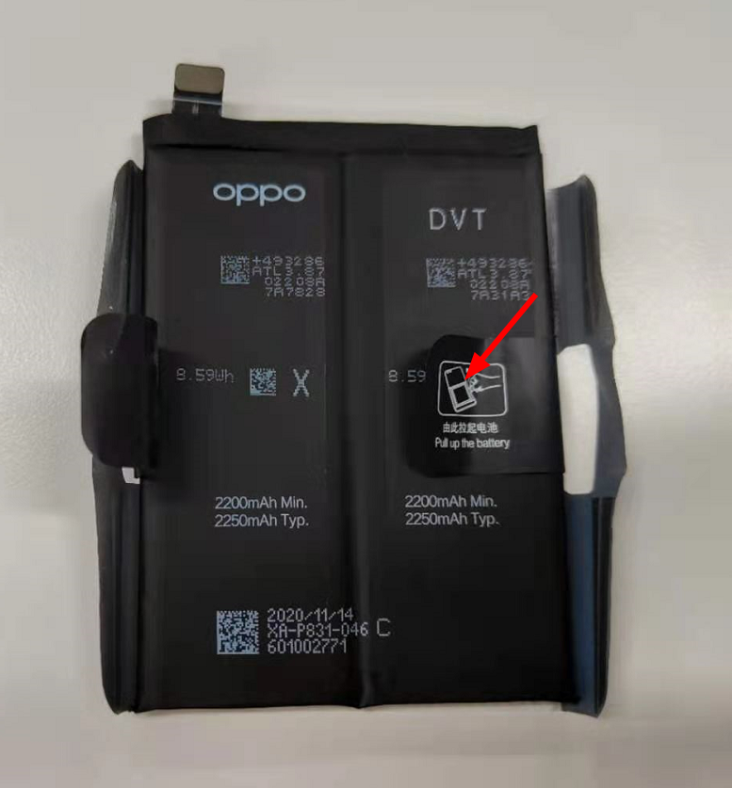 | 1 | Must change when disassemble battery
  battery extracting sticker
4 | 5181952 |  |  | 1 | Must change when disassemble battery
  battery extracting sticker
5 | 4884811 | light pipe double-sided adhesive | 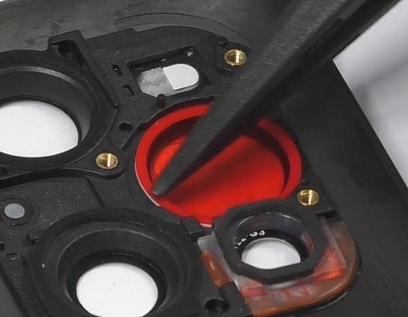 | 1 | Must change when disassemble microscope camera
6 | 4885625 | Battery cover foam rubber(waterproof) | 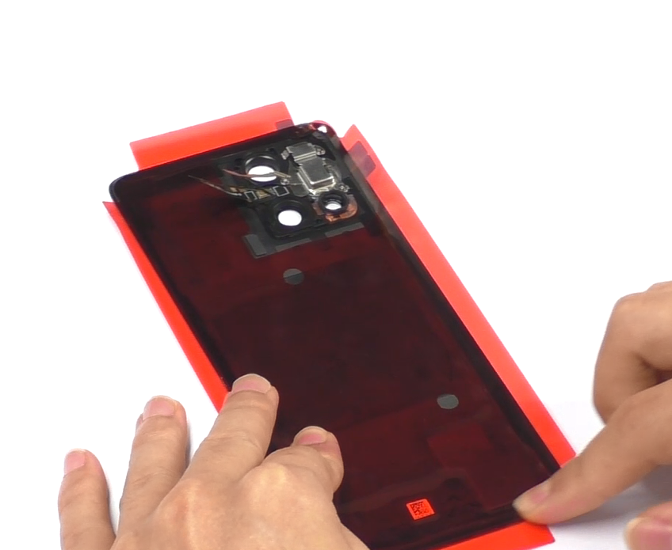 | 1 | Must change when disassemble
7 | 4884763 | Battery cover PET sheet | 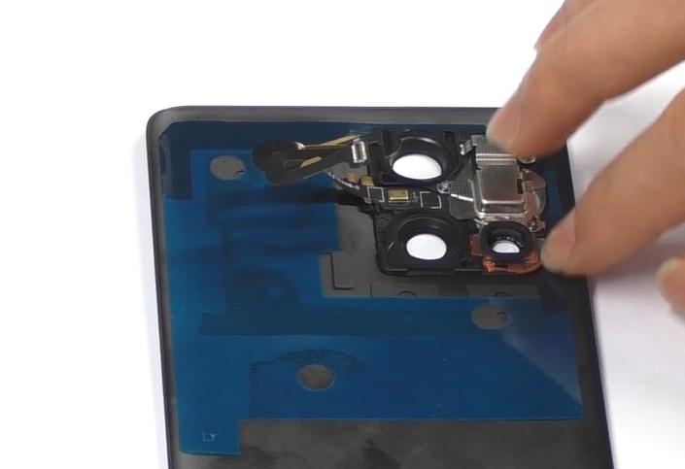 | 1 | Must change when disassemble
8 | 4886504 | battery pull tape | 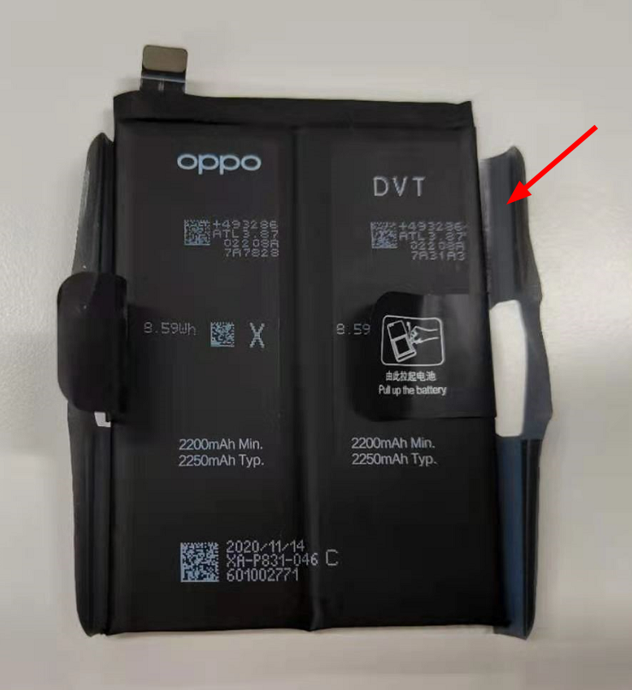 | 1 | Must change when disassemble battery

5.2 Assembly Steps
NO. | Details | Picture | Cautions
1 | Install vibration motor and receiver | 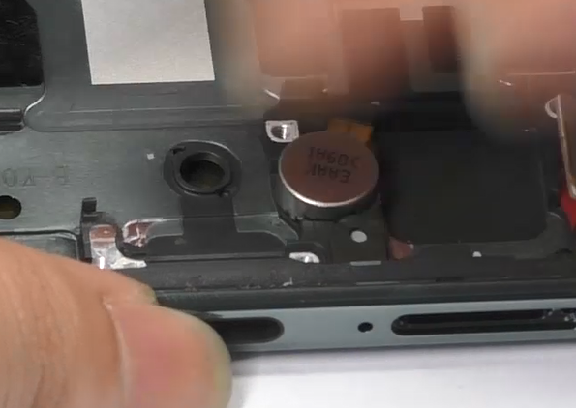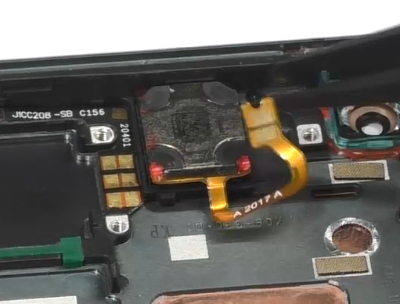 | /
2 | Install mainboard | 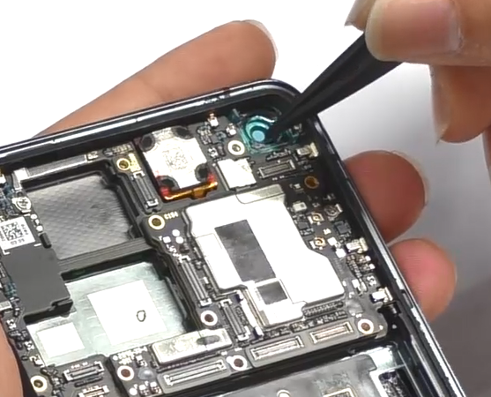  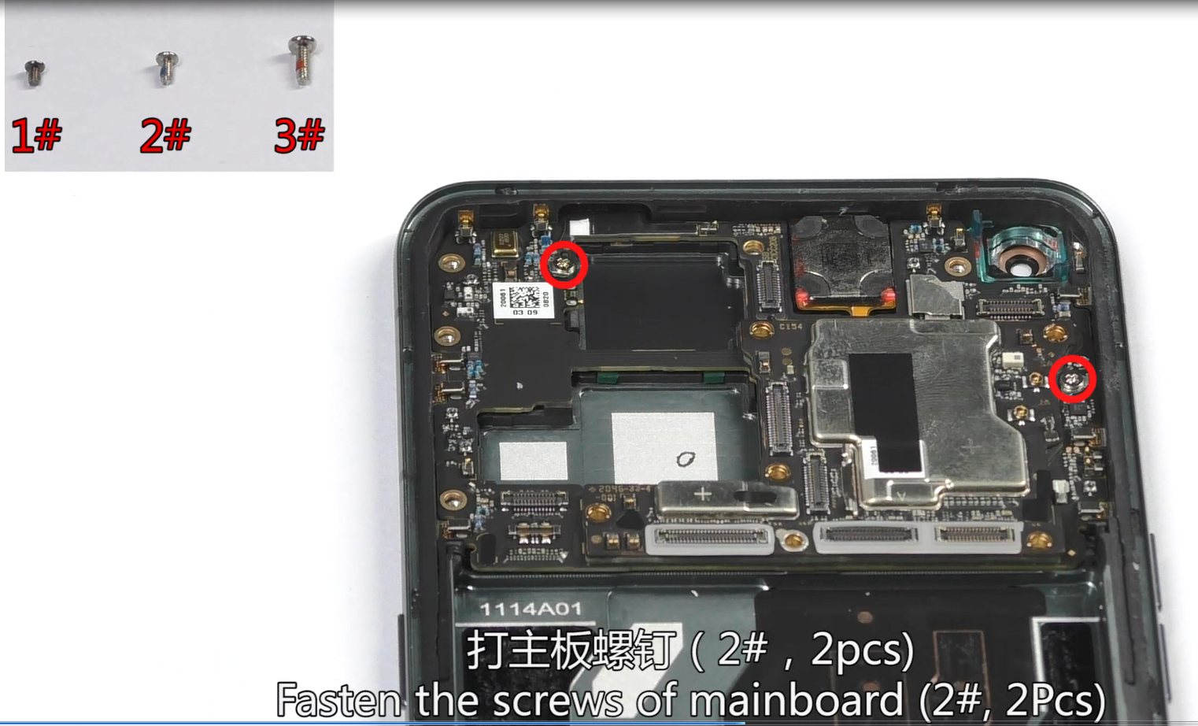  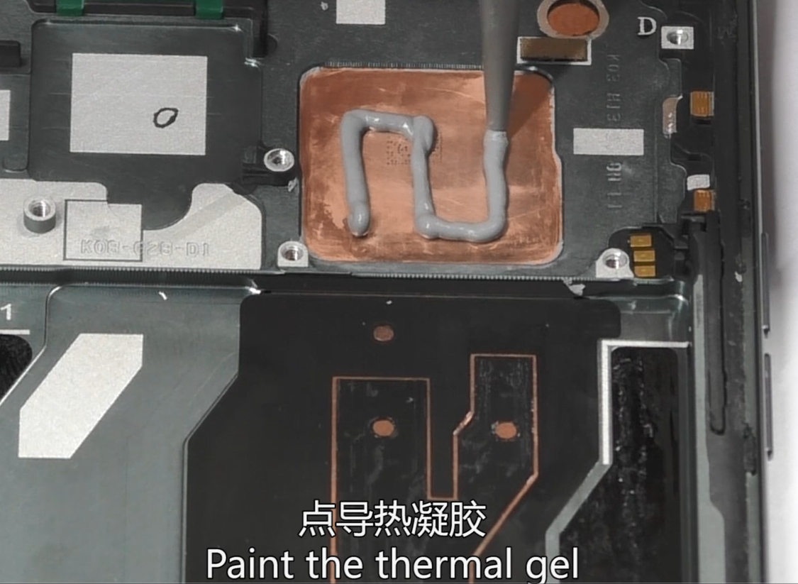  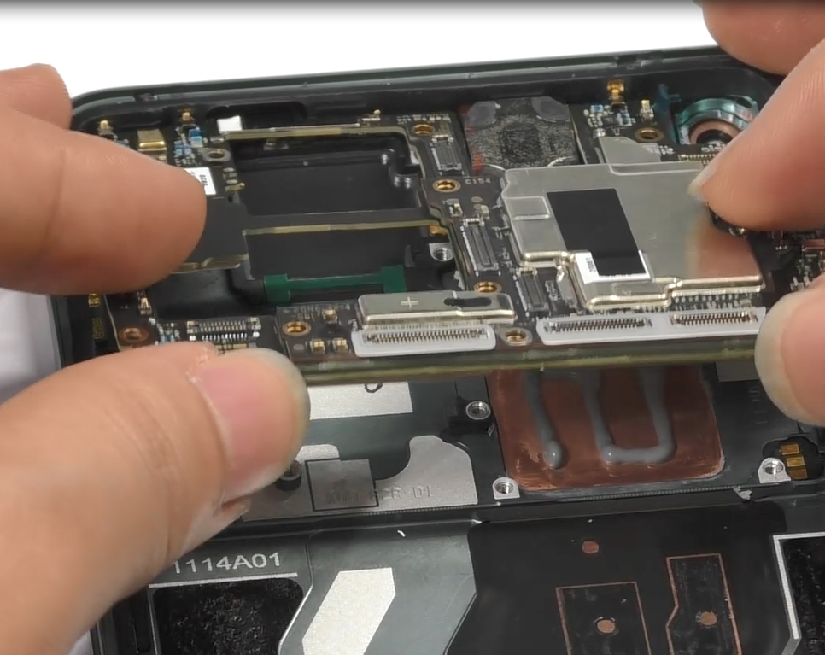 | 1. Paste thermal gel before installing the mainboard;  2. Need to fix the mainboard fixing screws 2pcs;  3.Should change the front camera fixed double-sided adhesive(4884752).
3 | Install front camera | 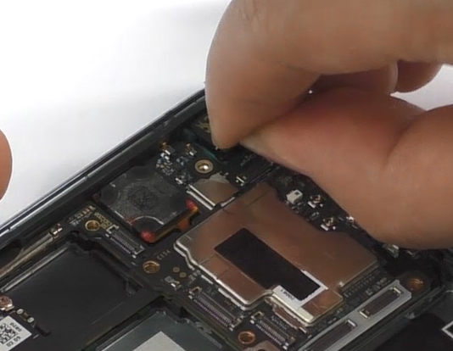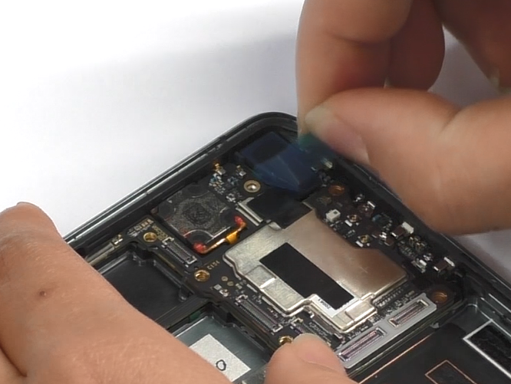 | Should change the front camera graphite sheet（4884821）
4 | Install USB、fingerprint sensor | 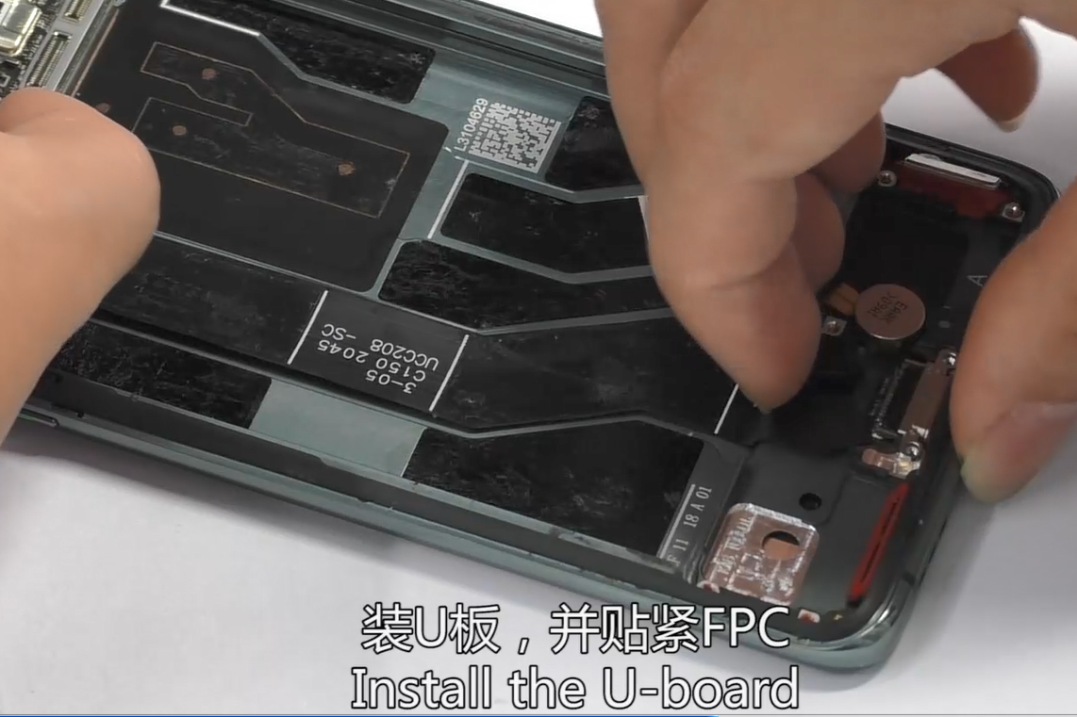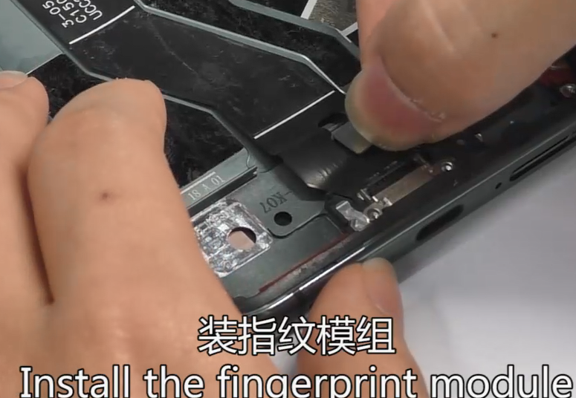 | /
5 | Install antenna board | 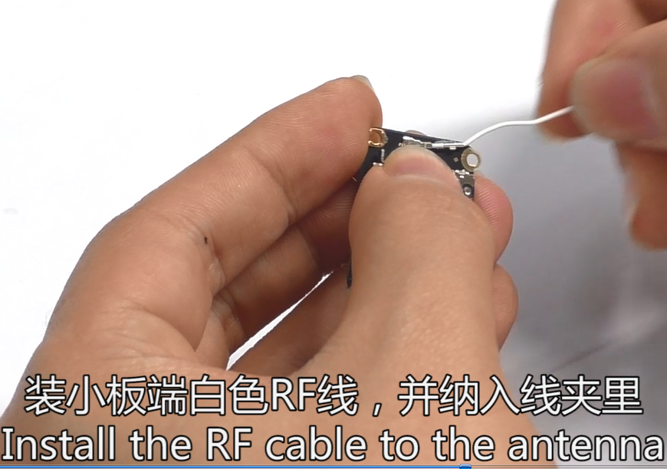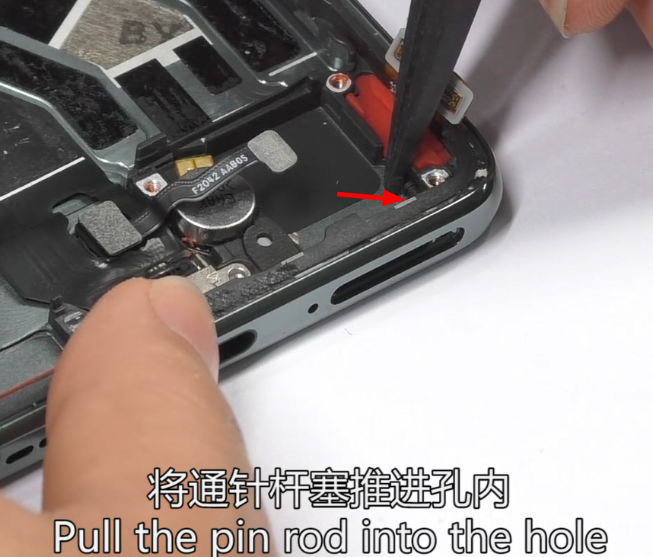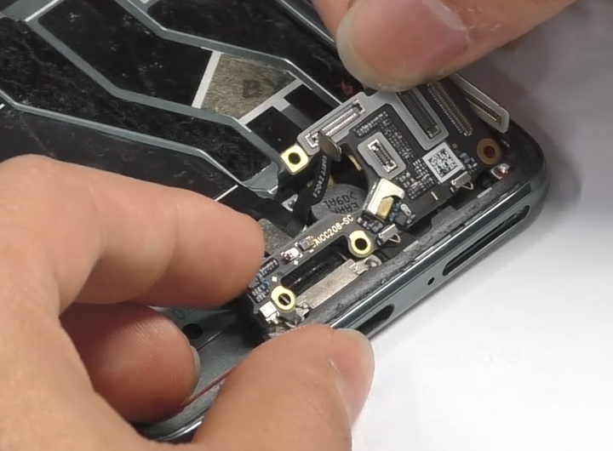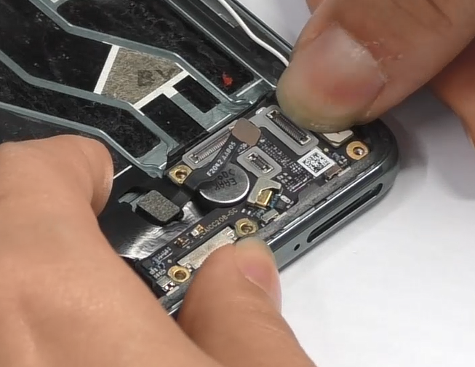 | The putter needs to be pushed back (see Figure 2)
6 | Install speaker and RF cable | 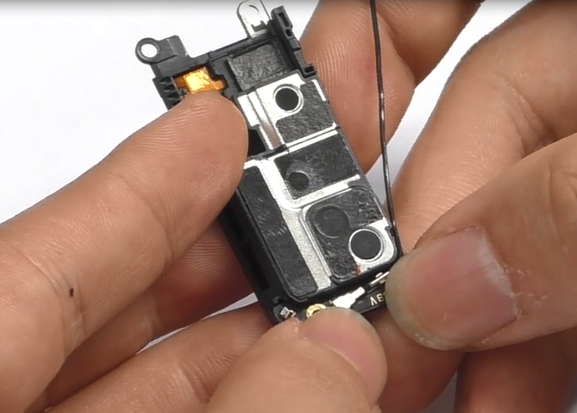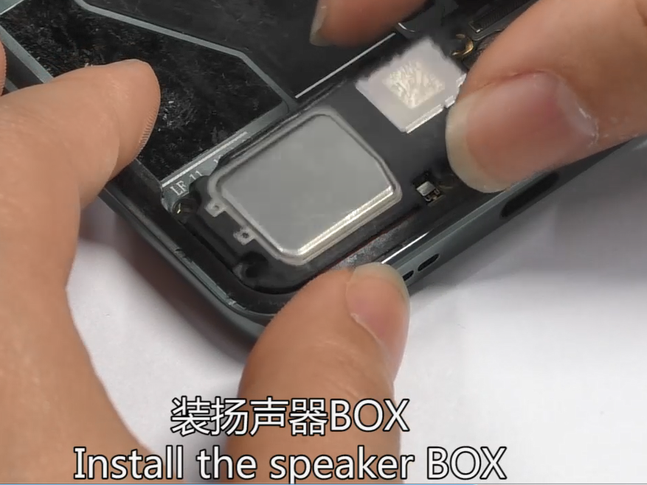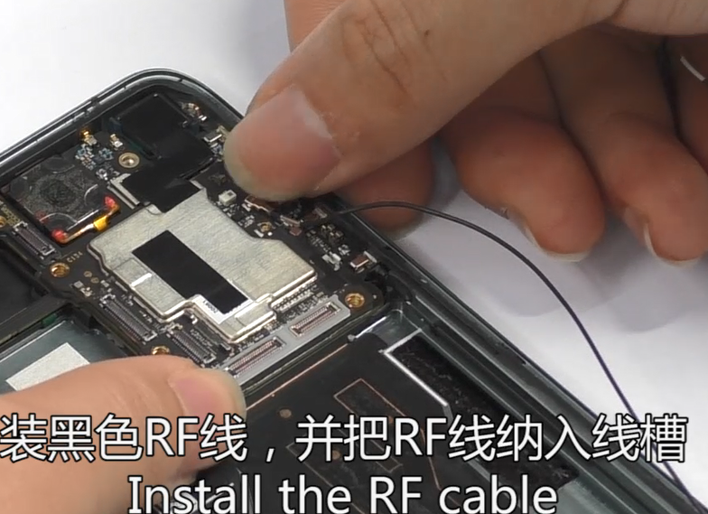 | /
7 | Attach the foam | 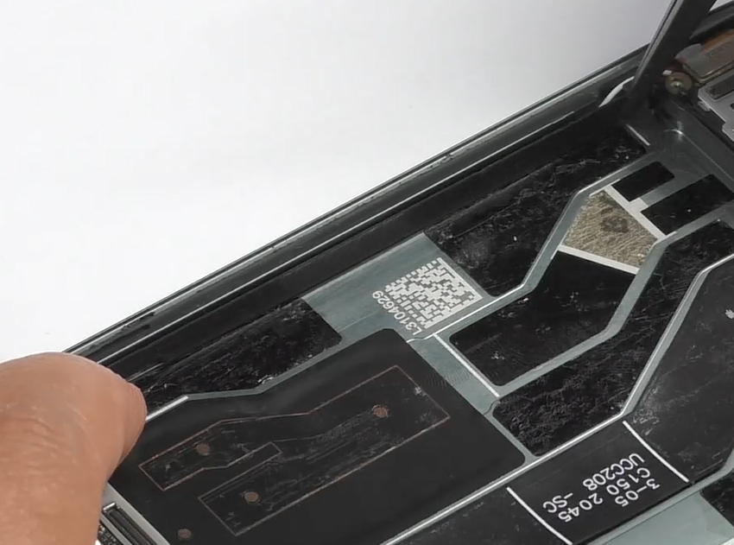 | /
8 | Install L-FPC, bracket of antenna board | 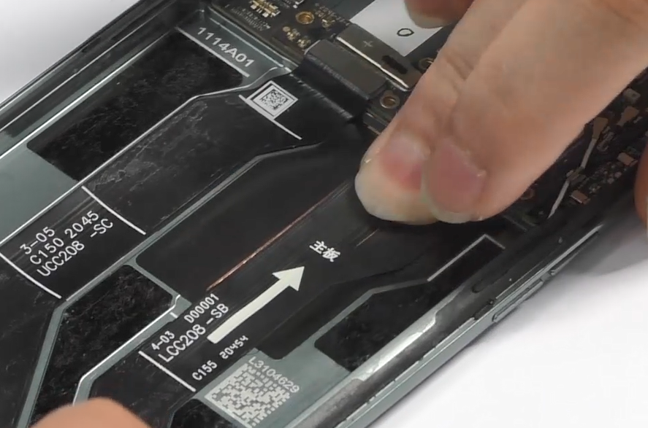  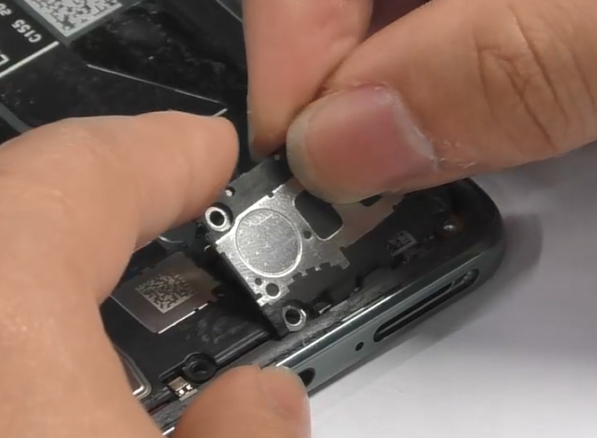 | /
9 | Attach the foam at the bottom of the battery compartment | 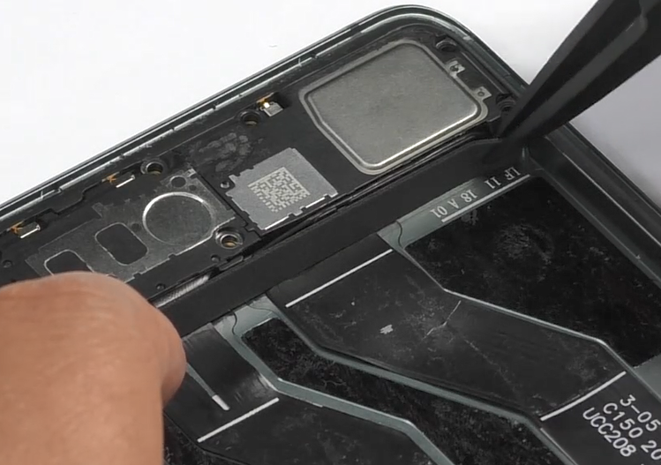
10 | Fix the screws | 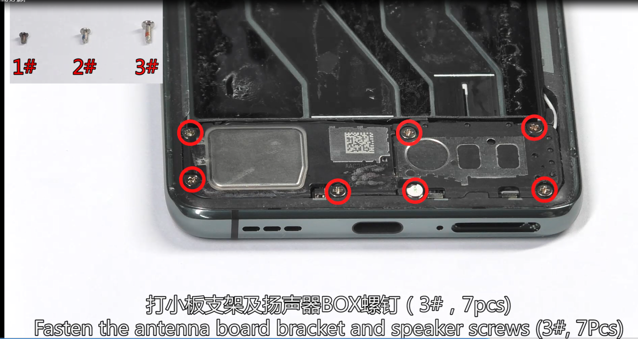 | 3#7pcs
11 | Install the rear cameras | 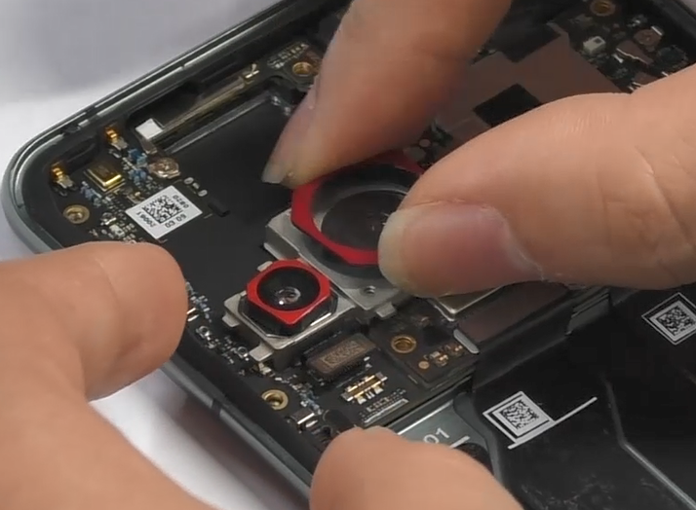
12 | Install the battery | 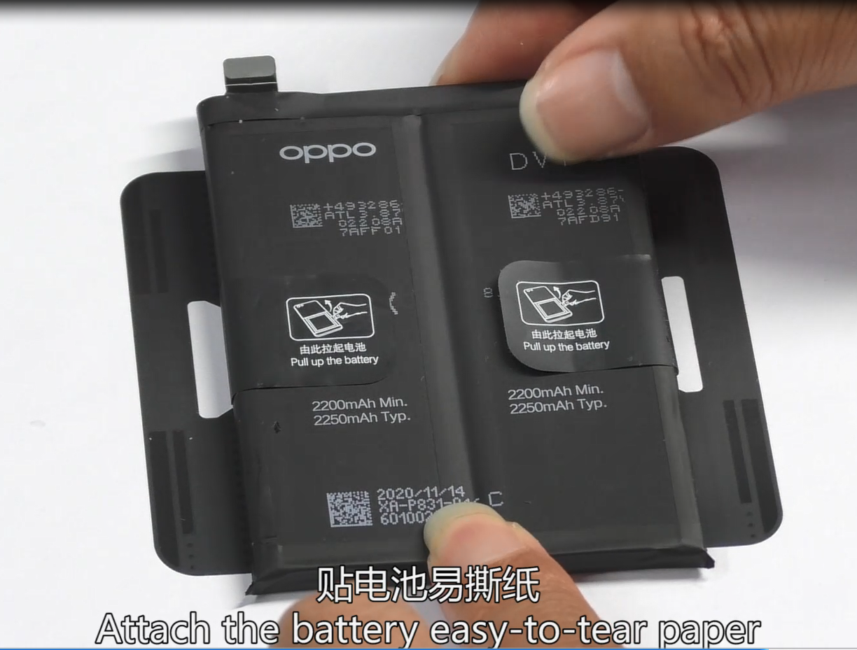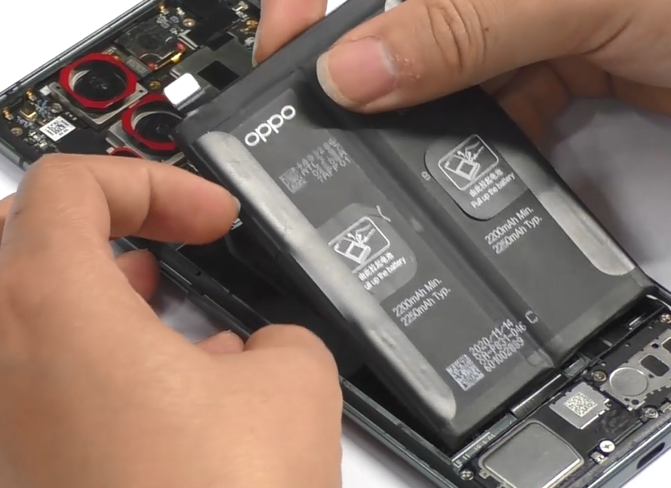 | Should change battery pull tape, code: 4886504
13 | Install the bracket of mainboard | 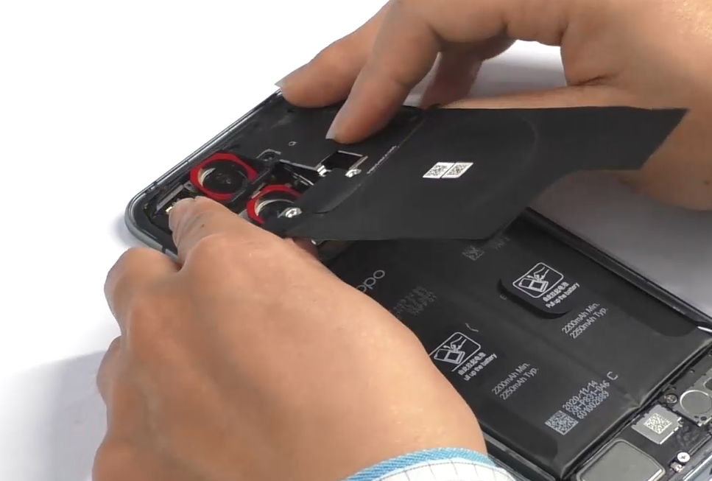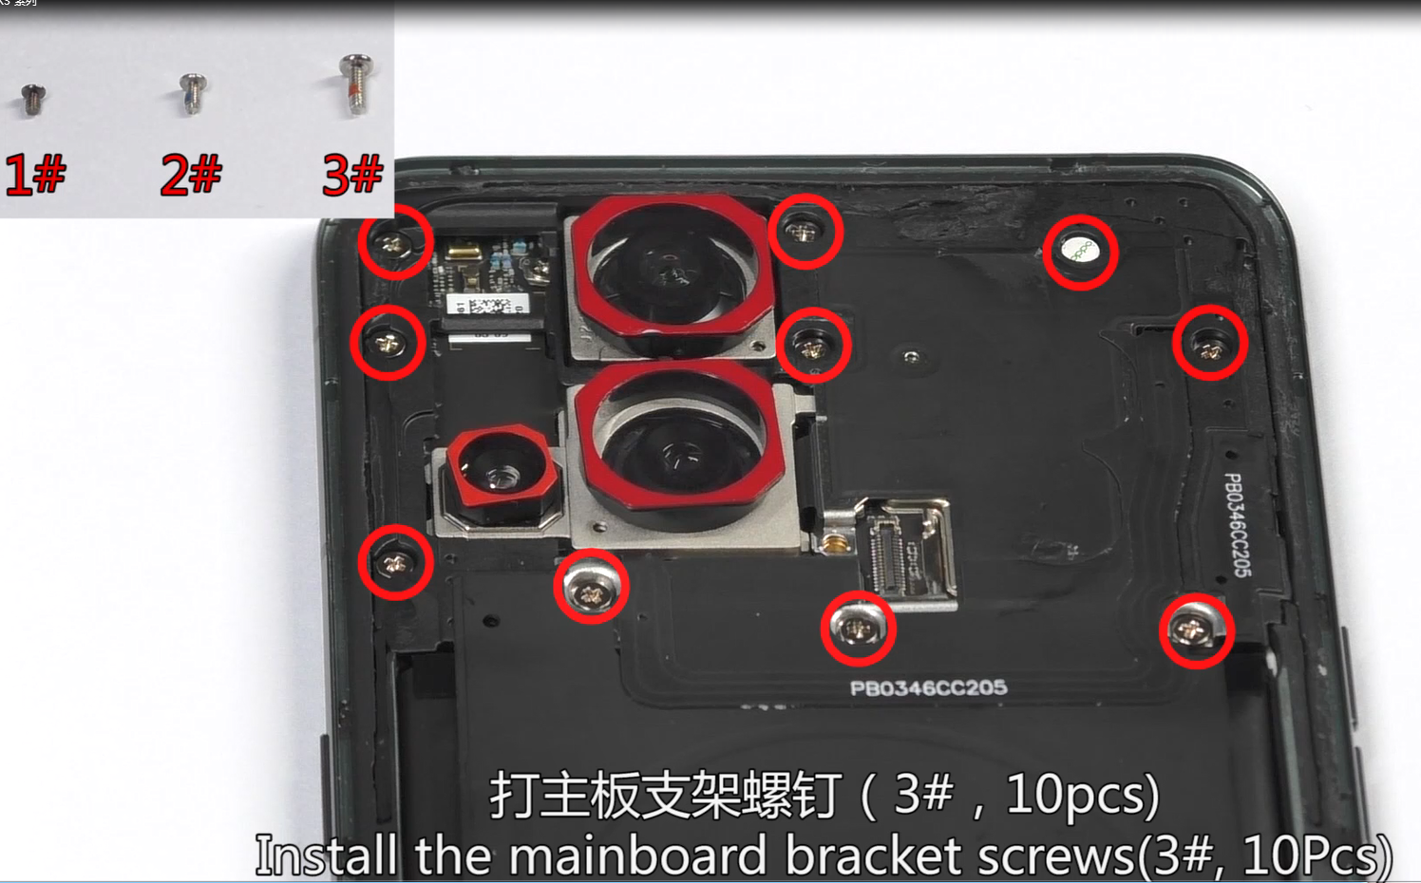 | 3#，10pcs
14 | Install the microscope camera | 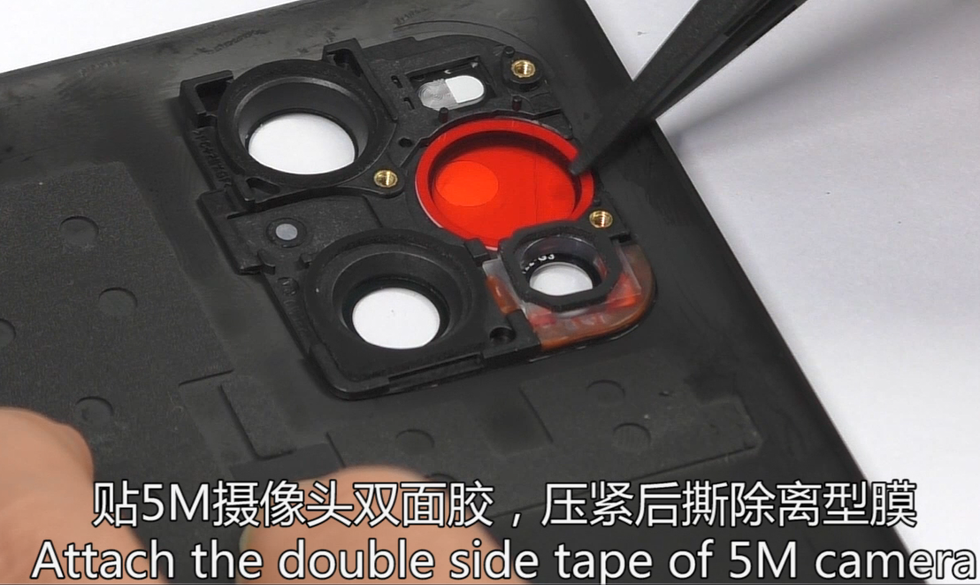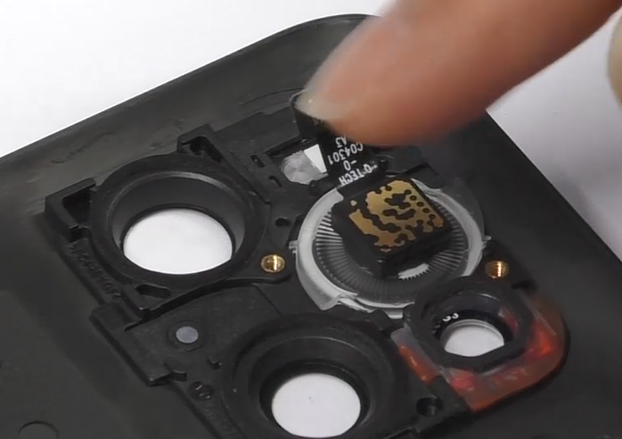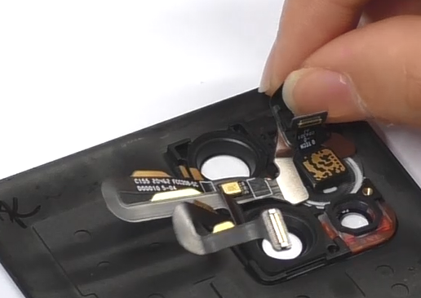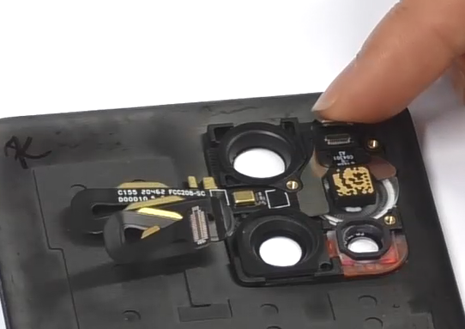 | Should change the light pipe double-sided adhesive, code: 4884811
15 | Install the Camera fastening bracket | 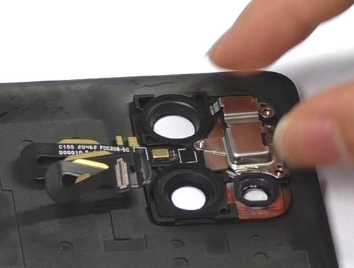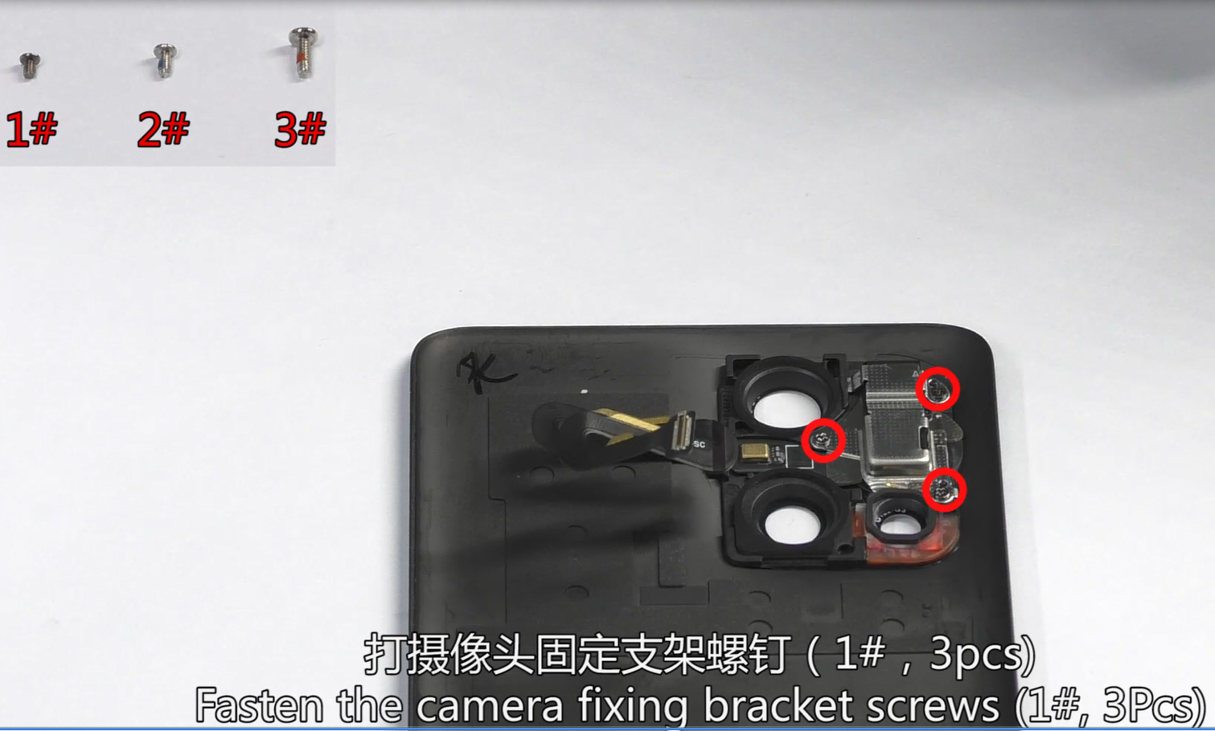 | 1#，3pcs
16 | Attach the double side tape and PET | 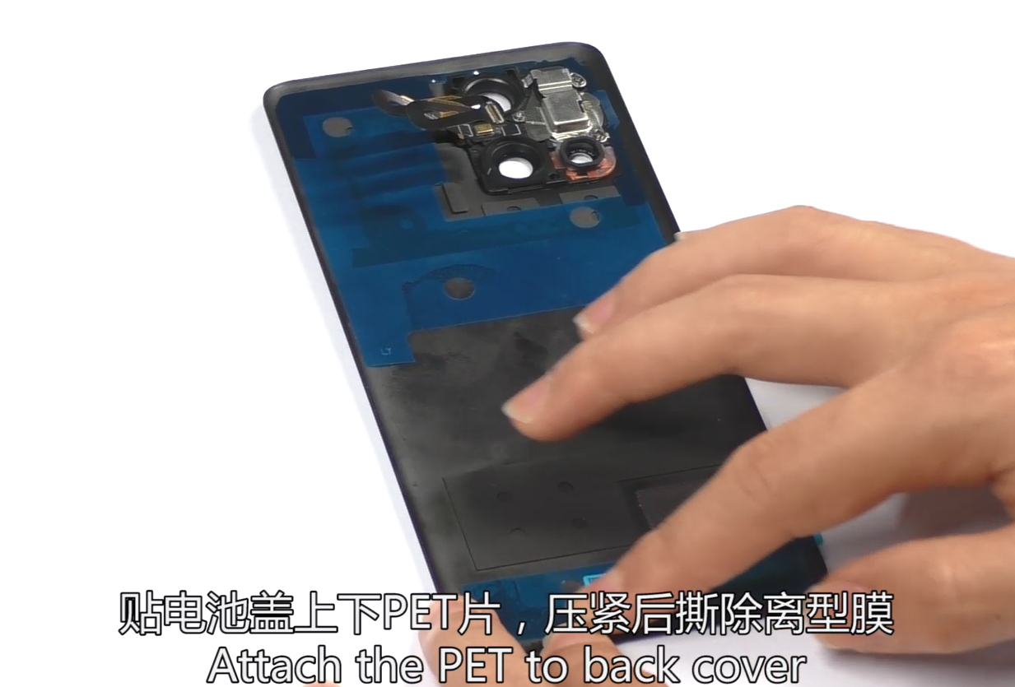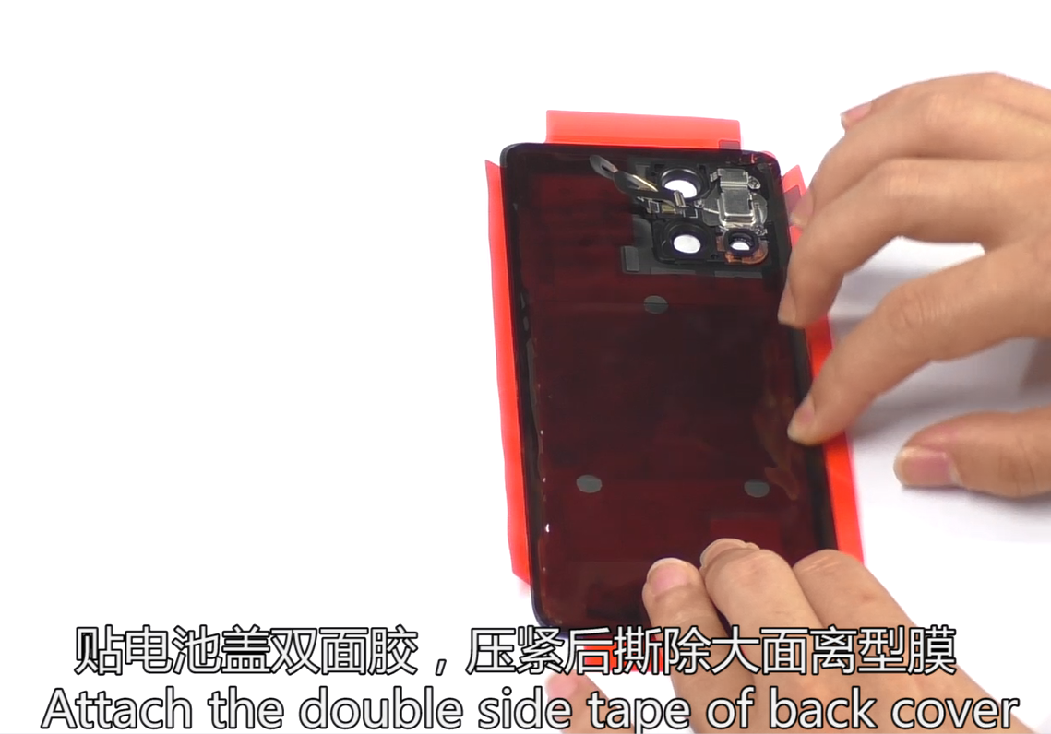 | PET code: 4884763  Double side code: 4885625
17 | Dispense glue | 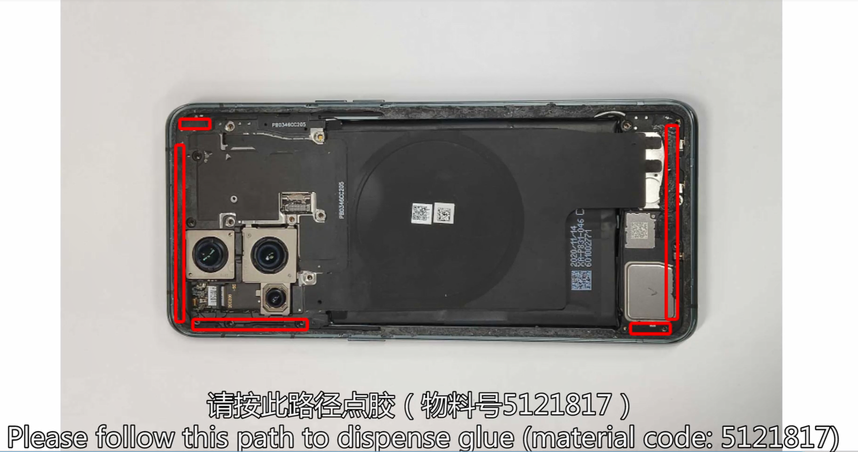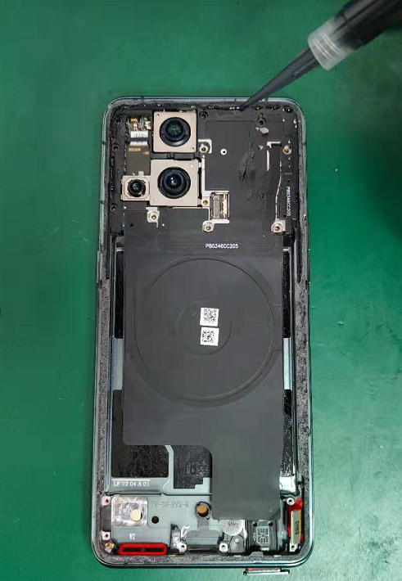 | Glue code: 5121817  Please dispense glue as shown in the glue path
18 | Install the FPC of flash | 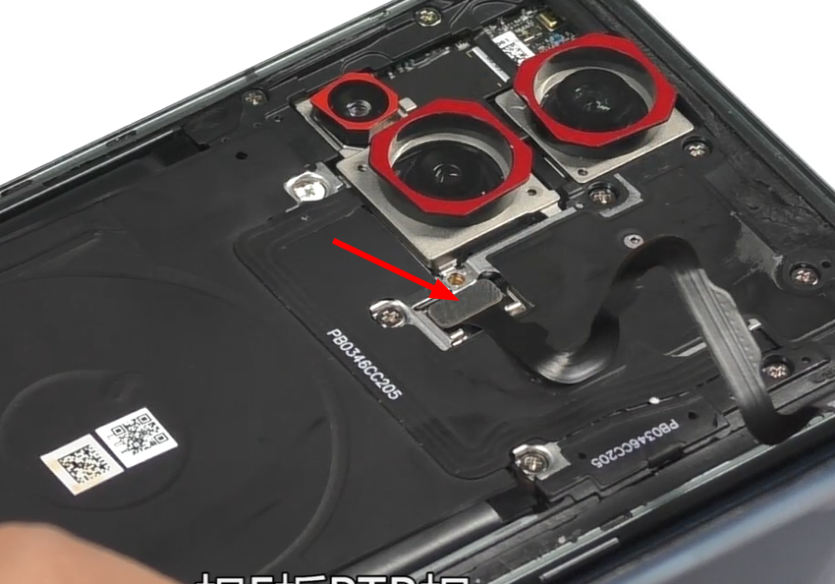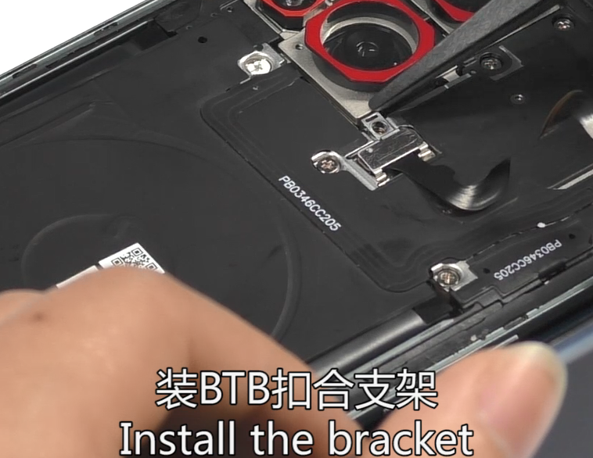  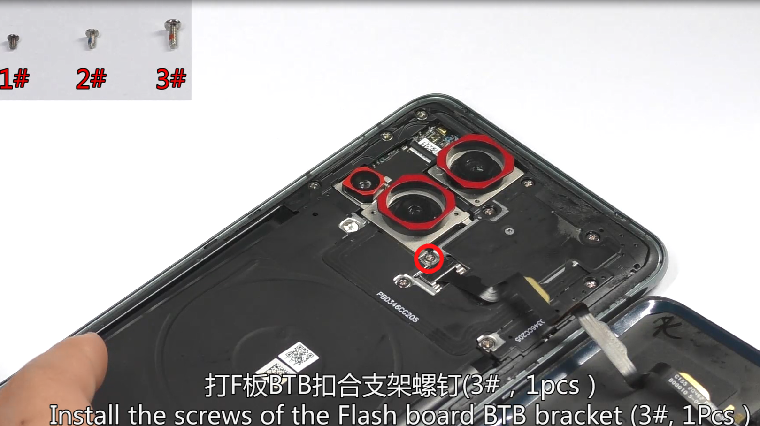 | 3#，1pcs
19 | Install the back cover and sim card tray, power up and check function | 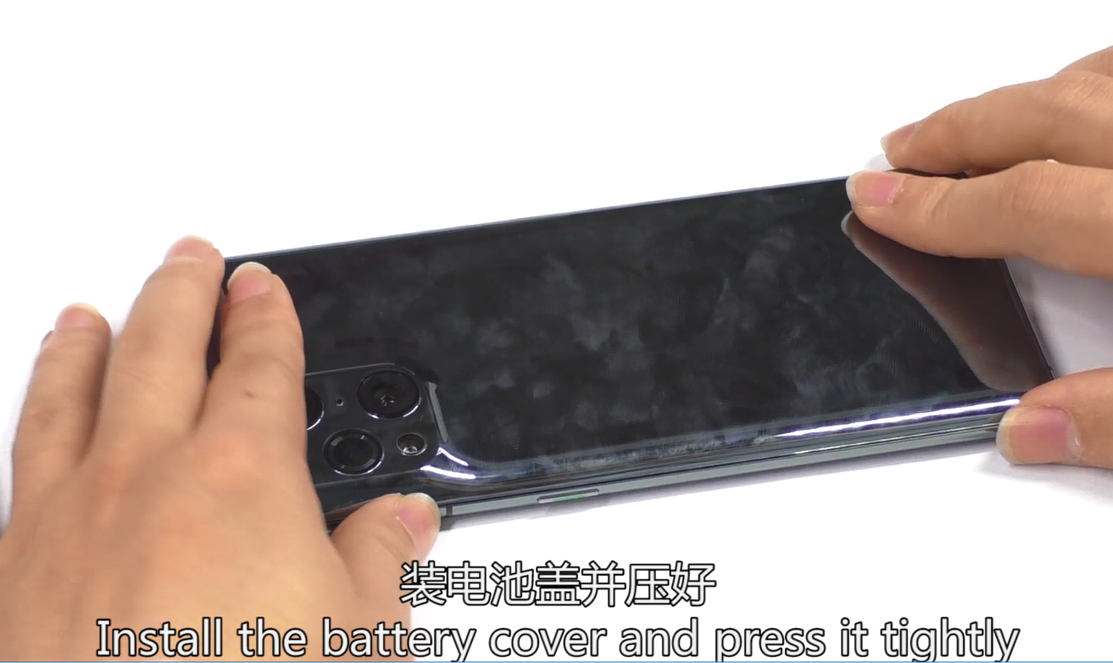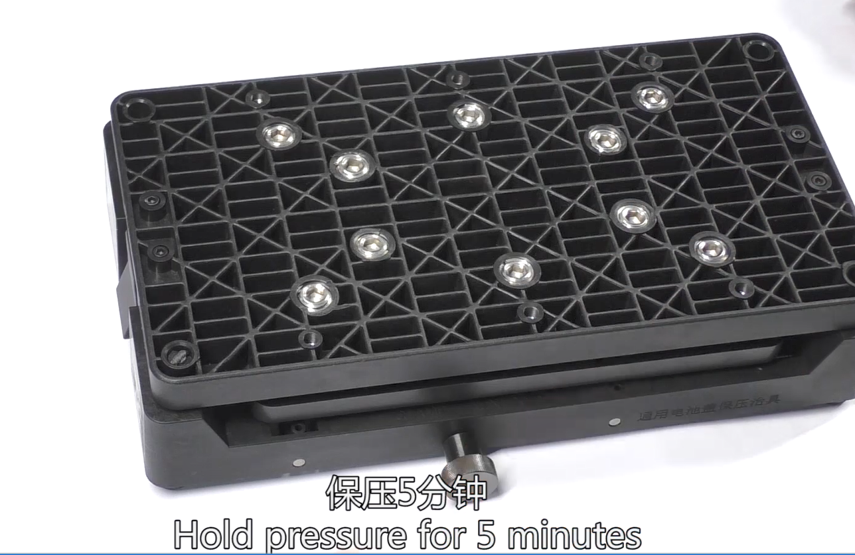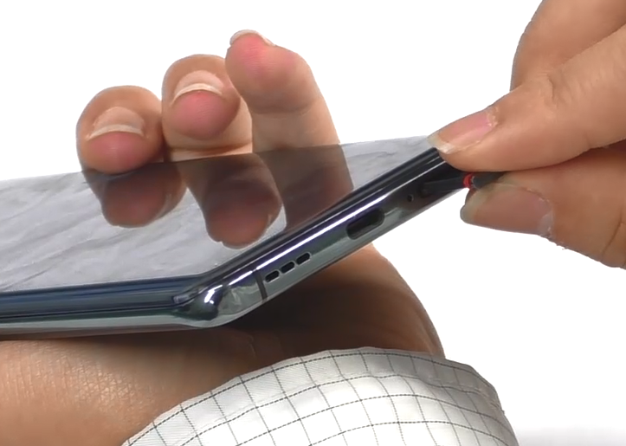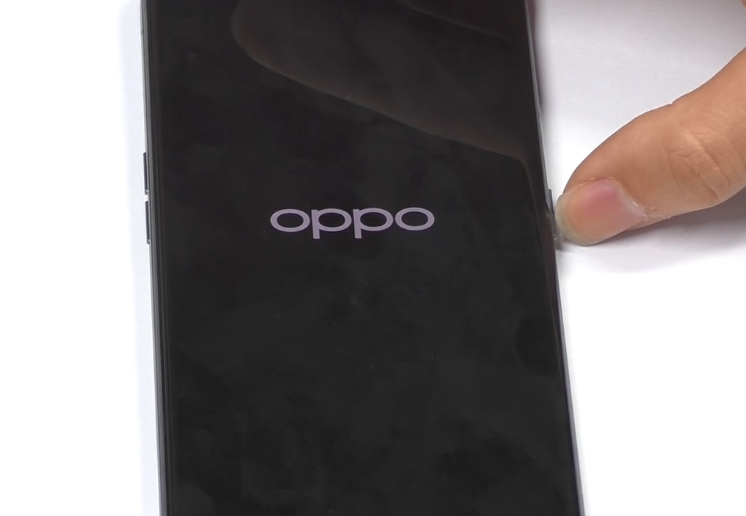 | Hold pressure for five minutes

6. Calibration
After the phone is disassembled and assembled, the aftersale devices calibration must be calibrated first. The calibration of this model includes( Front color sensor calibration--fingerprint optical calibration--aftersales calibration--smart power amplifier calibration--Vibrator Calibrate)..
Enter Password: 6776 | Click ”Front color sensor calibration ” | 1.Click "START" to start calibration after it jumps into the fingerprint optical calibration
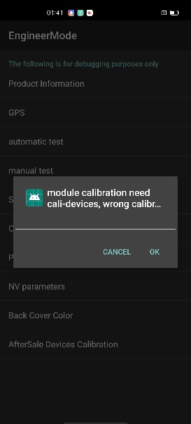 | 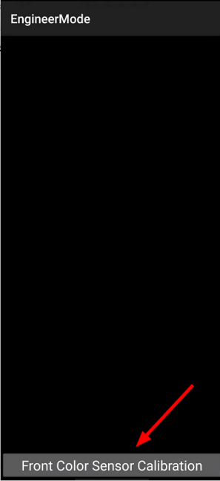 | 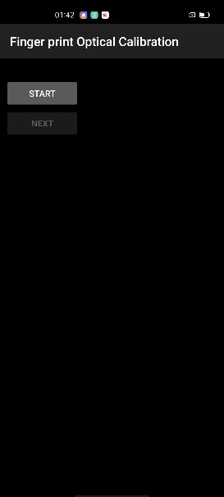
2. According to the prompt "please place the yellow rubber ", put the yellow rubber on the fingerprint spot area (the groove is facing down), and click "NEXT" until it prompts " please place the black rubber". | 3. According to the prompt "please place the black rubber head", put the black rubber on the fingerprint spot area (the groove is facing down), click "NEXT" until the "please place the yellow stripe rubber " prompts to remove the black rubber ; | 4. According to the prompt “Please place the yellow- striped rubber”, put the yellow stripe rubber (striped down) in the spot area, click “NEXT”;
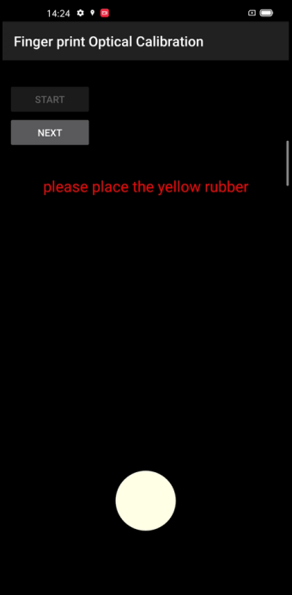 | 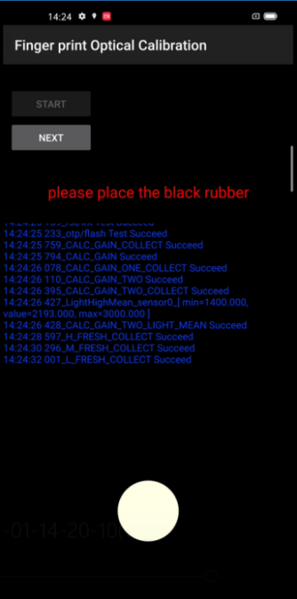 | 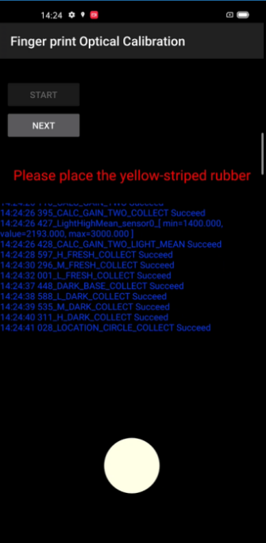
5. Jumps into the after sales calibration from fingerprint optical calibration 4. According to the prompt “Please place the yellow- striped rubber”, put the yellow stripe rubber (striped down) in the spot area, click “NEXT”; | 6. After the calibration is completed，it’s will jump into smart power amplifier calibration it jumps into the after interface | 7.After the test is completed, it will automatically jump to "Vibrator calibration", click to start calibration
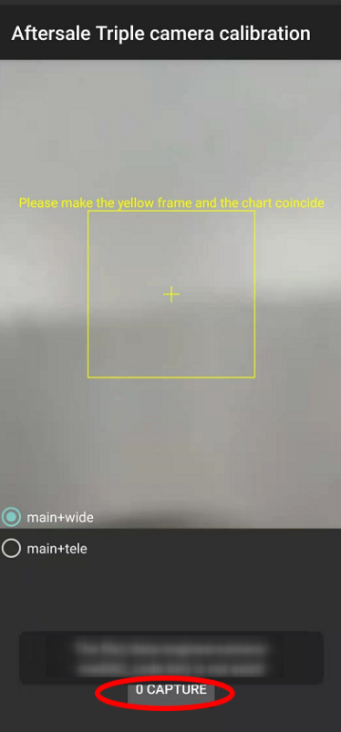 | 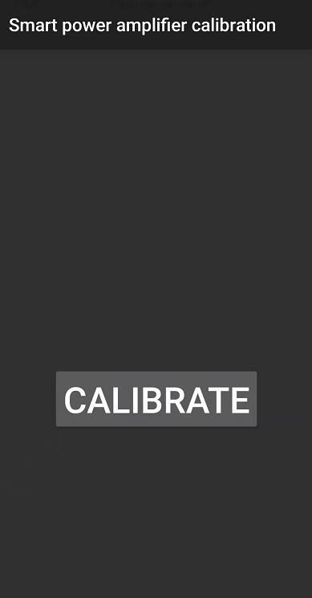 | 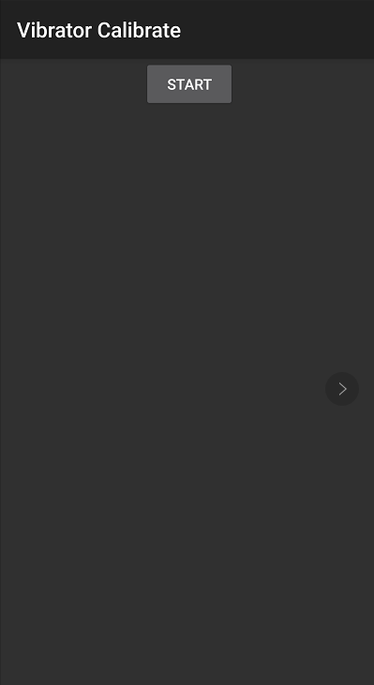
After the calibration is completed, restart the phone to make the calibration take effect, and guide the user to delete the original fingerprint and re-enter.

7. Function Test

7.1 Test Path
Dialing Interface>Enter*#899#>Enter automatic test； The "Confirm" dialog box will pop up after the test complete, if there is no problem choose “Pass”, otherwise choose “Fail”.

7.2 Test Requirements
No. | Test Items | Test Requirements
1 | LCD Test | Observe the red, green, blue, white, black, gray, grayscale and color interface successively; If there are black spots, bright spots and other anomalies, the function is good;
2 | Vibration Test | Get ear close to check the vibration from the motor for 3 seconds.  If the motor vibrates normally(No noises or weak vibration), the function is good;
3 | Touch Screen Auto Test | If the interface shows “PASS” and jumps to the next test, the function is good;
4 | Front Camera Preview | Align the camera with a white surface and a black surface. If there is no black dot, black line or blurred screen on the screen after aligning the white surface, and there is no bright spot on the screen after aligning the black surface, the camera is good;
5 | Rear camera preview | Align the rear camera with a white surface, a black surface, and a surface with text. If there is no black dot, black line or blurred screen on the screen after aligning the white surface, there is no bright spot on the screen after aligning the black surface, white point or blurred screen, the camera is good;
6 | Second rear camera preview | Align the Second rear camera with a white surface, a black surface, and a surface with text. If there is no black dot, black line or blurred screen on the screen after aligning the white surface, there is no bright spot on the screen after aligning the black surface, white point or blurred screen, the camera is good;
7 | third rear camera preview | Align the third rear camera with a white surface, a black surface, and a surface with text. If there is no black dot, black line or blurred screen on the screen after aligning the white surface, there is no bright spot on the screen after aligning the black surface, white point or blurred screen, the camera is good;
8 | Fourth rear camera preview | 1. After entering the camera, put the mobile phone close to the subject, such as the desktop or paper surface (shooting distance is about 1mm), and check for bright spots, white spots, and blurred screens. If the above phenomena do not exist, it is a good product.
9 | Echo test | Testing Main MIC: Blow the air to the MIC hole on the bottom of the phone. If the receiver (earphone) sounds, the function of Main MIC is good;  Testing Sub MIC: Blow the air to the sub MIC hole on the top of the phone. If the speaker sounds, the function of Main MIC is good;
10 | Flashlight Test | Open the flashlight. If it can be opened normally with color deviations, the function is good;
11 | Charging Test( Super VOOC) | Use the original OPPO adapter and USB cable to charge. If the interface shows “PASS” and jumps to the next test, the function is good;
12 | Wireless Normal Charger | Align the wireless charging area of the mobile phone with the charging area of the charging stand, and the test will automatically jump to the next test item.
13 | Wireless Fast Charger | Align the wireless charging area of the mobile phone with the charging area of the charging stand (you need to use the original base & Supervooc charger), and the test will automatically jump to the next test item.
14 | Headset in-out Plug test | Plug in and out the earphone with the OPPO earphone. If the interface shows “PASS” and jumps to the next test, the function is good;
15 | Sensor Self-test and Calibration | When the phone enters into the Sensor self-calibration interface, the phone must be placed on the desk flatly. Then click the first calibration item. After the test is passed, it will automatically jump to the next test item;
16 | Gyroscope Test | Take the mobile phone to draw the "8" word graphic. If the interface shows “PASS” and jumps to the next test, the function is good;
17 | M-Sensor Test | Shake the phone from the left to the right side. If the interface shows “PASS” and jumps to the next test, the function is good;
18 | Proximity-sensor Test | Use the palm to cover the light sensor hole, and the screen will turn green from black. If the interface shows “PASS” and jumps to the next test, the function is good;
19 | Keypad Test | Press the power key and volume key one by one. If keys can be pressed normally and the interface jumps to the next test, the function is good;
20 | Fingerprint Auto Test | If the interface shows “PASS” and jumps to the next test, the function is good;
21 | Media test | Click the “20-4K（-3db)signal” to test the sound of the media function for 5s. If there is no silence, weak sound, noises, and breaking sound, the interface shows “PASS” and jumps to the next test, the function is good;
22 | Call test | If the phone has been installed with the operator's SIM card, dial the corresponding operator's phone number. If no card is installed, call the 112 to test (Calling the Operator is recommended). If the call can be performed normally and the receiver is without noises or weak sounds, the function is good;
23 | NFC test | Connect the NFC card reader to the computer. After the phone automatically selects the SIM1 simulation, move the phone’s rear camera area close to the NFC card reader, and the card reader’s signal light changes from red to green with a beep sound.
24 | Esim test | Click to open the eSIM, and the eid is displayed and the test is passed.
After the above 20 items are tested, they will prompt to the test result interface. If the test PASS, project will show “√”; If the test FAIL, project will show “×” as shown below.

8. General Cautions
1. Before instal the FPC. The mainboard bracket and the small board bracket need to be glued. The glue dispensing method is as shown in the figure:
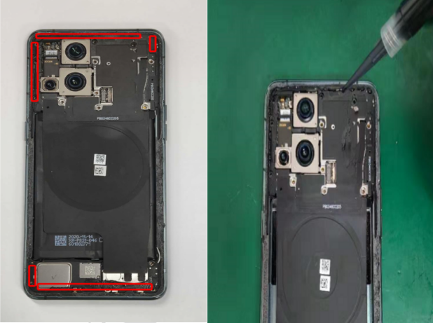
Version | Date | Draft | Review | Approve | Modified content
V1.0 | 2021-03-09 | Jimi | Lin  binbin | Chenwei | 1.First Edition

