OPPO A93&F17 Pro&Reno4 lite&Reno4 F Service Manual_V1.0

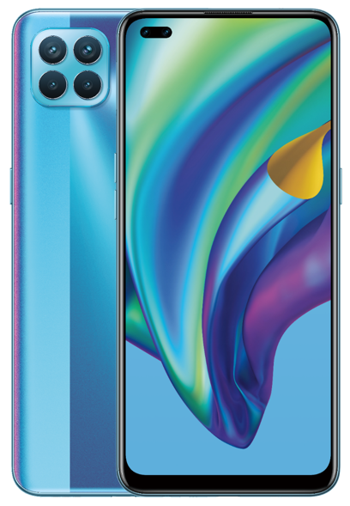

Confidential

Contents
1. Guidance 4
1.1 Warnings 4
1.2 Cautions 4
2. General Repair Information 5
3. Phone Structure Diagram 6
3.1 Product Appearance 6
3.2 Phone Structure Explosive View 7
3.3 Explosive Map BOM 7
4. Disassembly Steps 10
4.1 Disassembly tools required as shown below: 10
4.2 Preparation 10
4.3 Disassembly Steps 11
5. Assembly Step 13
5.1 Materials are required to be replaced after disassembly 13
5.2 Assembly Steps 13
6. Calibration 15
6.1.1 Leak Calibration 15
6.1.2 Fingerprint optical calibration 16
6.1.2 Fingerprint optical calibration 17
6.2 Dual Camera Calibration 17
6.2.1 Calibration Scenario 17
6.2.2 Calibration Tool 17
6.2.3 Calibration Method 18
6.2.4 Front Camera Calibration Method 18
7. Function test 18
7.1 Test Path 18
7.2 Test Requirements 19
8. Cautions 21

1. Guidance
The purpose of this document is only to guide OPPO technicians to carry out maintenance service to OPPO products. The content shall be keep in confidential, only avail be able to OPPO authorized service centers, and cannot be provided to third parties without authorization. Please follow the regulations and the guidance for maintenance service. For any problems, please contact China HQ in time.

1.1 Warnings
1. Care must be taken on installation in vehicles fitted with electronic engine management systems and ABS (Anti–skid Braking Systems). Under certain fault conditions, emitted RF energy can affect their operation. If necessary, consult the vehicle dealer/manufacturer to determine the immunity of vehicle electronic systems to RF energy.
2. Phones must not be operated in areas likely to contain potentially explosive atmospheres, e.g. petrol stations (service stations), blasting areas etc.
3. Operation of any radio transmitting equipment, including cellular telephones, may interfere with the functionality of inadequately protected medical devices. Consult a physician or the manufacturer of the medical device if you have any questions. Other electronic equipment may also be subject to interference.

1.2 Cautions
1. Repair services and calibrations must be undertaken by qualified personnel only.
2. Use only approved components as specified in the parts list.
3. Ensure all components, modules screws and insulators are correctly re-fitted after servicing and alignment.
4. Electrostatic discharge is the main cause of damage to sensitive components of electronic products. Service centers must operate in accordance with OPPO's requirements for ESD protection. Ensure all work is carried out at an ESD workstation and that an ESD wristband is worn.

2. General Repair Information
1. Ensure all work is carried out at an ESD workstation and that an ESD wristband is worn before starting maintenance.
2. Wear ESD gloves to avoid oil stains and fingerprints.
3. Use protective films to protect the display, camera, camera lens to prevent dust and scratches.
4. Use a clean cloth, ESD brush and alcohol (Concentration above 95%) for appearance cleaning. Do not use other items (such as an eraser) for cleaning to prevent the protective layer from being scratched, which may lead to oxidation and corrosion.
5. Faulty welded mechanical parts (except shield cover and shield frame parts) can only be replaced and not repairable.
6. Use accessories provided by OPPO.
7. Check the contacts or solder joints of devices that may cause simple faults (e.g. soldered interfaces or switches). Re-weld if necessary (only for service centers where lead-free soldering is available) and clean the flux remaining after soldering.
8. Use the equipment provided by OPPO to test the phone (e.g. When the charging function of the device is abnormal, do use the original OPPO adapter to test to ensure the accuracy of the test results).
9. Fill in the fault phenomenon code and fault reason code according to the actual situation, and accurately enter the replacement material code in the CRM system.
10. For more information about products,
Mainland China please visit:
http://172.16.41.122:8888/kbaseui-dev/main.do
Regions except for Mainland China please visit:
ftp://ftpex.oppo.com:919 or https://oppo-knowledge.custhelp.com

3. Phone Structure Diagram

3.1 Product Appearance
As shown in Figure 3-1-1
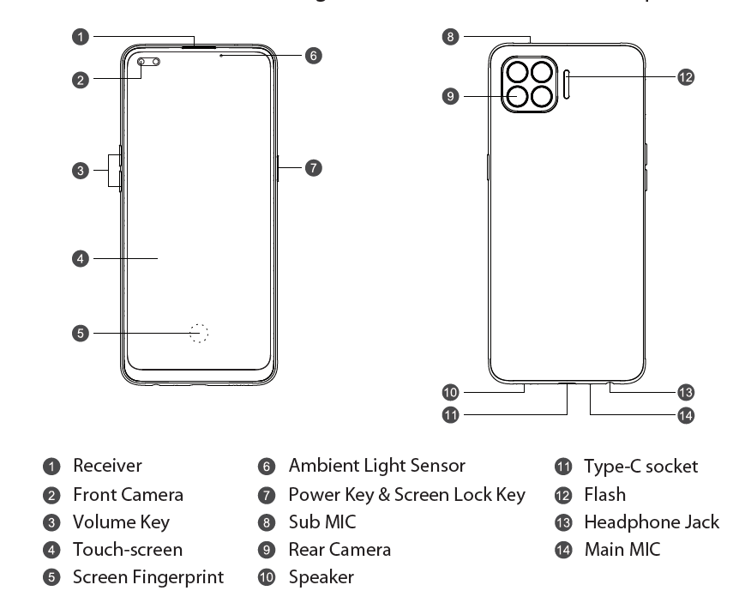
Figure 3-1-1

3.2 Phone Structure Explosive View
As shown in Figure 3-2-1
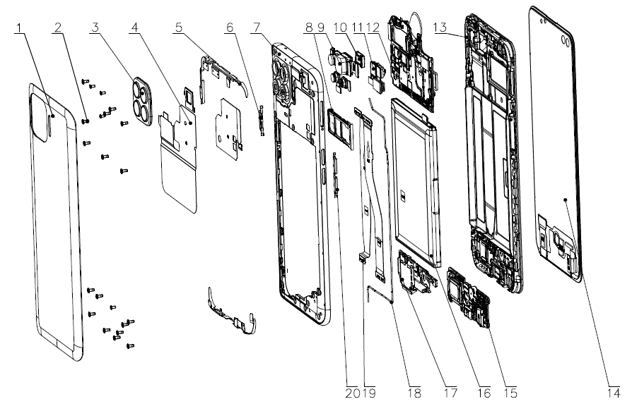

3.3 Explosive Map BOM
NO | Material Name | Picture | Sub-Category | QTY | Unit
1 | Screen | 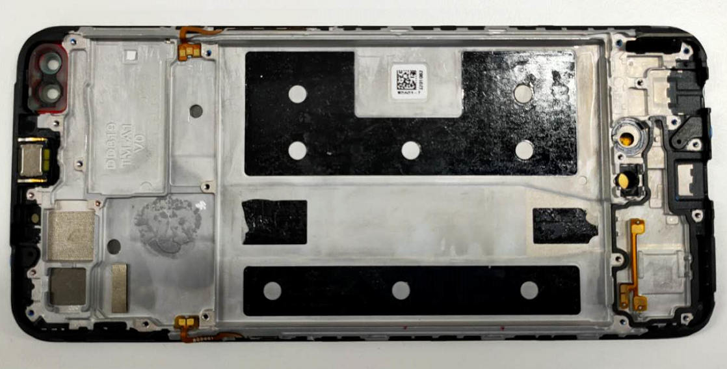 | (14) TP+Display | 1 | PCS
1 | Screen |  | (13) Top cover | 1 | PCS
1 | Screen |  | (10) Receiver | 1 | PCS
1 | Screen |  | Screen guard | 1 | PCS
2 | Back cover | 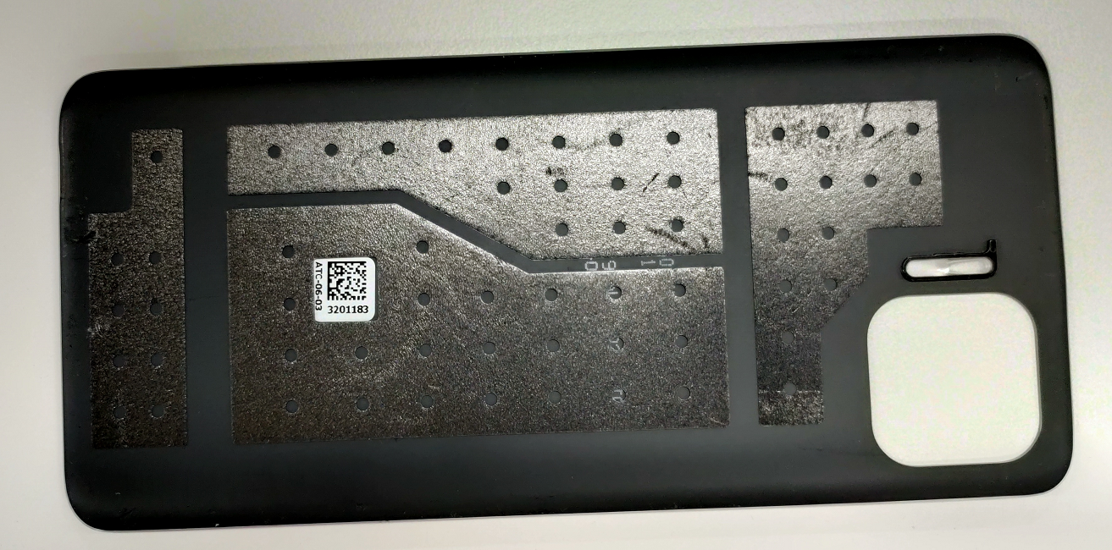 | (1) Back cover | 1 | PCS
2 | Back cover |  | Battery-cover-buffer-sponge | 1 | PCS
3 | Antenna Board | 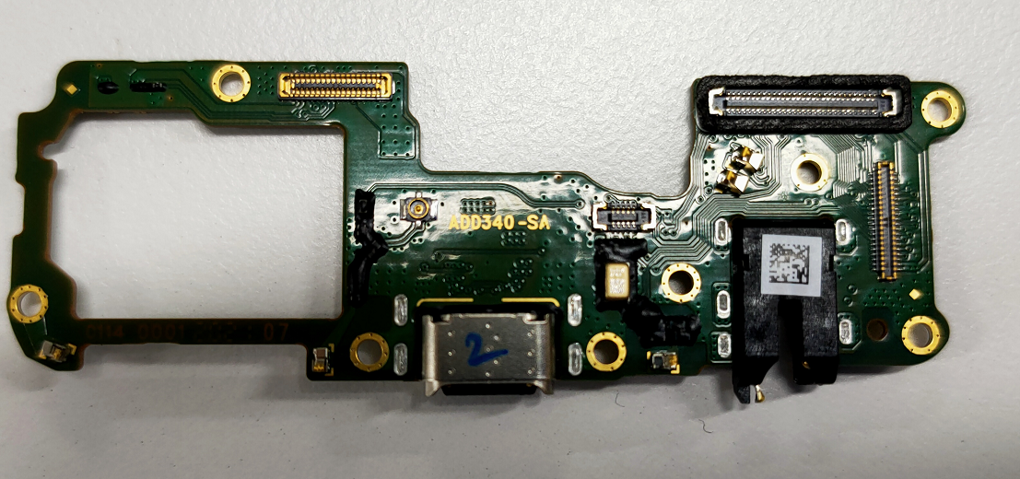 | (15) Antenna Board | 1 | PCS
4 | Mainboard | 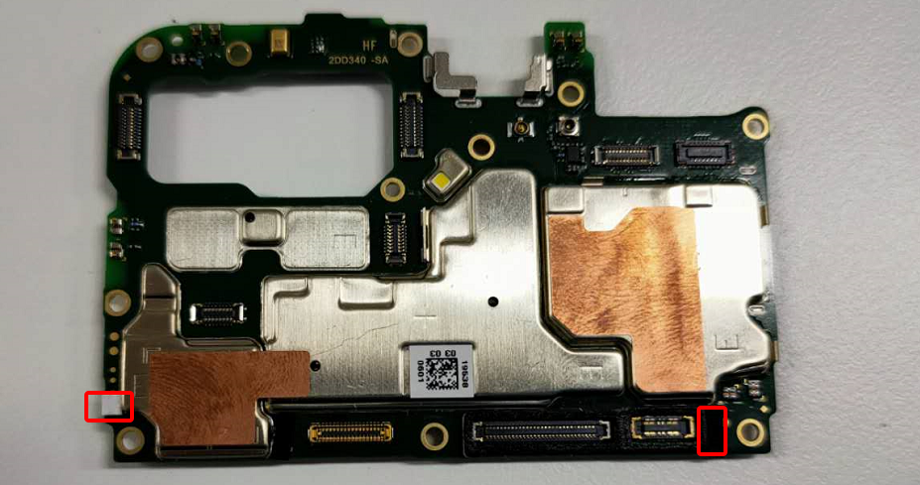 | (23) Antenna Board | 1 | PCS
4 | Mainboard |  | Mainboard waterproof PET sheet | 1 | PCS
4 | Mainboard |  | Motherboard waterproof PET sheet | 1 | PCS
5 | Rear Camera | 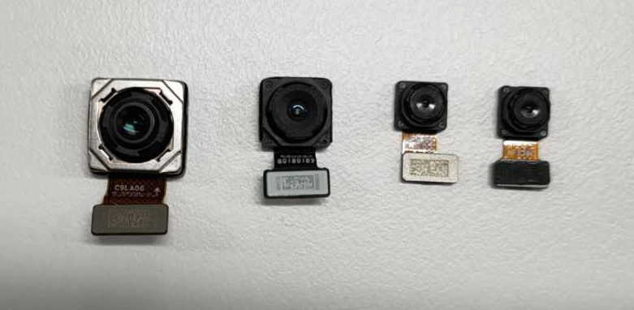 | (9) Camera 48M+8M+2M+2M | 4 | PCS
6 | Front Camera | 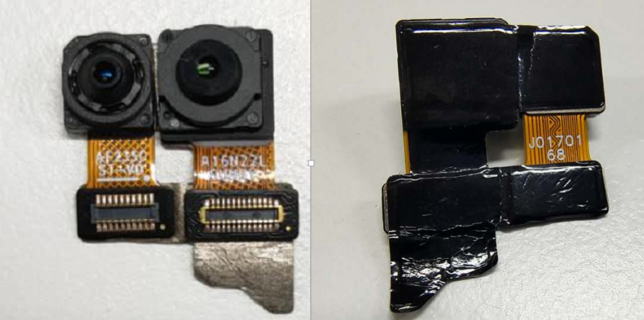 | (11) Camera 16M+2M | 2 | PCS
7 | SIM card holder | 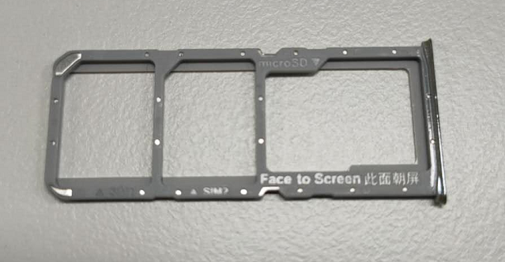 | (8) SIM card holder FA205 Black | 1 | PCS
8 | Middle frame | 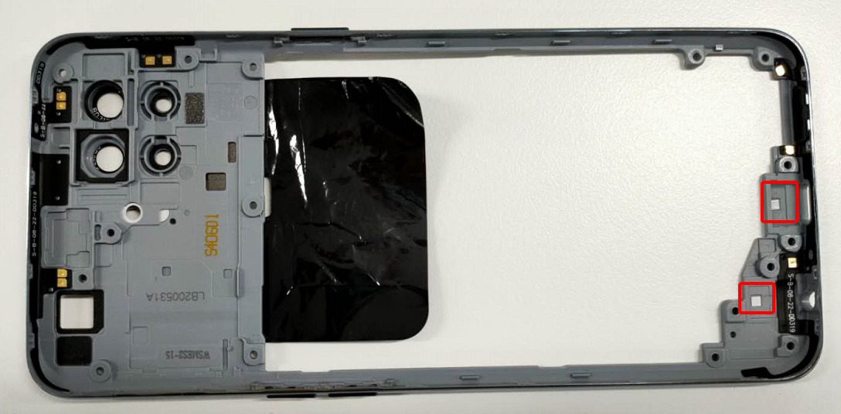 | (7) Middle frame | 1 | PCS
8 | Middle frame |  | Waterproof PET sheet | 1 | PCS
9 | Speaker module | 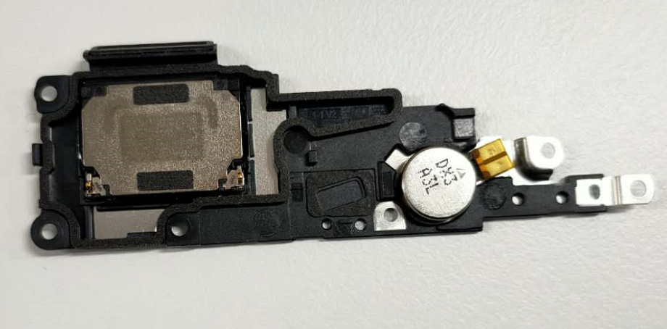 | (17) Speaker | 1 | PCS
9 | Speaker module |  | Vibration Motor | 1 | PCS
10 | Screws | 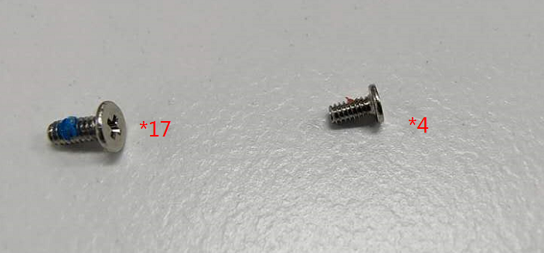 | (2) Screws | 17+4 | PCS
11 | RF cable | 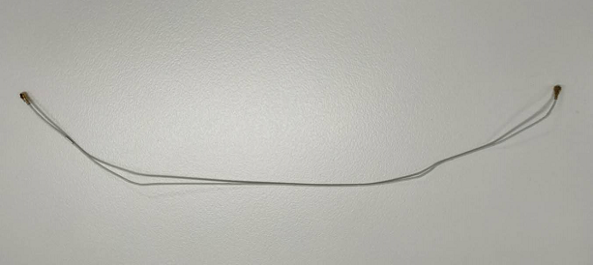 | (18) RF cable | 1 | PCS
12 | Battery | 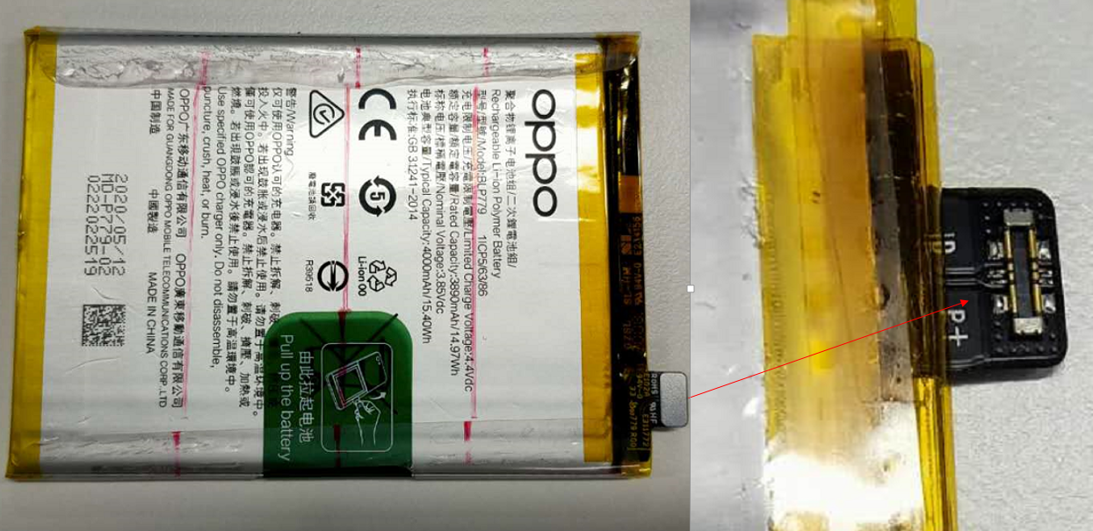 | (16) 3920mAh 3.87V 1.5C BLP791 | 1 | PCS
13 | C-board | 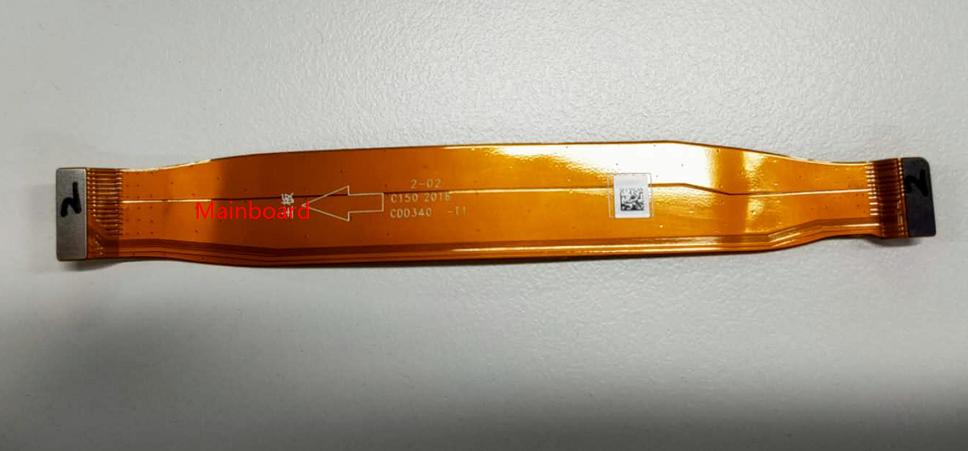 | (19) CDD340-0-patch 19537 | 1 | PCS
14 | Volume key | 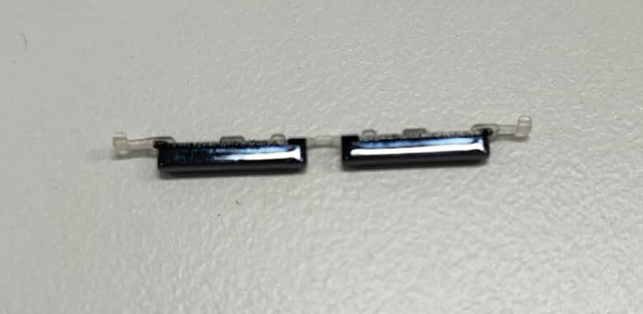 | (20) Volume key | 1 | PCS
15 | Power key | 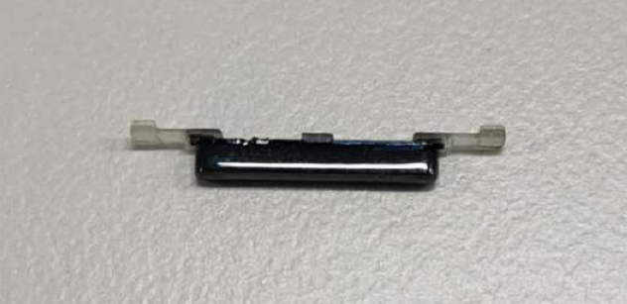 | (6) Power key | 1 | PCS
16 | Antenna | 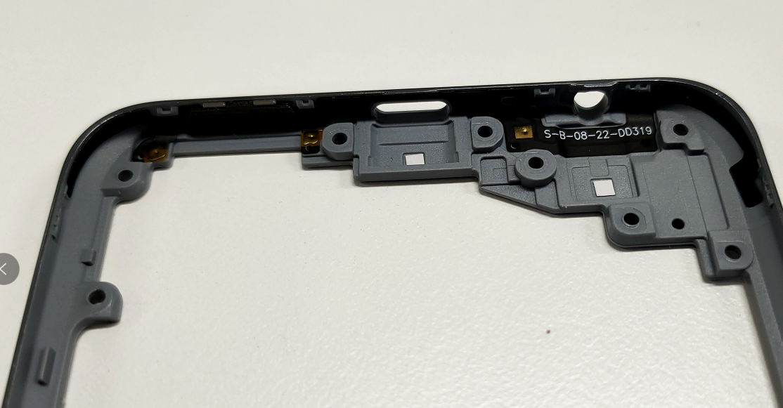 | (5) Antenna +NFC (Mexico + Eastern Europe) | 1 | PCS
17 | RF cable | 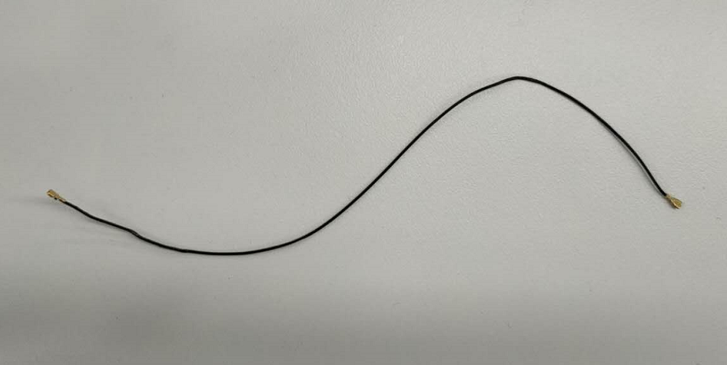 | (20) RF cable 50Ω 170.3mm | 1 | PCS
18 | Camera decoration | 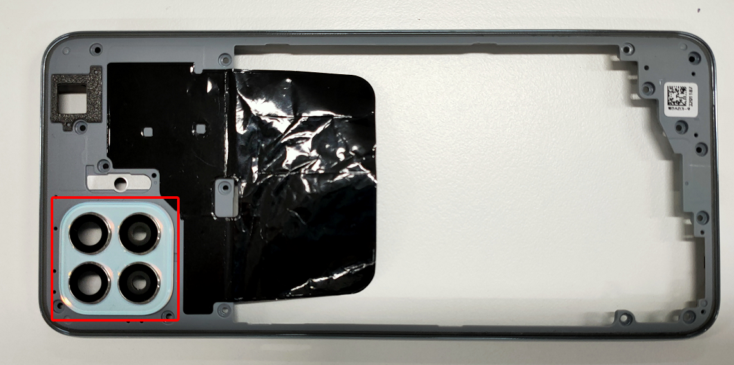 | (3) Camera decoration(big one) | 1 | PCS
19 | Graphite plate with middle frame | 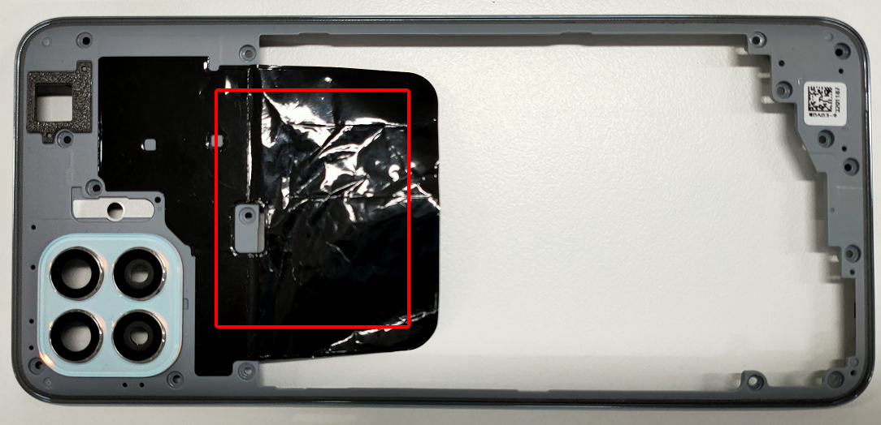 | (4) @4100/3.85V/0.7C BLP673 | 1 | PCS
Note: This table is used only for the name of the annotation. It is not suitable for the preparation of materials. Please refer to the “Price list of Commonly-used Materials and Accessories” for the preparation.

4. Disassembly Steps

4.1 Disassembly tools required as shown below:
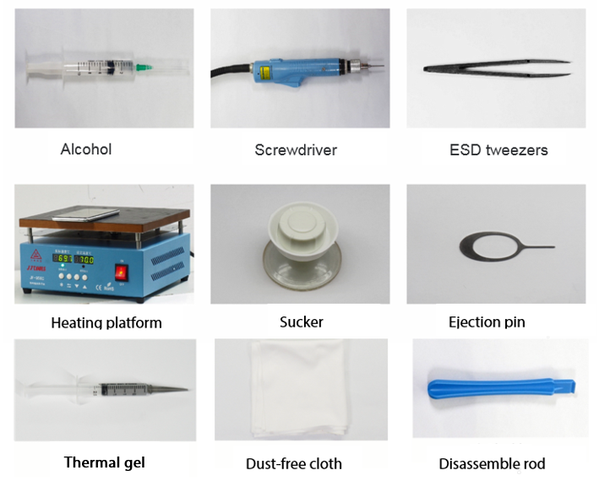

4.2 Preparation
The phone must be shut down with the power option before disassembling. Way to Shut Down: Press the power button then slide to power off.( The forced shutdown method is long press the volume + button and power button for about 8 seconds until the display is off)

4.3 Disassembly Steps
Steps | Details | Picture | Cautions
1 | Remove the SIM card holder | 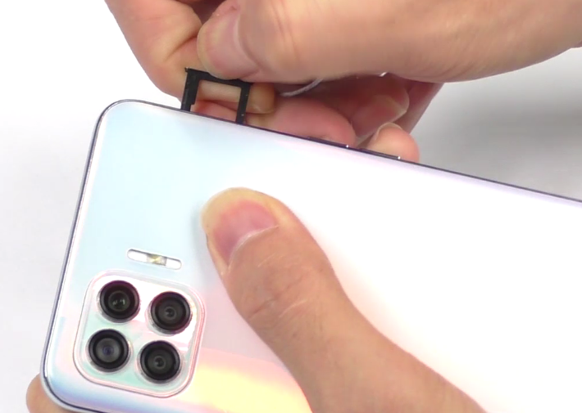 | Insert the card pin vertically, taking care not to scratch the back cover
2 | Remove the back cover | 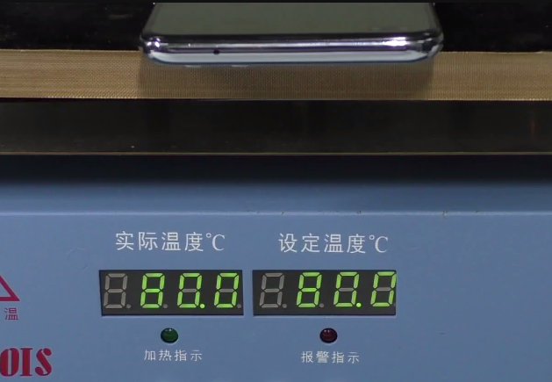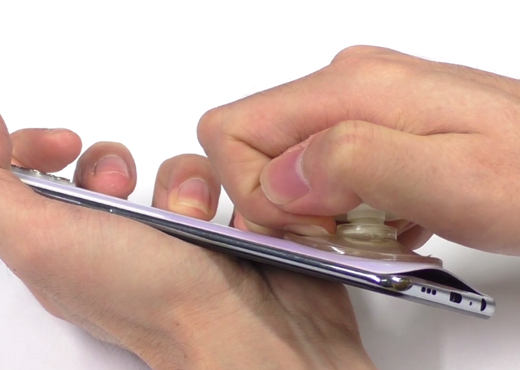  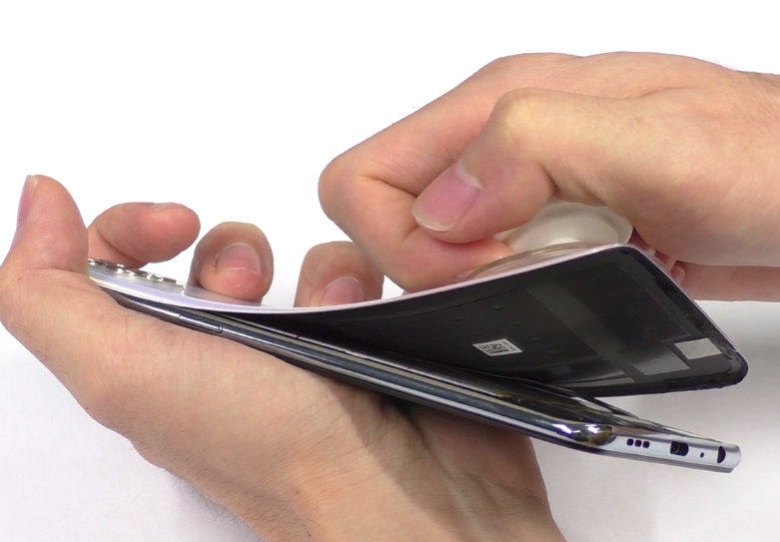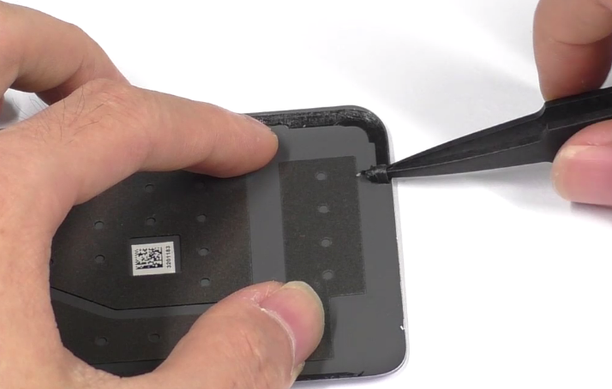 | 1. Place the back cover face down and heat it at 80℃ for 5 minutes.  2. Pull the back cover off from the USB end with a suction cup
3 | Remove the middle frame | 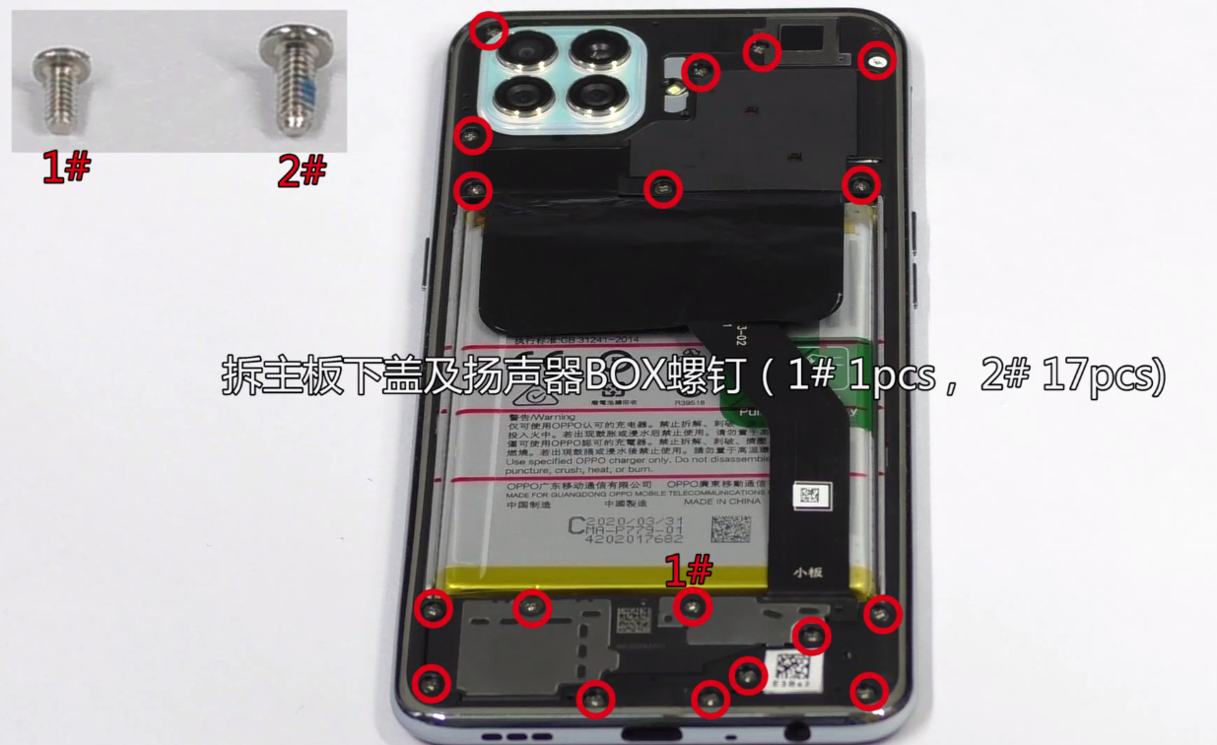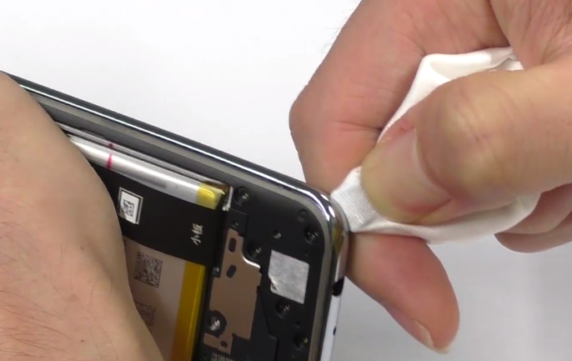 | 1. Cover the disassembly rod/piece with dust-free cloth to avoid scratching back cover  2. Pry off the gap from the earphone jack side, and then cut along the side of the power button (please note that the location of the card holder hole is easy to deform)  3. Then open each buckle in turn counterclockwise, taking care not to scratch or damage the edges of the middle frame
4 | Remove the speaker | 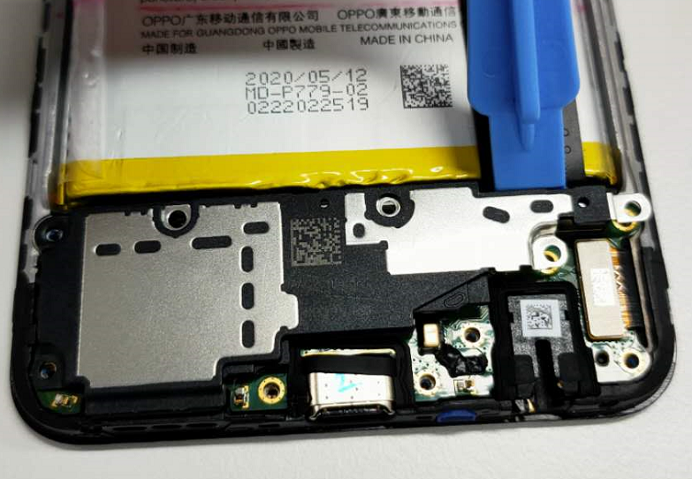 | Remove the speaker from the right side near the C-board
5 | Remove the vibration motor | 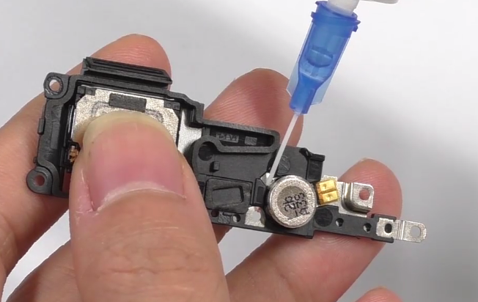 | /
6 | Remove the  L-board | 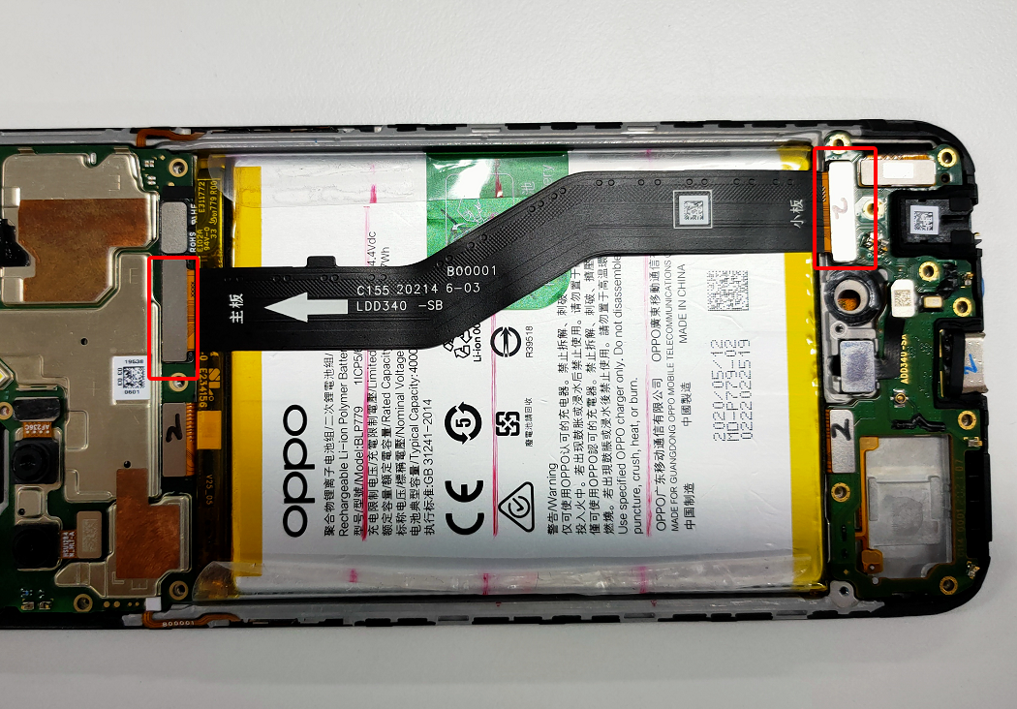 | /
7 | Remove the battery | 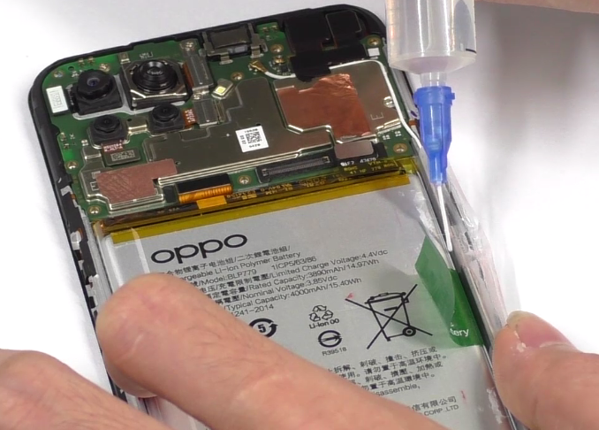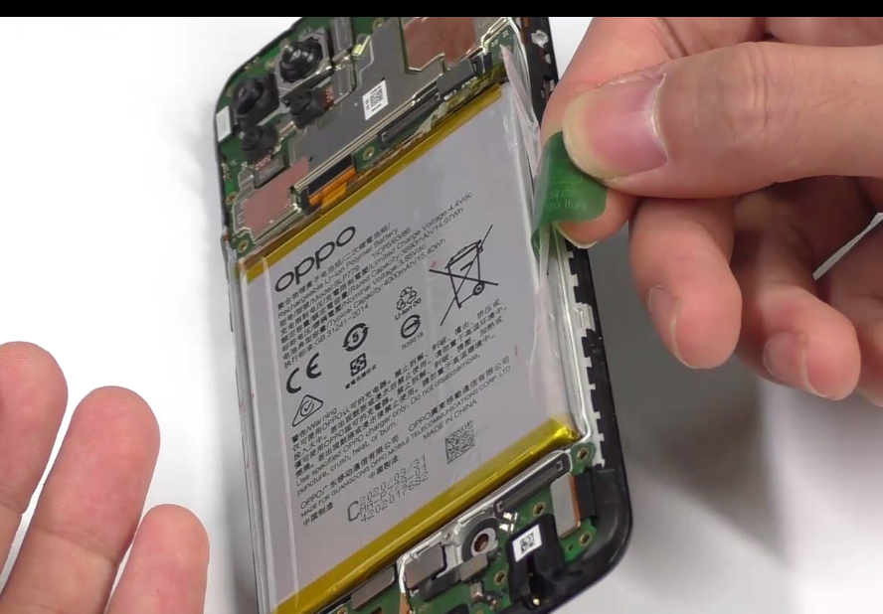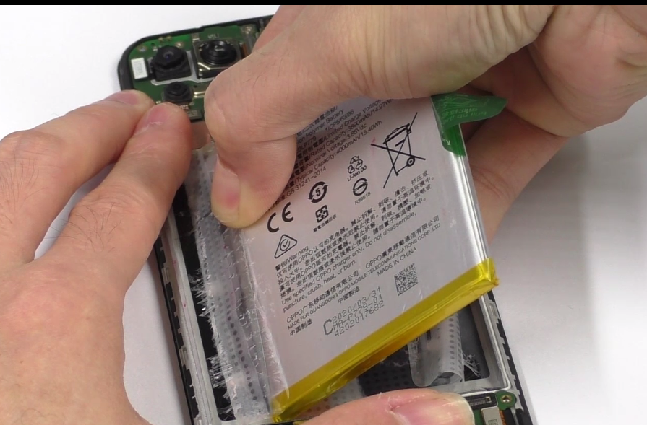 | 1. neither put too much alcohol, nor drop alcohol on the handle;  2. Sideward stand up the phone for 5-10s until the alcohol spreads fully  3. Pull out the battery at a 45-degree, do not pull it vertically.  4. Check for puncture, indentation, leakage and other defects after removing the battery
8 | Remove the battery buffer foam and C-board | 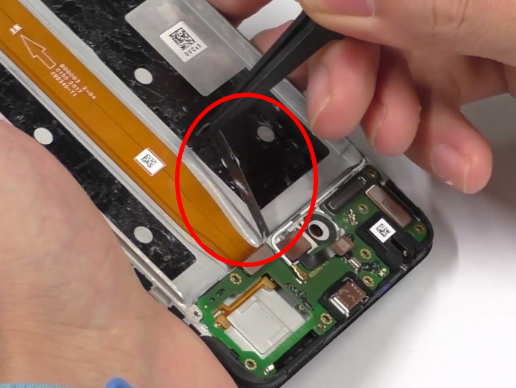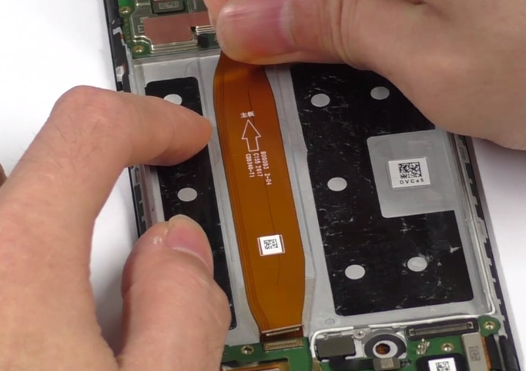 | /
9 | Remove the RF cable | 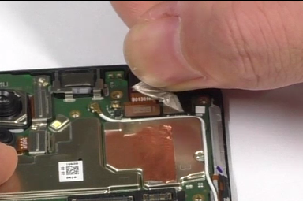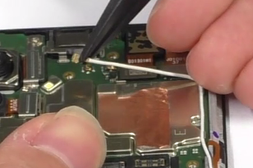 | 1. The RF connector should be pulled vertically to prevent damage to the socket  2.Tear off the graphite sheet of the front camera, and then remove the RF cable
10 | Remove the fingerprint and antenna board | 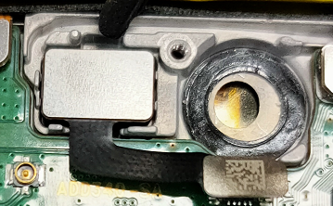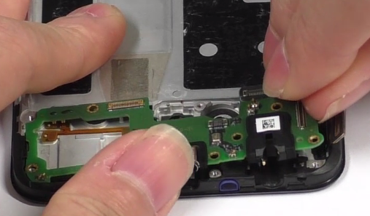 | 1.Remove gently to avoid damaging the FPC；  2. Pry off the motor from the disassembly position and drip a small amount of alcohol if it is difficult to disassemble
11 | Remove the rear & front cameras | 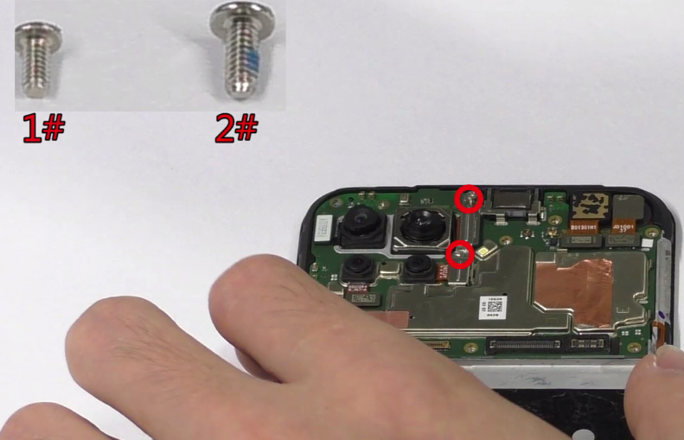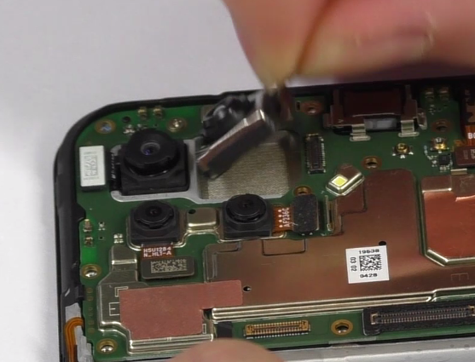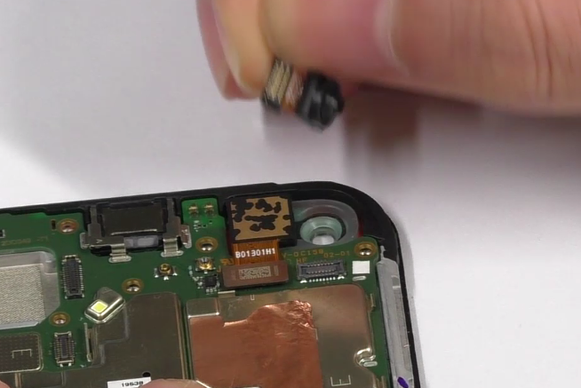 | /
12 | Remove the mainboard | 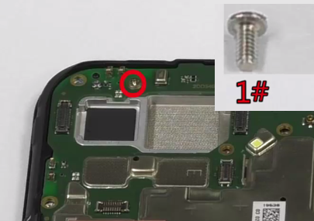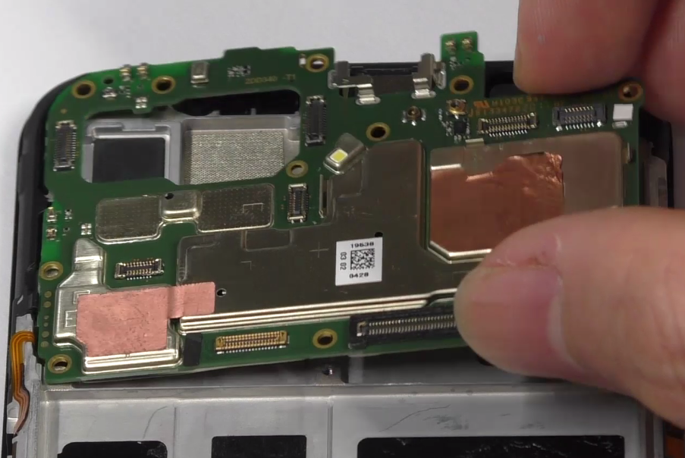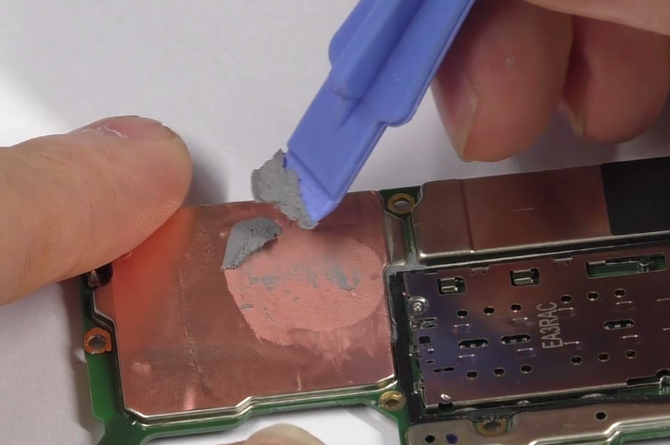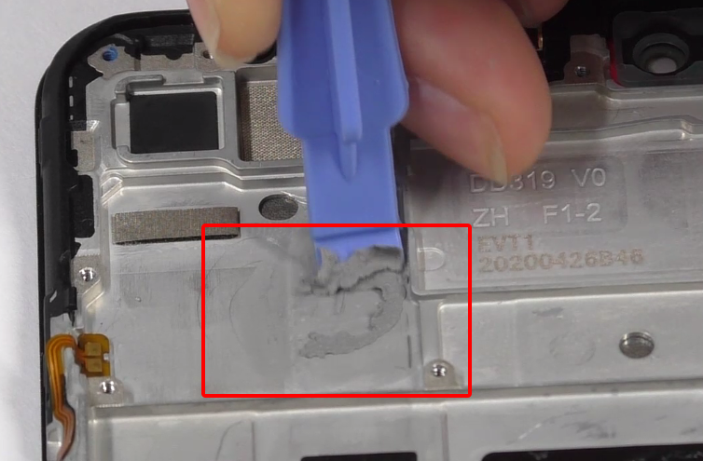 | 1. Note that one mainboard fixing screw needs to be removed firstly;  2. The thermal conductive gel on the main board and display should be cleaned.
13 | Remove the receiver and button FPC | 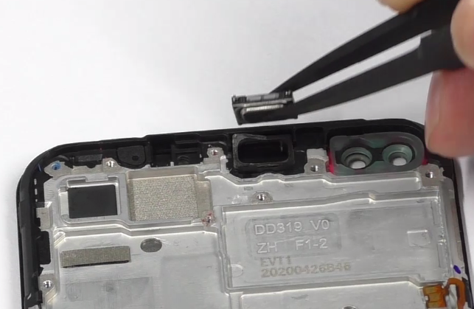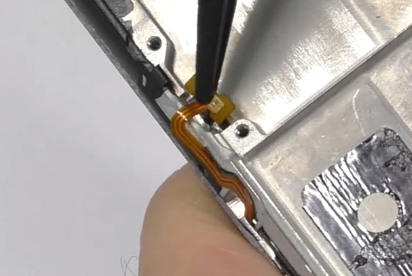 | /
14 | The whole device materials | 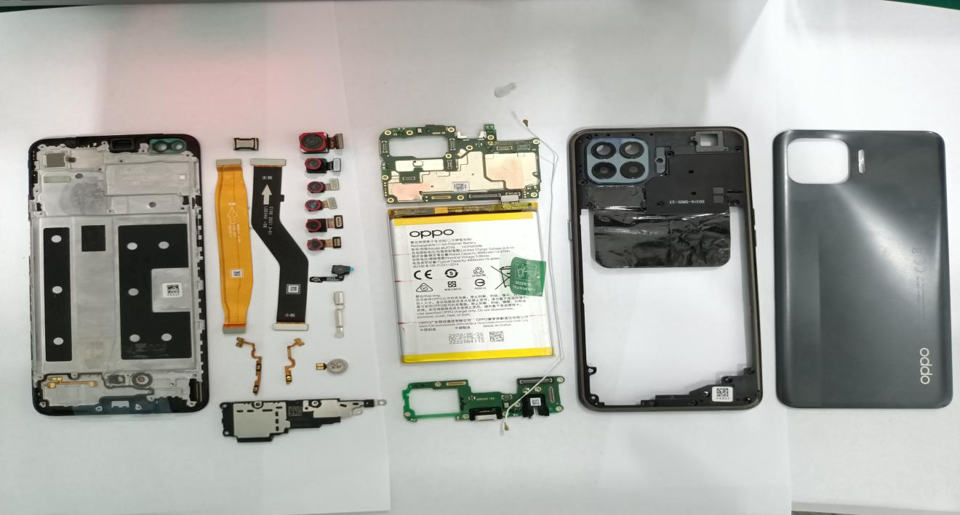 | /

5. Assembly Step

5.1 Materials are required to be replaced after disassembly
NO | Material code | Material name | Picture | QTY | Remark
1 | 4883010  4875006 | Battery easy-tore paper | 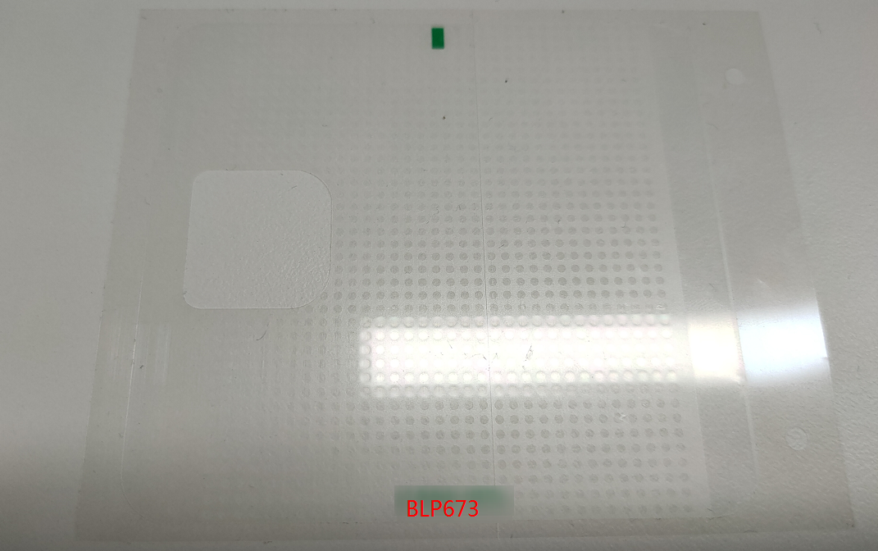 | 1 | must be replaced new one if removed battery
2 | 5181653 | Battery extracting sticker | 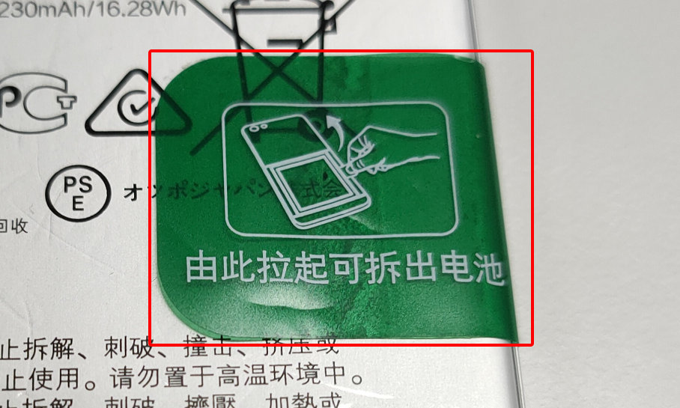 | 1 | must be replaced new one if removed battery
3 | 4882223  4880664 | Fingerprint module foam adhesive | 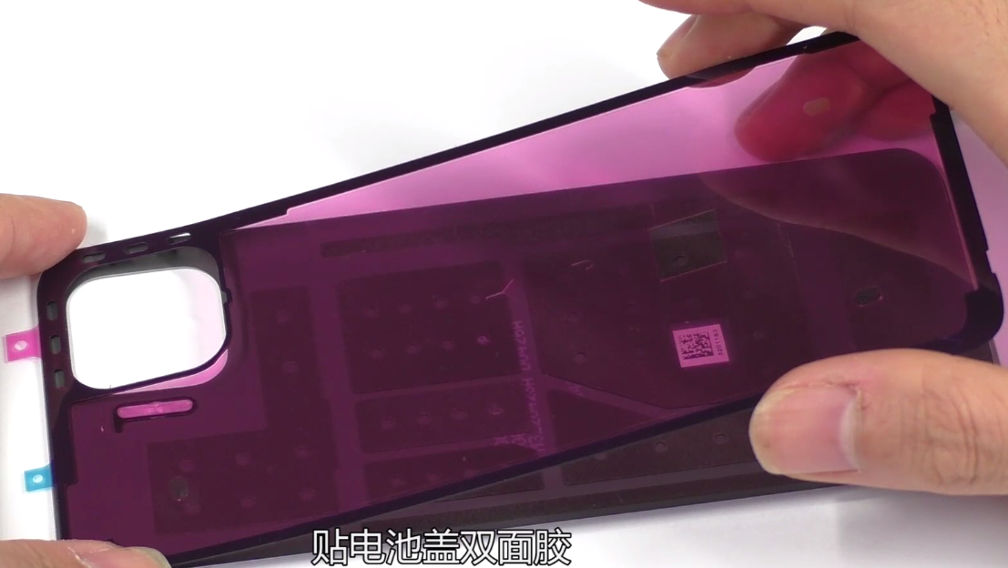 | 1 | must be replaced new one if removed back cover
4 | 4882639 | Front camera conductive copper foil | 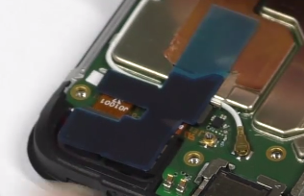 | 1 | must be replaced new one if changed front camera

5.2 Assembly Steps
NO | Details | Picture | Cautions
1 | Assemble the receiver and vibration motor and button FPC | 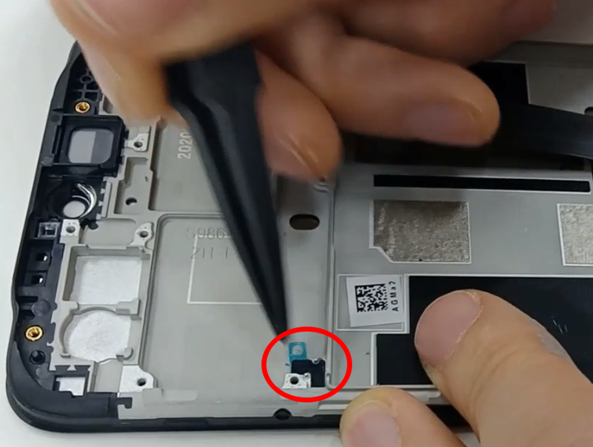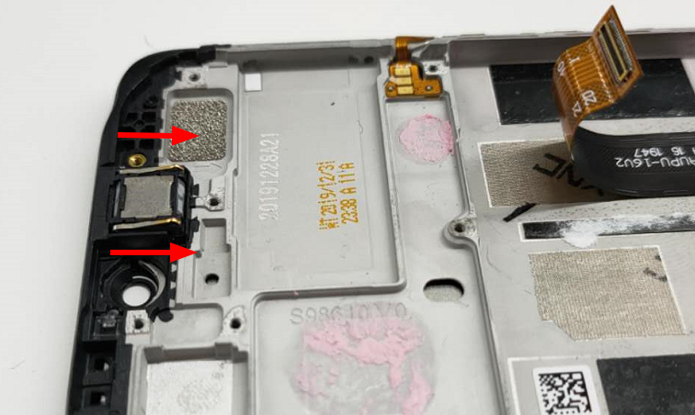 | 1. Pay attention to the direction of the pin when installing the receiver  2. FPC should be installed according to the positioning column
2 | Assemble the mainboard and rear camera | 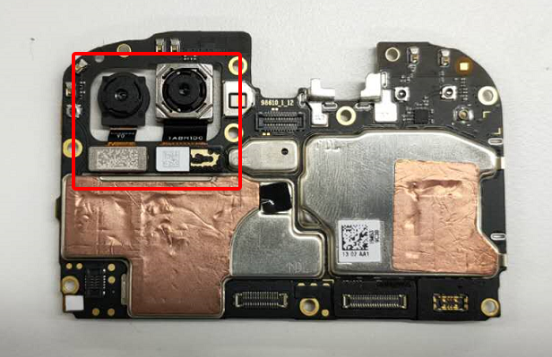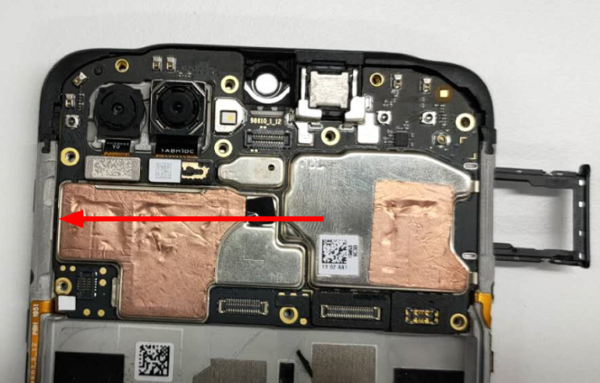 | 1.Don't forget to add thermal gel  2. Put into the mainboard from the left side  3. Fix the main board with SIM card holder
3 | Assemble the front camera | 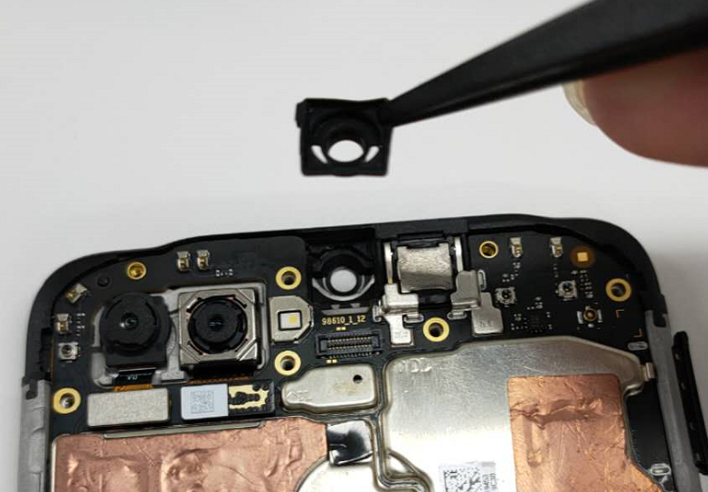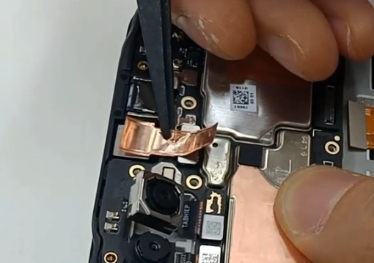 | 1. Install the Front camera silicone sleeve first;  2. Camera copper foil and conductive cloth must be replaced with new one
4 | Assemble the antenna board and RF cable | 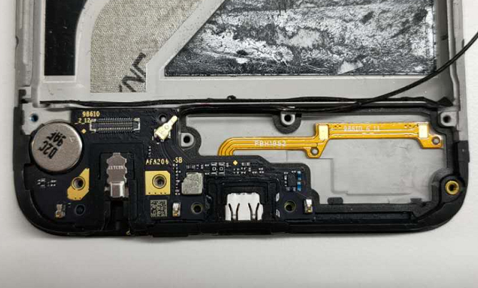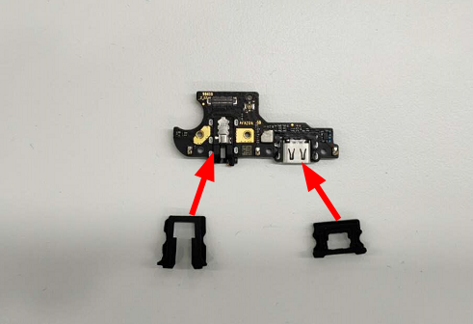 | 1. Install from the left side, notice that there are 2 silicone sleeves on the board.  2. Press the BTB buckle vertically to prevent damage to the socket
5 | Assemble the main FPC & battery buffer foam & speaker | 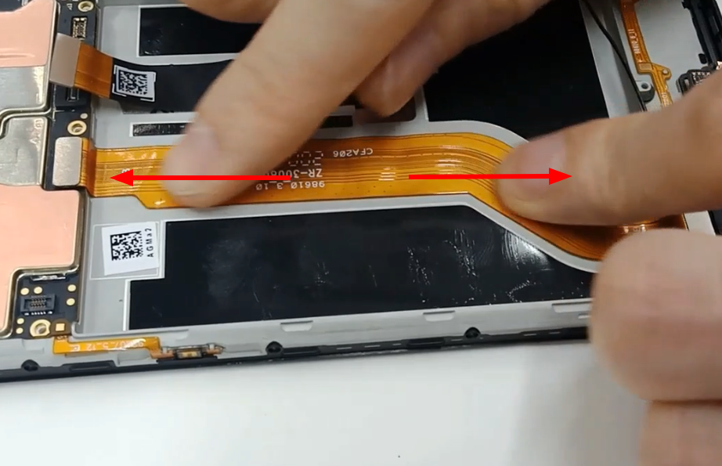 | 1. After buckled both ends of the main FPC BTB, smooth it from the middle to the sides to prevent the protruding parts from damaging the battery;  2. Please pay attention to that there are 9 screws on the speaker
6 | Assemble the battery | 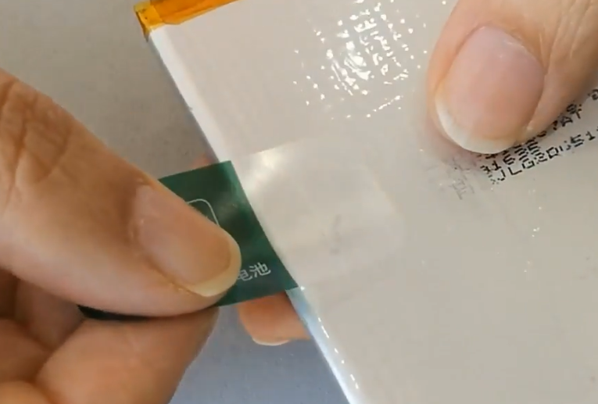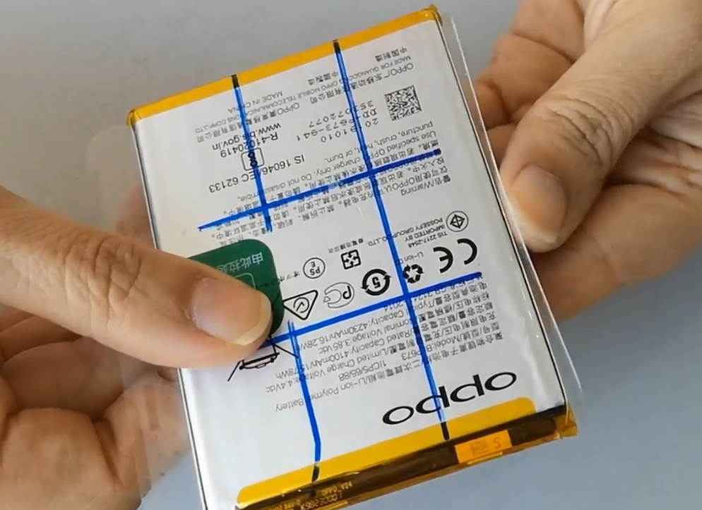  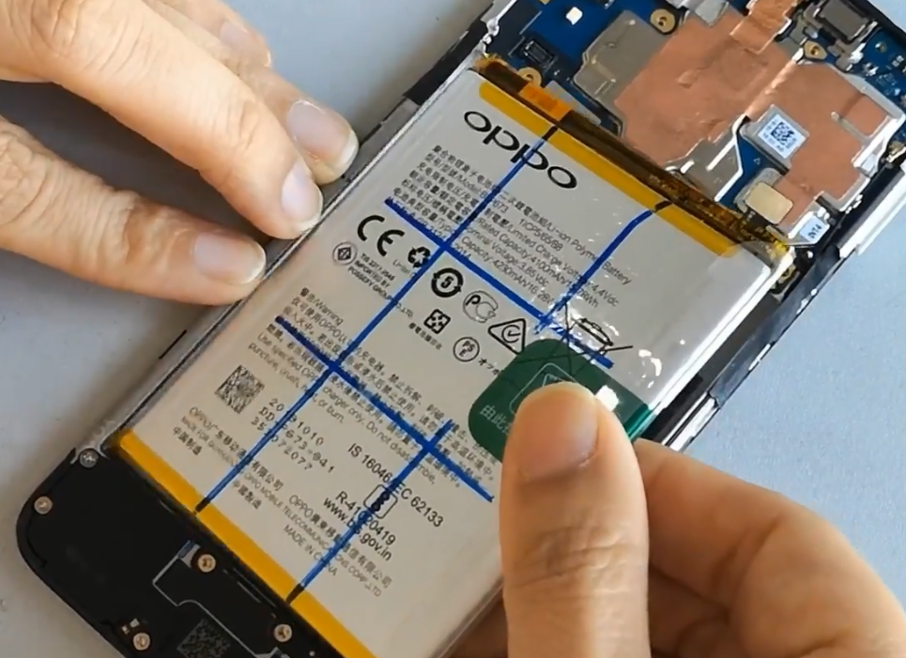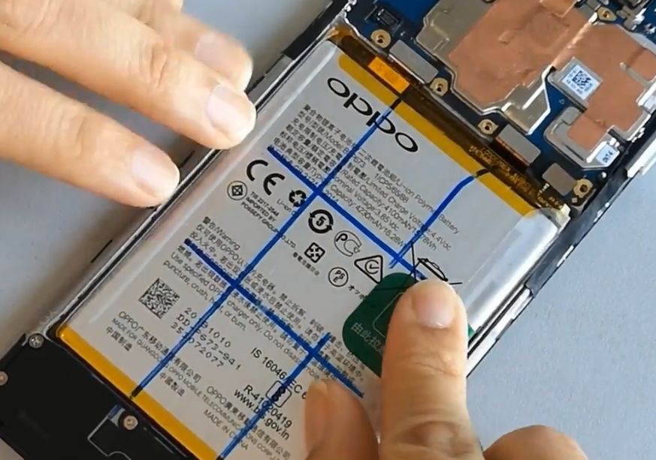 | 1. Battery easy-tore paper and extracting sticker must be replaced new one  2. Install the battery from the left side, pay attention to that not to install it in the wrong direction
7 | Assemble the fingerprint sensor and mainboard bracket | 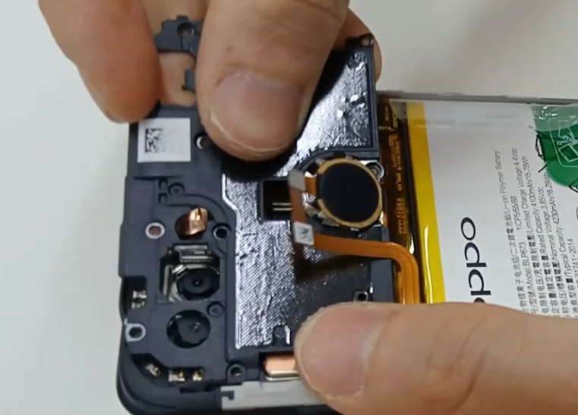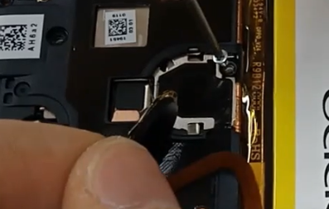 | Please pay attention to that there are 10 screws on the mainboard bracket
8 | Assemble the back cover | 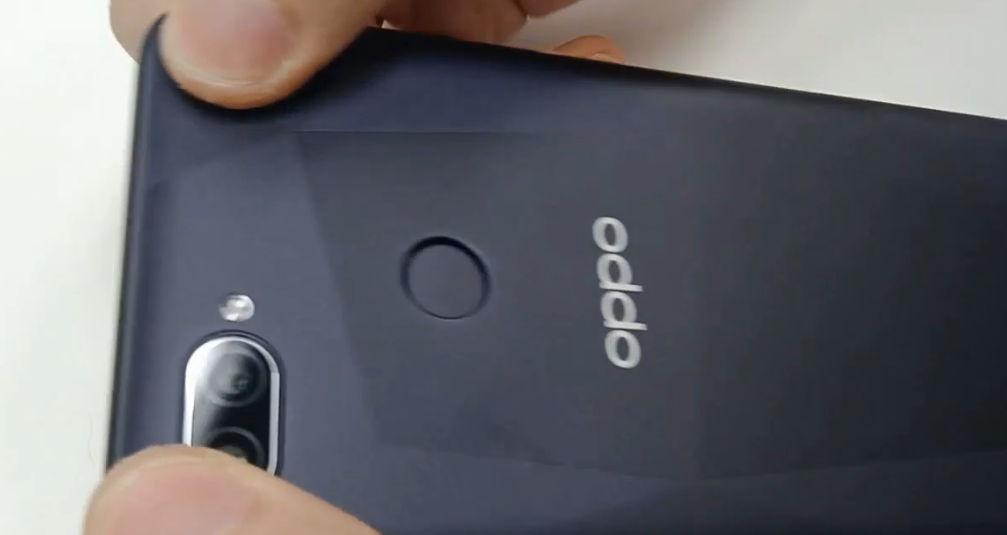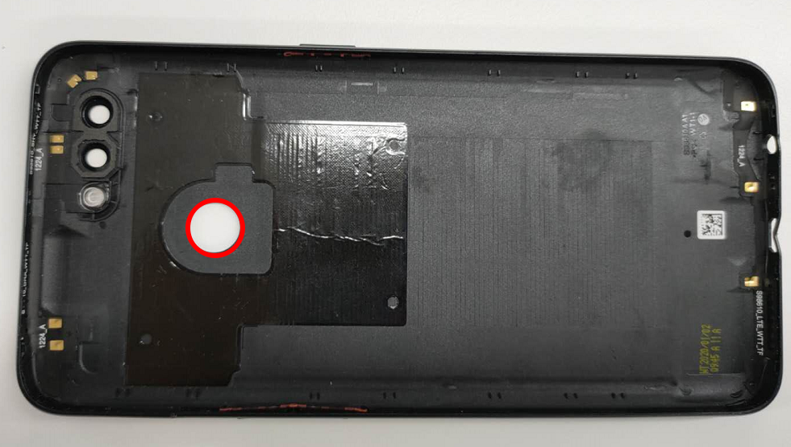 | 1. Make sure the SIM card holder has been removed before installing the back cover  2. Fingerprint double-sided adhesive must be replaced with new one  3. When installing the back cover, please install the 4 corners first, and then gently press the edge of the fingerprint to activate the double-sided adhesive.

6. Calibration

6.1.1 Leak Calibration
Operation step | 1. Make sure there is no material covering the phone, then press the infrared access calibration button. | 2. Put the upper part of the phone into the airbag and click ”Leak Calibration” | 3. After the calibration result is Pass, the calibration will automatically jump to the fingerprint calibration item after the calibration is completed.
Picture | 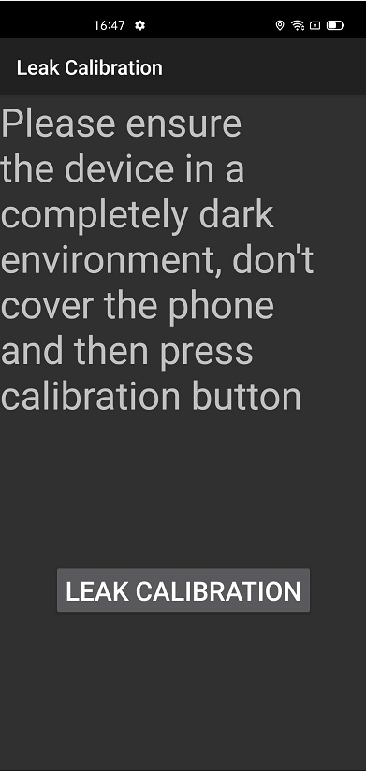 | 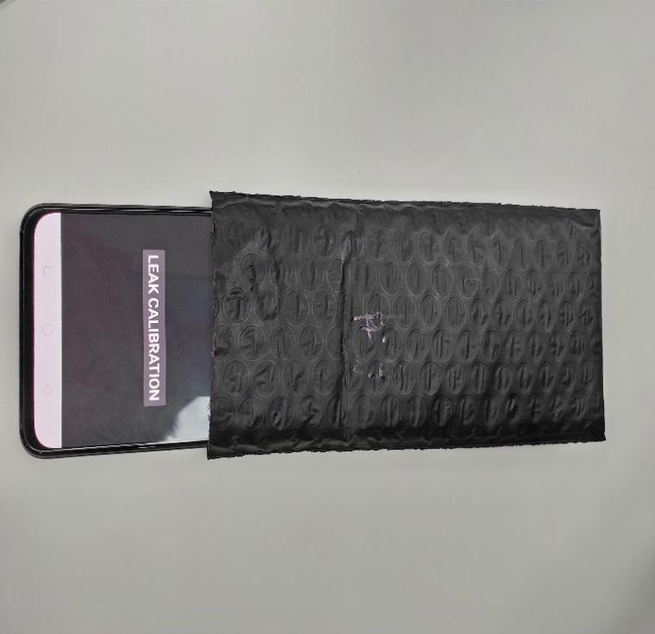 | 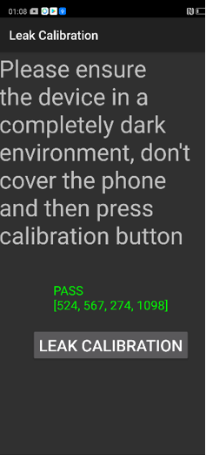

6.1.2 Fingerprint optical calibration
Operation step | 1. Click "START" to start calibration after it jumps into the fingerprint optical calibration, | 2. According to the prompt "please place the yellow rubber ", put the yellow rubber on the fingerprint spot area (the groove is facing down), and click "NEXT" until it prompts " please place the black rubber". | 3.According to the prompt "please place the black rubber", put the black rubber on the fingerprint spot area (the groove is facing down), click "NEXT" until the "please place the yellow stripe rubber " prompts to remove the black rubber ;
Picture | 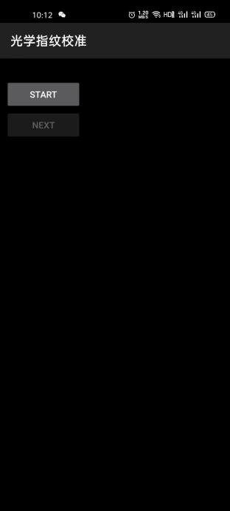 | 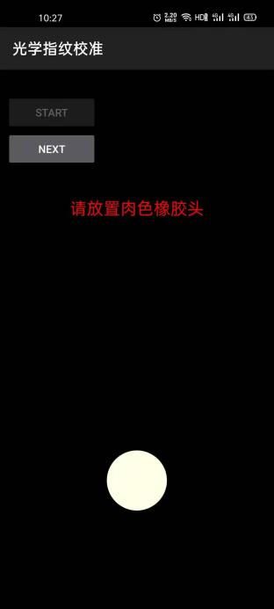 | 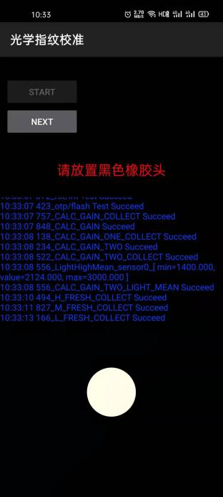
Operation step | 4. According to the prompt “Please place the yellow- striped rubber”, put the yellow stripe rubber (striped down) in the spot area, click “NEXT”; | Note: The stripe direction of the yellow stripe rubber should follow the long side of the phone. | Use the new fingerprint calibration tool
Picture | 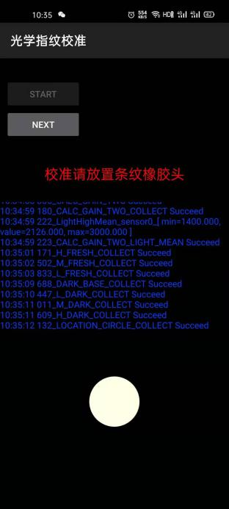 | 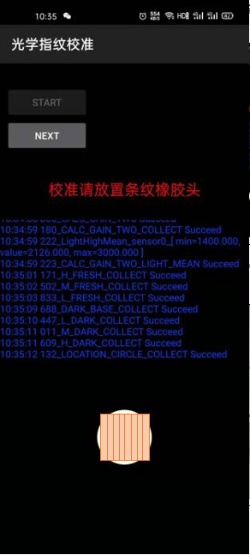 | 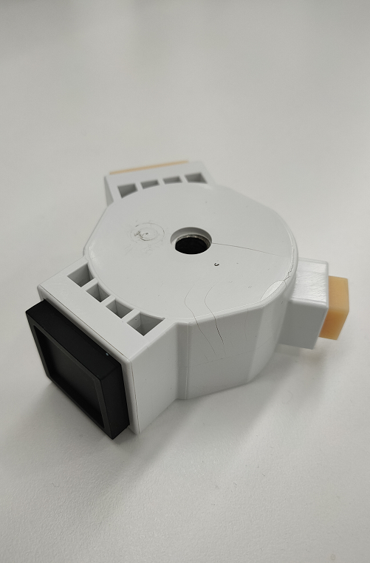

6.1.2 Fingerprint optical calibration
Operation step | 1. After the camera calibration is completed, it will automatically jump to the smart power amplifier calibration | 2. Click Calibrate | 3. The calibration result will be displayed after 2 short beeps
Picture | 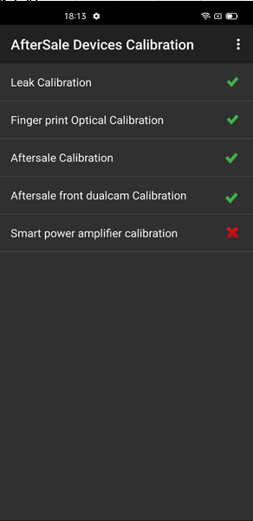 | 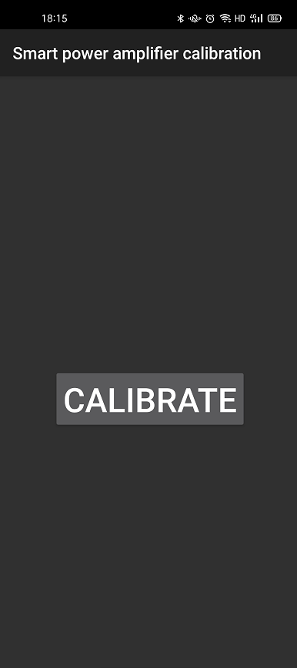 | 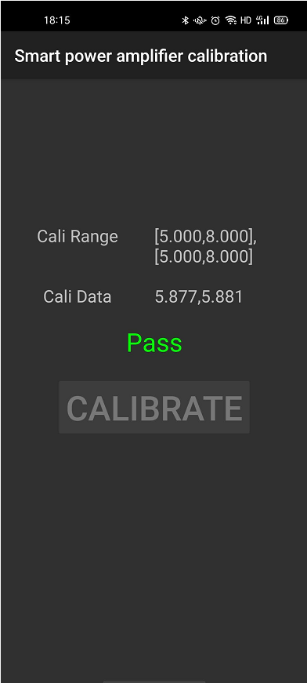

6.2 Dual Camera Calibration

6.2.1 Calibration Scenario
1. When the portrait mode is poorly blurred, the after-sales service center needs to calibrate the phone.
2. All devices must be calibrated after the phone has disassembled, or the portrait mode will be poorly blurred.

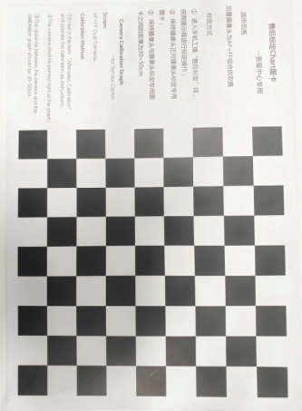
6.2.2 Calibration Tool
After-sales calibration Chart,
As shown in Figure 6.2.2-1:

Figure 6.2.2-1

6.2.3 Calibration Method
Please align the yellow box with the edge of the chart, and then take a Photo. Then, do not operate the phone when the phone enters the computing interface until it displays “Pass” with the calibration completed.
Calibration interface | Calibration calculation process | Calibration result
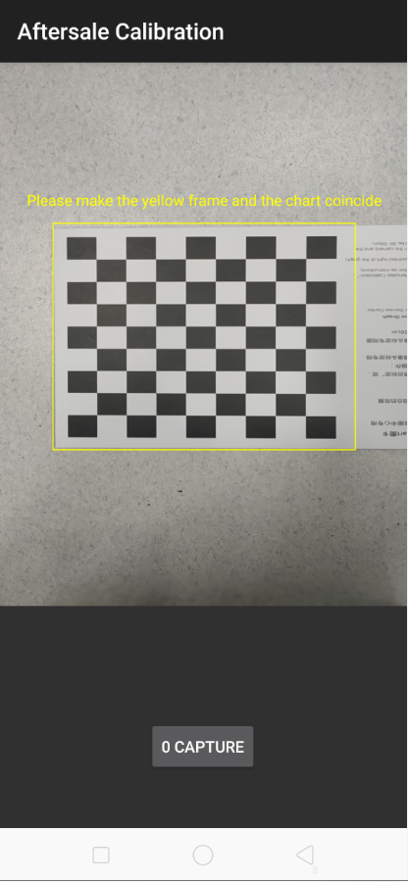 | 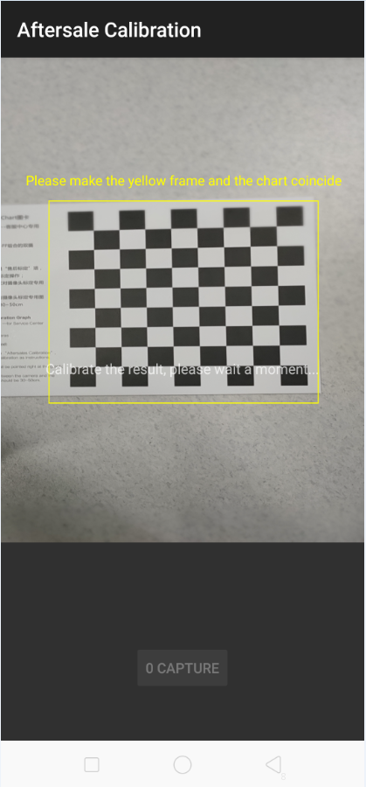 | 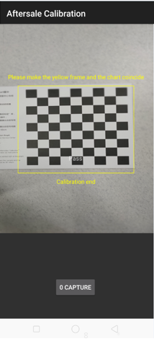

6.2.4 Front Camera Calibration Method
The same method as rear camera calibration
Note: After the calibration is completed, enter the camera and select "Portrait Mode" to check the blur effect.

7. Function test

7.1 Test Path
Dialing Interface>Enter*#899#>Enter automatic test； The "Confirm" dialog box will pop up after the test complete, if there is no problem choose “Pass”, otherwise choose “Fail”.

7.2 Test Requirements
No | Testing item | Testing requirements
1 | LCD test | Observe the red, green, blue, white, black, gray, grayscale and color interface successively; If there are black spots, bright spots and other anomalies, the function is sound;
2 | Vibration test | Get ear close to check the vibration from the motor for 3 seconds.  If the motor vibrates normally(No noises or weak vibration), the function is sound;
3 | Touch screen auto test | If the interface shows “PASS” and jumps to the next test, the function is sound;
4 | Front camera preview | Align the front camera with a white surface and a black surface. If there is no black dot, black line or blurred screen on the screen after aligning the white surface, and there is no bright spot on the screen after aligning the black surface, the camera is sound;
5 | Front sub camera preview | Align the front camera with a white surface and a black surface. If there is no black dot, black line or blurred screen on the screen after aligning the white surface, and there is no bright spot on the screen after aligning the black surface, the camera is sound;
6 | Rear camera preview | Align the rear camera with a white surface, a black surface, and a surface with text. If there is no black dot, black line or blurred screen on the screen after aligning the white surface, there is no bright spot on the screen after aligning the black surface, white point or blurred screen, the camera is sound;
7 | Second rear camera preview | Align the rear camera with a white surface, a black surface, and a surface with text. If there is no black dot, black line or blurred screen on the screen after aligning the white surface, there is no bright spot on the screen after aligning the black surface, white point or blurred screen, the camera is sound;
8 | Third rear camera preview | Align the rear camera with a white surface, a black surface, and a surface with text. If there is no black dot, black line or blurred screen on the screen after aligning the white surface, there is no bright spot on the screen after aligning the black surface, white point or blurred screen, the camera is sound;
9 | Fourth rear camera preview | Align the rear camera with a white surface, a black surface, and a surface with text. If there is no black dot, black line or blurred screen on the screen after aligning the white surface, there is no bright spot on the screen after aligning the black surface, white point or blurred screen, the camera is sound;
10 | Echo test | Testing Main MIC: Blow the air to the MIC hole on the bottom of the phone. If the receiver (earphone) sounds, the function of Main MIC is sound;  Testing Sub MIC: Blow the air to the sub MIC hole on the top of the phone. If the speaker sounds, the function of Main MIC is sound;
11 | Flash-light test | Open the flashlight. If it can be opened normally with color deviations, the function is sound;
12 | Generic Charger | Use the original OPPO adapter and USB cable to charge. If the interface shows “PASS” and jumps to the next test, the function is sound;
13 | QC Charger | Use the original OPPO QC adapter and USB cable to charge. If the interface shows “PASS” and jumps to the next test, the function is sound;
14 | Headset in-out plug test | Plug in and out the earphone with the OPPO earphone. If the interface shows “PASS” and jumps to the next test, the function is sound;
15 | Sensor self-test and calibration | When the phone enters into the Sensor self-calibration interface, the phone must be placed on the desk flatly. Then click the first calibration item. After the test is passed, it will automatically jump to the next test item
16 | Gyroscope | Take the mobile phone to draw the "8" word graphic. If the interface shows “PASS” and jumps to the next test, the function is sound;
17 | M-Sensor | Shake the phone from the left to the right side. If the interface shows “PASS” and jumps to the next test, the function is sound;
18 | Proximity test | Use the palm to cover the light sensor hole, and the screen will turn green from black. If the interface shows “PASS” and jumps to the next test, the function is sound;
19 | Keypad test | Press the power key and volume key one by one. If keys can be pressed normally and the interface jumps to the next test, the function is sound;
20 | Finger print auto test | If the interface shows “PASS” and jumps to the next test, the function is sound;
21 | Media test | Click the “20-4K（-3db）signal” to test the sound of the media function for 5s. If there is no silence, weak sound, noises, and breaking sound, the interface shows “PASS” and jumps to the next test, the function is sound;
22 | Call test | If the phone has been installed with the operator's SIM card, dial the corresponding operator's phone number. If no card is installed, call the 112 to test (Calling the Operator is recommended). If the call can be performed normally and the receiver is without noises or weak sounds, the function is sound;
After the above 22 items are tested, they will prompt to the test result interface. If the test PASS, project will show “√”; if the test FAIL, project will show “×” as shown below.
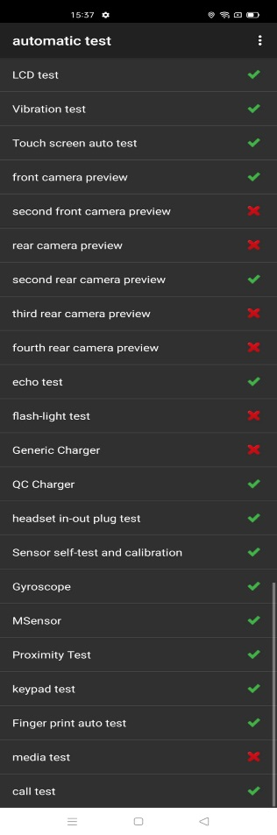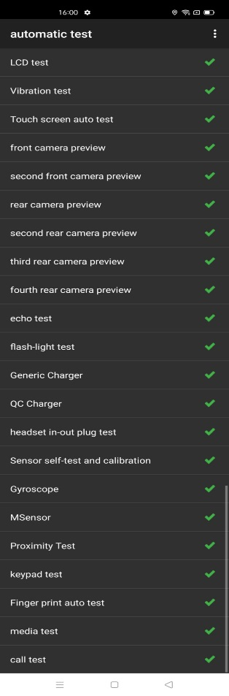

8. Cautions
1. This model does not have camera lens components for replacement. If customer‘s phone need repairing the camera lens, directly replace the middle frame and charge the lens fee;
2. When disassembling the phone, please use a protective film to protect the components to prevent dust from contacting；
3. It is required to clean the original thermal gel when replacing the screen or mainboard, and apply new thermal gel according to the above installation steps.
4. When replacing the old L board, the back cover support foam should be replaced at the same time.
5. Assembly and disassembly teaching video：
FTP：ftp://ftpex.oppo.com:919/Overseas Customer Service/OPPO Technical Service/Product Material/ F17 Pro&Reno4 F&Reno4 Lite&A93
Knowledge Base：Search OPPO A93&F17 Pro&Reno4 F&Reno4 lite Disassembly and Assembly Teaching Video

Version | Date | Drafted | Verified | Approved | Modified content
V1.0 | 2020-08-30 | HuYun | Li BinBin | Huang GuoXin | 1st Version

