OPPO F19 Pro&Reno5 F&Reno5 Lite&A94 Service Manual -V1.0

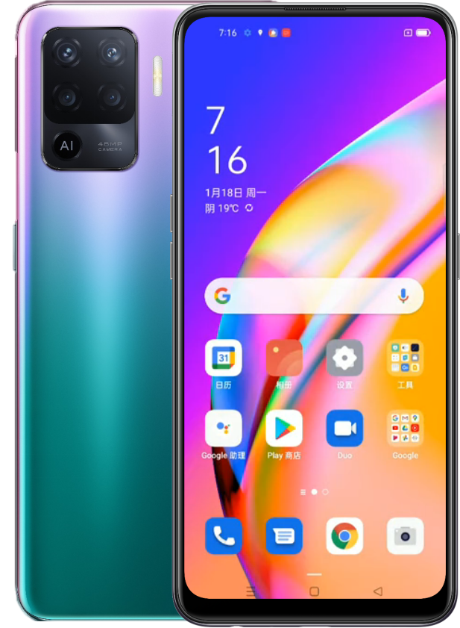

Confidential

Content

1. Guidance
1.1 Warnings
1.2 Cautions
2. General Repair Information
3. Phone Structure Diagram
3.1 Product Appearance
3.2 Phone Structure Explosive View
3.3 Explosive Map BOM
4. Disassembly Steps
4.1 Disassembly Tools
4.2 Preparation
4.3 Disassembly Steps
5. Assembly Steps
5.1 Bill of Must-Be-Replaced Materials
5.2 Assembly Steps
6. After-sale calibration
6.1 Leak Calibration 14
6.1.1 Calibration Scenario 14
6.1.2 Calibration Tool 14
6.1.3 Calibration Method 14
6.2 Fingerprint optical calibration 14
6.2.1 Calibration Scenario 14
6.2.2 Calibration Tool 1
6.2.3 Calibration Method 17
6.3 Dual Camera Calibration 17
6.3.1 Calibration Scenario 17
6.3.2 Calibration Tool 17
6.3.3 Calibration Method 17
7. Function Test 19
7.1 Test Path 20
7.2 Test Requirements 20
8. General Cautions

Guidance
The purpose of this document is only to guide OPPO technicians to carry out maintenance service to OPPO products. The content shall be keep in confidential, only avail be able to OPPO authorized service centers, and cannot be provided to third parties without authorization. Please follow the regulations and the guidance for maintenance service. For any problems, please contact China HQ in time.

1.1 Warnings
1. Care must be taken on installation in vehicles fitted with electronic engine management systems and ABS (Anti–skid Braking Systems). Under certain fault conditions, emitted RF energy can affect their operation. If necessary, consult the vehicle dealer/manufacturer to determine the immunity of vehicle electronic systems to RF energy.
2. Phones must not be operated in areas likely to contain potentially explosive atmospheres, e.g. petrol stations (service stations), blasting areas etc.
3. Operation of any radio transmitting equipment, including cellular telephones, may interfere with the functionality of inadequately protected medical devices. Consult a physician or the manufacturer of the medical device if you have any questions. Other electronic equipment may also be subject to interference

1.2 Cautions
1. Repair services and calibrations must be undertaken by qualified personnel only.
2. Use only approved components as specified in the parts list.
3. Ensure all components, modules screws and insulators are correctly re-fitted after servicing and alignment.
4. Electrostatic discharge is the main cause of damage to sensitive components of electronic products. Service centers must operate in accordance with OPPO's requirements for ESD protection. Ensure all work is carried out at an ESD workstation and that an ESD wristband is worn.

General Repair Information
- Ensure all work is carried out at an ESD workstation and that an ESD wristband is worn before starting maintenance.
- Wear ESD gloves to avoid oil stains and fingerprints.
- Use protective films to protect the display, camera, camera lens to prevent dust and scratches.
- Use a clean cloth, ESD brush and alcohol (Concentration above 95%) for appearance cleaning. Do not use other items (such as an eraser) for cleaning to prevent the protective layer from being scratched, which may lead to oxidation and corrosion.
- Faulty welded mechanical parts (except shield cover and shield frame parts) can only be replaced and not repairable.
- Use accessories provided by OPPO.
- Check the contacts or solder joints of devices that may cause simple faults (e.g. soldered interfaces or switches). Re-weld if necessary (only for service centers where lead-free soldering is available) and clean the flux remaining after soldering.
- Use the equipment provided by OPPO to test the phone (e.g. When the charging function of the device is abnormal, do use the original OPPO adapter to test to ensure the accuracy of the test results).
- Fill in the fault phenomenon code and fault reason code according to the actual situation, and accurately enter the replacement material code in the CRM system.
- For more information about products,
Mainland China please visit:
https://kbase.oppoer.me/kbaseui-oppo/login.html
Regions except for Mainland China please visit:
ftp://ftpex.oppo.com:919 or https://oppo-knowledge.custhelp.com

3. Phone Structure Diagram

3.1 Product Appearance
As shown in Figure 3-1-1
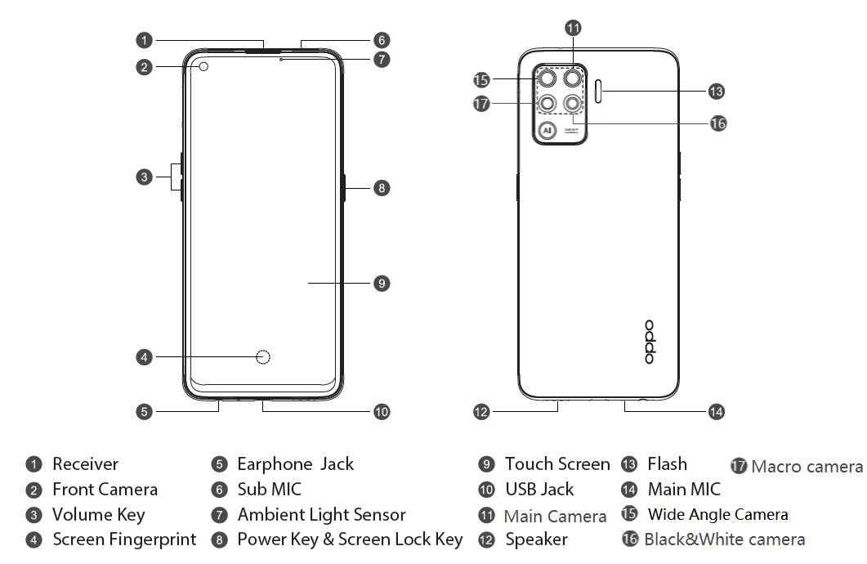
Figure 3-1-1

3.2 Phone Structure Explosive View
As shown in Figure 3-2-1
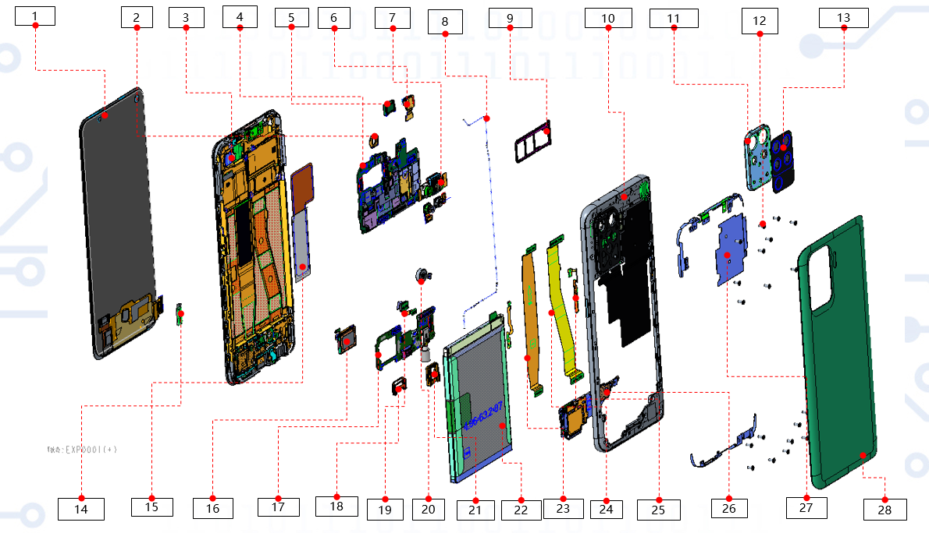
Figure 3-2-1

3.3 Explosive Map BOM
No. | Material Name(After-sales) | Physical Figure | Sub material | QTY | Unit
1 | Screen | 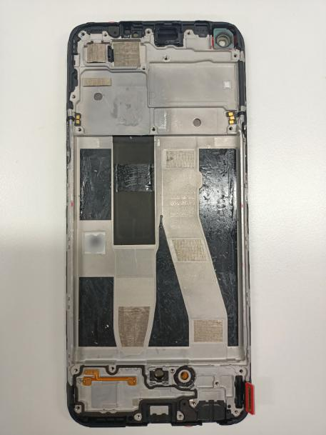 | (3)Display assembly | 1 | PCS
1 | Screen |  | Capacitive touch screen protective film | 1 | PCS
1 | Screen |  | (14)LCM BTB Waterproof silica gel sleeve | 1 | PCS
1 | Screen |  | Waterproof paste | 1 | PCS
1 | Screen |  | (1)OLED screen | 1 | PCS
1 | Screen |  | (15)Graphite sheet for screen | 1 | PCS
1 | Screen |  | (2)Front Camera BTB bracket | 1 | PCS
1 | Screen |  | FPC Waterproof Silicone Plug for Display Screen | 1 | PCS
2 | Back cover | 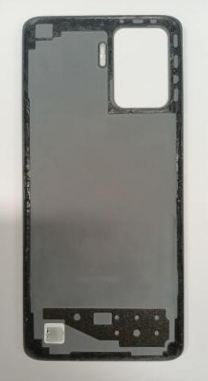 | (28)Back cover | 1 | PCS
3 | Middle frame | 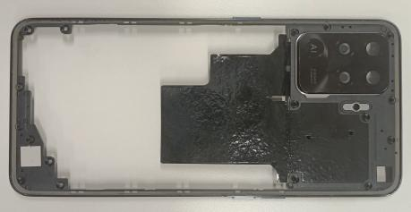 | (10)Middle frame | 1 | PCS
3 | Middle frame |  | (13)Shield backcover | 1 | PCS
3 | Middle frame |  | (11)Camera decoration | 1 | PCS
3 | Middle frame |  | (25)Power-key | 1 | PCS
3 | Middle frame |  | (27)Graphite sheet on the main board | 1 | PCS
3 | Middle frame |  | Waterproof paste | 1 | PCS
4 | Main board | 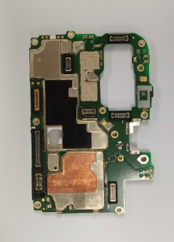 | (4)Main board | 1 | PCS
4 | Main board |  | Pet Safety Shield | 1 | PCS
4 | Main board |  | Test point waterproof sticker | 1 | PCS
5 | Antenna board | 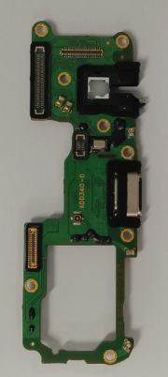 | (17)PCB | 1 | PCS
5 | Antenna board |  | (21)Earphone silicone cover | 1 | PCS
5 | Antenna board |  | (26)Antenna board bracket | 1 | PCS
5 | Antenna board |  | (18)USB silicone cover | 1 | PCS
6 | Speaker | 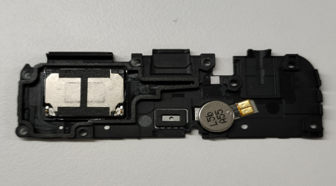 | (16)Speaker Box | 1 | PCS
6 | Speaker |  | (20)Vibration motor | 1 | PCS
7 | L-FPC | 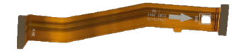 | (8)L-FPC | 1 | PCS
8 | C-FPC | 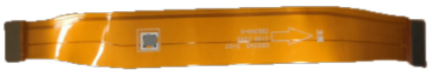 | (18)C-FPC | 1 | PCS
9 | Battery | 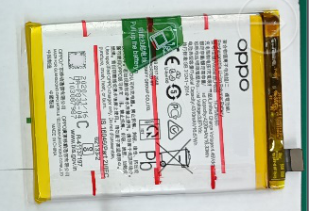 | (22)Battery | 1 | PCS
10 | RFcable | 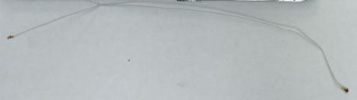 | (8)RF cable | 1 | PCS
11 | Front camera | 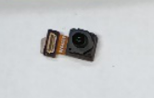 | (6)Front camera | 1 | PCS
12 | Machine-tapping screw | 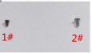 | 1#Screw | 3 | PCS
12 | Machine-tapping screw |  | (12)2#Screw | 18 | PCS
13 | Fingerprint sensor | 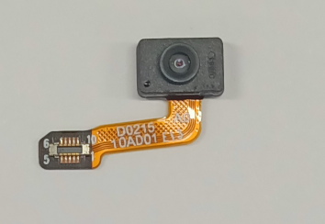 | (19)Fingerprint sensor | 1 | PCS
14 | SIM card tray | 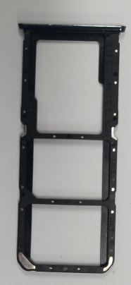 | (9)SIM card tray | 1 | PCS
15 | Receiver | 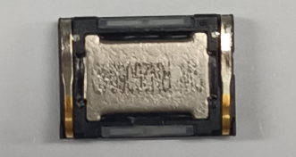 | (5)Receiver | 1 | PCS
16 | Cameras | 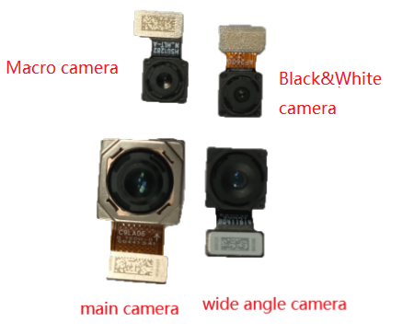 | (7)48M main camera(Lower left) | 1 | PCS
16 | Cameras |  | 8M wide angle camera(Lower right) | 1 | PCS
16 | Cameras |  | 2M Macro camera(Top right) | 1 | PCS
16 | Cameras |  | 2M Black&White camera(Top left) | 1 | PCS
17 | Foam of the battery | 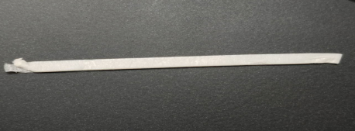 | (19)Battery foam | 1 | PCS

Note：This table is used only for the name of the annotation but not for the preparation of materials. Please refer to the Price List of OPPO Mobile Phone Original Accessories (for Mainland China)/Price List of Commonly-Used Materials and Accessories (Regions except for Mainland China) for the preparation.

4. Disassembly Steps

4.1 Disassembly Tools
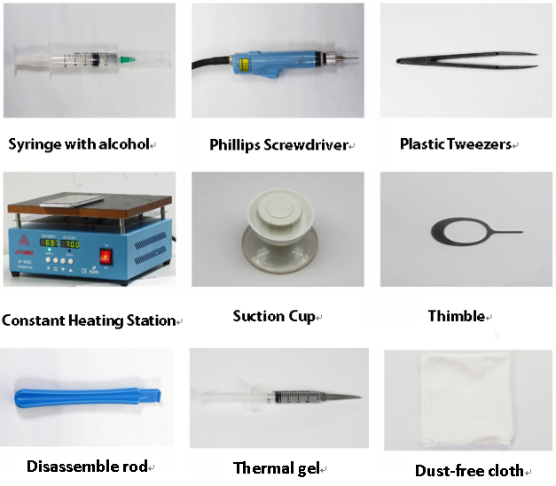

4.2 Preparation
1. The phone must be powered off before disassembly.
2. Way to Power Off:
System Power Off: Press the power key then slide to power off.
Forced Power Off: Long press the volume “+” key and power key for about 8 seconds until the display is off.

4.3 Disassembly Steps

Step | Content | Figure | Cautions
1 | Remove SIM card tray | 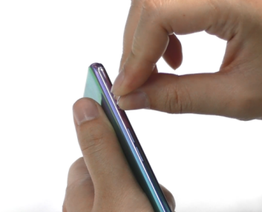 | /
2 | Remove the back cover | 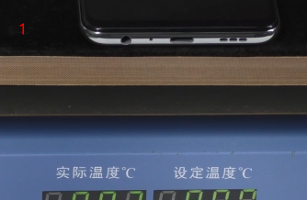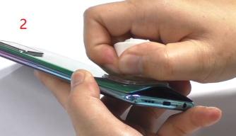 | /
3 | Clean the back cover and middle frame | 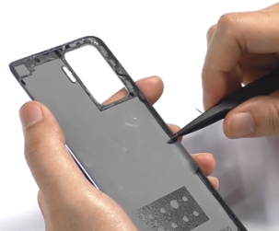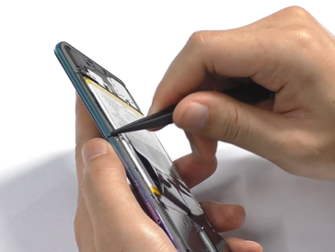 | /
4 | Remove the screws (1#1pcs, 2#18pcs) | 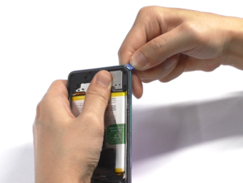  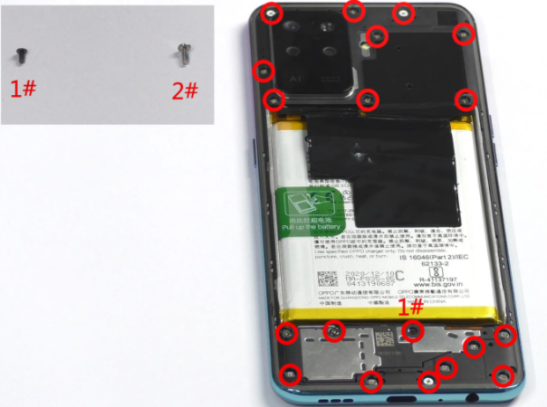 | - Pay attention to the screw type, do not mix, you can remove the 1# screw first  - Pay attention to avoiding the position of the card tray when rowing
5 | Remove the battery | 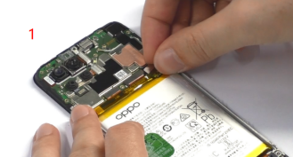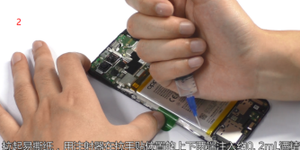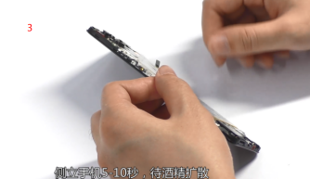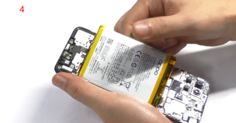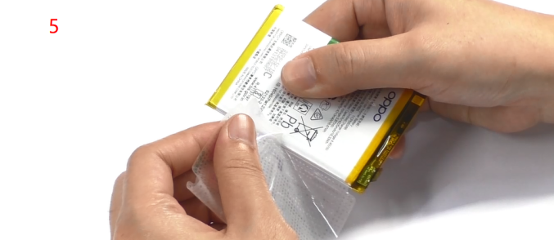 | /
6 | Remove the battery compartment foam, speaker BOX | 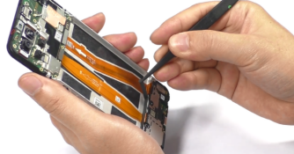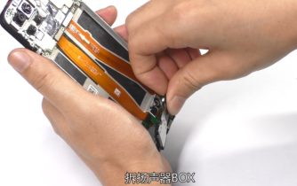 | /
7 | Remove FPC | 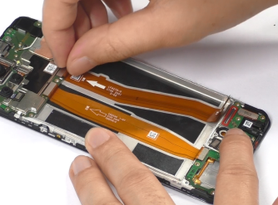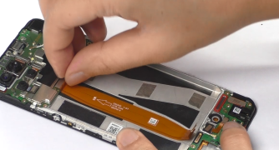 | /
8 | Remove RF cable and front camera | 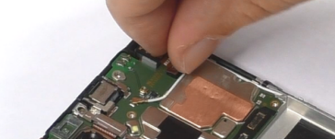  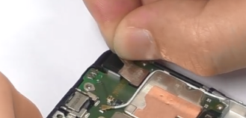  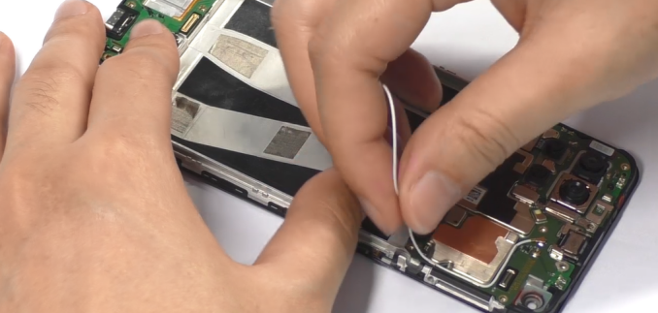 | /
9 | Remove the main board screws (1#，2pcs) and the bracket | 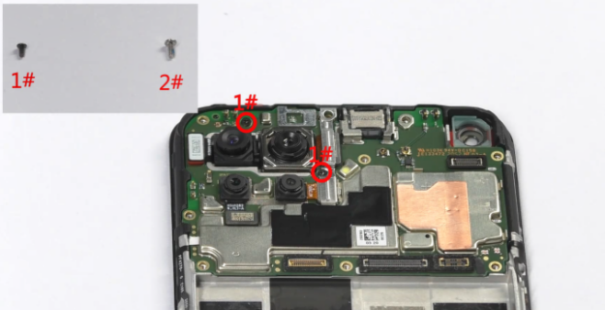  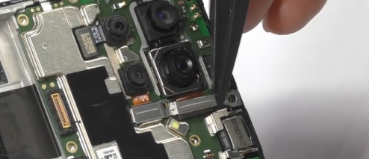 | /
10 | Remove the rear camera | 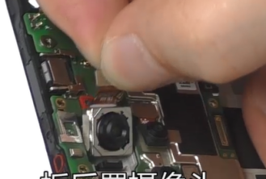  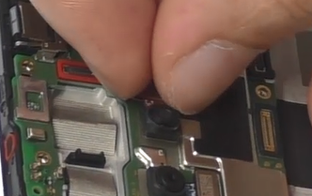  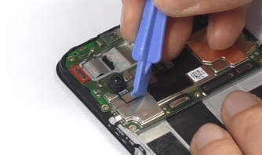  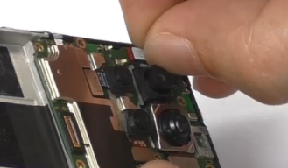 | /
11 | Remove main board and the fingerprint sensor | 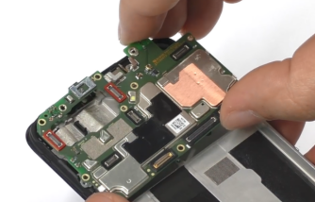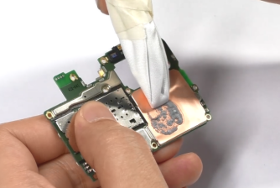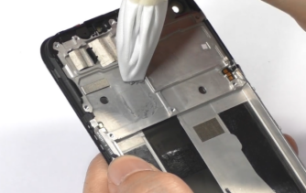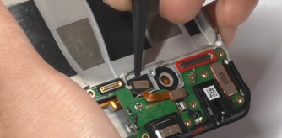 | /
12 | Remove the fingerprint sensor | 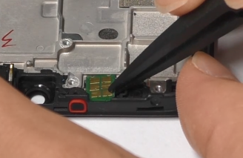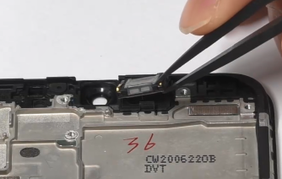 | /
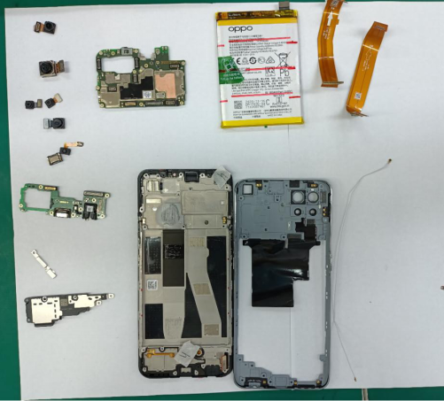
Figure 4.3 All Materials of the Phone

5. Assembly Steps

5.1 Bill of Must-Be-Replaced Materials
No. | Code | Material | SPEC. | QTY | Remark
1 | 4884926 | Battery-cover-double-sided-adhesive | FA271 | 1 | Must replace when remove the back cover
2 | 4883010 | battery pull tape | BLP835 transparent | 1 | Must replace when remove battery
3 | 5181653 | battery extracting sticker | common right green | 1 | Must replace when remove battery

5.2 Assembly Steps
Step | Content | Figure | Cautions
1 | Install Antenna Board & receiver | 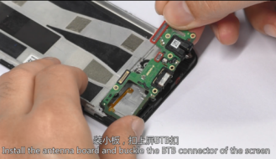  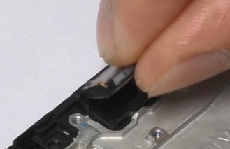
2 | Install Fingerprint Sensor Module& main board | 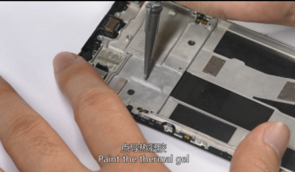  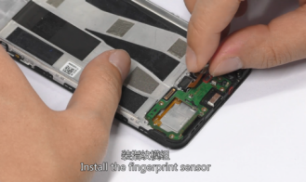  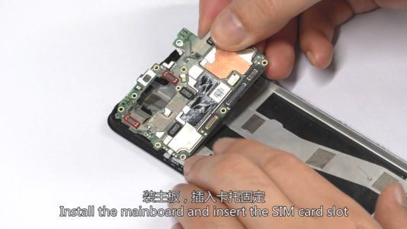 | Paste thermal gel
3 | Install front camera | 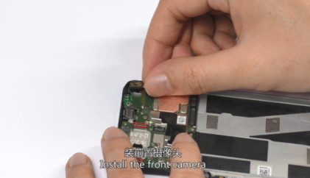 | Stick the copper foil
4 | Install RF cable | 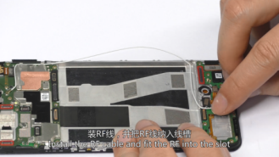  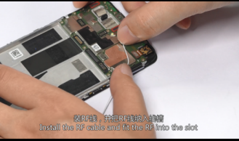 | /
5 | Install FPC | 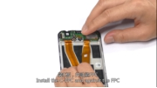  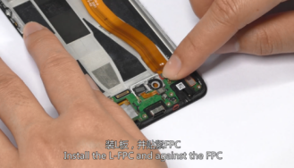 | /
6 | Install the rear camera | 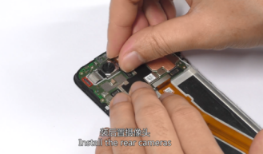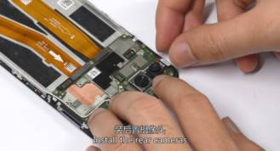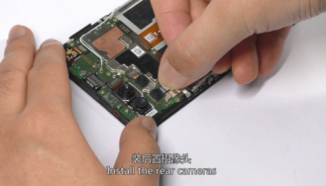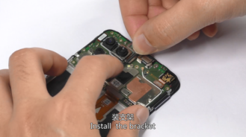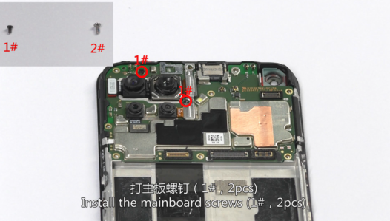 | Distinguish the screws
7 | 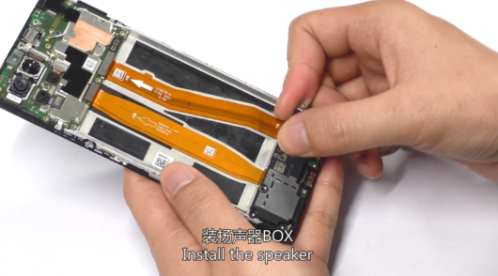  Paste the conductive copper foil of the front camera&install BOX | 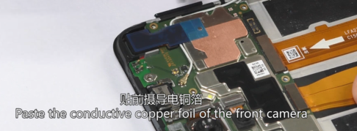 | /
8 | Install the battery | 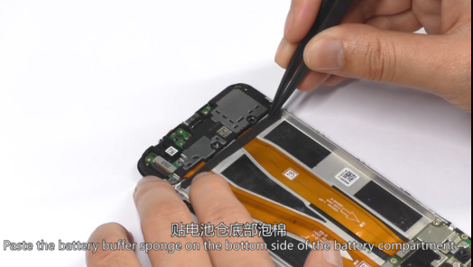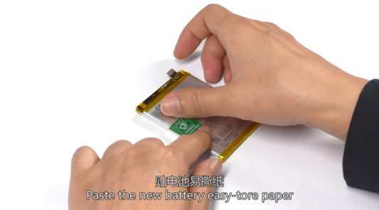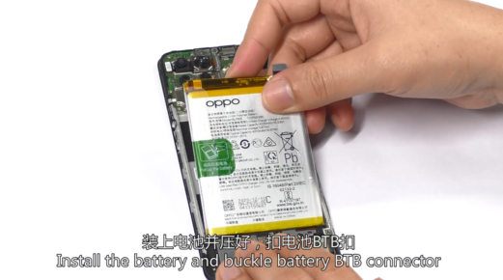 | /
9 | Install the back cover | 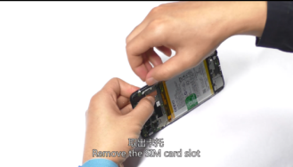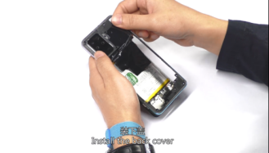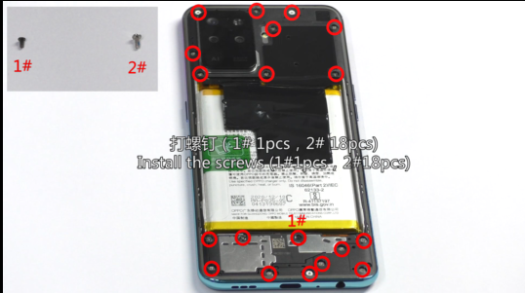 | Distinguish the screws
10 | Install the back cover and the SIM card slot | 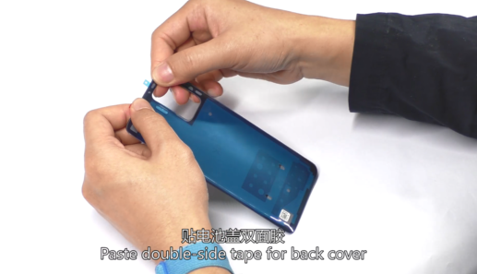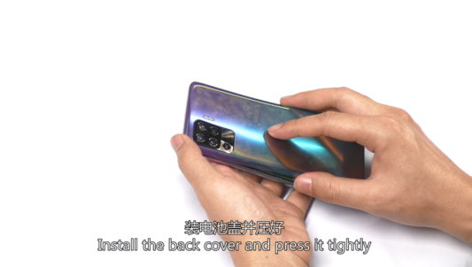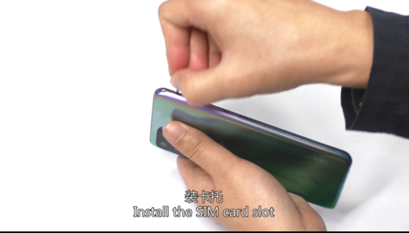 | The back cover needs to be kept under pressure for a certain period of time.
11 | Power on and check all functions | 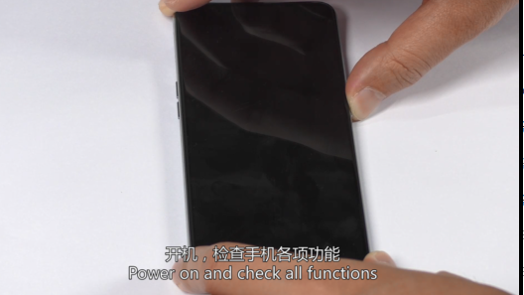 | /

6. Calibration
After the phone is disassembled and assembled, the aftersale devices calibration must be calibrated first. The calibration of this model includes(leak calibration--fingerprint optical calibration--aftersales calibration.
Enter Password: 6776 | Click ”leak calibration ” |  | When the environment is completely black, click the "leak calibration" button; |  | 1.Click "START" to start calibration after it jumps into the fingerprint optical calibration
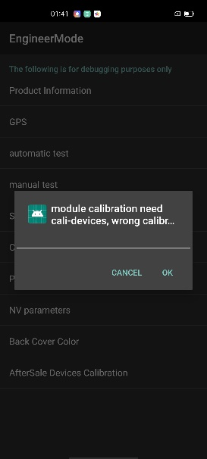 | 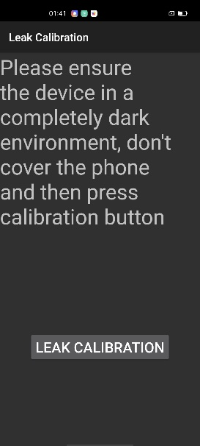 |  | 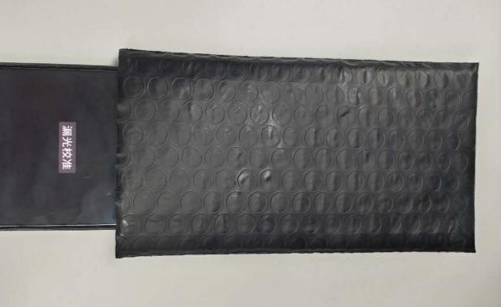 |  | 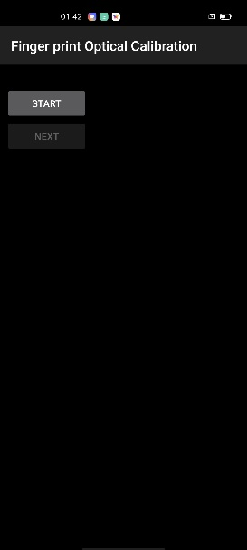
2. According to the prompt "please place the yellow rubber ", put the yellow rubber on the fingerprint spot area (the groove is facing down), and click "NEXT" until it prompts " please place the black rubber". |  | 3. According to the prompt "please place the black rubber head", put the black rubber on the fingerprint spot area (the groove is facing down), click "NEXT" until the "please place the yellow stripe rubber " prompts to remove the black rubber ; |  | 4. According to the prompt “Please place the yellow- striped rubber”, put the yellow stripe rubber (striped down) in the spot area, click “NEXT”;
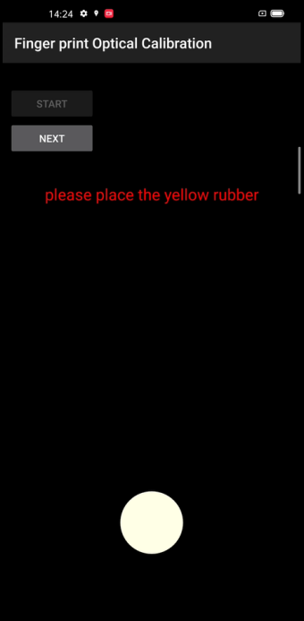 |  | 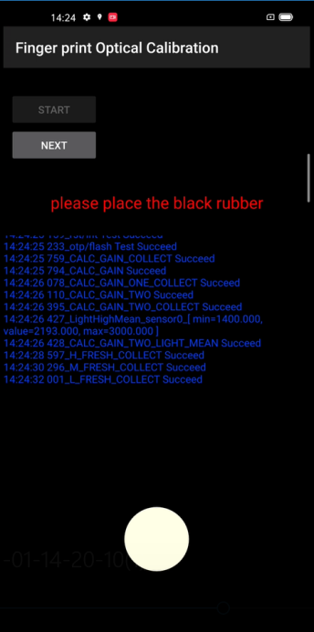 |  | 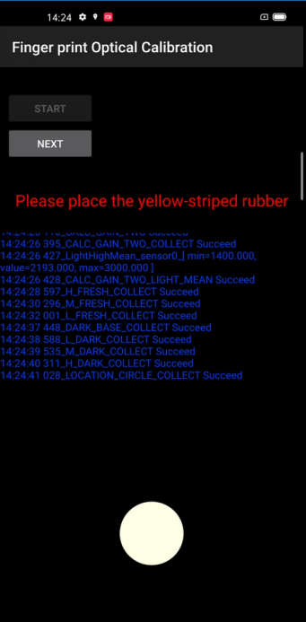
it jumps into the after sales calibration from fingerprint optical calibration
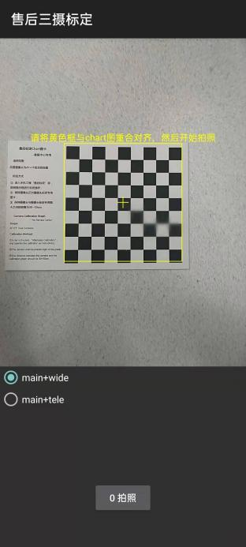
After the calibration is completed, restart the phone to make the calibration take effect, and guide the user to delete the original fingerprint and re-enter.

7. Function Test

7.1 Test Path
Dialing Interface>Enter*#899#>Enter automatic test； The "Confirm" dialog box will pop up after the test complete, if there is no problem choose “Pass”, otherwise choose “Fail”.

7.2 Test Requirements
No. | Test Items | Test Requirements
1 | LCD Test | Observe the red, green, blue, white, black, gray, grayscale and color interface successively; If there are black spots, bright spots and other anomalies, the function is good;
2 | Vibration Test | Get ear close to check the vibration from the motor for 3 seconds.  If the motor vibrates normally(No noises or weak vibration), the function is good;
3 | Touch Screen Auto Test | If the interface shows “PASS” and jumps to the next test, the function is good;
4 | Front Camera Preview | Align the camera with a white surface and a black surface. If there is no black dot, black line or blurred screen on the screen after aligning the white surface, and there is no bright spot on the screen after aligning the black surface, the camera is good;
5 | Rear camera preview | Align the rear camera with a white surface, a black surface, and a surface with text. If there is no black dot, black line or blurred screen on the screen after aligning the white surface, there is no bright spot on the screen after aligning the black surface, white point or blurred screen, the camera is good;
6 | Second rear camera preview | Align the Second rear camera with a white surface, a black surface, and a surface with text. If there is no black dot, black line or blurred screen on the screen after aligning the white surface, there is no bright spot on the screen after aligning the black surface, white point or blurred screen, the camera is good;
7 | third rear camera preview | Align the third rear camera with a white surface, a black surface, and a surface with text. If there is no black dot, black line or blurred screen on the screen after aligning the white surface, there is no bright spot on the screen after aligning the black surface, white point or blurred screen, the camera is good;
8 | Fourth rear camera preview | Align the fourth rear camera with a white surface, a black surface, and a surface with text. If there is no black dot, black line or blurred screen on the screen after aligning the white surface, there is no bright spot on the screen after aligning the black surface, white point or blurred screen, the camera is good;
9 | Echo test | Testing Main MIC: Blow the air to the MIC hole on the bottom of the phone. If the receiver (earphone) sounds, the function of Main MIC is good;  Testing Sub MIC: Blow the air to the sub MIC hole on the top of the phone. If the speaker sounds, the function of Main MIC is good;
10 | Flashlight Test | Open the flashlight. If it can be opened normally with color deviations, the function is good;
11 | Charging Test(VOOC) | Use the original OPPO adapter and USB cable to charge. If the interface shows “PASS” and jumps to the next test, the function is good;
12 | Headset in-out Plug test | Plug in and out the earphone with the OPPO earphone. If the interface shows “PASS” and jumps to the next test, the function is good;
13 | Sensor Self-test and Calibration | When the phone enters into the Sensor self-calibration interface, the phone must be placed on the desk flatly. Then click the first calibration item. After the test is passed, it will automatically jump to the next test item;
14 | Gyroscope Test | Take the mobile phone to draw the "8" word graphic. If the interface shows “PASS” and jumps to the next test, the function is good;
15 | M-Sensor Test | Shake the phone from the left to the right side. If the interface shows “PASS” and jumps to the next test, the function is good;
16 | Proximity-sensor Test | Use the palm to cover the light sensor hole, and the screen will turn green from black. If the interface shows “PASS” and jumps to the next test, the function is good;
17 | Keypad Test | Press the power key and volume key one by one. If keys can be pressed normally and the interface jumps to the next test, the function is good;
18 | Fingerprint Auto Test | If the interface shows “PASS” and jumps to the next test, the function is good;
19 | Media test | Click the “20-4K（-3db)signal” to test the sound of the media function for 5s. If there is no silence, weak sound, noises, and breaking sound, the interface shows “PASS” and jumps to the next test, the function is good;
20 | Call test | If the phone has been installed with the operator's SIM card, dial the corresponding operator's phone number. If no card is installed, call the 112 to test (Calling the Operator is recommended). If the call can be performed normally and the receiver is without noises or weak sounds, the function is good;
After the above 20 items are tested, they will prompt to the test result interface. If the test PASS, project will show “√”; If the test FAIL, project will show “×” as shown below.
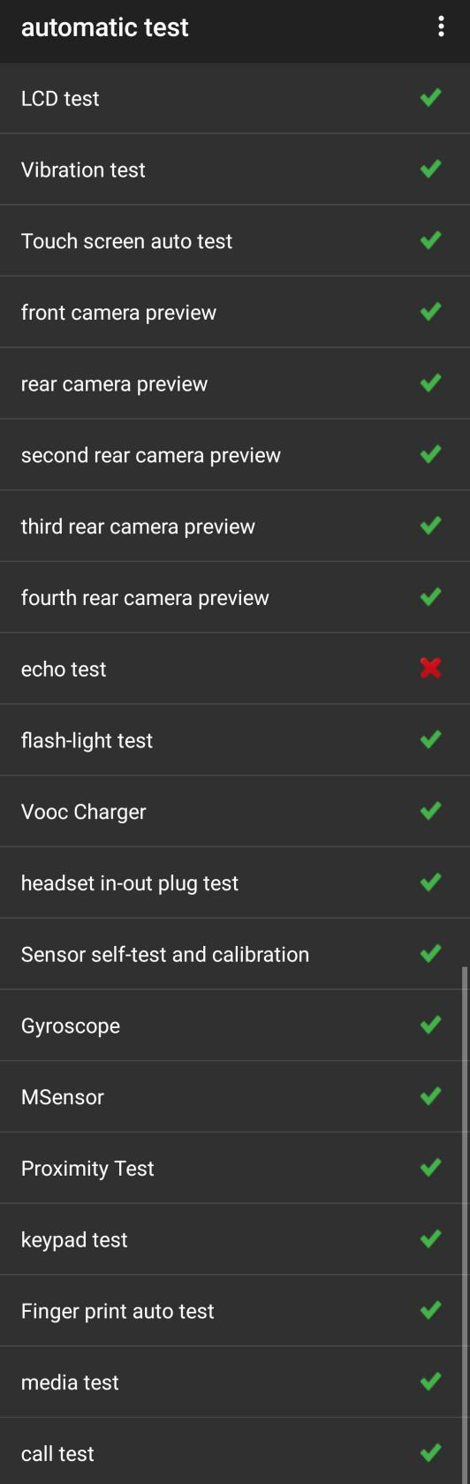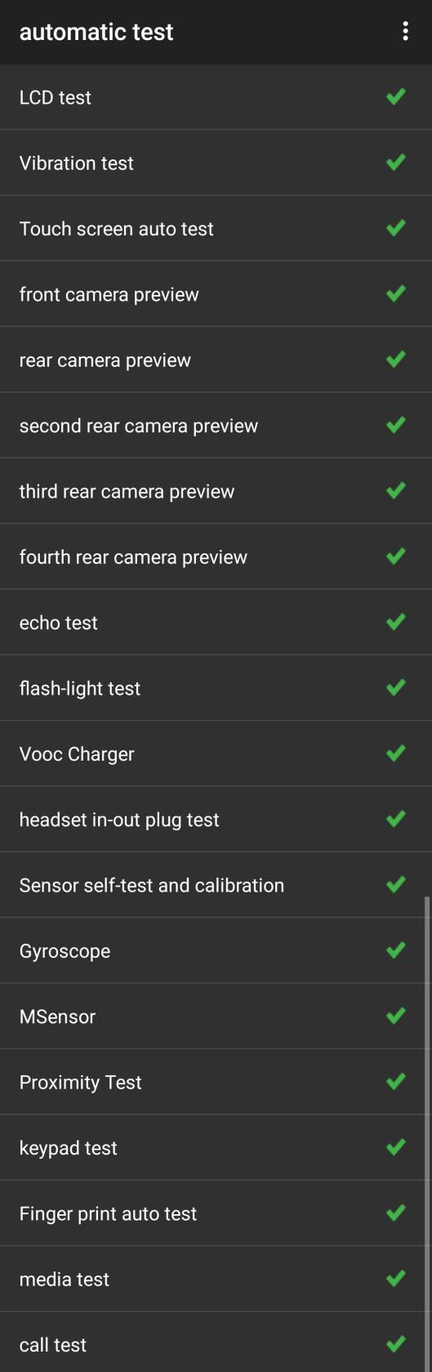

8. General Cautions
1. When disassembling (front/rear) camera and fingerprint module, pay attention to protect the camera lens with low mucosa;
2. If it involves replacing the screen assembly, the main board or cleaning the original thermal gel, it is necessary to apply tShe thermal conductive gel according to the above installation steps;
3. It should be noted screws Model when tighten the screws;
For Disassembly Video Please visit:
FTP: Overseas Customer Service--- OPPO Technical Service--- Product Material---F19 Pro&Reno5 F&Reno5 Lite&A94.
Version | Date | Draft | Review | Approve | Modified content
V1.0 | 2021-02-10 | Zhengcunyi | Lin  binbin | Chenwei | 1.First Edition

1. Guidance
1.1 Warnings
1.2 Cautions
2. General Repair Information
3. Phone Structure Diagram
3.1 Product Appearance
3.2 Phone Structure Explosive View
3.3 Explosive Map BOM
4. Disassembly Steps
4.1 Disassembly Tools
4.2 Preparation
4.3 Disassembly Steps
5. Assembly Steps
5.1 Bill of Must-Be-Replaced Materials
5.2 Assembly Steps
6. After-sale calibration
6.1 Leak Calibration
6.1.1 Calibration Scenario
6.1.2 Calibration Tool
6.1.3 Calibration Method
6.2 Fingerprint optical calibration
6.2.1 Calibration Scenario
6.2.2 Calibration Tool
6.2.3 Calibration Method
6.3 Dual Camera Calibration
6.3.1 Calibration Scenario
6.3.2 Calibration Tool
6.3.3 Calibration Method
7. Function Test
7.1 Test Path
7.2 Test Requirements
8. General Cautions

