OPPO Find X2 Service Manual_V1.1
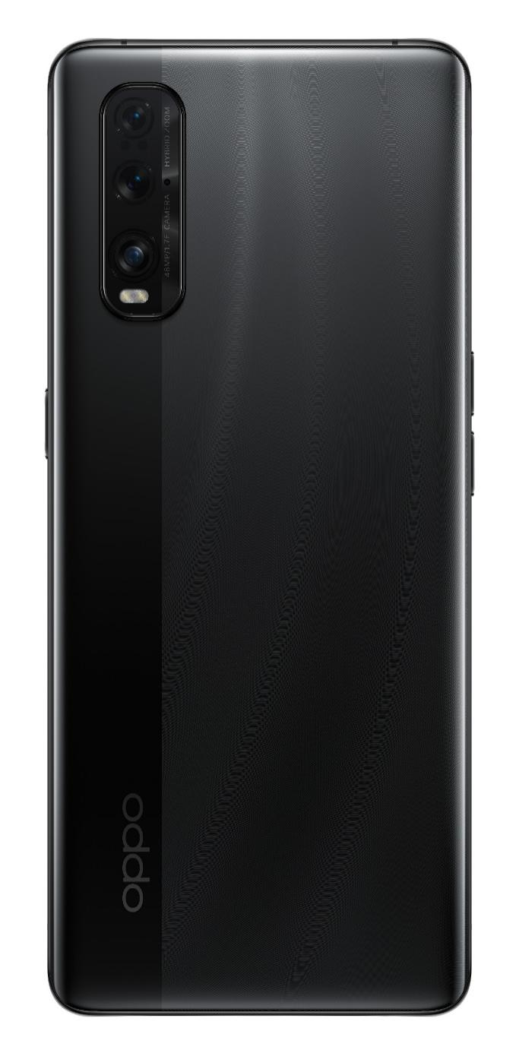
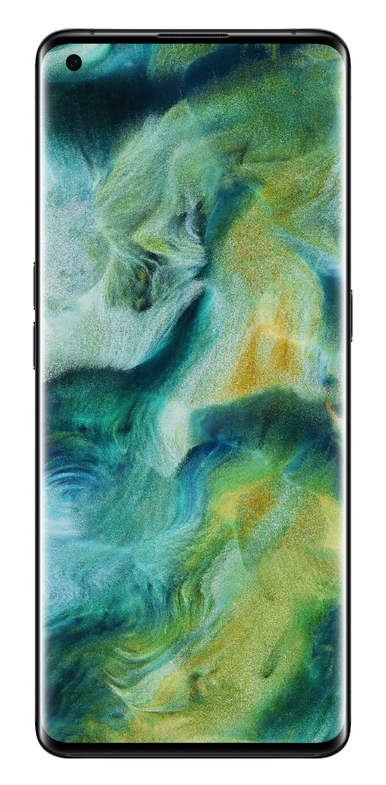

Confidential

Guidance
The purpose of this document is only to guide OPPO technicians to carry out maintenance service to OPPO products. The content shall be keep in confidential, only avail be able to OPPO authorized service centers, and cannot be provided to third parties without authorization. Please follow the regulations and the guidance for maintenance service. For any problems, please contact China HQ in time.

1.1 Warnings
1. Care must be taken on installation in vehicles fitted with electronic engine management systems and ABS (Anti–skid Braking Systems). Under certain fault conditions, emitted RF energy can affect their operation. If necessary, consult the vehicle dealer/manufacturer to determine the immunity of vehicle electronic systems to RF energy.
2. Phones must not be operated in areas likely to contain potentially explosive atmospheres, e.g. petrol stations (service stations), blasting areas etc.
3. Operation of any radio transmitting equipment, including cellular telephones, may interfere with the functionality of inadequately protected medical devices. Consult a physician or the manufacturer of the medical device if you have any questions. Other electronic equipment may also be subject to interference

1.2 Cautions
1. Repair services and calibrations must be undertaken by qualified personnel only.
2. Use only approved components as specified in the parts list.
3. Ensure all components, modules screws and insulators are correctly re-fitted after servicing and alignment.
4. Electrostatic discharge is the main cause of damage to sensitive components of electronic products. Service centers must operate in accordance with OPPO's requirements for ESD protection. Ensure all work is carried out at an ESD workstation and that an ESD wristband is worn.

General Repair Information
- Ensure all work is carried out at an ESD workstation and that an ESD wristband is worn before starting maintenance.
- Wear ESD gloves to avoid oil stains and fingerprints.
- Use protective films to protect the display, camera, camera lens to prevent dust and scratches.
- Use a clean cloth, ESD brush and alcohol (Concentration above 95%) for appearance cleaning. Do not use other items (such as an eraser) for cleaning to prevent the protective layer from being scratched, which may lead to oxidation and corrosion.
- Faulty welded mechanical parts (except shield cover and shield frame parts) can only be replaced and not repairable.
- Use accessories provided by OPPO.
- Check the contacts or solder joints of devices that may cause simple faults (e.g. soldered interfaces or switches). Re-weld if necessary (only for service centers where lead-free soldering is available) and clean the flux remaining after soldering.
- Use the equipment provided by OPPO to test the phone (e.g. When the charging function of the device is abnormal, do use the original OPPO adapter to test to ensure the accuracy of the test results).
- Fill in the fault phenomenon code and fault reason code according to the actual situation, and accurately enter the replacement material code in the CRM system.
- For more information about products,
Mainland China please visit:
http://172.16.41.122:8888/kbaseui-dev/main.do
Regions except for Mainland China please visit:
ftp://ftpex.oppo.com:919 or
https://oppo-knowledge.custhelp.com

3. Phone Structure Diagram

3.1 Product Appearance
As shown in Figure 3-1-1
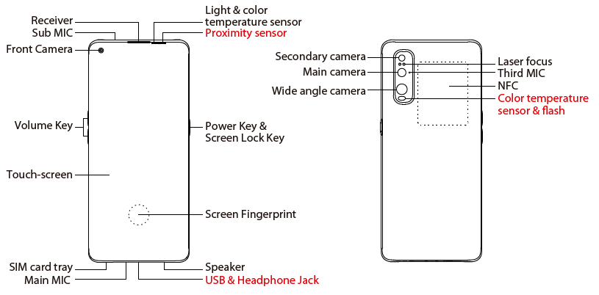
Figure 3-1-1

3.2 Phone Structure Explosive View
As shown in Figure 3-2-1
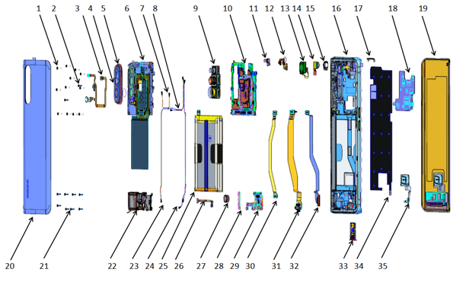
Figure 3-2-1

3.3 Explosive Map BOM
NO | Material Name | Picture | Sub-Category | QTY | Unit
1 | Screen | 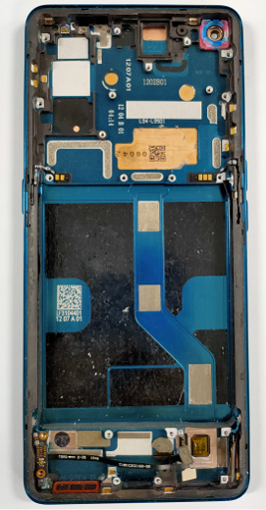 | (19) TP+Display | 1 | PCS
1 | Screen |  | (16) Top cover | 1 | PCS
1 | Screen |  | (26) C2 FPC semi-finished | 1 | PCS
1 | Screen |  | (28) A2 PCB semi-finished | 1 | PCS
1 | Screen |  | Receiver conductive copper foil | 1 | PCS
2 | Back cover | 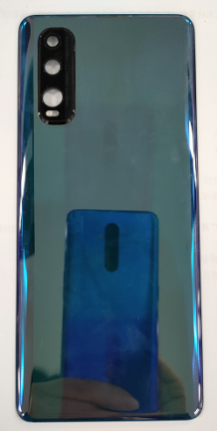 | (20) Back cover | 1 | PCS
3 | Mainboard | 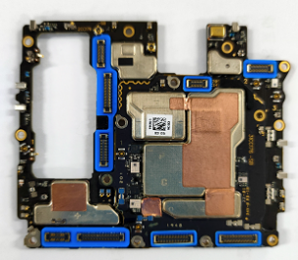 | Test point PET sheet 1 | 1 | PCS
3 | Mainboard |  | Test point PET sheet 2 | 1 | PCS
3 | Mainboard |  | (10) Mainboard | 1 | PCS
4 | Front camera | 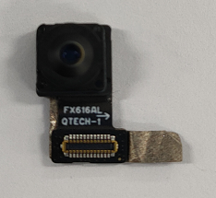 | (14) Front camera | 1 | PCS
4 | Front camera |  | Front camera copper foil | 1 | PCS
4 | Front camera |  | Front camera double-sided adhesive | 1 | PCS
5 | Rear Camera lens | 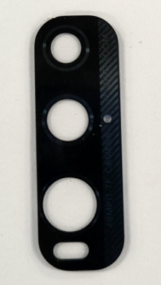 | (4) Rear camera lens | 1 | PCS
5 | Rear Camera lens |  | Rear camera lens foam rubber | 1 | PCS
6 | Camera decoration | 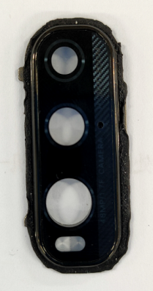 | (5) Camera decoration | 1 | PCS
6 | Camera decoration |  | (4) Rear camera lens | 1 | PCS
7 | Receiver | 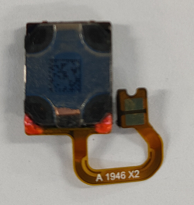 | (13) Speaker | 1 | PCS
7 | Receiver |  | Receiver conductive copper foil
7 | Receiver |  | Receiver Seal Sponge | 1 | PCS
8 | Battery | 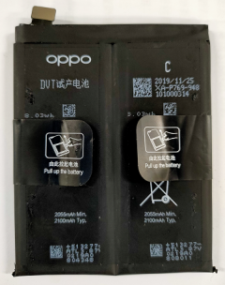 | (12) Battery | 1 | PCS
8 | Battery |  | Battery easy-tore paper | 1 | PCS
8 | Battery |  | battery extracting sticker | 1 | PCS
9 | Power key | 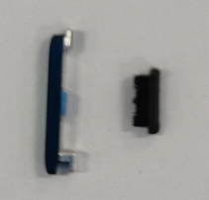 | Power key | 1 | PCS
9 | Power key |  | Key bracket | 1 | PCS
10 | Volume key | 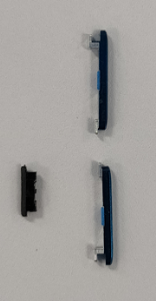 | Volume key | 1 | PCS
10 | Volume key |  | Key bracket | 1 | PCS
11 | Power key FPC | 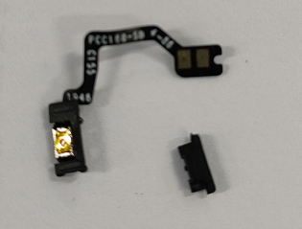 | Power key FPC | 1 | PCS
11 | Power key FPC |  | Key bracket | 1 | PCS
11 | Power key FPC |  | Power key FPC fixed double-sided adhesive | 1 | PCS
12 | Volume key FPC | 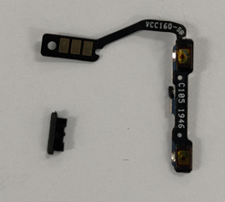 | Volume key FPC | 1 | PCS
12 | Volume key FPC |  | Key bracket | 1 | PCS
12 | Volume key FPC |  | Volume key FPC fixed double-sided adhesive | 1 | PCS
13 | Light sensor FPC | 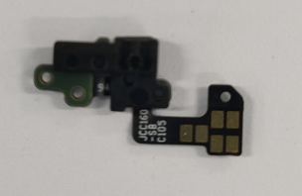 | Photoinductor supporting bracket | 1 | PCS
13 | Light sensor FPC |  | J-FPC patch semi-finished product | 1 | PCS
14 | RF Cable 1# | 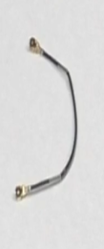 | (7) RF Cable 1# | 1 | PCS
15 | RF Cable 2# | 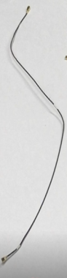 | (23) RF Cable 2# | 1 | PCS
16 | RF Cable 3# | 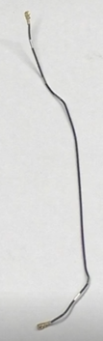 | (24) RF Cable 3# | 1 | PCS
17 | RF Cable 4# | 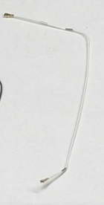 | (8) RF Cable 4# | 1 | PCS
18 | Screws | 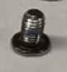 | (1) Screws |  | PCS
19 | C1 smallboard | 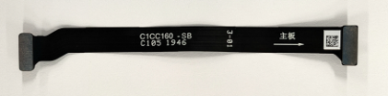 | （30）C1 smallboard | 1 | PCS
20 | USB smallboard | 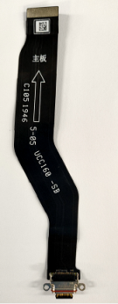 | （31）USB smallboard | 1 | PCS
21 | Flash smallboard | 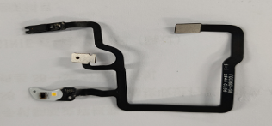 | （3）Flash smallboard | 1 | PCS
22 | A1 Antenna board | 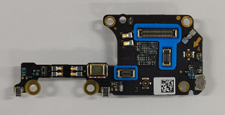 | （29）A1 Antenna board | 2 | PCS
23 | L3 smallboard | 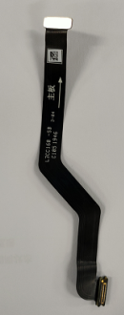 | （32）L3 smallboard | 1 | PCS
24 | Speaker BOX | 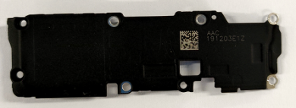 | （22）Speaker BOX | 1 | PCS
25 | Z-motor | 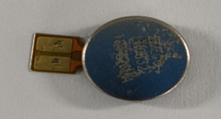 | （27）Z-motor | 1 | PCS
26 | Rear Camera | 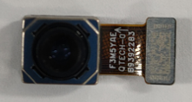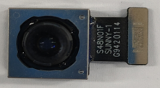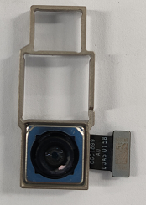 | （9）Rear Camera | 1 | PCS
27 | SIM card tray | 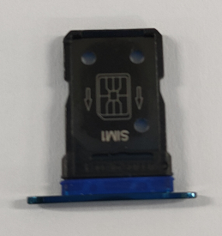 | （33）SIM card tray | 1 | PCS
28 | C2 smallboard | 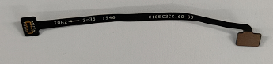 | （26）C2 smallboard | 1 | PCS
29 | Mainboard bracket | 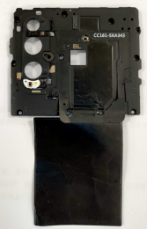 | （6）Mainboard bracket | 1 | PCS
30 | A2 Antenna board | 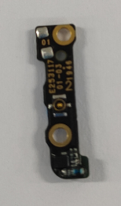 | （28）A2 Antenna board | 1 | PCS
31 | Camera conductive fabric | 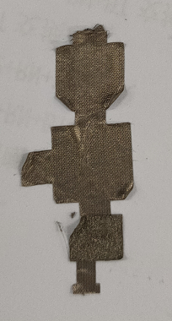 | Camera conductive fabric | 1 | PCS
32 | Battery RF Connection foam | 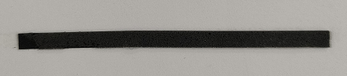 | Battery RF Connection foam | 1 | PCS
33 | Battery bottom foam |  | Battery bottom foam | 1 | PCS
Note: This table is used only for the name of the annotation. It is not suitable for the preparation of materials. Please refer to the “Price list of Commonly-used Materials and Accessories” for the preparation.

4. Disassembly Steps

4.1 Disassembly tools required as shown below:
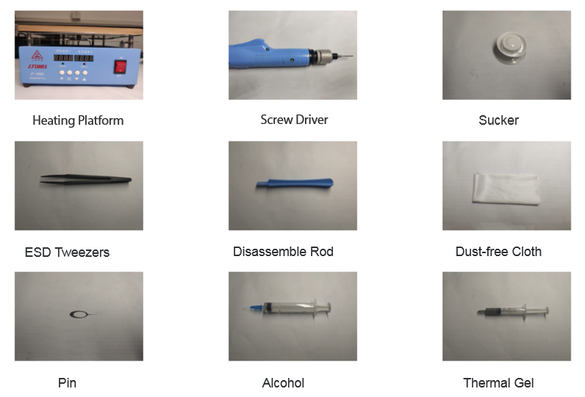

4.2 Preparation
1. The phone must be shut down with the power option before disassembling.
2. Way to Shut Down: Press the power button then slide to power off.( The forced shutdown method is long press the volume + button and power button for about 8 seconds until the display is off)

4.3 Disassembly Steps
Steps | Details | Picture | Cautions
1 | Remove the SIM card holder | 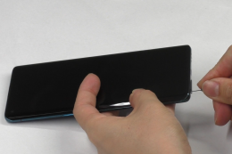 | Insert the card pin vertically, taking care not to scratch the battery cover
2 | Remove the battery cover | 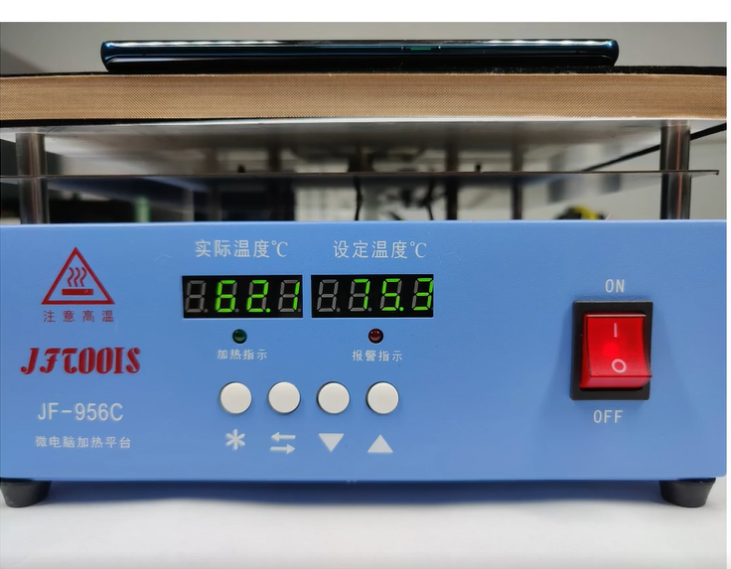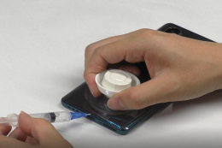  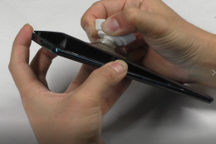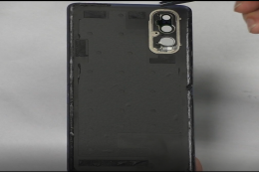 | 1. Be careful not to pull the battery cover with force.  2. inject alcohol, and pull the battery cover and inject alcohol.  3. Pay attention to clean the shockproof foam of the battery cover  （The Vegan Leather battery cover can't be cleaned and disassembled with alcohol. Disassembly Steps is Refer to“4.4 Disassembly Steps For Vegan Leather Battery cover”）
3 | Remove the Camera Lens | 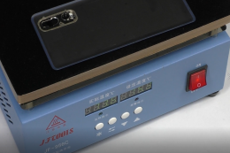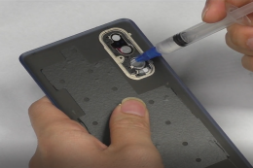 | 1. When disassembling the camera lens, be sure to heating it and inject alcohol, and not push the camera lens with force.
4 | Remove the phone screw | 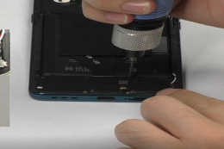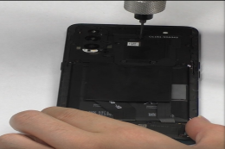 | 1. There are 12 mainboard screws and 8 speaker screws . with different sizes.
5 | Remove mianboard bracket / remove flash FPC | 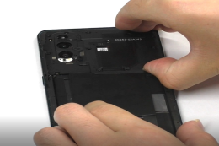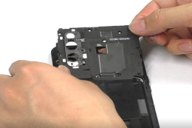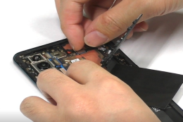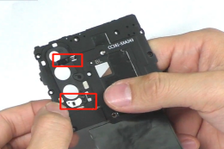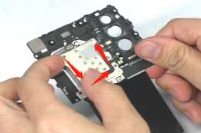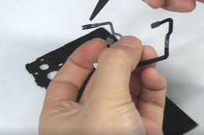 | 1. When disassembling the mianboard bracket, first release the flash FPC BTB;  2. Be careful to check if the laser silicone sleeve is still on the FPC
6 | tear the front camera conductive cloth,the copper foil of the receiver/ loosen the USB FPC and C1 FPC mianboard side BTB | 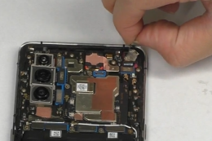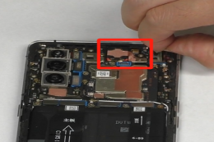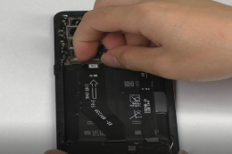
7 | Remove the battery | 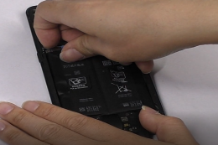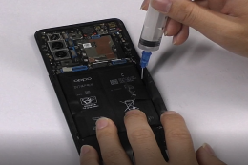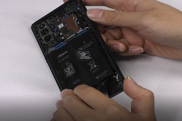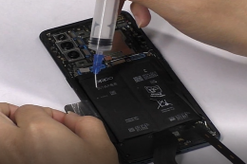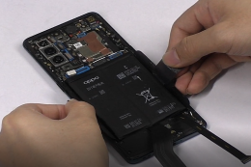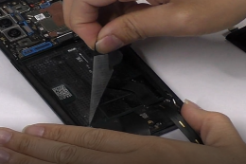 | 1. Battery BTB connector must be removed before disassembly;  2. Both sides need to be filled with alcohol .neither put too much alcohol, nor drop alcohol on the handle;  3. Sideward stand up the phone for 10-15s until the alcohol spreads fully  4. Pull out the battery at a 45-degree, do not pull it vertically.  5. Check for puncture, indentation, leakage and other defects after removing the battery
8 | Remove the speaker and C1 FPC | 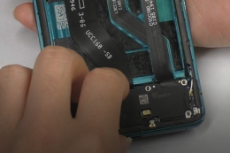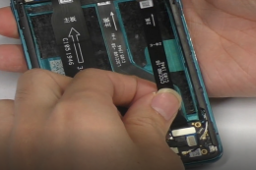 | 1.Remove the speaker from the side of positioning post.
9 | Remove fingerprint BTB/C2 FPC BTB / vibration motor | 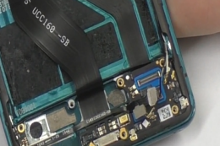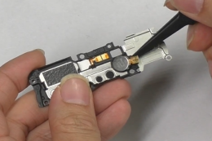 | 1. Pay attention to assemble the vibration motor back to the speaker bracket
10 | Remove the A1 smallboard /the USB cable / Remove the A2 smallboard | 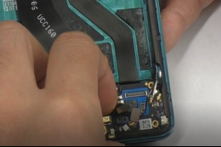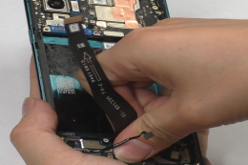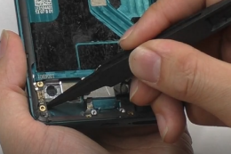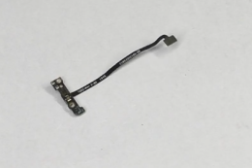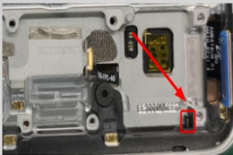 | 1.A2 antenna smallboard must be change after removed  2. Pay attention to check the SIM card tray lever, and push the lever out
11 | Remove the battery protection foam, RF cable foam, battery bottom foam / remove the L3 FPC | 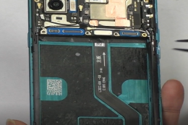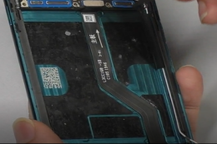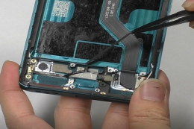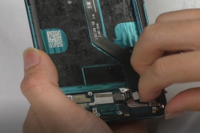 | 1. the battery protection foam must change after remove
12 | Remove the rear camera/ rear camera conductive cloth / front camera / RF cable | 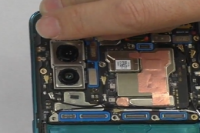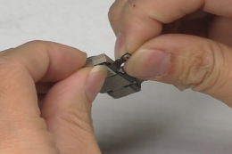  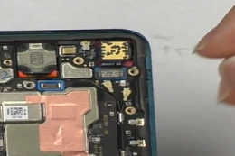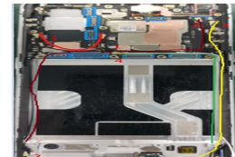 | 1. the conductive cloth of the rear camera must be change after removed;  2. Use plastic tweezers to release RF buckle, don’t damage the socket.
13 | Remove mianboard screws/ the mianboard / Clean the thermal gel / Remove receiver / key FPC, Motor | 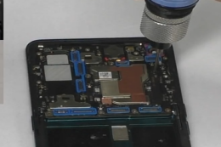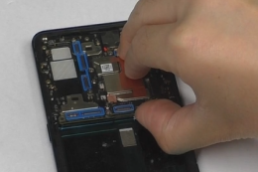  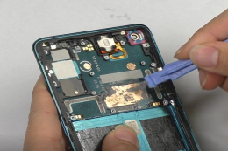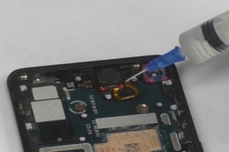 | 1. The thermally gel must be cleaned and replaced after replacing the mianboard or screen .  2. Clean the thermal gel with a disassembly rod and a dust-free cloth.  3. When disassembling the receiver, Removed it from the disassembly position, and when it is difficult to disassemble, inject a little of alcohol.
14 | Remove light FPC / key bracket / Remove key / Remove key FPC | 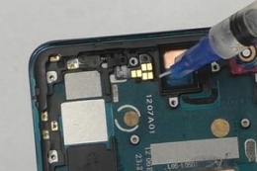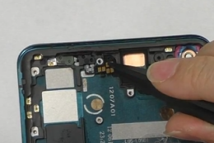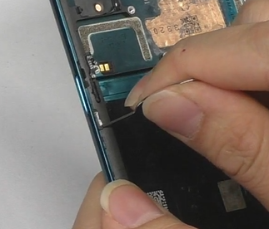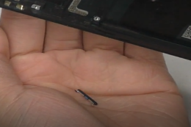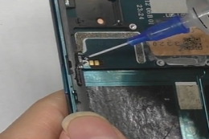 | 1.Remove the speaker from the side of positioning post.  2. Use the pin to disassemble the keys  3. When disassembling the FPC, Removed it from the disassembly position, and when it is difficult to disassemble, inject a little of alcohol.

4.4 Disassembly Steps For Vegan Leather Battery cover
Steps | Details | Picture | Cautions
1 | Disassembly tools required as shown below | 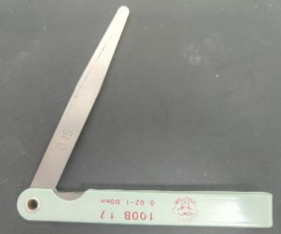 | 1. Constant temperature heating platform  2. Disassemble card  3. Plug gauge(Select 0.15mm plug gauge)  Tips：  The Vegan Leather battery cover can't be cleaned and disassembled with alcohol.
2 | Remove the battery cover | 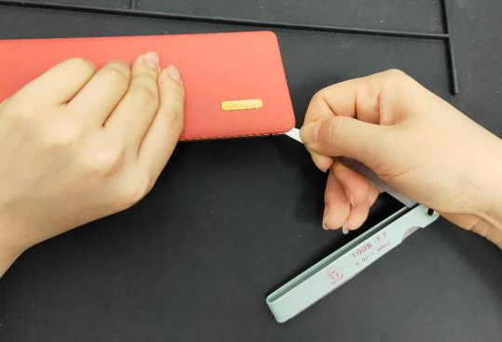  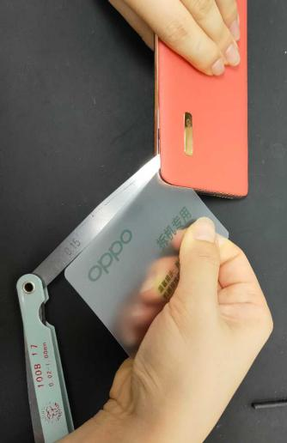  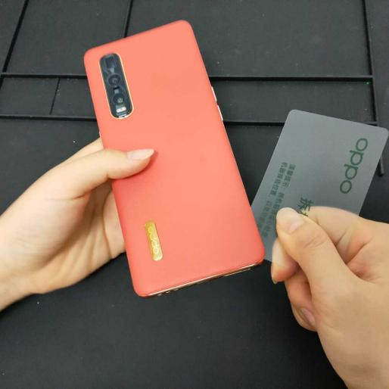 | 1. 75°heating the battery cover for 5-10 minutes（167 ℉）  2. Find a gap on the battery cover perimeter, insert a 0.15 plug gauge in parallel, stand upright to support the battery cover gap insert disassemble card.  3. After disassembled card inserted into the gap, pull out plug gauge, ues disassembled card to slowly sliding until the battery cover is separated from the middle frame of the phone.  4. Clean residual double-sided tape .  Tips：  a. If no gap is found, try pressing the battery cover at the battery compartment to find it.  b. The gap is between the rubber ring and the middle frame. (Battery cover = Vegan Leather + rubber ring)

5. Assembly Step

5.1 Materials are required to be replaced after disassembly
NO | Material code | Material name | Picture | QTY | Remark
1 | 4881176 | Battery cover prevention shell shock foam rubber | 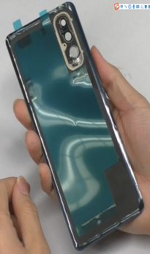 | 1 | must be replaced new one if removed battery cover
2 | 4879201 | Camera conductive fabric |  | 1 | must be replaced new one if removed rear camera
3 | 4881178 | Battery protective foam | 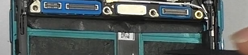 | 1 | must be replaced new one if removed the foam
4 | 4879212 | Rear camera lens foam rubber | 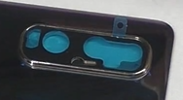 | 1 | must be replaced new one if removed camera lens
5 | 4879165 | Battery cover foam | 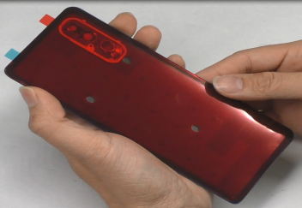 | 1 | must be replaced new one if removed front battery cover
6 | 4880952 | Receiver Seal Sponge | 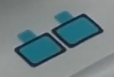 | 1 | must be replaced new one if removed receiver
7 | 4965358 | A2 antenna board |  | 1 | must be replaced new one if removed A2 antenna board
8 | 4881086 | battery pull tape | 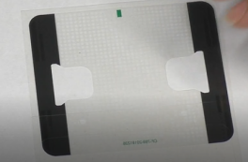 | 1 | must be replaced new one if removed battery
9 | 5181951/  5181952 | battery extracting sticker | 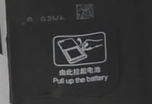 | 1 | must be replaced new one if removed battery

5.2 Assembly Steps
NO | Details | Picture | Cautions
1 | assemble power and volume keys | 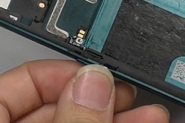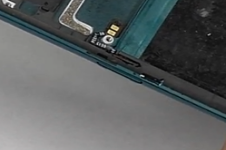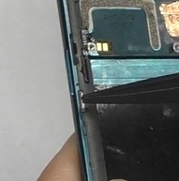
2 | Assemble Light sensor FPC /Receiver / Thermal Gel | 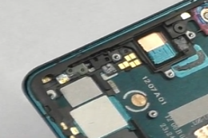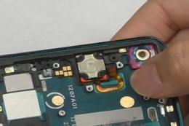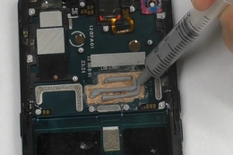 | 1. Pay attention to press the receiver FPC tightly in the screen assembly  2. Pay attention that the thermal gel should not be too much, and it dont overflow to the key FPC, which will cause the side key to be non-functional;
3 | assemble mainboard/ mainboard Screws/ Front Camera/ RF Cable1 # | 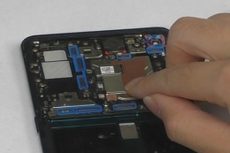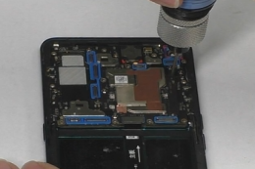  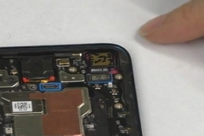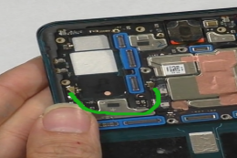 | 1.assemble the mainboard from the top  2. first put the front camera into the camera hole, buckle the camera BTB.  3. Pay attention to the positions of the two RF ends.
4 | assemble rear camera / A2 small board and C2 FPC | 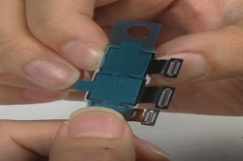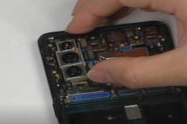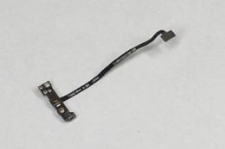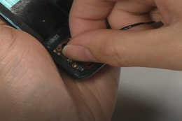 | 1. Do not to press the camera lens with your fingers  2. pay attention to that the A2 small plate buckle is in place.
5 | Assemble RF 2 # / L3 FPC / A1 board / sim tray/ buckle C2 FPC and fingerprint BTB | 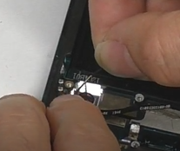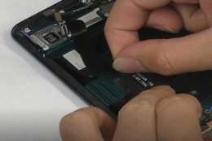  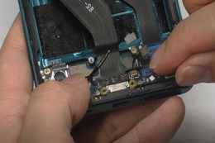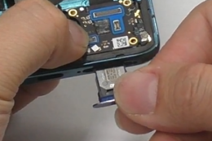 | 1.Pay attention to the positions of the two RF ends.  2.Note that assembly of the A1 antenna small board after check the SIM card lever  3. Note that the C2 FPC and fingerprint FPC should not be pinched by the A1 antenna board.
6 | Assemble RF 4# and 3#/ paste battery foam | 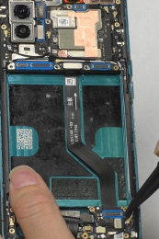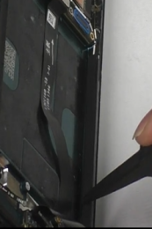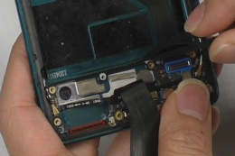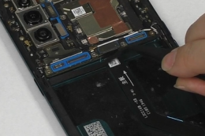 | 1.Pay attention to the positions of the two RF ends.  2. Put the RF wire into the groove  3. Pay attention to the battery foam material don't paste worng place.
7 | Assemble battery / paste copper foil, front camera copper foil / buckle USB and C1 FPC BTB | 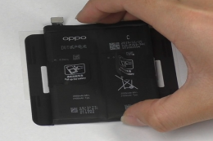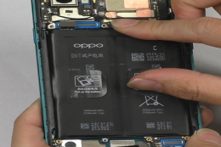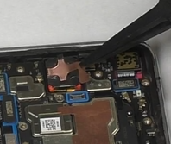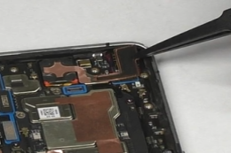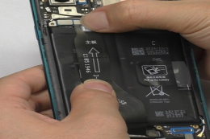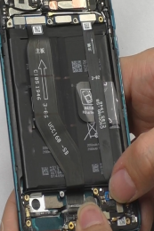 | 1. Be careful not to wrinkle the easy-tear stickers  2. assemble the battery bottom side first  3. press the battery to well  4. The copper foil of the receiver needs to be paste on the shielding cover.
8 | Assemble flash FPC / buckle flash BTB / assemble mainboard bracket and speakers/ screw mainboard bucket and speaker screws | 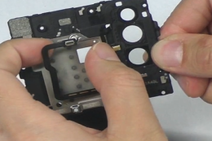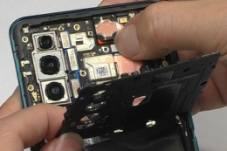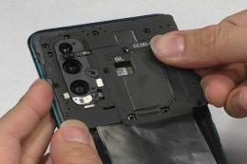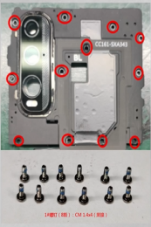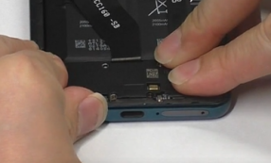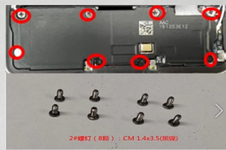 | 1. Check the laser silicone cover comes off before assemble the flash FPC  2.Before assemble the mainboard bracket, first buckle the flash BTB  3.Be careful not to mix mainboard screws and speaker screws
9 | paste camera lens adhesive/assemble camera lens /paste battery cover adhesive, battery cover anti-shock foam | 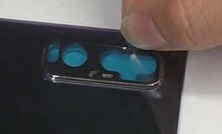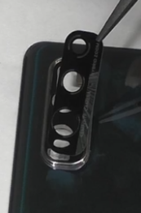  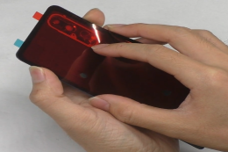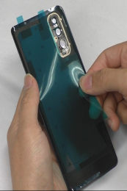  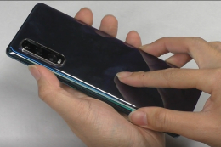 | 1. press the camera lens in place.  2. Double-sided tape should not be crooked  3. The anti-shock foam must be change after removed it

6. Calibration
After the phone is disassembled and assembled, the aftersale devices calibration must be calibrated first. The calibration of this model includes Front color sensor calibration – fingerprint optical calibration- TP cablibration-aftersale triple camera calibration- Optical anti-vibraion –Smart power amplifier calibration- vibrator calibration
Enter Password: 6776 | Click ”front color sensor calibration” |  | put the phone on the desktop and click "front color sensor calibration" to check whether the calibration results pass |  | it will automatically jump to the fingerprint optical calibration when the it is completed, and click “start” to start the calibration;
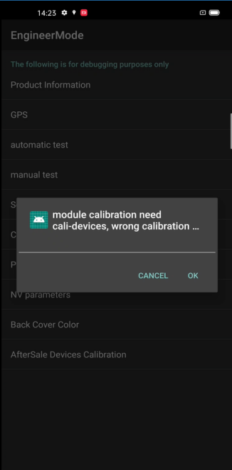 | 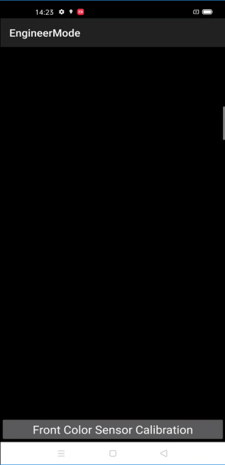 |  | 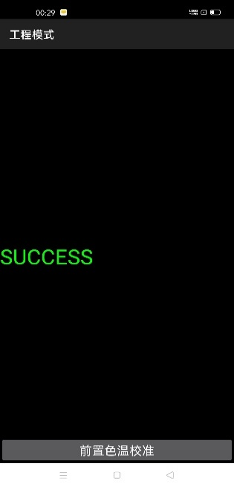 |  | 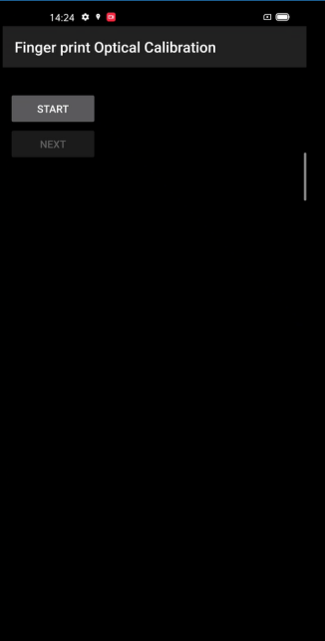
According to the prompt "please place the yellow rubber ", put the yellow rubber on the fingerprint spot area (the groove is facing down), and click "NEXT" until it prompts " please place the black rubber". |  | According to the prompt "please place the black rubber head", put the black rubber on the fingerprint spot area (the groove is facing down), click "NEXT" until the "please place the yellow stripe rubber " prompts to remove the black |  | According to the prompt “Please place the yellow- striped rubber”, put the yellow stripe rubber (striped down) in the spot area, click “NEXT”;
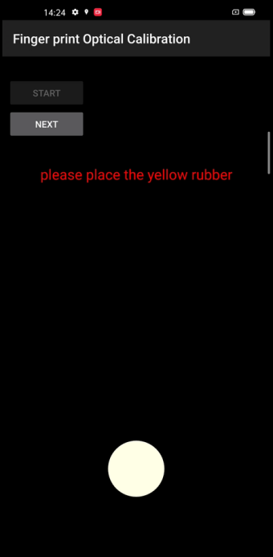 |  | 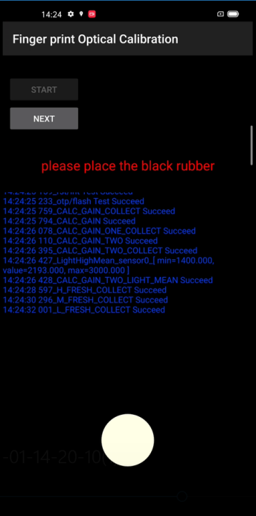 |  | 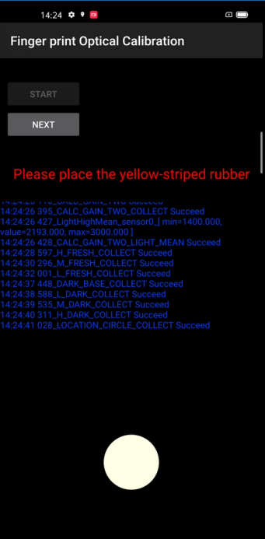
Automatically jump to “TP Calibration” after test |  | After the test is completed, it will automatically jump to the "aftersales Triple camera calibration" |  | After the calibration is completed, it will automatically jump to“Optical anti-vibration”，click the “SR test” .
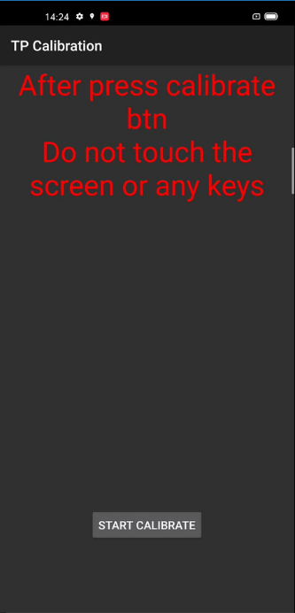 |  | 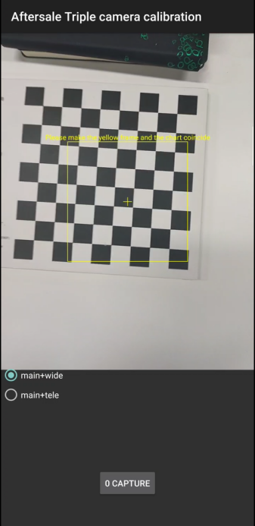 |  | 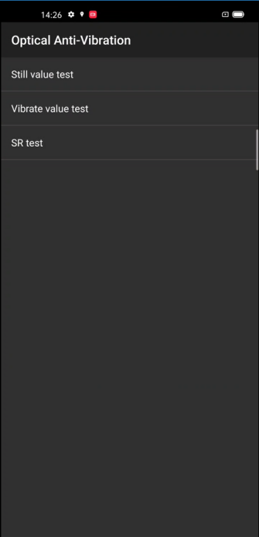
put the phone still on the table and wait for " successful" |  | After the test is successful, click back to perform "smart power amplifier calibration" |  | After calibration successful, enter “Vibrator Calibration” automatically, click to start calibration, and put the mobile phone on the table
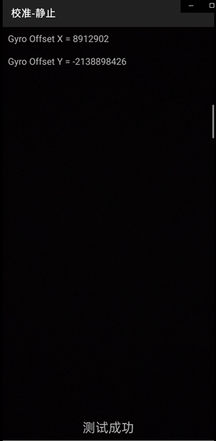 |  | 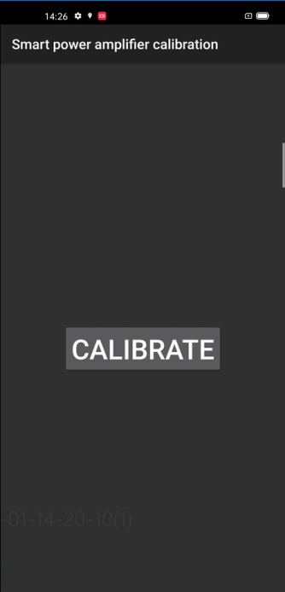 |  | 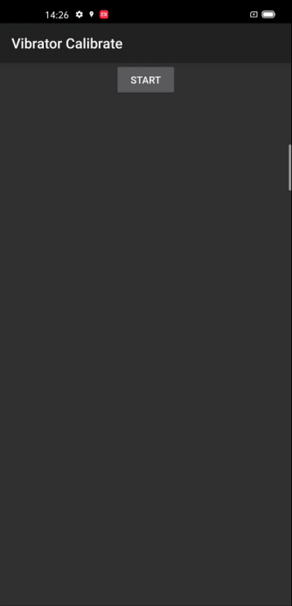
At this point, the calibration process is over and the phone must be restarted after the calibration process is completed for the calibration to take effect! After rebooting, enter the functional test.

7. Function test

7.1 Test Path
Dialing Interface>Enter*#899#>Enter automatic test； The "Confirm" dialog box will pop up after the test complete, if there is no problem choose “Pass”, otherwise choose “Fail”.

7.2 Test Requirements
No | Testing item | Testing requirements
1 | LCD test | Observe the red, green, blue, white, black, gray, grayscale and color interface successively; If there are black spots, bright spots and other anomalies, the function is sound;
2 | Vibration test | Get ear close to check the vibration from the motor for 3 seconds.  If the motor vibrates normally(No noises or weak vibration), the function is sound;
3 | Touch screen auto test | If the interface shows “PASS” and jumps to the next test, the function is sound;
4 | Front camera preview | Align the front camera with a white surface and a black surface. If there is no black dot, black line or blurred screen on the screen after aligning the white surface, and there is no bright spot on the screen after aligning the black surface, the camera is sound;
5 | Rear camera preview | Align the rear camera with a white surface, a black surface, and a surface with text. If there is no black dot, black line or blurred screen on the screen after aligning the white surface, there is no bright spot on the screen after aligning the black surface, white point or blurred screen, the camera is sound;
6 | Rear second camera preview | Align the rear camera with a white surface, a black surface, and a surface with text. If there is no black dot, black line or blurred screen on the screen after aligning the white surface, there is no bright spot on the screen after aligning the black surface, white point or blurred screen, the camera is sound;
7 | Rear third camera preview | Align the rear camera with a white surface, a black surface, and a surface with text. If there is no black dot, black line or blurred screen on the screen after aligning the white surface, there is no bright spot on the screen after aligning the black surface, white point or blurred screen, the camera is sound;
8 | Echo test | Testing Main MIC: Blow the air to the MIC hole on the bottom of the phone. If the receiver (earphone) sounds, the function of Main MIC is sound;  - Testing Sub MIC: Blow the air to the sub MIC hole on the top of the phone. If the speaker sounds, the function of Main MIC is sound;
9 | Flash-light test | Open the flashlight. If it can be opened normally with color deviations, the function is sound;
10 | Super VOOC charger | Use the original OPPO supervooc adapter and USB cable to charge. If the interface shows “PASS” and jumps to the next test, the function is sound;
11 | Headset in-out plug test | Plug in and out the earphone with the OPPO earphone. If the interface shows “PASS” and jumps to the next test, the function is sound;
12 | Sensor self-test and calibration | When the phone enters into the Sensor self-calibration interface, the phone must be placed on the desk flatly. Then click the first calibration item. After the test is passed, it will automatically jump to the next test item
13 | Gyroscope | Take the mobile phone to draw the "8" word graphic. If the interface shows “PASS” and jumps to the next test, the function is sound;
14 | M-Sensor | Shake the phone from the left to the right side. If the interface shows “PASS” and jumps to the next test, the function is sound;
15 | Proximity test | Use the palm to cover the light sensor hole, and the screen will turn green from black. If the interface shows “PASS” and jumps to the next test, the function is sound;
16 | Keypad test | Press the power key and volume key one by one. If keys can be pressed normally and the interface jumps to the next test, the function is sound;
17 | Finger print auto test | If the interface shows “PASS” and jumps to the next test, the function is sound;
18 | Media test | Click the “20-4K（-3db）signal” to test the sound of the media function for 5s. If there is no silence, weak sound, noises, and breaking sound, the interface shows “PASS” and jumps to the next test, the function is sound;
19 | Call test | If the phone has been installed with the operator's SIM card, dial the corresponding operator's phone number. If no card is installed, call the 112 to test (Calling the Operator is recommended). If the call can be performed normally and the receiver is without noises or weak sounds, the function is sound;
20 | NFC test | Close the phone of the rear camera area to the NFC card reader. If the signal light of the card reader changes from red to green with “Beep” sound, the interface shows “PASS” and jumps to the next test, the function is good.
21 | Laser Focus | let the mobile phone at the object, move the phone, reduce the distance between the mobile phone and the object. After the mobile phone detects the distance change, test the pass
After the above 21 items are tested, they will prompt to the test result interface. If the test PASS, project will show “√”; if the test FAIL, project will show “×” as shown below.
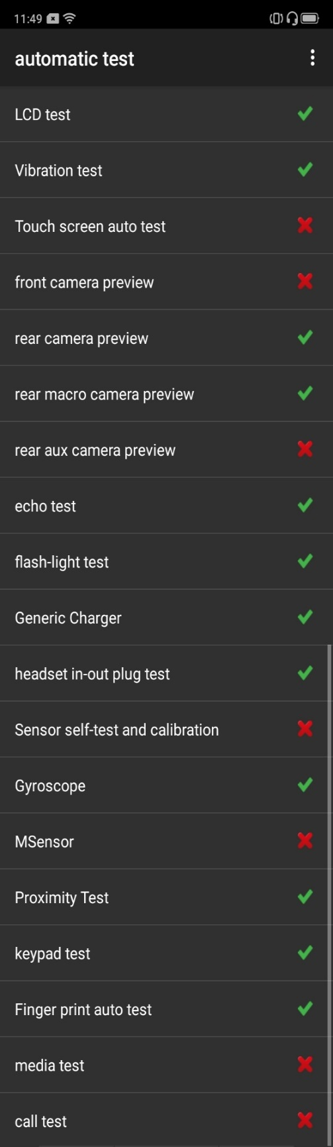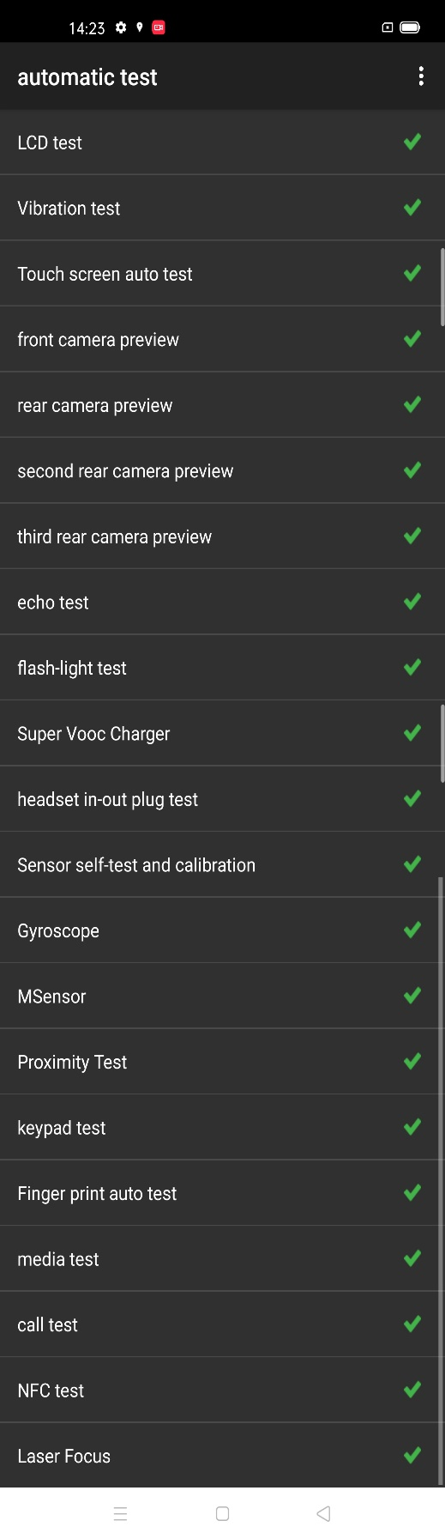

8. Cautions
1. When change the screen /mainboard/front camera,please do the front camera color sensor calibration .
2.when the glue break between the top cover and the screen, the glue can be repaired according to the video.
Baidu Netdisk: https://pan.baidu.com/s/1s8ZYcuw4DKT3kpZF2AXGQA
Password: 0vzx
FTP：overseas costumer service/OPPO technical service/product material/Find X2 series
3.Assembly and disassembly teaching video：
Baidu Netdisk: https://pan.baidu.com/s/1l_NJyPUhEL5tgCYRCMU29Q
Password: 2j9g
FTP：overseas costumer service/OPPO technical service/product material/Find X2 series
Version | Date | Drafted | Verified | Approved | Modified content
V1.0 | 2020-02-18 | Max | Li BinBin | Huang GuoXin | 1st Version
V1.1 | 2020-04-01 | Chen jinling | Li BinBin | Huang GuoXin | Add“4.4 Disassembly Steps For Vegan Leather Battery cover”

