Version record
Version | Issuance Date | Revision | Drafted | Reviewed | Approved
V1.0 | 2018-06-01 | First Version | Hu Yun | Chen Wei | Wang Lei
V1.1 | 2020-09-25 | Added IoT product content | Hu Yun | Li BinBin | Huang GuoXin
V1.2 | 2020-10-26 | Modify the judgment of screen crack/afterimage | Hu Yun | Li BinBin | Huang GuoXin
Content
1. Purpose 2
2. Scope 2
3. Principles for Replacement 3
4. Principles for Warranty Judgment 3
5. Warranty judgment for handset 4
5.1 Appearance Inspection 4
5.2 Electronic Components Inspection 13
5.3 Liquid Inspection 14
5.4 Software Inspection 15
5.4.1 Check ROM 15
5.5 Check ROOT status 16
6.1 Warranty Judgment for power bank 17
6.1.1 Appearance Inspection—IW (in-warranty) 17
6.1.2 Basic function Inspection (power bank) 19
6.1.3 Liquid Inspection (power bank) 19
6.1.4 Software Detection (power bank) 19
6.2 Warranty Judgment for neck-mounted earphones 20
6.2.1 Appearance Inspection 20
6.2.2 Basic function inspection (Neck-mounted earphones) 24
6.2.3 Liquid Detection (Neck-mounted earphones) 24
6.2.4 Software Detection (Neck-mounted earphones) 24
6.3 Warranty Judgment for Selfie Stick 25
6.3.1 Appearance Inspection 25
6.3.2 Basic function inspection (Selfie stick) 27
6.4 Warranty Judgment for Game Pad 28
6.4.1 Appearance Inspection 28
6.4.2 Basic function inspection (game pad) 29
6.5 Warranty Judgment for OPPO Watch 30
6.6 Warranty Judgment for TWS Headphones 31
6.7 Warranty Judgment for Accessories 32
7. Warranty Judgment for Accessories 32

- Purpose
The guidance is issued to guide the OPPO service centers and authorized service cooperation agencies to judge the repair of OPPO products more accurately, unify the understanding of the warranty policy, also provide a reference for the HQ staff to check the bad materials return from each service center.

- Scope
All OPPO mobile phones and IoT products

- Principles for Replacement
  - Definition
DOA - dead on arrive: Phones are found to fail in the first opening of the cartons or color-boxes before being sold
DAP – dead after purchase: Phones with non-human damage are guaranteed for return or replacement in line with the conditions of return or replacement.
  - DOA&DAP Eligibility Condition and Flow
Fault phenomenon  Type | DOA | DAP
With good appearance and normal functions | × | ×
With good appearance but abnormal functions | √ | √
With slightly defective appearance but normal functions | √ | ×
With slightly defective appearance and abnormal functions | √ | √
“√”means that the replacement is available;
“×”means that the replacement is unavailable;

- Principles for Warranty Judgment
Item | OW(out of warranty) Condition
Out-of-Warranty for the phone | (1)The phone is not in warranty period；  (2) The phone operated beyond the permission or the requirement of the User Manual;  (3) The phone disassembled by users itself, any non-OPPO official or non-OPPO authorized service providers;  (4) The phone damaged destructively by accidents, misuse, fire, earthquake or other external factors.  (5) The phone was suffered by water damage and the user does not agree to pay for the replacement of all the damaged components. (the detail will be stated in the Liquid Inspection);  (6) The IMEI has been tampered.
Note: After the phone is replaced, the return phone (malfunction) must be attached with complete accessories. If the machine head can only be returned, special explanation is required. IW=In Warranty, OOW=Out of Warranty.
- Warranty judgment for handset

5.1 Appearance Inspection
Each of the following inspection item must be carefully checked, and all items must meet the warranty conditions before the phone can be warranted.
Type | Descriptions | Warranty Status
Dust into the camera | 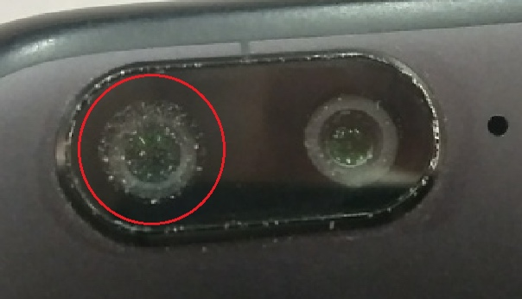 | IW
Camera lens missing | 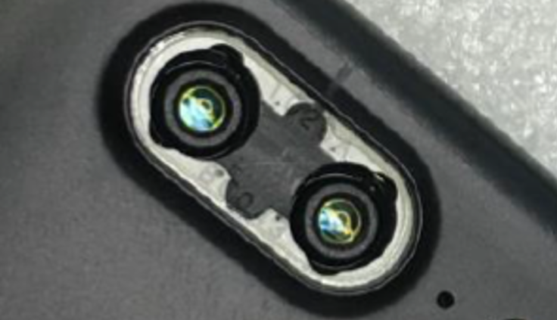 | OOW (IW If the lens is only degummed)
Damage of SIM card holder | 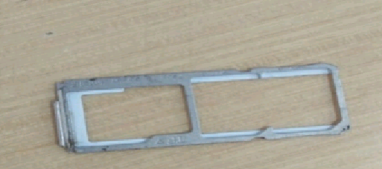 | IW
Battery Swelling | 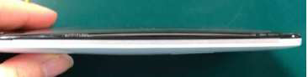 | Warranty for the whole device (Quality Record)
Foreign color dots on the battery cover | 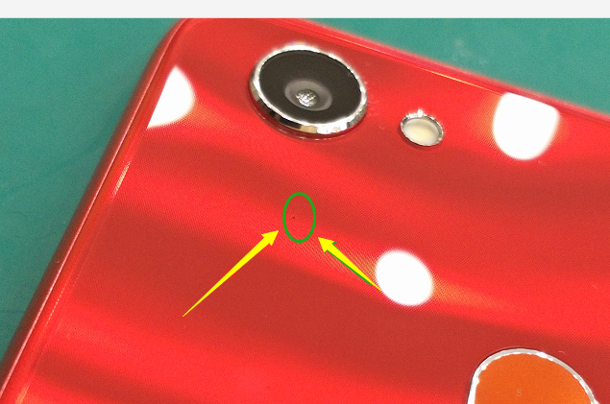 | IW
There is glue overflow at the connection between the screen and the middle frame | 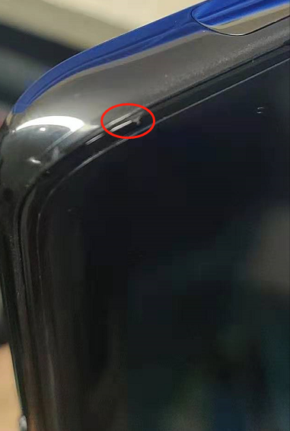 | IW
Decoration/ LOGO  Fall off the back cover | 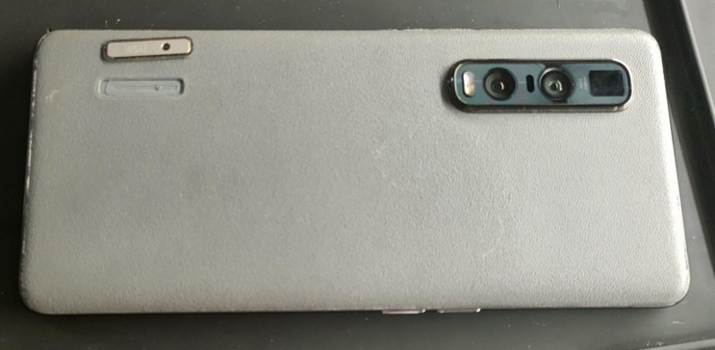 | IW
Volume button, power button or other physical buttons missing | 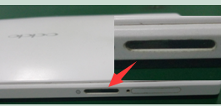 | Warranty for the button
Flaking paint-off  - a flaw in a production process | 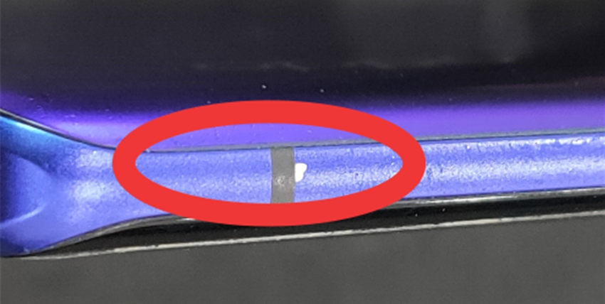  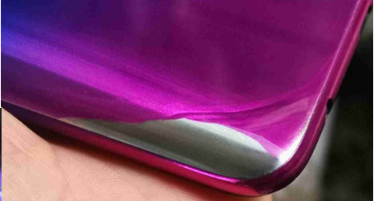 | Warranty for paint-off components.
Scuffed to flake paint | 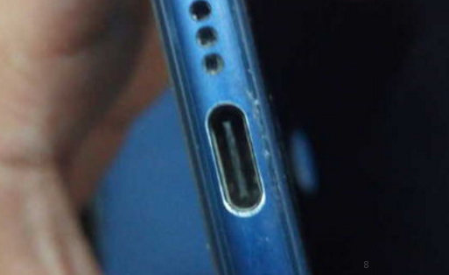  Scuffed to flake paint | OOW
Destruction damage and deformation of the whole phone; | The mobile phone has been crushed by wheels or damaged destructively, such as serious deformation, fracture or missing of the middle frame.  ※Explanation: If the phone is damaged destructively, the whole machine will not warranted.  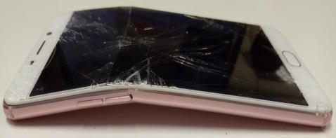 | OOW  (The phone is unable to be repaired.)
The bending of the whole phone; | Frame bending: The machine with bending deformation more than 0.5mm is not recommended to be warranted.  Deformation of the whole machine may cause damage to the main board.  Explanation: the thickness of 0.5mm is equivalent to the thickness of 6 sheets of A4.  The outsourcer needs to install a plug gauge.  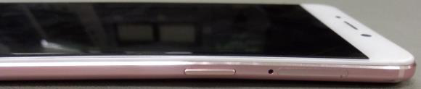 | According to the measurement results
Appearance Damage | 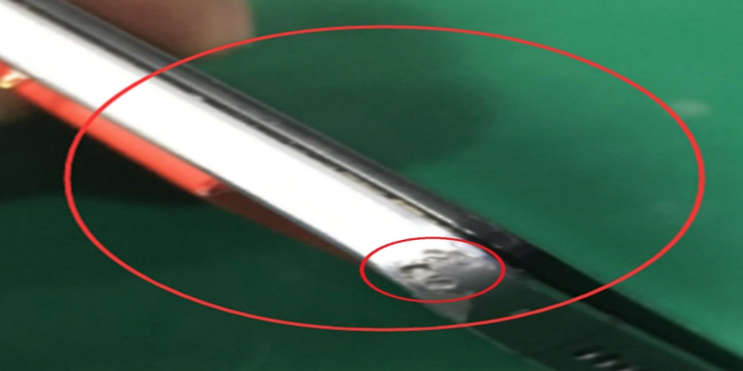 | The damaged components are out of warranty.
USB port/earphone port or SIM-card slot pot is damaged or deformed | 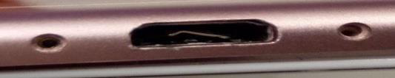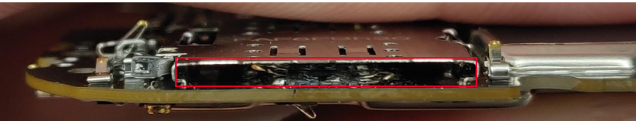 | The damaged components are out of warranty.
SIM card tray lost or human damaged | 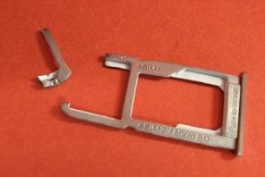 | OOW
The outside appearance is dyed | 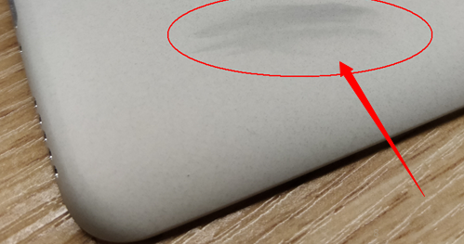 | The appearance components are out of warranty.
Cover Deformation | 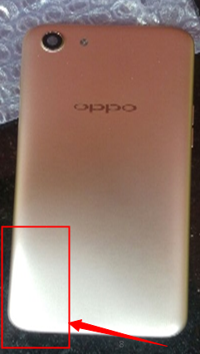 | The deformed components are out of warranty.
UV screen protect film residual glue | 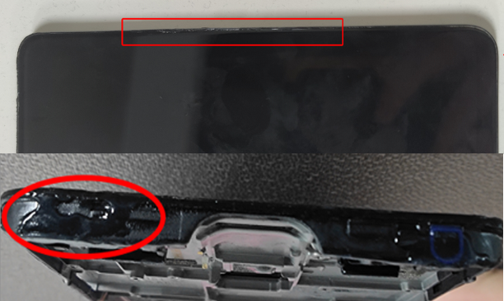 | OOW

5.2 Screen Inspection
Type | Description | Warranty Status
The screen (touch screen or display screen) is cracked with obvious stress concentration points. | 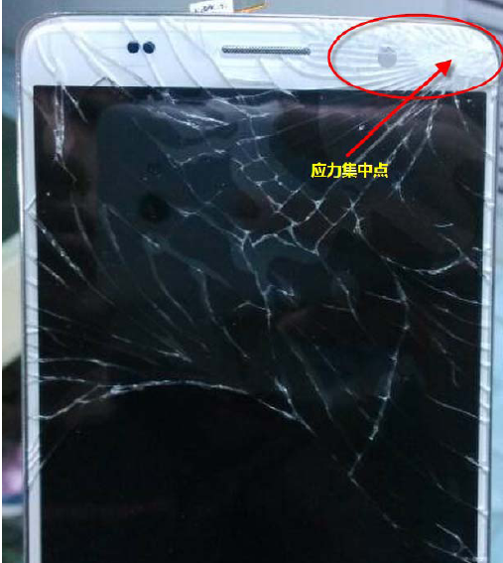 | OOW
Screen malfunction, slight fracturing or missing of the screen edge (plastic frame), but no damage to the screen body | 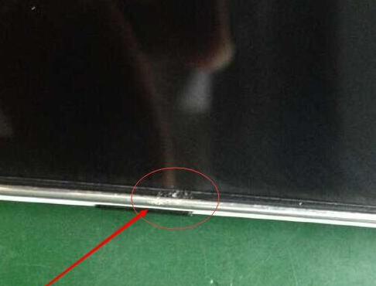 | IW
Screen Cracking | 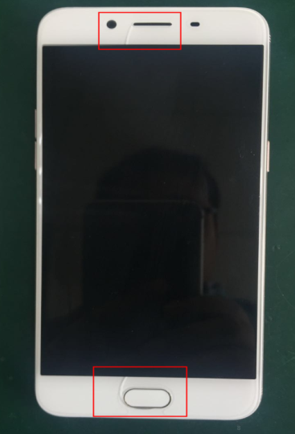 | OOW
Low glue-intensity of the screen (The screen is open without broken or missing.) | 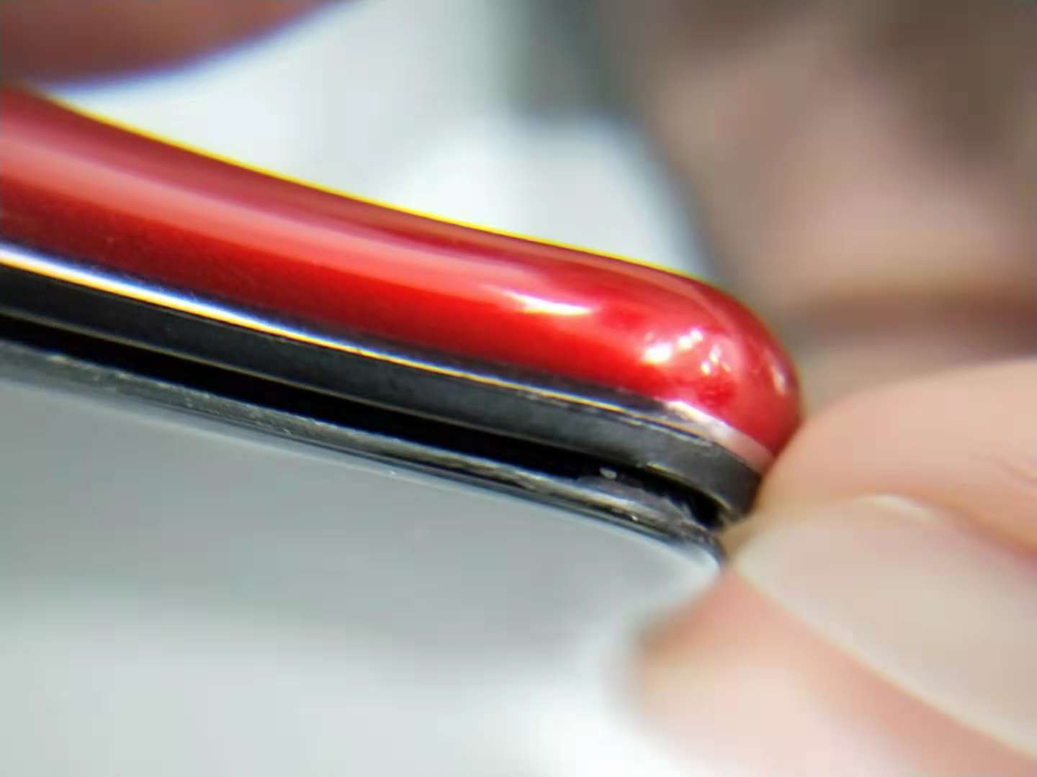 | IW
Liquid Leakage in the screen | 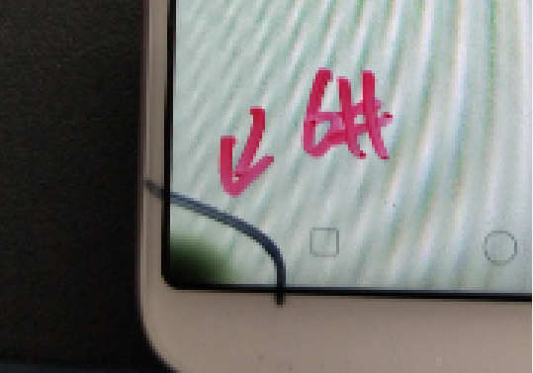 | IW
Screen oxidation layering (The local or entire screen discolored.) | 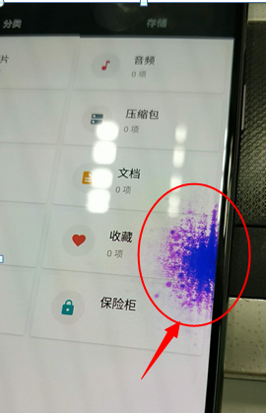 | IW
Water damage or artificial water damage to the screen | 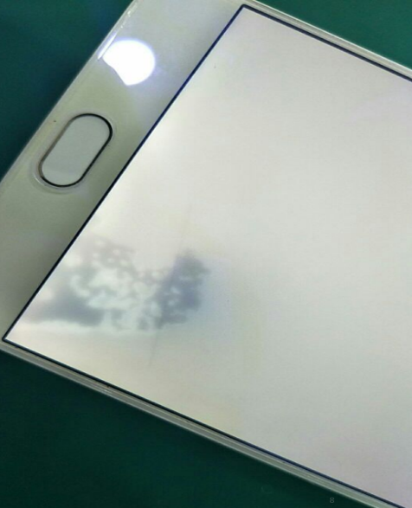 | OOW
Screen afterimage | 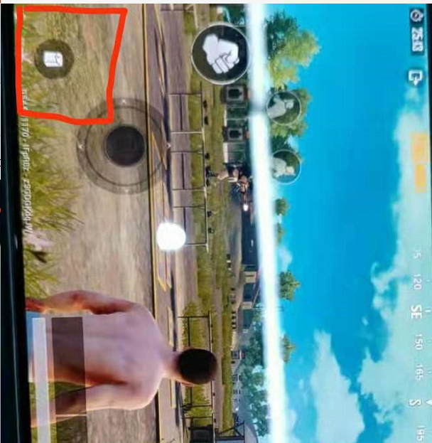 | IW
Dust inside the screen | 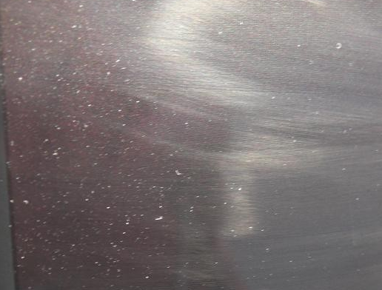 | IW
Black spots on the edge of the screen, bumps and scratches, but no cracks on the screen | 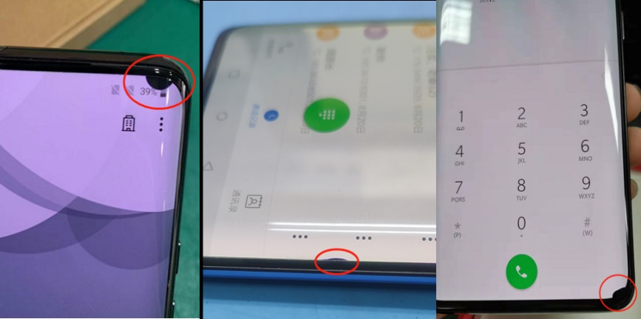 | IW
The screen shows lines, with slight scratches or knocks, no cracks | 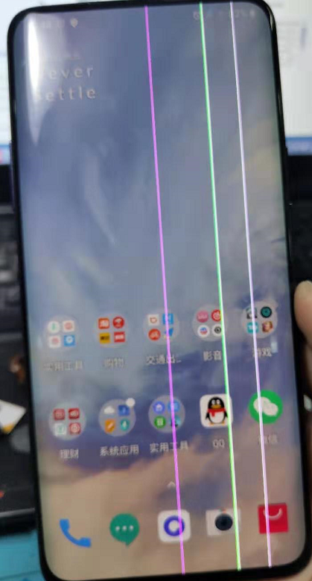 | IW

5.3 Electronic Components Inspection
Type | Description | Warranty Status
The shield cover is damaged | 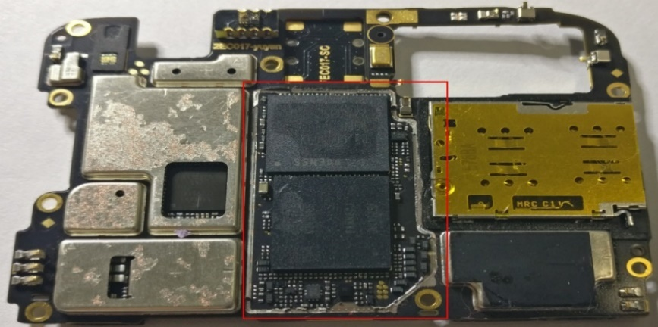 | OOW
The components are dampened or corroded, and there is obvious accumulation of salt crystals. | 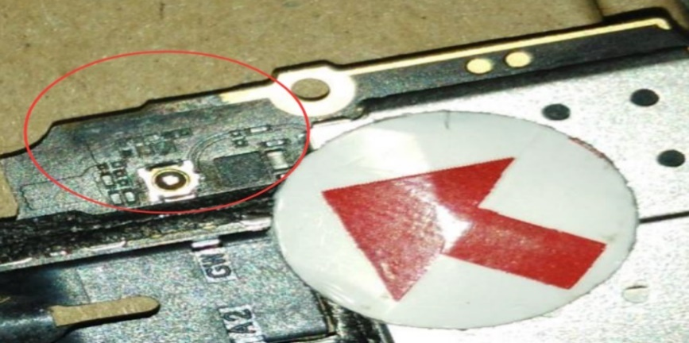 | OOW
The mother board is bended  (deformed) | 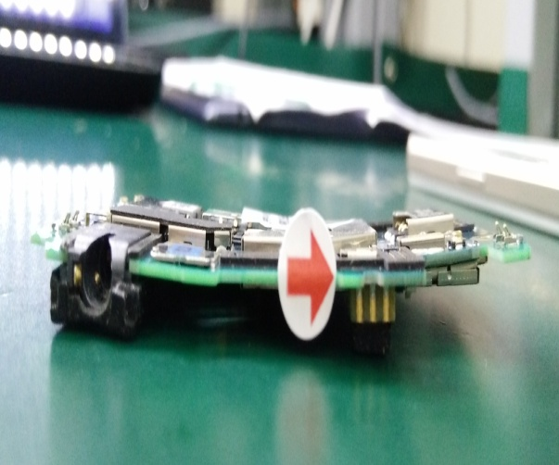 | OOW
The component are falling out from the mother board | 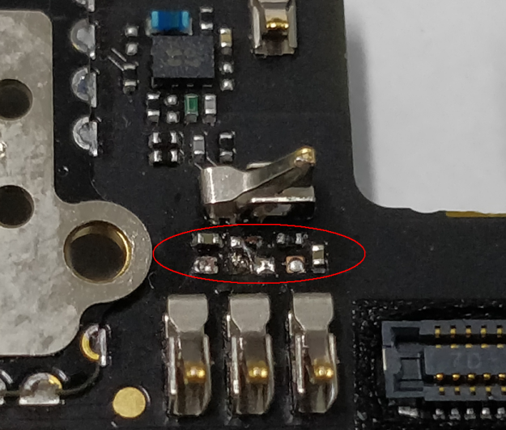 | OOW
Anti-disassembly label (fragile sticker) is broken  If the phone is disassembled, the whole machine will be no longer warranted. | 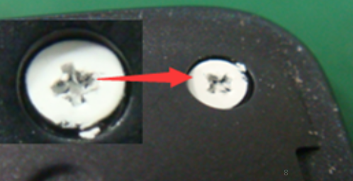 | OOW

5.4 Liquid Inspection
Type | Descriptions | Warranty Status
The phone is damaged by liquid | 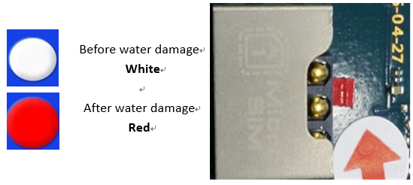 | OOW

5.5 Software Inspection
The mobile phone has been flashed the unofficial ROM or ROOT, or suffered other software problems:
a) If the problem can be solved for users through flashing or other software processing methods, the problem can be solved for free.
b) If the system cannot work normally after being flashed to recover, the phone is judged as “hardware damaged from ROOT” and it can be free for the maintenance but cannot DOA or DAP.
c) If it is not possible to judge whether the device is root, the device can be free for the maintenance but cannot DOA or DAP.

5.5.1 Check ROM
Type | Description | Warranty Status
Being flashed the unofficial ROM | OPPO Official System：Color OS system  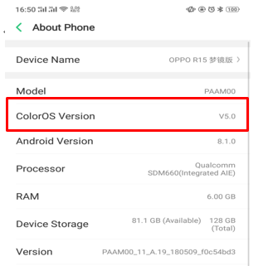 | Being flashed the unofficial ROM (can be free for the maintenance but cannot DOA or DAP)

5.5.2 Check ROOT status
Type | Descriptions | Warranty Status
Check whether the phone is rooted | 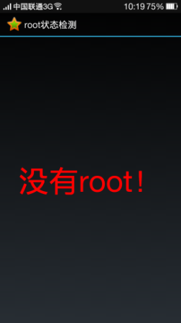  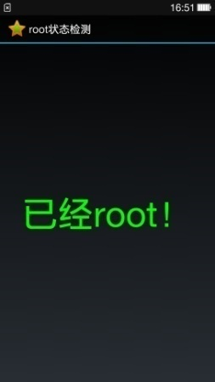  1. Input the *#808# in the dial of standby interface, and all the models with the system before Android 5.0 Version will enter the engineering mode to check the "Root Status detection". The display interface of the root status is as follows:  Without Root  Rooted!  2. The phone with the system after Android 5.0 Version: Press the power key and volume down button at the same time to enter the Recovery Mode----Simplified Chinese-- Disk Detection. If the phone is without being Rooted, the interface will appear "Disk Detection".  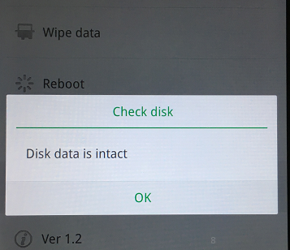 | If the phone detected is Rooted (can be free for the maintenance but cannot DOA or DAP))

6. Warranty Judgment for IoT Products

6.1 Warranty Judgment for power bank

6.1.1 Appearance Inspection—IW (in-warranty)
Each of the following inspection items must be carefully checked, and all items must meet the warranty conditions before the device can be warranted.
Type | Descriptions | Warranty Status
Low glue-intensity of the shell | 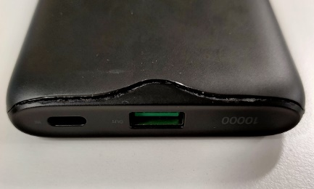 | IW
Destructive damage and deformation of the whole device | 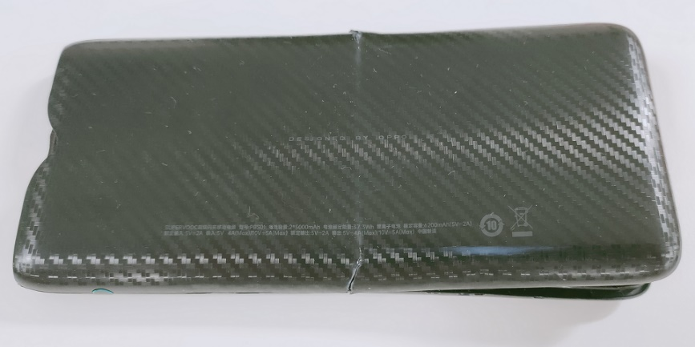 | OOW
The USB jack is damaged or deformed. There are foreign bodies that cannot be removed in the USB jack. | 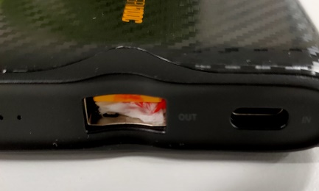 | OOW
The battery is removed privately or damaged | 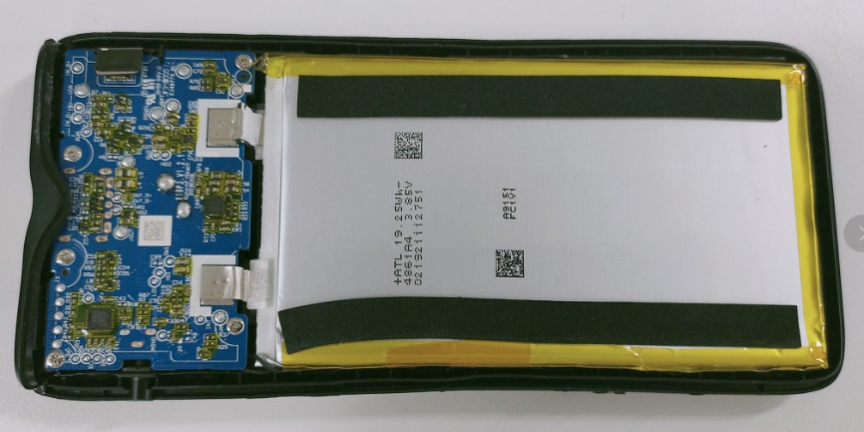 | OOW
The device was disassembled privately | 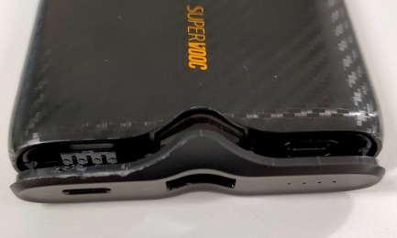 | OOW
The bending of the whole device | The device with bending thickness more than 0.5mm is out of warranty.  Deformed appearance may cause damage to the battery. | According to the measurement results

6.1.2 Basic function Inspection (power bank)
Type | Descriptions | Warranty Status
Unable to charge the power bank | - Unable to charge ordinary power bank with OPPO ordinary adapter  - Unable to charge VOOC power bank with OPPO VOOC adapter  - Unable to charge SUPER VOOC power bank with OPPO SUPER VOOC adapter | IW
Unable to charge the phone with power bank | (1) Ordinary power bank cannot charge the phone  (2) VOOC power bank cannot charge or cannot VOOC charge the phone  (3) SUPER VOOC power bank cannot charge or cannot super VOOC charge the phone | IW
The charging indicator is abnormal | (1) The charging indicator doesn't work  (2) Unable to switch the corresponding charging mode (VOOC/super VOOC)  (3) Other functional malfunctions | IW
Abnormal charging | - Serious heat during charging  - Slow charging  - Fast power consumption | IW

6.1.3 Liquid Inspection (power bank)
Type | Descriptions | Warranty Status
Damaged by liquid | There is an abnormal sound when shaking the power bank, and the USB jack has obvious water stained and rusted. | OOW
Damaged by liquid | Normal appearance, cannot judge whether it is damaged by liquid | IW

6.1.4 Software Detection (power bank)
If still face abnormal charging issue after replaced new USB cable or adapter, try to flash the latest version software for the power bank. If the problem can be solved for users through flashing software, help users deal with it for free.

6.2 Warranty Judgment for neck-mounted earphones

6.2.1 Appearance Inspection
Each of the following inspection items must be carefully checked, and all items must meet the warranty conditions before the device can be warranted.
Type | Descriptions | Warranty Status
The silicone plug of the earphone has a dimensional deviation and is easy to fall off. | 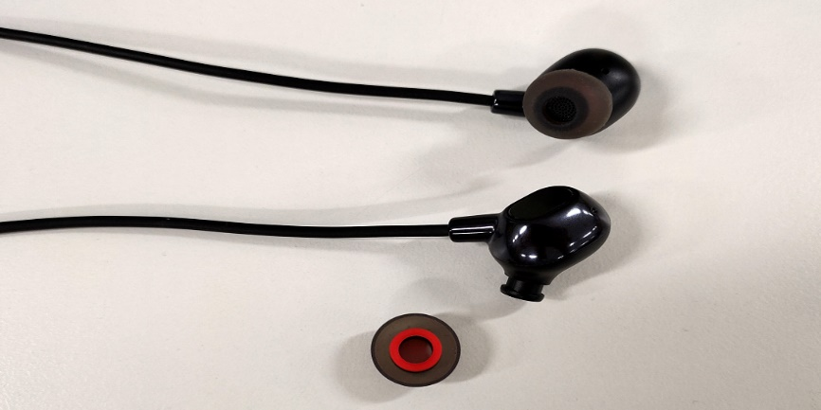 | IW
Earphone speaker cracking | 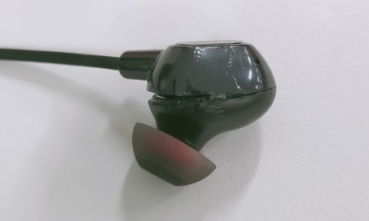 | OOW
Decorative sheet cracking/deformation | 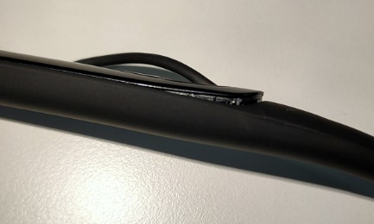 | IW
The earphone wire is stretched to deform or extruded to fracture | 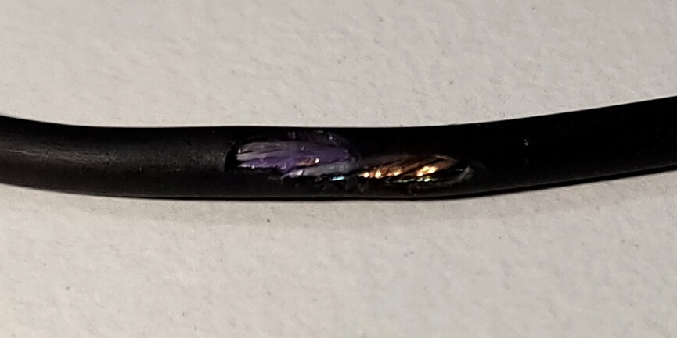 | OOW
Earphone main bracket break | 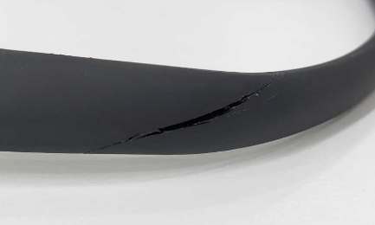 | OOW
Rupture in button protection silicone sleeve | 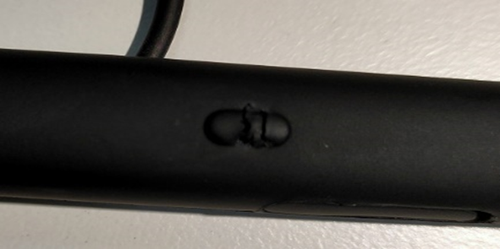 | OOW
Multifunction button missing | 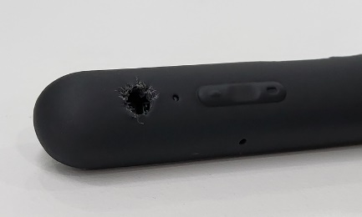 | OOW
USB jack silicone plug break | 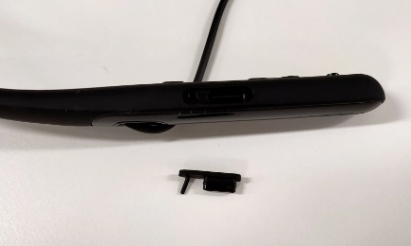 | OOW
Earphone silicone plug missing | 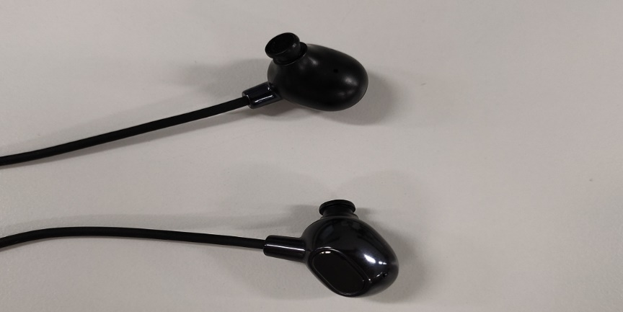 | OOW
Earphone silicone plug deformation, cracking | 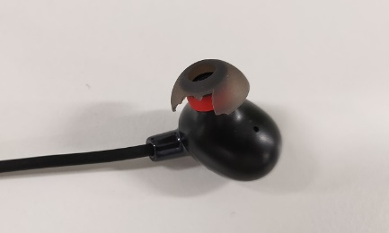 | OOW
The jack is damaged or deformed. /There are foreign bodies that cannot be removed in the jack. | 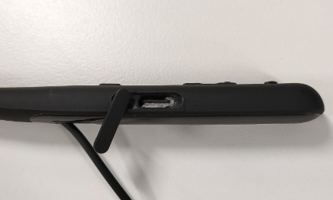 | OOW
The outside appearance staining/paint flaking/  scratching | 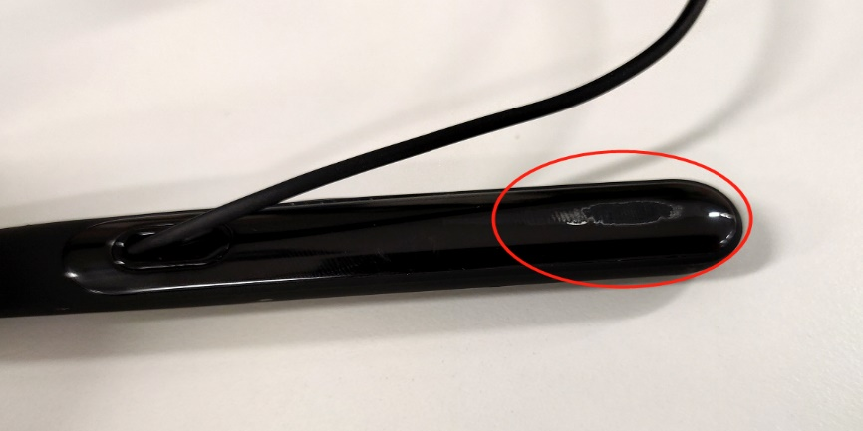 | OOW
Deformation of earphone body | 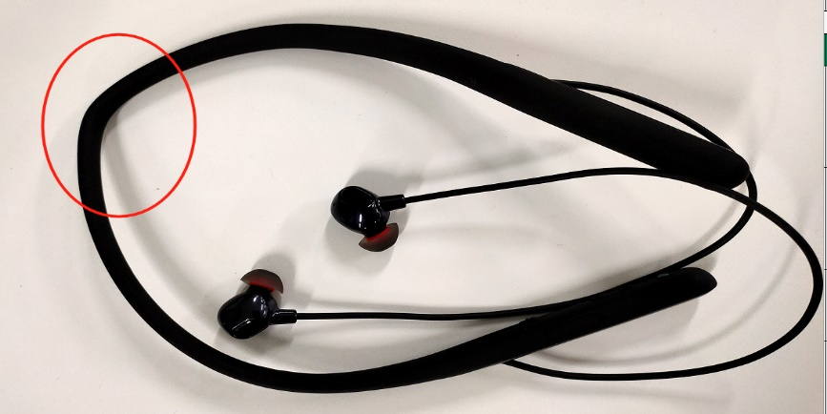 | OOW
The device was disassembled privately | 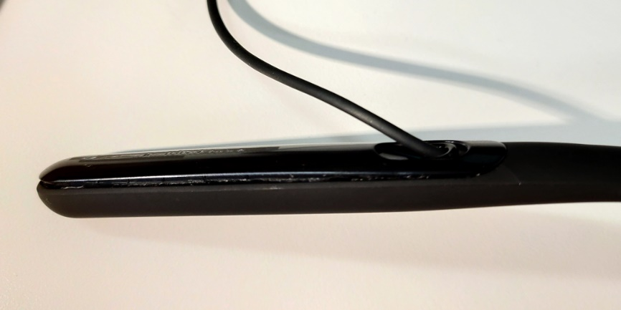 | OOW
Privately disassembled then glued together | 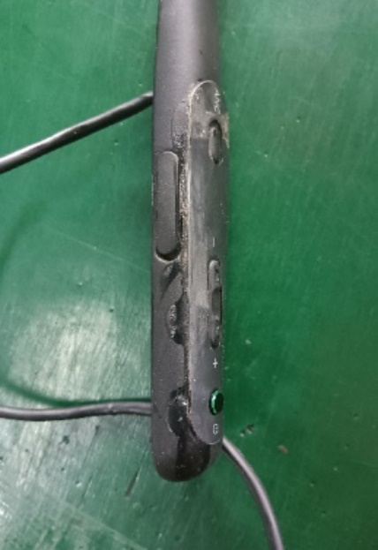 | OOW
Earphone degumming | 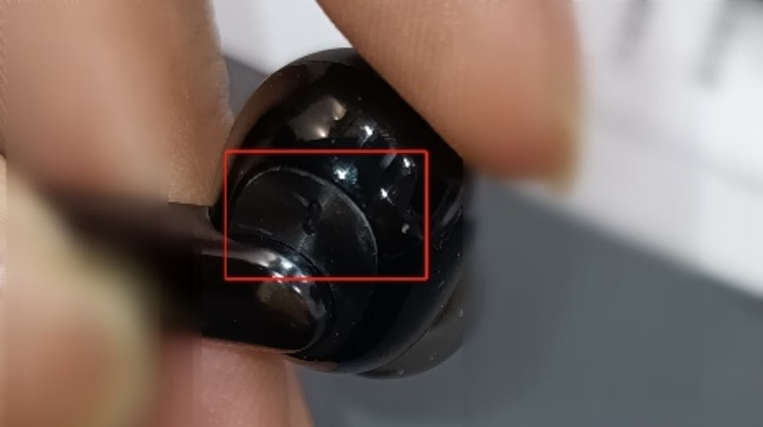 | IW

6.2.2 Basic function inspection (Neck-mounted earphones)
Type | Descriptions | Warranty Status
Abnormal sound | (1) No sound from the speaker, low sound, noise  (2)Different sound levels between two speakers  (3)No sound from the microphone, low sound, noise | IW
The other function malfunction | 1. Bluetooth is not compatible (not connected, pairing failed, disconnected after connection)  2. Unable to charge, serious heating when charging, fast power consumption  3. Buttons malfunction  4. Abnormal charging indicator  5. Call function malfunction  6. APP compatibility issues | IW

6.2.3 Liquid Detection (Neck-mounted earphones)
Type | Descriptions | Warranty Status
Damaged by liquid | There is an abnormal sound when shaking the power bank, and the USB jack has obvious water and rust. | OOW
Damaged by liquid | Normal appearance, cannot judge whether it is damaged by liquid | IW

6.2.4 Software Detection (Neck-mounted earphones)
If the above problems can be solved for users through flashing software, help users deal with it for free.

6.3 Warranty Judgment for Selfie Stick

6.3.1 Appearance Inspection
Each of the following inspection items must be carefully checked, and all items must meet the warranty conditions before the device can be warranted.
Type | Descriptions | Warranty Status
The remote controller is not firmly installed and easy to fall off | 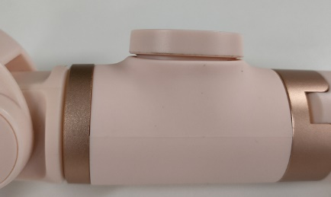 | IW
The selfie stick automatically pulls back after being pulled out | 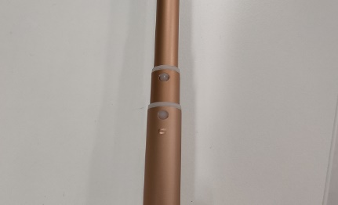 | IW
Plastic buckle fails, connecting rod falls off | 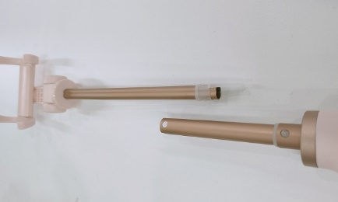 | OWW
Tripod deformed/  rupture | 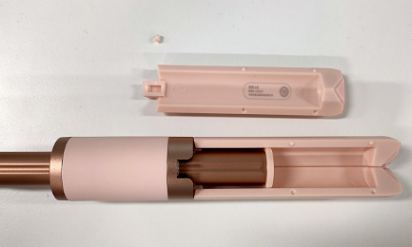 | OWW
Phone clamp deformed/  rupture | 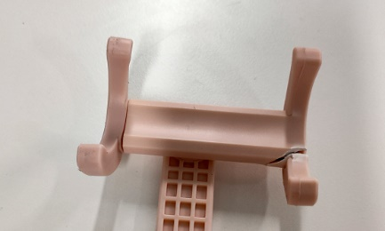 | OWW
The outside appearance staining/paint flaking/  scratching | 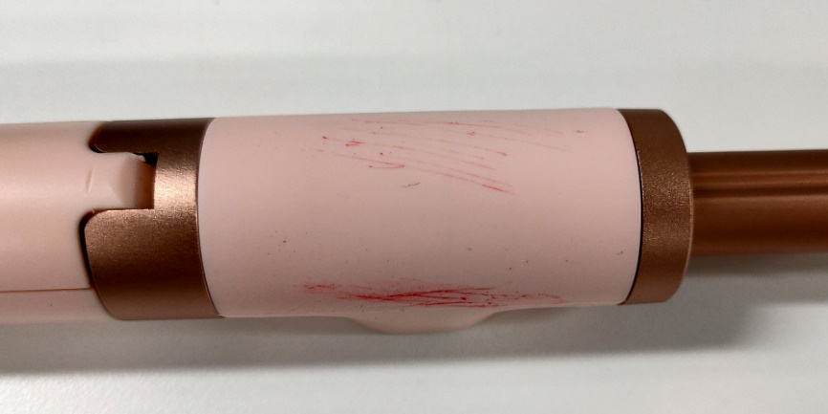  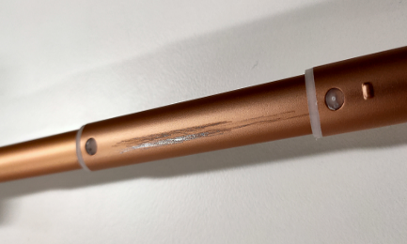 | OOW
Selfie stick deformation/  break | 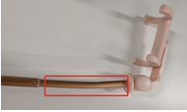 | OOW
Remote controller lost due to users’ reasons | 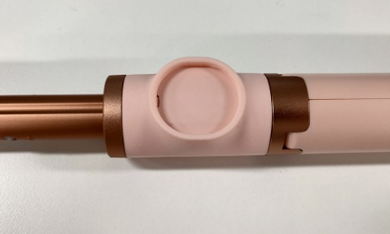 | OOW
Remote controller socket rupture/deformation | 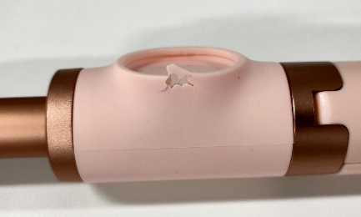 | OOW

6.3.2 Basic function inspection (Selfie stick)
Type | Descriptions | Warranty Status
Remote controller malfunction | (1) The remote controller cannot connect to the phone  (2) Can't take pictures remotely | IW

6.3.3Liquid Detection (Selfie stick)
Type | Descriptions | Warranty Status
Water stained in remote controller | 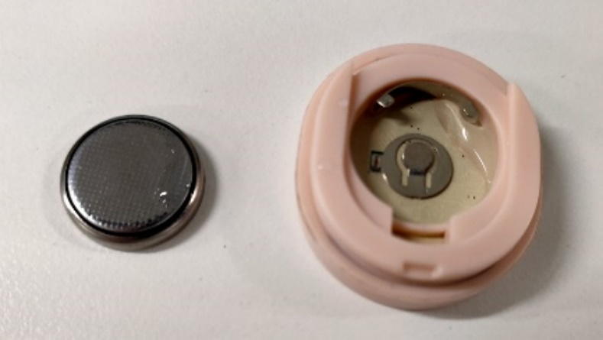 | OOW

6.4 Warranty Judgment for Game Pad

6.4.1 Appearance Inspection
Type | Descriptions | Warranty Status
Good appearance but abnormal functions | 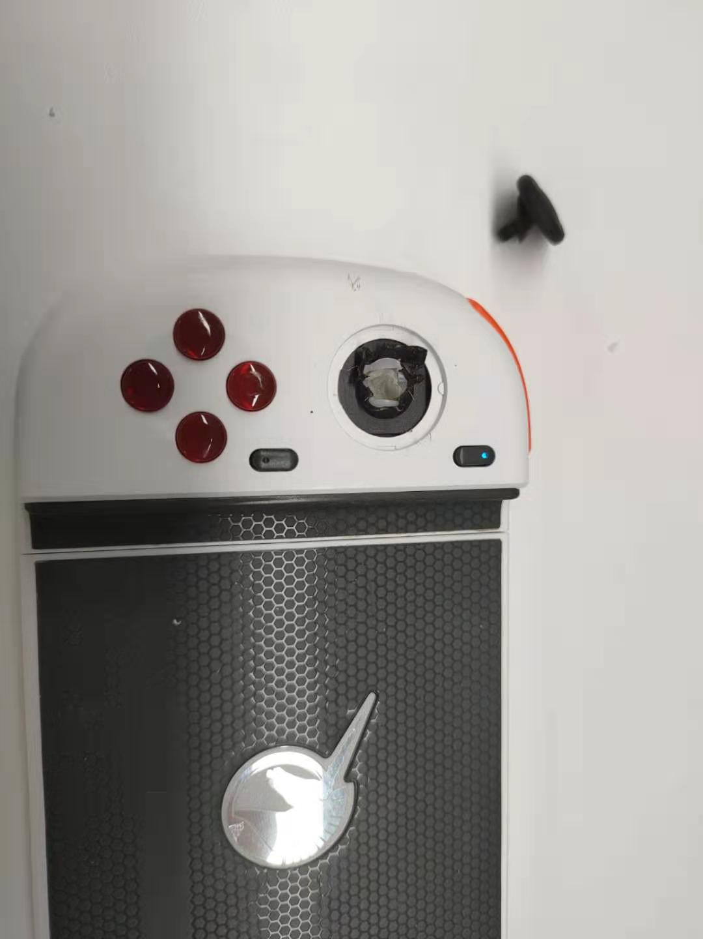  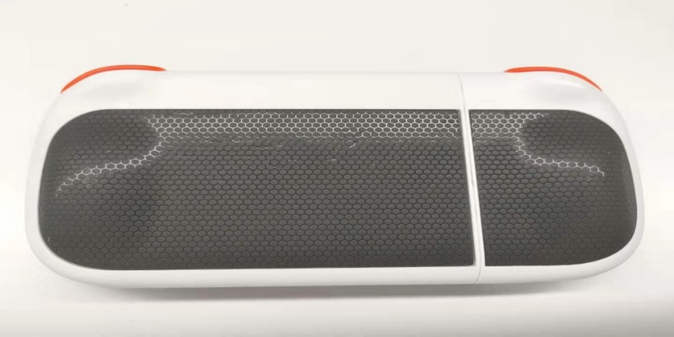 | IW
The button/joystick was forcibly removed by external force |  | OOW
Disassemble privately, missing screws | 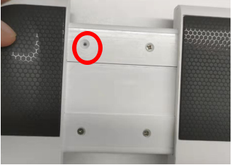 | OOW
The game pad is split in half | 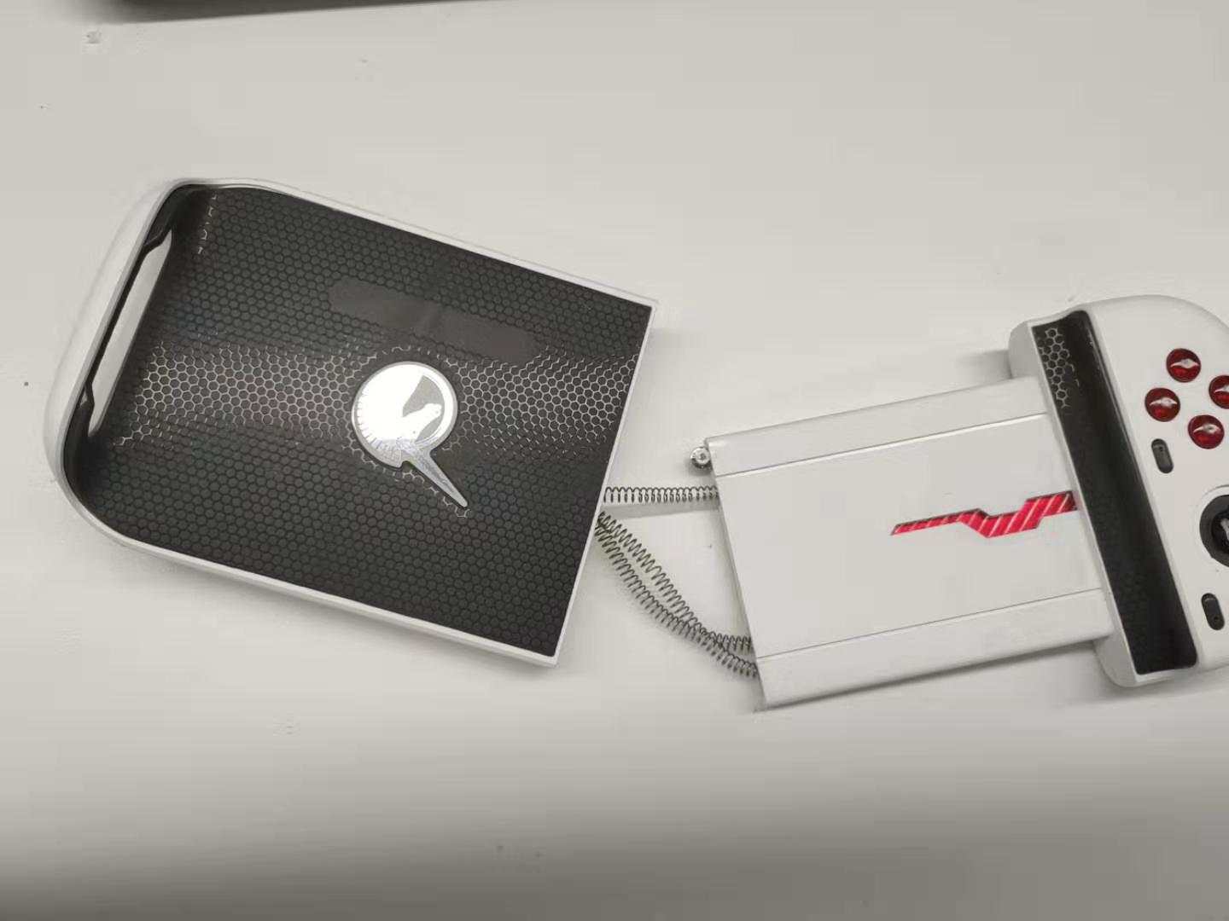 | OOW
Button missing | 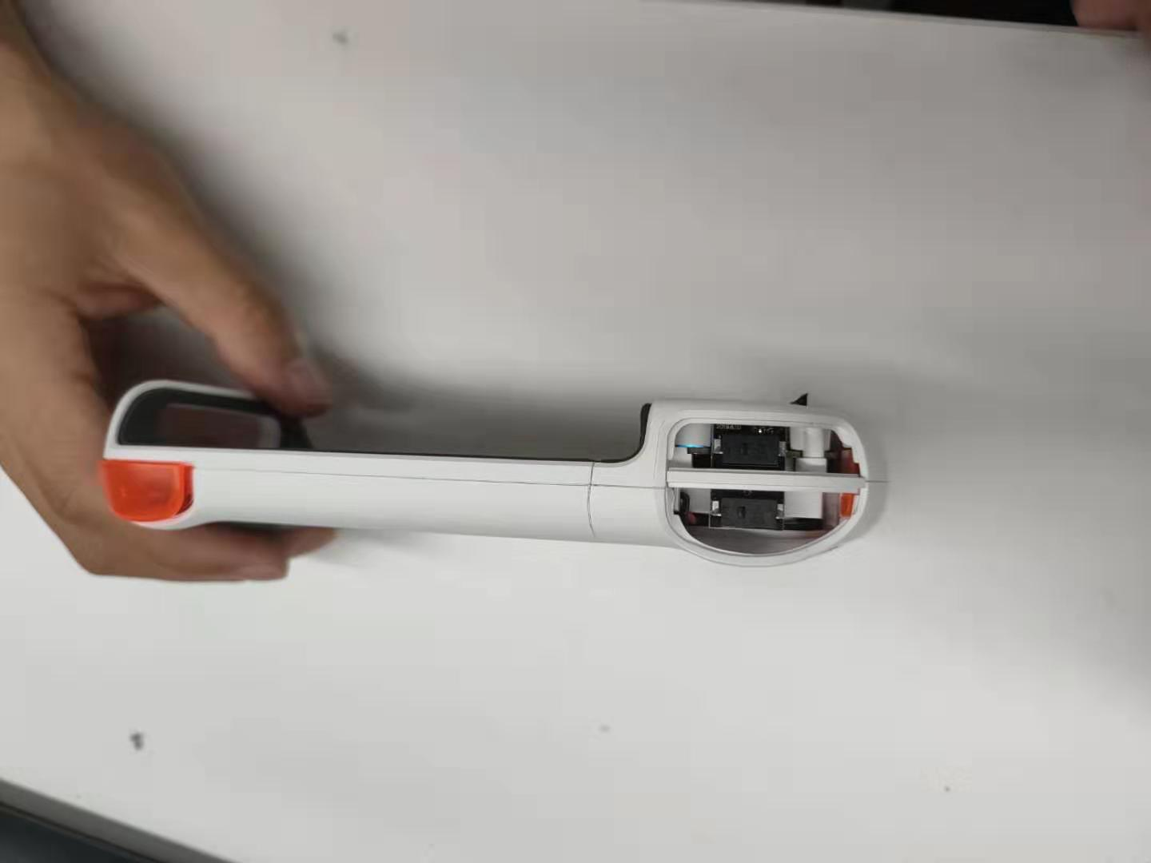 | OOW

6.4.2 Basic function inspection (game pad)
Type | Descriptions | Warranty Status
Cannot power on | No liquid damage, cannot power on | IW
Cannot be charged | Cannot be charged with the rated charger. | IW
Bluetooth connection | Bluetooth connection is not available when used on any device. | IW
Playing A Game | After the Bluetooth is connected, the game cannot be operated through the game pad | IW

6.5 Warranty Judgment for OPPO Watch
Type | Descriptions | Warranty Status
Back shell damaged by external force | 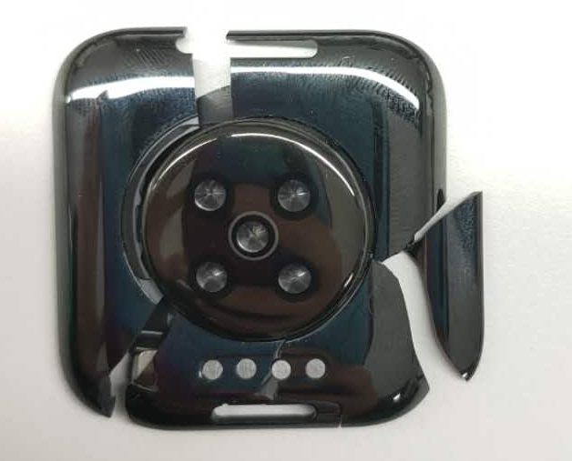 | OOW
The screen is damaged by external force | 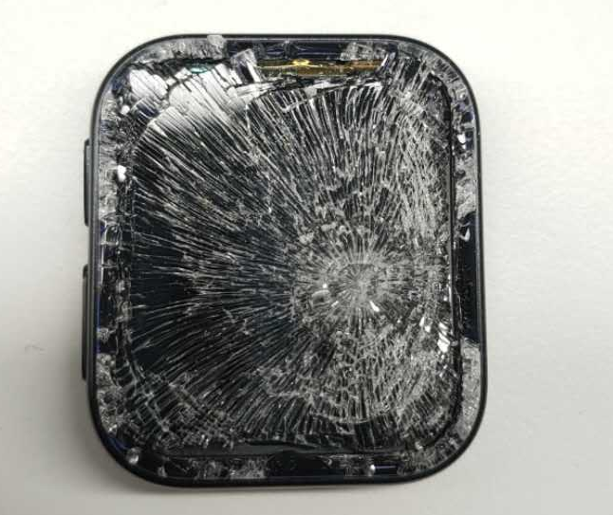 | OOW
The strap is cut | 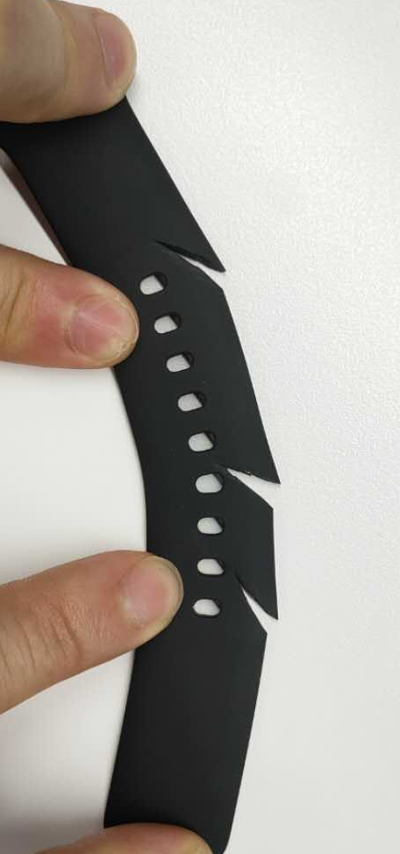 | OOW
Liquid entering the product | / | OOW
The charging pin is broken | / | OOW
Separation of human factors from screen and middle frame | / | OOW
The strap buckle comes off and is missing | / | IW
Watch buttons fall off | / | IW

6.6 Warranty Judgment for TWS Headphones
Type | Descriptions | Warranty Status
The earphone rubber plug is not assembled well | / | IW
The headphone body (including the charging case) is cracked and lifted | 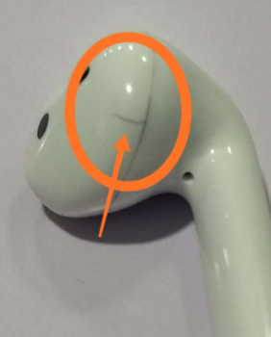  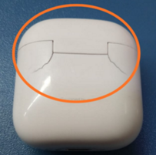 | 1. Obvious signs of external force, OOW  2.No obvious signs of external force, IW
The charging pin is broken | 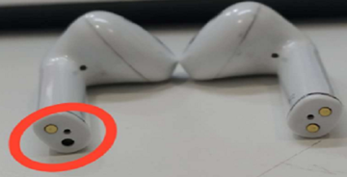 | 1. Obvious signs of external force, OOW  2.No obvious signs of external force, IW
Headphone speaker cracked | / | OOW
The USB interface is damaged or deformed / There is a foreign object in the interface that cannot be removed | 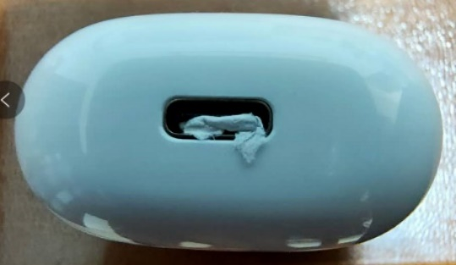 | OOW
Shell staining, paint peeling, scratches | / | OOW
Shell deformation | / | OOW
The shell was disassembled or glued privately | / | OOW

6.7 Warranty Judgment for Accessories
Type | Descriptions | Warranty Status
Smart band prong damaged | 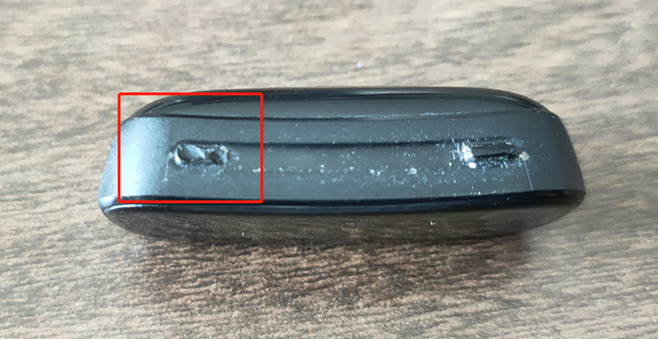 | OOW

7. Warranty Judgment for Accessories
The accessories including the adapter, data cable, and earphone can be individually replaced after the appearance detection according to the warranty policy.
Type | Descriptions | Warranty Status
The plug is deformed or bended | 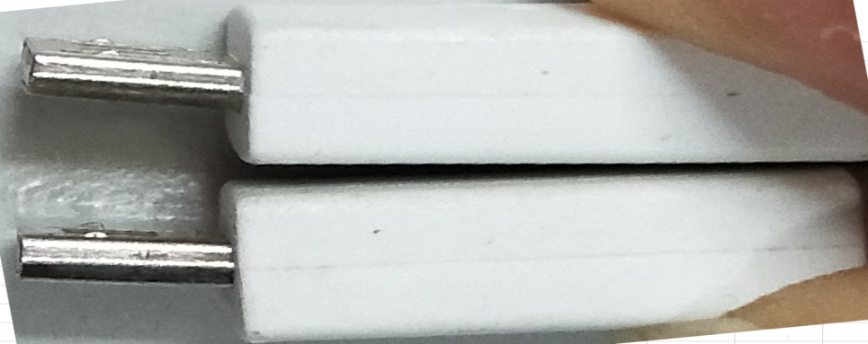 | OOW
The plastic at the plug is cracked | 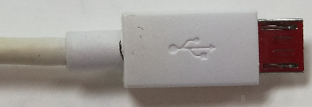 | OOW
The line body is cracked | 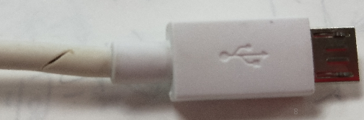 | OOW
The earphone plug is deformed or broken | 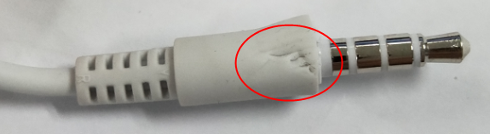 | OOW
The plug is burned out | 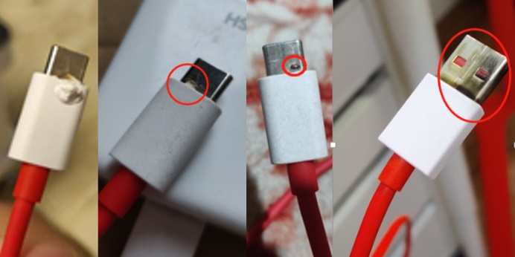 | IW
The connection between the plug and the wire body is short-circuited and burned out | 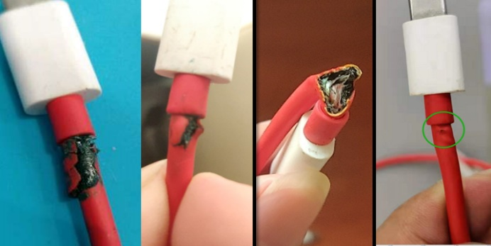 | IW
The earphone wire is stretched to deform or extruded to fracture | 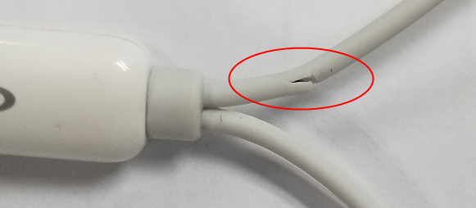  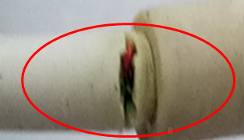  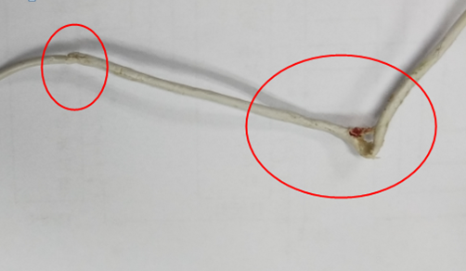 | OOW
The insulating adhesive of the earphone jack is damaged or deformed; | 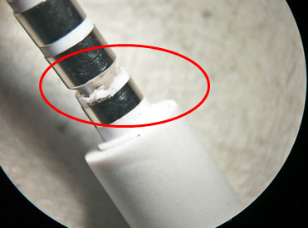  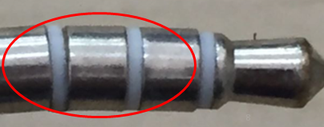 | OOW
The dust cloth of the speaker is punctured, and there is obvious oil and other liquid blocking the sound hole. | 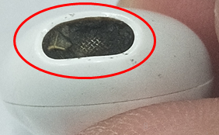  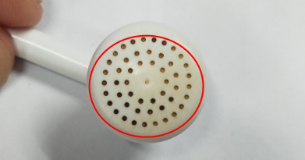 | OOW
Adapter | - Man-made damage, liquid damage, private disassembly, etc.;  2. Scan the two-dimensional code above the adapter to check the authenticity. If it is a fake one, the adapter will be out of warranty. | OOW
Adapter burnt out | 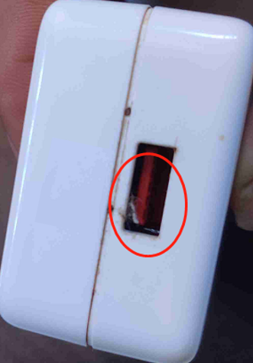 | IW
Adapter burnt out | 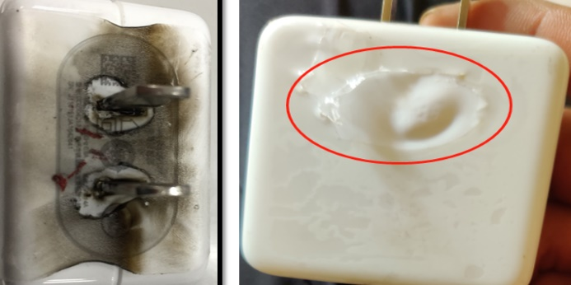 | IW

1. If the USB cable of the IoT product is damaged, the user can be informed that the they can use the normal charging, VOOC, SUPER VOOC USB cable corresponding to the original OPPO mobile phone accessories for charging;
2. If there is any other item without being listed, contact the factory technology support group;
3. All the "IW" judgment for the failures listed above are only repaired free of charge during the warranty period, and the warranty time is implemented in accordance with local policies. (Battery swelling problems can be repaired free of charge outside the warranty period).

The guidance is executed from the date of the issuance! The final explanation right is reserved by Global Service Department Technical Support Team.

