OPPO Reno4 5G Service Manual -V1.0

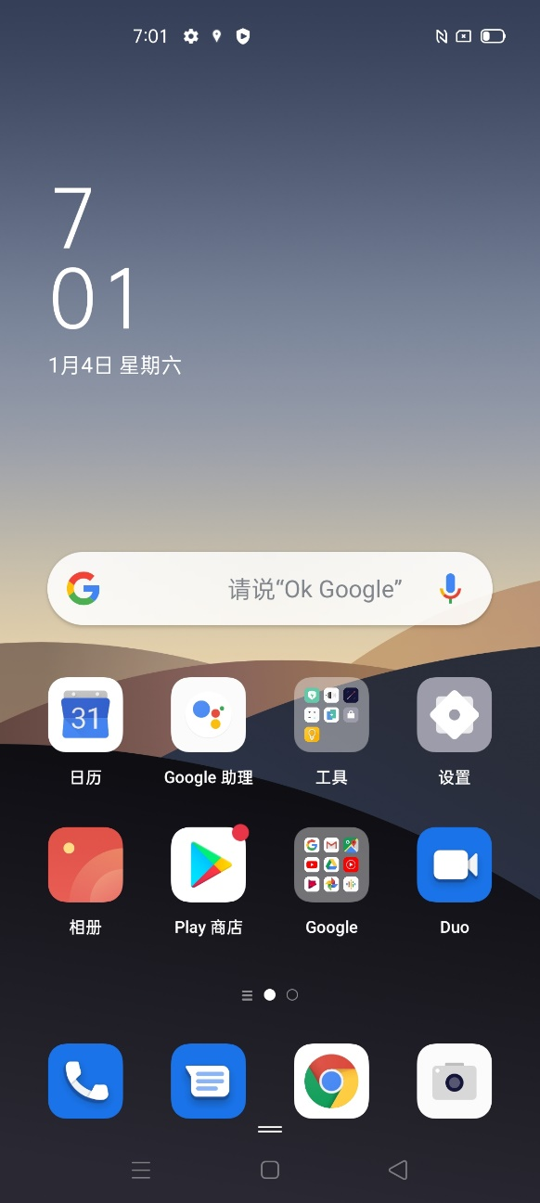
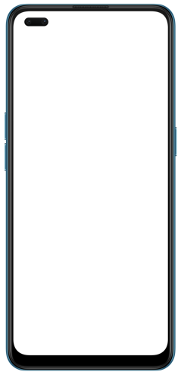
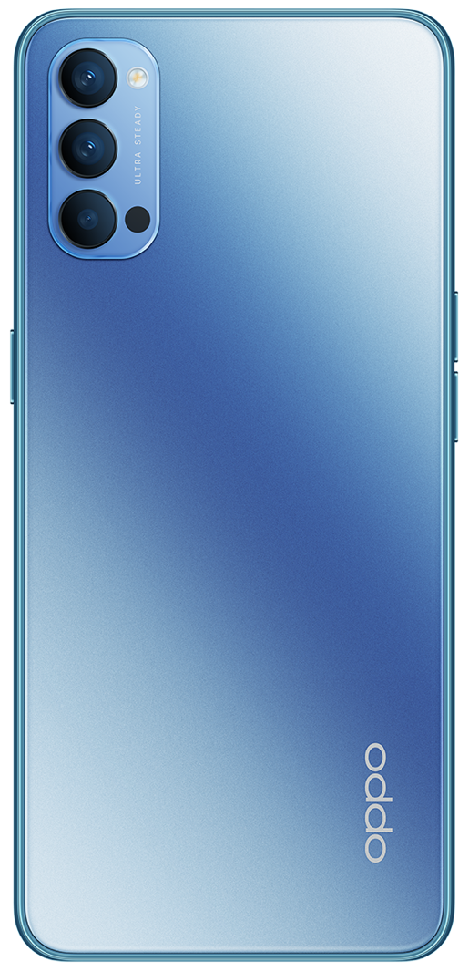

Confidential

Content

1. Guidance 4
1.1 Warnings and Cautions 4
1.1.1 Warnings 4
1.1.2 Cautions 4
2. General Repair Information 5
3. Phone Structure Diagram 6
3.1 Product Appearance 6
3.2 Phone Structure Explosive View 6
3.3 Explosive Map BOM 7
4. Disassembly Steps 13
4.1 Disassembly Tools 13
4.2 Preparation 13
4.3 Disassembly Steps 13
5. Assembly Steps 19
5.1 Bill of Must-Be-Replaced Materials 19
5.2 Assembly Steps 19
6. Calibration 25
6.1 Motor Hall Calibrate 25
6.2 Infrared Proximity Calibration 26
Click Infrared Proximity Calibration 26
6.3 Fingerprint optical calibration 26
6.3.1 Calibration Tool 26
6.3.2 Calibration Method 28
6.4 Dual Camera Calibration 29
6.4.1 Calibration Scenario 29
6.4.2 Calibration Tool 29
6.4.3 Calibration Method 30
7. Function Test 31
7.1 Test Path 31
7.2 Test Requirements 31
8. General Cautions 34

Guidance
The purpose of this document is only to guide OPPO technicians to carry out maintenance service to OPPO products. The content shall be keep in confidential, only avail be able to OPPO authorized service centers, and cannot be provided to third parties without authorization. Please follow the regulations and the guidance for maintenance service. For any problems, please contact China HQ in time.

1.1 Warnings
1. Care must be taken on installation in vehicles fitted with electronic engine management systems and ABS (Anti–skid Braking Systems). Under certain fault conditions, emitted RF energy can affect their operation. If necessary, consult the vehicle dealer/manufacturer to determine the immunity of vehicle electronic systems to RF energy.
2. Phones must not be operated in areas likely to contain potentially explosive atmospheres, e.g. petrol stations (service stations), blasting areas etc.
3. Operation of any radio transmitting equipment, including cellular telephones, may interfere with the functionality of inadequately protected medical devices. Consult a physician or the manufacturer of the medical device if you have any questions. Other electronic equipment may also be subject to interference

1.2 Cautions
1. Repair services and calibrations must be undertaken by qualified personnel only.
2. Use only approved components as specified in the parts list.
3. Ensure all components, modules screws and insulators are correctly re-fitted after servicing and alignment.
4. Electrostatic discharge is the main cause of damage to sensitive components of electronic products. Service centers must operate in accordance with OPPO's requirements for ESD protection. Ensure all work is carried out at an ESD workstation and that an ESD wristband is worn.

General Repair Information
- Ensure all work is carried out at an ESD workstation and that an ESD wristband is worn before starting maintenance.
- Wear ESD gloves to avoid oil stains and fingerprints.
- Use protective films to protect the display, camera, camera lens to prevent dust and scratches.
- Use a clean cloth, ESD brush and alcohol (Concentration above 95%) for appearance cleaning. Do not use other items (such as an eraser) for cleaning to prevent the protective layer from being scratched, which may lead to oxidation and corrosion.
- Faulty welded mechanical parts (except shield cover and shield frame parts) can only be replaced and not repairable.
- Use accessories provided by OPPO.
- Check the contacts or solder joints of devices that may cause simple faults (e.g. soldered interfaces or switches). Re-weld if necessary (only for service centers where lead-free soldering is available) and clean the flux remaining after soldering.
- Use the equipment provided by OPPO to test the phone (e.g. When the charging function of the device is abnormal, do use the original OPPO adapter to test to ensure the accuracy of the test results).
- Fill in the fault phenomenon code and fault reason code according to the actual situation, and accurately enter the replacement material code in the CRM system.
- For more information about products,
Mainland China please visit:
http://172.16.41.122:8888/kbaseui-dev/main.do
Regions except for Mainland China please visit:
ftp://ftpex.oppo.com:919/ or
https://oppo knowledge.custhelp.com/app/home/loc/zh_CN

3. Phone Structure Diagram

3.1 Product Appearance
As shown in Figure 3-1-1
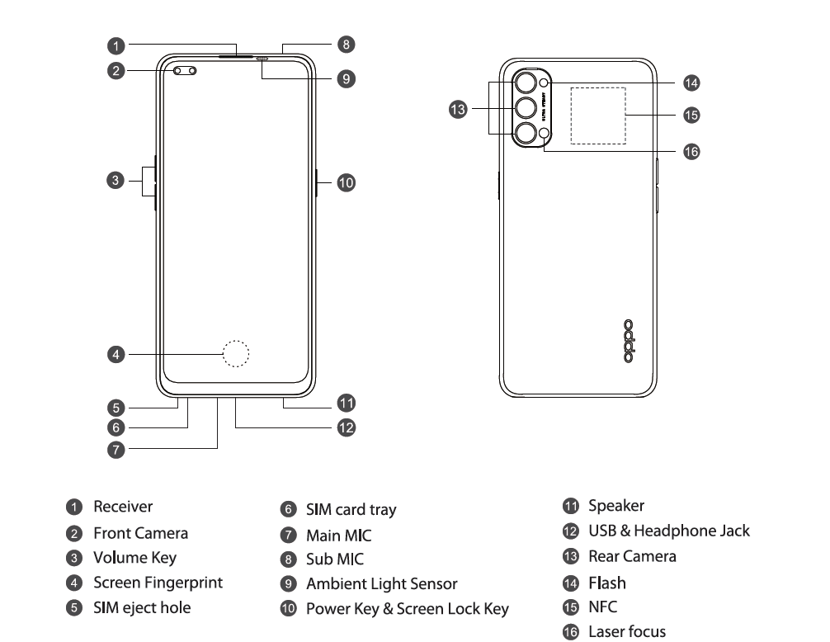

Figure 3-1-1

3.2 Phone Structure Explosive View
As shown in Figure 3-2-1

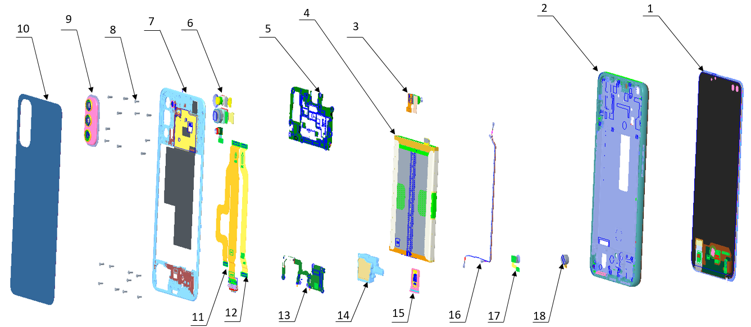

Figure 3-2-1

3.3 Explosive Map BOM
No. | Material Name(After-sales) | Physical Figure | Specifications | QTY | Unit
1 | Screen | 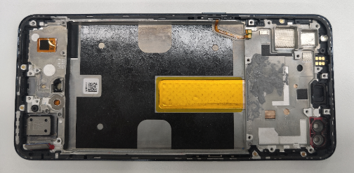 | (1) OLED Display Screen | 1 | PCS
1 | Screen |  | (2) Middle Frame(Larger) | 1 | PCS
2 | Battery cover | 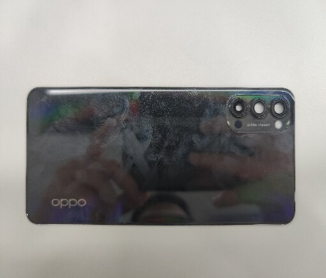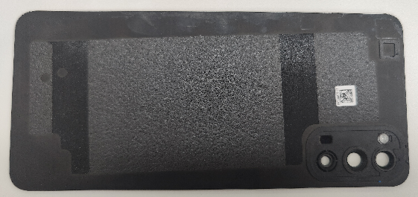 | (9)Rear camera decorative | 1 | PCS
2 | Battery cover |  | (10)battery cover | 1 | PCS
2 | Battery cover |  | Rear camera lens(main) | 2 | PCS
2 | Battery cover |  | Rear camera lens(vice) | 1 | PCS
3 | Rear Camera lens | 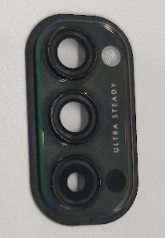 | (9)Rear camera decorative | 1 | PCS
3 | Rear Camera lens |  | Rear camera lens(main) | 2 | PCS
3 | Rear Camera lens |  | Rear camera lens(vice) | 1 | PCS
4 | Mainboard bracket | 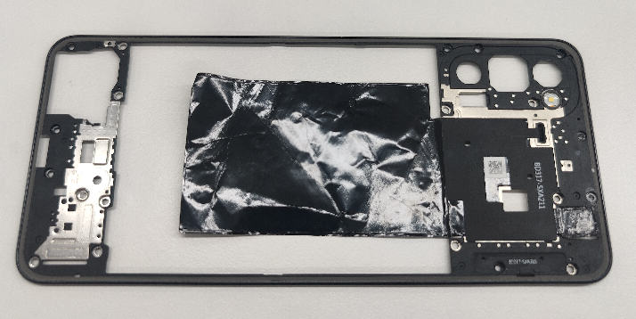 | (7)Main board bracket | 1 | PCS
4 | Mainboard bracket |  | Flash FPC | 1 | PCS
5 | Speaker | 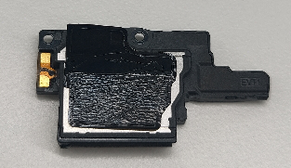 | (14)Speaker-BOX | 1 | PCS
5 | Speaker |  | Loudspeaker graphite sheet | 1 | PCS
6 | Rear Main Camera | 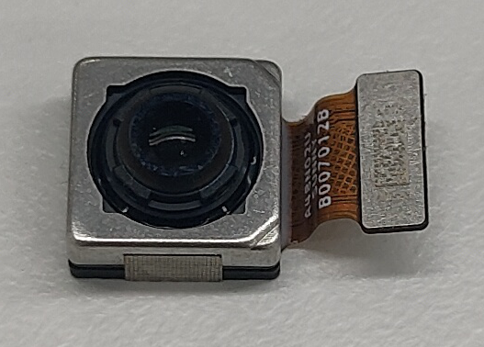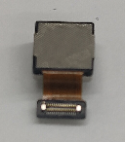 | (6)Rear Main Camera | 1 | PCS
6 | Rear Main Camera |  | Conductive cloth for rear camera | 1 | PCS
7 | Rear Wide Angle Camera | 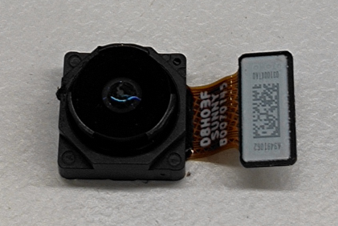 | (6)Rear Wide Angle Camera | 1 | PCS
8 | Front Main Camera | 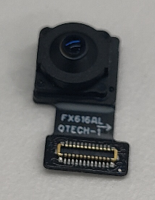 | (3)Front Main Camera | 1 | PCS
9 | Front Portrait Camera | 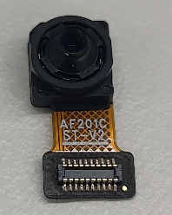 | (3)Front Portrait Camera | 1 | PCS
10 | Antenna board | 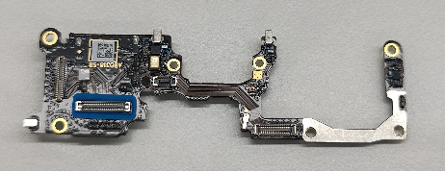 | (13)Antenna board | 1 | PCS
11 | Battery | 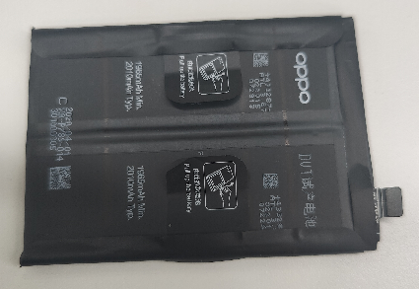 | (4)battery | 1 | PCS
12 | Mainboard | 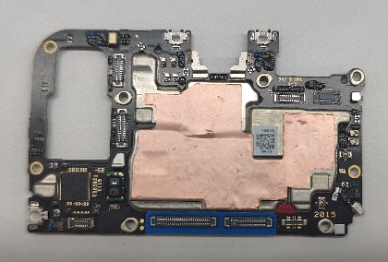 | (5)Mainboard | 1 | PCS
12 | Mainboard |  | waterproof paste | 1 | PCS
13 | Power key FPC | 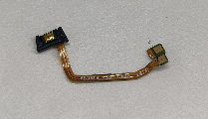 | PBD318-0 19015 | 1 | PCS
14 | Volume key FPC | 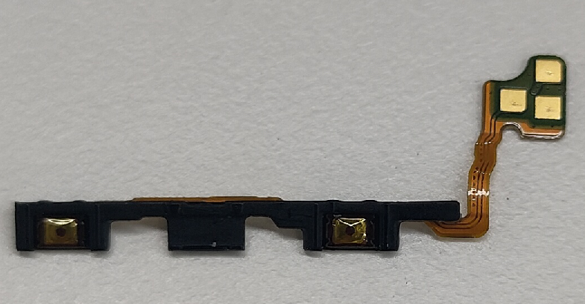 | VBD318-0 19015 | 1 | PCS
15 | Fingerprint sensor | 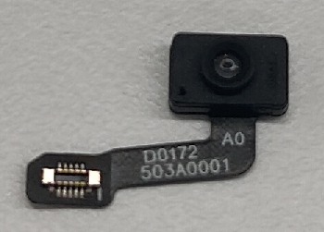 | (17)Fingerprint sensor | 1 | PCS
16 | Power key | 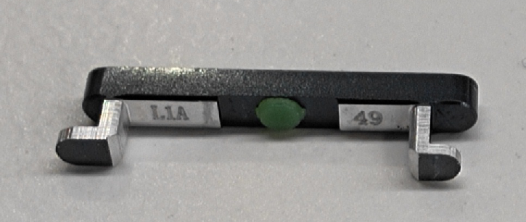 | Power key | 1 | PCS
17 | Flash | 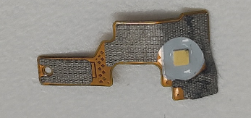 | Flash | 1 | PCS
18 | L smallboard | 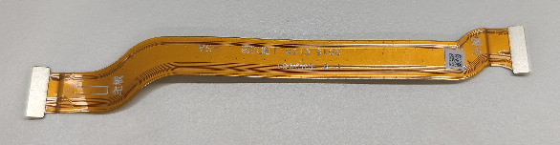 | (12) L smallboard | 1 | PCS
19 | U smallboard | 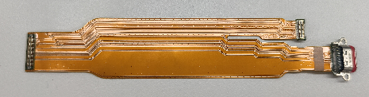 | (11) U smallboard | 1 | PCS
20 | Rear black- white camera | 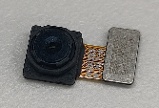 | (6) Rear black- white camera | 1 | PCS
21 | SIM card holder | 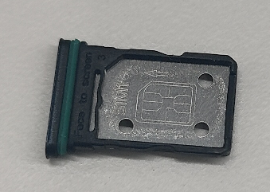 | (15) SIM card holder | 1 | PCS
22 | Volume key | 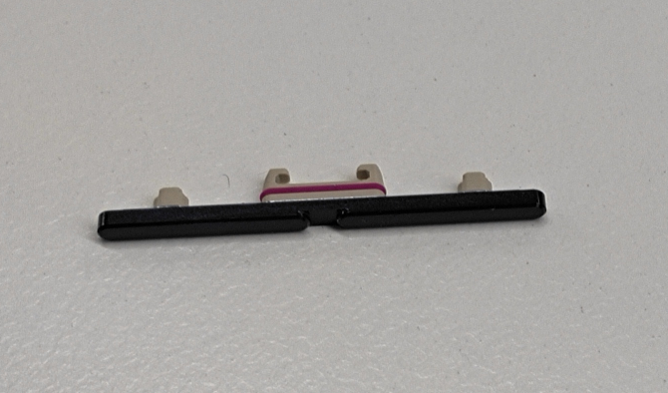 | Volume key | 1 | PCS
23 | Rotor motor | 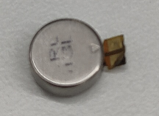 | (18)Rotor motor | 1 | PCS
24 | Receiver | 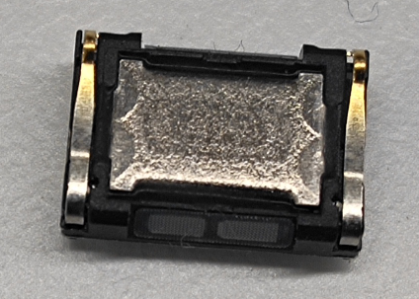 | Receiver | 1 | PCS
25 | RF connecting cable#1 | 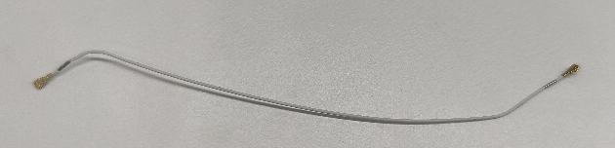 | (16)RF connecting cable#1 | 1 | PCS
26 | RF connecting cable#2 | 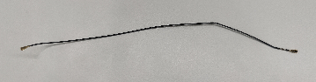 | (16)RF connecting cable#1 | 1 | PCS
27 | Machine-tapping screw | 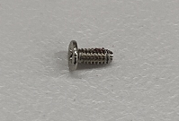 | (8)Machine-tapping screw | 1 | PCS
28 | Waterproof double-sided adhesive for upper cover of main board | 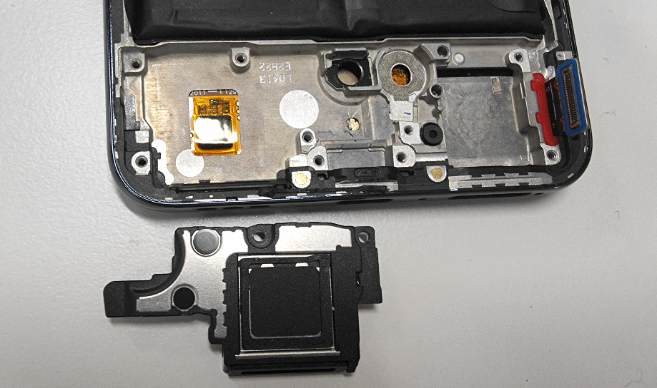 | Waterproof double-sided adhesive for upper cover of main board | 1 | PCS
29 | Double-sided adhesive for main board support | 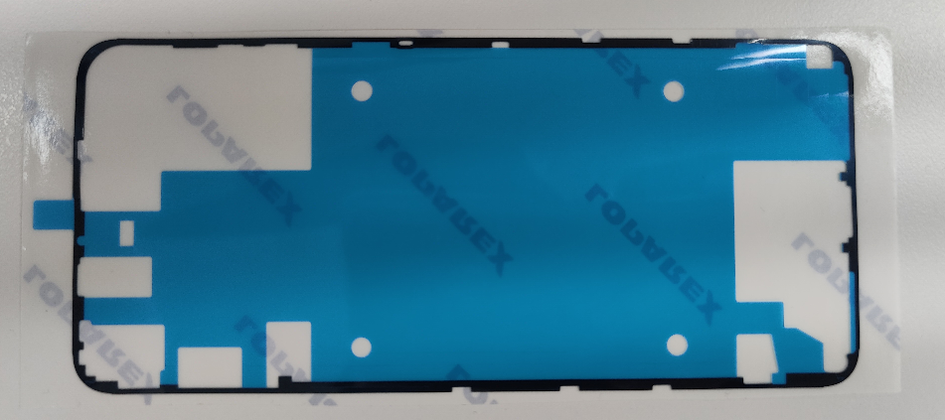 |  | 1 | PCS
30 | J board | 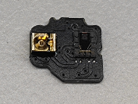 |  | 1 | PCS

Note：This table is used only for the name of the annotation but not for the preparation of materials. Please refer to the Price List of OPPO Mobile Phone Original Accessories (for Mainland China)/Price List of Commonly-Used Materials and Accessories (Regions except for Mainland China) for the preparation.

4. Disassembly Steps

4.1 Disassembly Tools
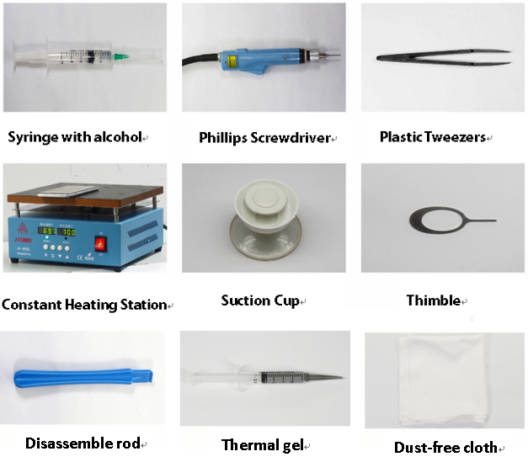

4.2 Preparation
1. The phone must be powered off before disassembly.
2. Way to Power Off:
System Power Off: Press the power key then slide to power off.
Forced Power Off: Long press the volume “+” key and power key for about 8 seconds until the display is off.

4.3 Disassembly Steps
Step | Content | Figure | Cautions
1 | Remove SIM Tray | 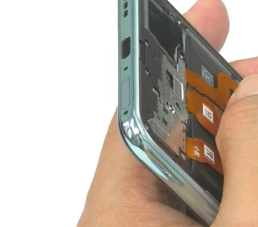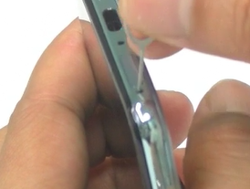 | 1. The pin Insert to hole, being careful not to scratch the battery cover  2. sim Tray hole is a hole near Sim Tray.
2 | Disassemble the battery cover & camera lens | 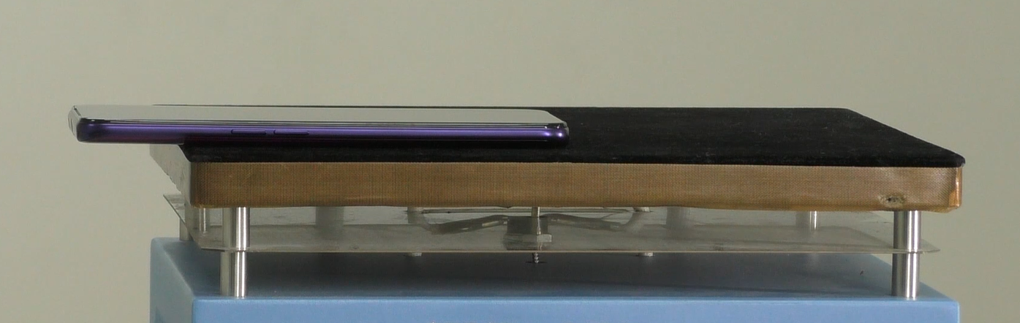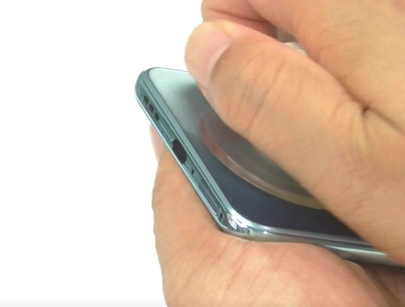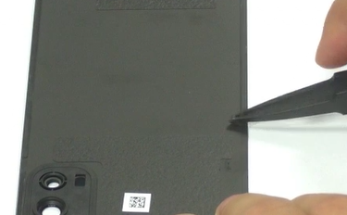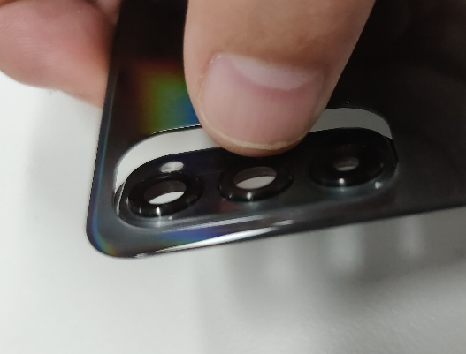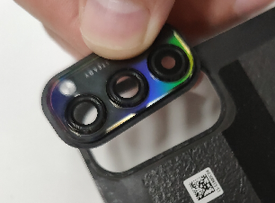 | (1) Avoid heating the camera. Heating requirements: 70 ° C -80 ° C for 5-10 mins;  (2) Use the suction cup to remove the battery cover from the bottom of the phone; adjust the suction cup and strength according to the tightness when separating it.
3 | Disassemble mainboard bracket/ flash board | 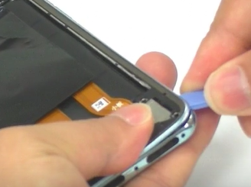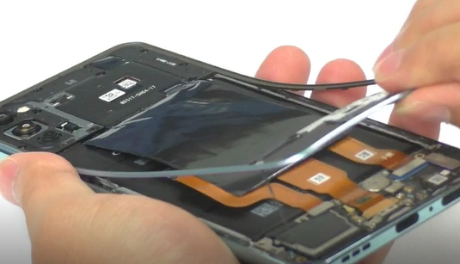  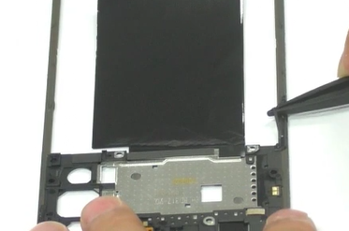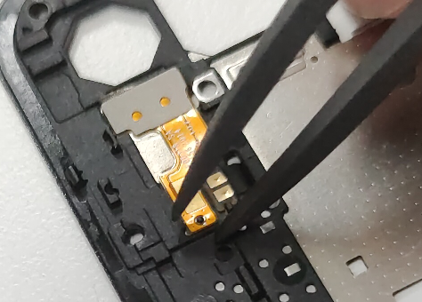 | (1) It is same size of the screw on mainboard bracket .  (2) When disassembling the mainboard bracket, be careful not to bend the mainboard bracket to prevent the mainboard bracket from damage. You can use a disassembly rod to disassemble the mainboard bracket; please clean the mainboard bracket and the cover of the top cover.
4 | Disassemble USB/ mainboard screw/L FPC | 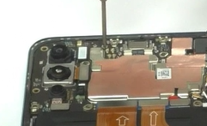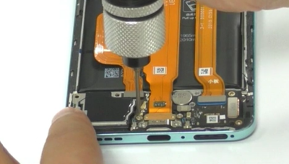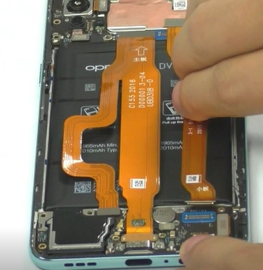 | 1，Don’t damage the FPC
5 | Removed battery | 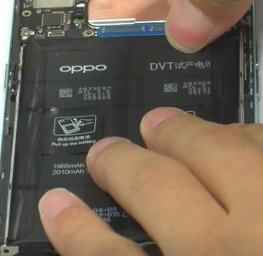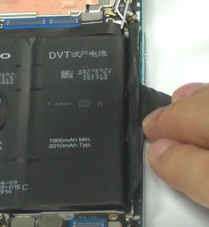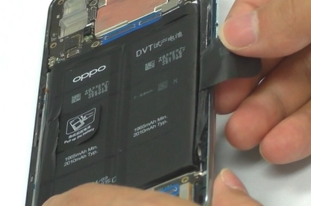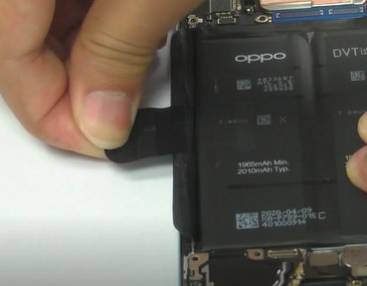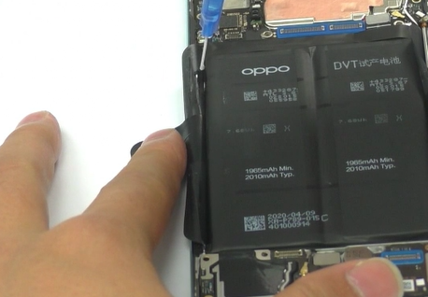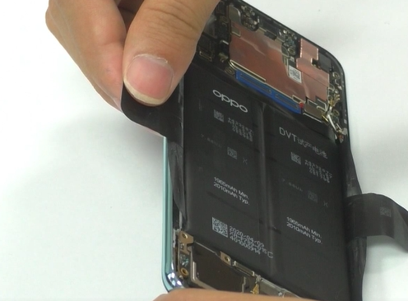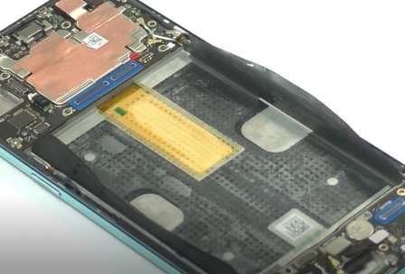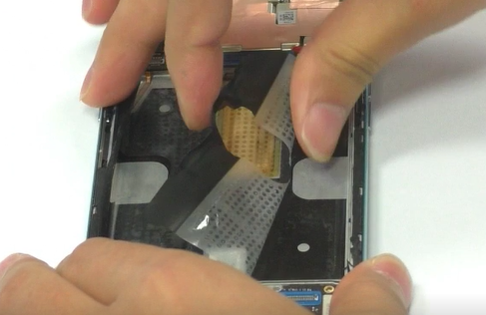 | 1.The battery BTB must be removed before removing the battery;  2. The alcohol on the left and right sides should not be too much, and the alcohol should not be dripped on the handle.  3.After tearing off the easy-tore paper, add 0.2ml of alcohol to the upper and lower sides of the handle, and stand the phone for 15 seconds  4. Place the phone flat and pull it diagonally. Make the angle between the handle position and the battery are larger than 90°, and slowly pull the battery off.  5.Check for puncture, indentation , leakage and other defects after removing the battery
6 | Removed rear camera / front camera | 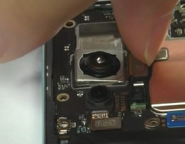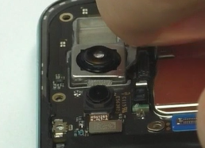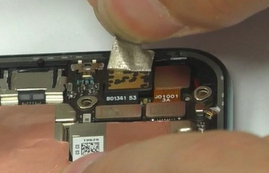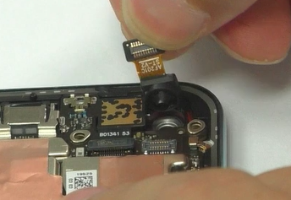 | 1, Must be replaced after removing the Rear camera copper foil
7 | Removed RF line PET /RF /mainboard | 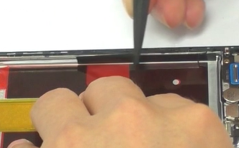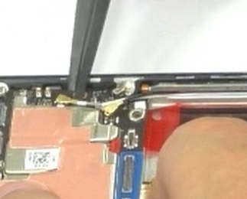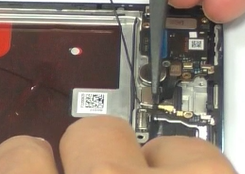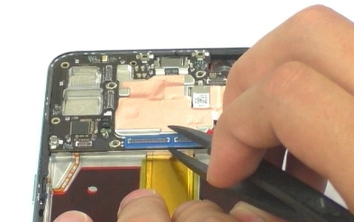
8 | Clean the thermal gel | 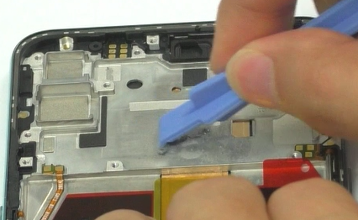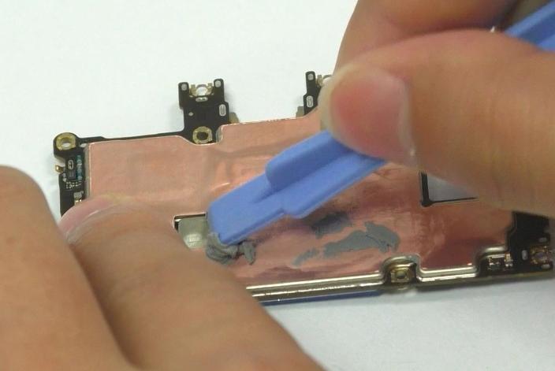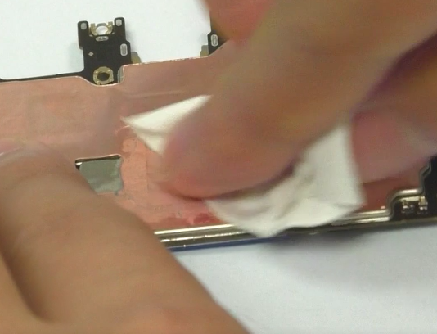
9 | Removed fingerprinter/  RF/antenna board/receiver/speaker  /motor | 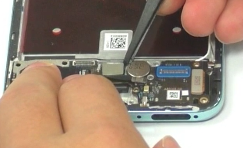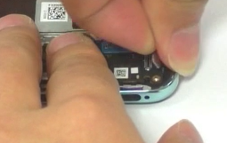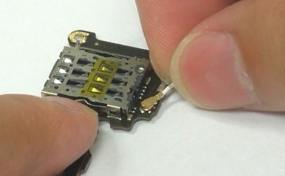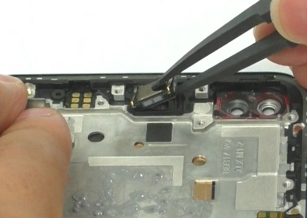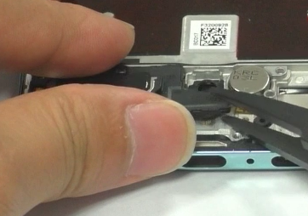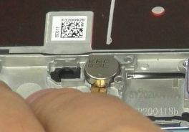 | 1. When disassembling the motor, be careful not to flow alcohol into the fingerprint hole
10 | Removed key FPC/key | 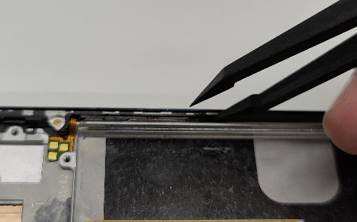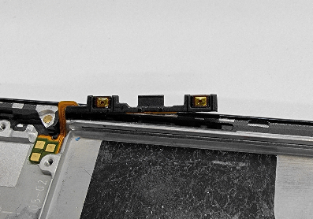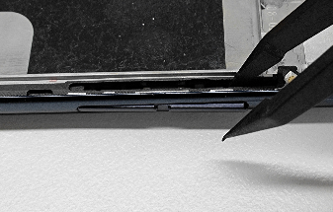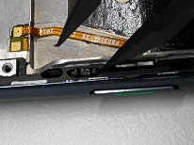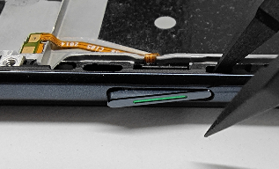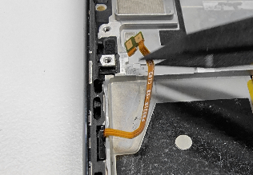 | 1. Be careful when removing the button FPC to prevent tearing the FPC  2. When disassembling the motor, pry away from the disassembly position. When it is difficult to disassemble, a little of alcohol can be dripped;

5. Assembly Steps

5.1 Bill of Must-Be-Replaced Materials
No. | Code | Material | SPEC. | QTY | Remark
1 | 4876675 | Thermal gel | 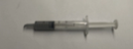 | 1 | Must be replaced after removing the mainboard and screen .
2 | 4881448 | Waterproof double-sided adhesive for upper cover of main board |  | 1 | Must be replaced when it’s damage
3 | 4881442 | Volume key bracket | 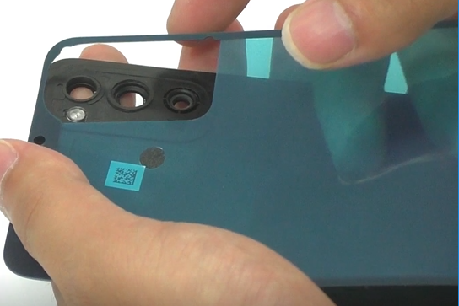 | 1 | Must be replaced after removing the battery cover.
4 | 4881086 | battery pull tape | 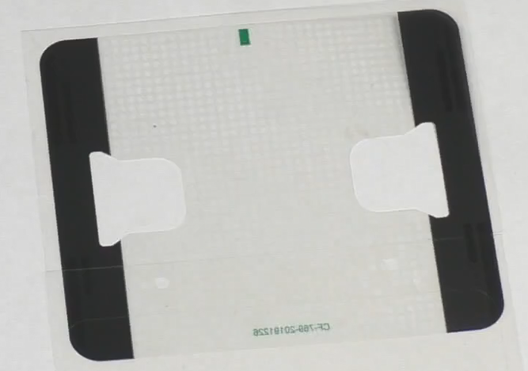 | 1 | Must be replaced after removing the battery.
5 | 5181951 | battery extracting sticker | 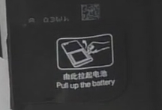 | 1 | Must be replaced after removing the battery.
6 | 5181952 | battery extracting sticker | 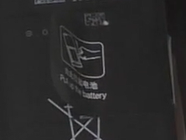 | 1 | Must be replaced after removing the battery.
7 | 4881444 | Double-sided adhesive for main board support |  | 1 | Must be replaced after removing the mainboard bracket

5.2 Assembly Steps
Step | Content | Figure | Cautions
1 | Assemble the key FPC and key |  | 1. Pay attention to the positioning column when assemble the FPC button and speaker FPC.
2 | Assemble receiver/ motor/ Thermal gel /mainboard | 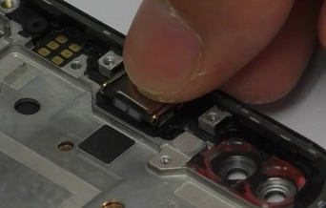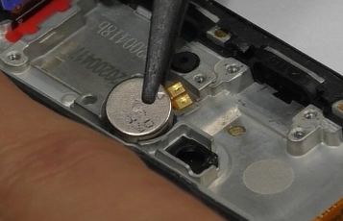  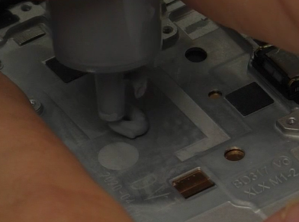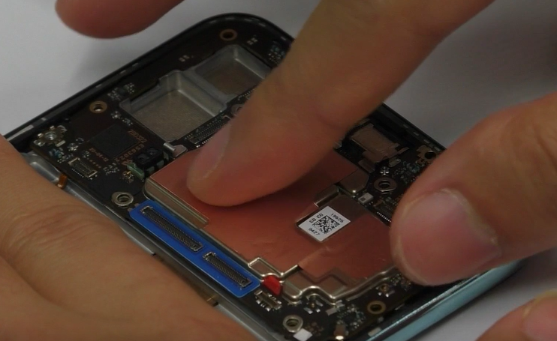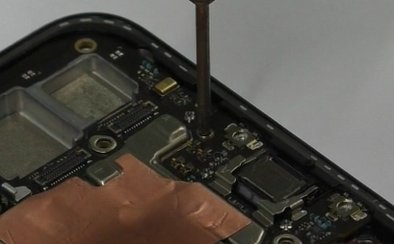 | 1. Apply thermal gel, take care not to apply too much, overflow onto the volume key FPC
3 | Assemble front camera/ front camera copper foil/rear camera | 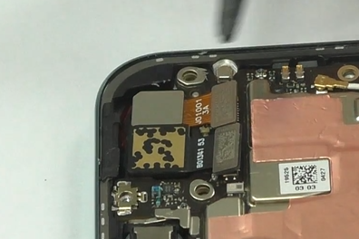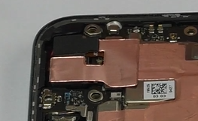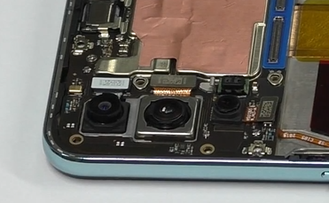 | 1. the front camera put to the front camera hole first, then buckle the BTB in place  2. paste the front camera copper foil should be flat.
4 | Assemble speaker/ RF line/ antenna board/ fingerprinter | 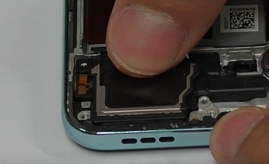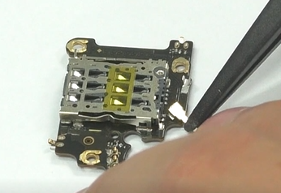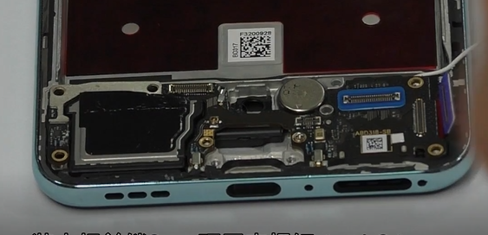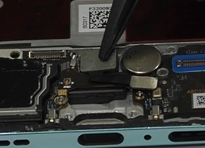 | 1. Pay attention to the assembly position of both ends of the RF cable.
5 | Assemble RF line | 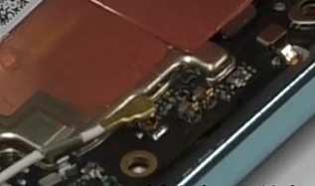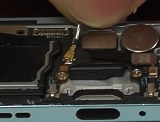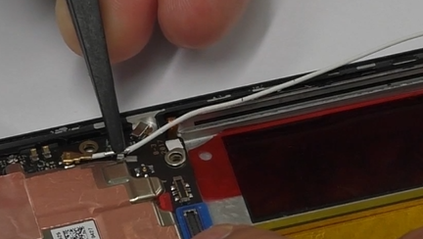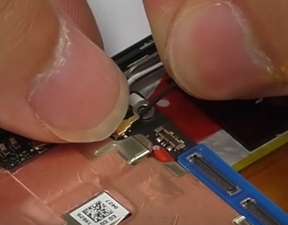 | 1. Pay attention to the assembly position of both ends of the RF cable.
6 | Paste Bottom foam of battery/ battery pull tape/ battery extracting sticker/assemble battery | 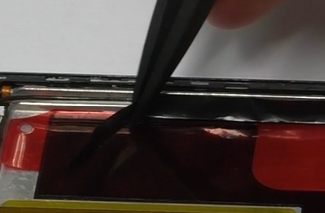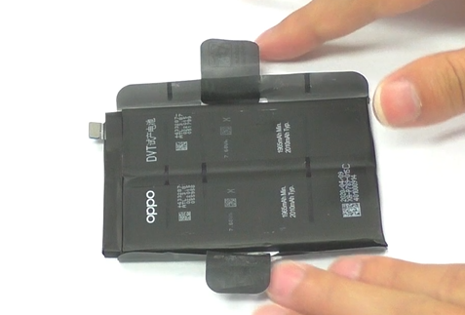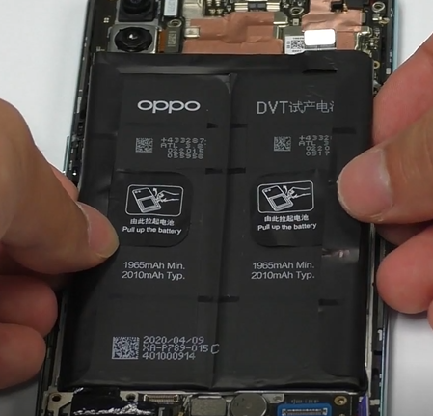 | 1. Must be change the easy-tear stickers ; Be careful not to wrinkle the easy-tear stickers
7 | Assemble USB FPC/ L FPC | 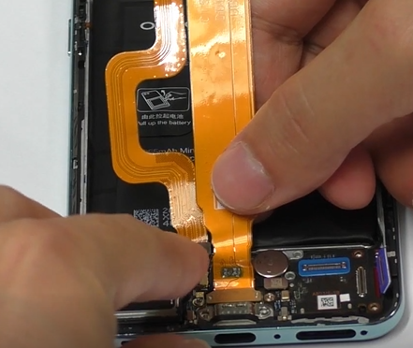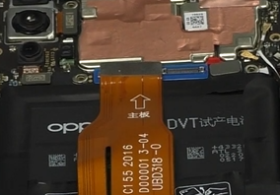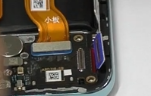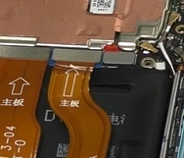
8 | Paste mainboard bracket adhesive/ battery cover adhesive /assemble the mainboard bracket/screws/battery cover / Sim tray | 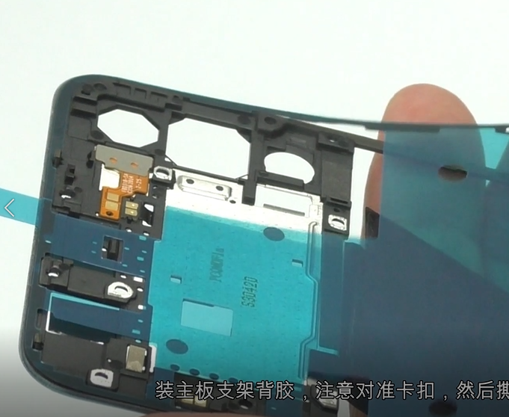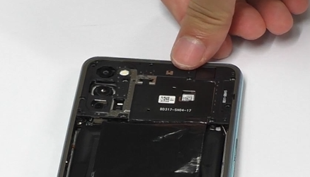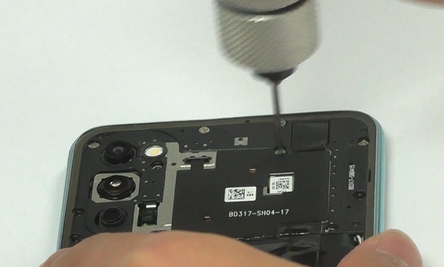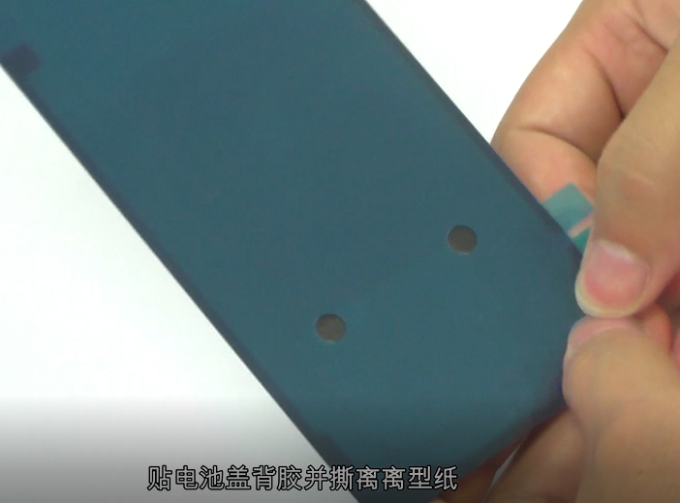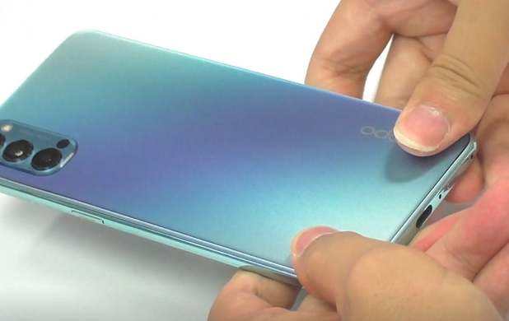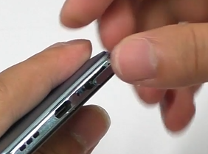 | 1. Pay attention to the BTB buckle, press it tightly, and finally tear off the release paper  2. When installing the mainboard bracket, press in place to prevent tilting and large gap

6. Calibration
After the phone is disassembled and assembled, the aftersale devices calibration must be calibrated first. The calibration of this model includes(leak calibration--fingerprint optical calibration--aftersales calibration--aftersale front dualcam calibration--smart power amplifier calibration
Enter Password: 6776 | Click ”leak calibration ” |  | When the environment is completely black, click the "leak calibration" button; |  | 1.Click "START" to start calibration after it jumps into the fingerprint optical calibration
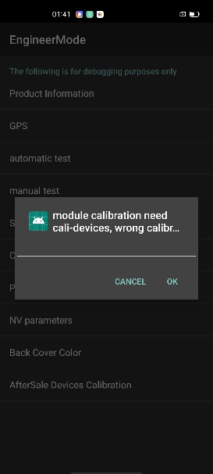 | 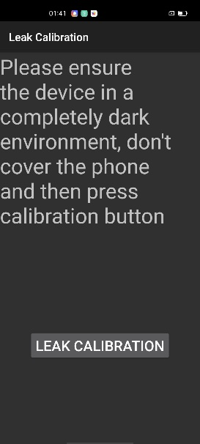 |  | 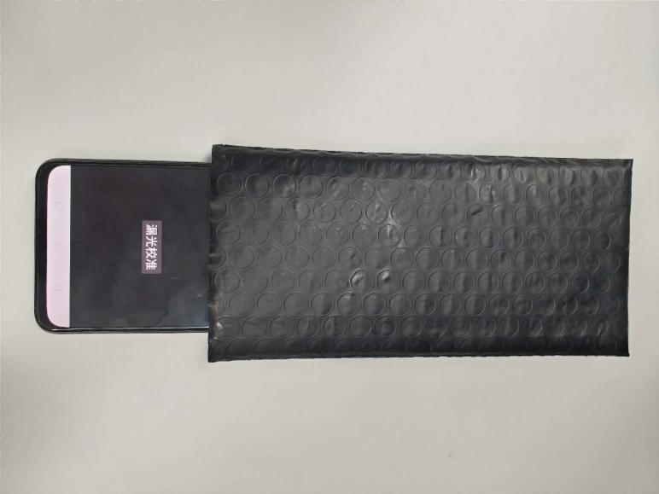 |  | 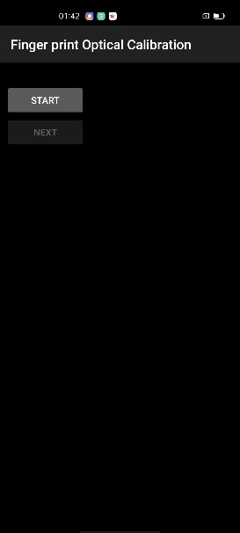
2. According to the prompt "please place the yellow rubber ", put the yellow rubber on the fingerprint spot area (the groove is facing down), and click "NEXT" until it prompts " please place the black rubber". |  | 3. According to the prompt "please place the black rubber head", put the black rubber on the fingerprint spot area (the groove is facing down), click "NEXT" until the "please place the yellow stripe rubber " prompts to remove the black rubber ; |  | 4. According to the prompt “Please place the yellow- striped rubber”, put the yellow stripe rubber (striped down) in the spot area, click “NEXT”;
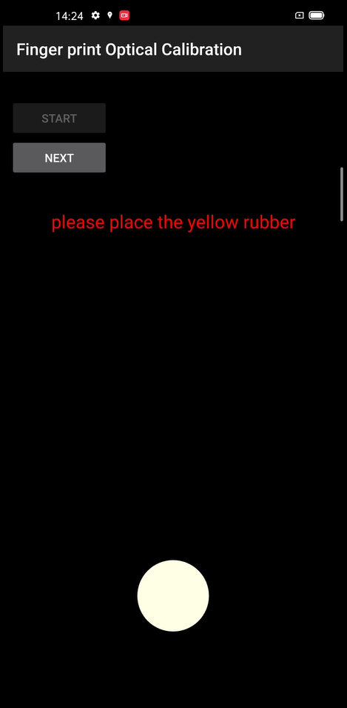 |  | 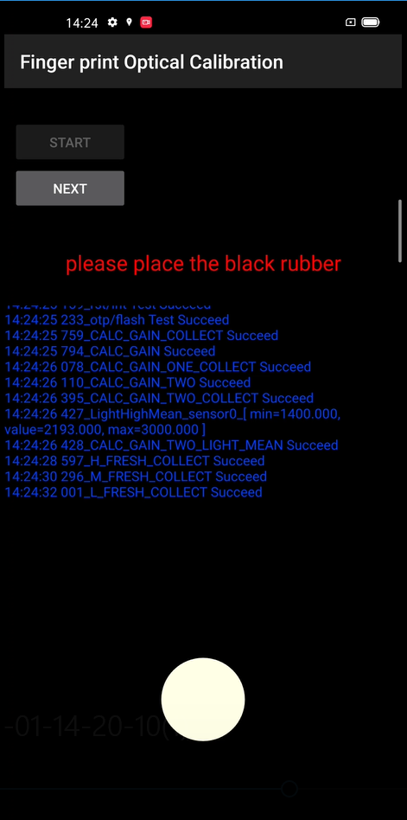 |  | 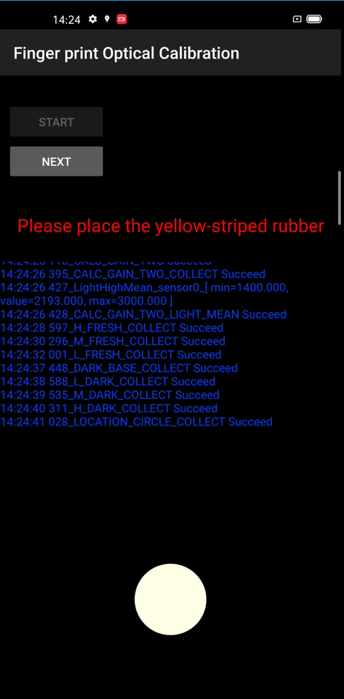
it jumps into the after sales calibration from fingerprint optical calibration |  | it jumps into the after sales front dualcam calibration from after sales calibration |  | After the calibration is completed，it’s will jump into smart power amplifier calibration
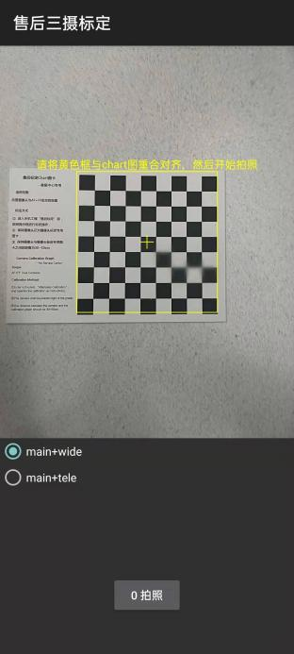 |  | 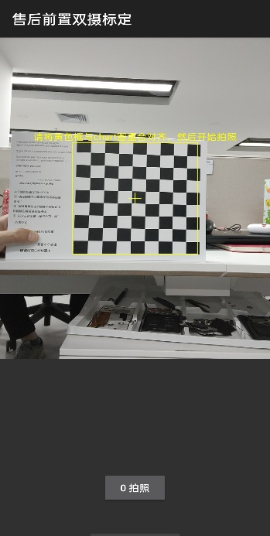 |  | 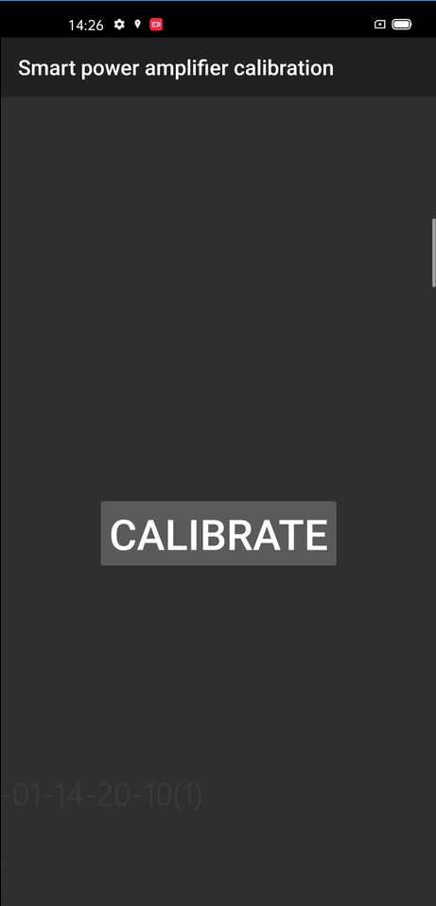
After the calibration is completed, restart the phone to make the calibration take effect, and guide the user to delete the original fingerprint and re-enter.

7. Function Test

7.1 Test Path
Dialing Interface>Enter*#899#>Enter automatic test； The "Confirm" dialog box will pop up after the test complete, if there is no problem choose “Pass”, otherwise choose “Fail”.

7.2 Test Requirements
No. | Test Items | Test Requirements
1 | LCD Test | Observe the red, green, blue, white, black, gray, grayscale and color interface successively; If there are black spots, bright spots and other anomalies, the function is good;
2 | Vibration Test | Get ear close to check the vibration from the motor for 3 seconds.  If the motor vibrates normally(No noises or weak vibration), the function is good;
3 | Touch Screen Auto Test | If the interface shows “PASS” and jumps to the next test, the function is good;
4 | Front Camera Preview | Align the camera with a white surface and a black surface. If there is no black dot, black line or blurred screen on the screen after aligning the white surface, and there is no bright spot on the screen after aligning the black surface, the camera is good;
5 | Second Front Camera Preview | Align the camera with a white surface and a black surface. If there is no black dot, black line or blurred screen on the screen after aligning the white surface, and there is no bright spot on the screen after aligning the black surface, the camera is good;
6 | Rear camera preview | Align the rear camera with a white surface, a black surface, and a surface with text. If there is no black dot, black line or blurred screen on the screen after aligning the white surface, there is no bright spot on the screen after aligning the black surface, white point or blurred screen, the camera is good;
7 | Second rear camera preview | Align the Second rear camera with a white surface, a black surface, and a surface with text. If there is no black dot, black line or blurred screen on the screen after aligning the white surface, there is no bright spot on the screen after aligning the black surface, white point or blurred screen, the camera is good;
8 | third rear camera preview | Align the third rear camera with a white surface, a black surface, and a surface with text. If there is no black dot, black line or blurred screen on the screen after aligning the white surface, there is no bright spot on the screen after aligning the black surface, white point or blurred screen, the camera is good;
9 | Echo test | Testing Main MIC: Blow the air to the MIC hole on the bottom of the phone. If the receiver (earphone) sounds, the function of Main MIC is good;  Testing Sub MIC: Blow the air to the sub MIC hole on the top of the phone. If the speaker sounds, the function of Main MIC is good;
10 | Flashlight Test | Open the flashlight. If it can be opened normally with color deviations, the function is good;
11 | Charging Test(SuperVOOC) | Use the original OPPO adapter and USB cable to charge. If the interface shows “PASS” and jumps to the next test, the function is good;
12 | Headset in-out Plug test | Plug in and out the earphone with the OPPO earphone. If the interface shows “PASS” and jumps to the next test, the function is good;
13 | Sensor Self-test and Calibration | When the phone enters into the Sensor self-calibration interface, the phone must be placed on the desk flatly. Then click the first calibration item. After the test is passed, it will automatically jump to the next test item;
14 | Gyroscope Test | Take the mobile phone to draw the "8" word graphic. If the interface shows “PASS” and jumps to the next test, the function is good;
15 | M-Sensor Test | Shake the phone from the left to the right side. If the interface shows “PASS” and jumps to the next test, the function is good;
16 | Proximity-sensor Test | Use the palm to cover the light sensor hole, and the screen will turn green from black. If the interface shows “PASS” and jumps to the next test, the function is good;
17 | Keypad Test | Press the power key and volume key one by one. If keys can be pressed normally and the interface jumps to the next test, the function is good;
18 | Fingerprint Auto Test | If the interface shows “PASS” and jumps to the next test, the function is good;
19 | Media test | Click the “20-4K（-3db)signal” to test the sound of the media function for 5s. If there is no silence, weak sound, noises, and breaking sound, the interface shows “PASS” and jumps to the next test, the function is good;
20 | Call test | If the phone has been installed with the operator's SIM card, dial the corresponding operator's phone number. If no card is installed, call the 112 to test (Calling the Operator is recommended). If the call can be performed normally and the receiver is without noises or weak sounds, the function is good;
21 | NFC Test | Close the phone of the rear camera area to the NFC card reader. If the signal light of the card reader changes from red to green with “Beep” sound, the interface shows “PASS” and jumps to the next test, the function is good.
22 | Laser focus | Aim the mobile phone at any object, move the mobile phone, and change the distance between the mobile phone and the object. test the pass when After the mobile phone detects the distance change,
After the above 22 items are tested, they will prompt to the test result interface. If the test PASS, project will show “√”; If the test FAIL, project will show “×” as shown below.
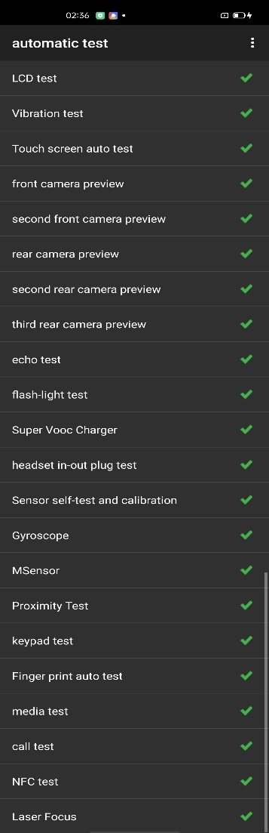
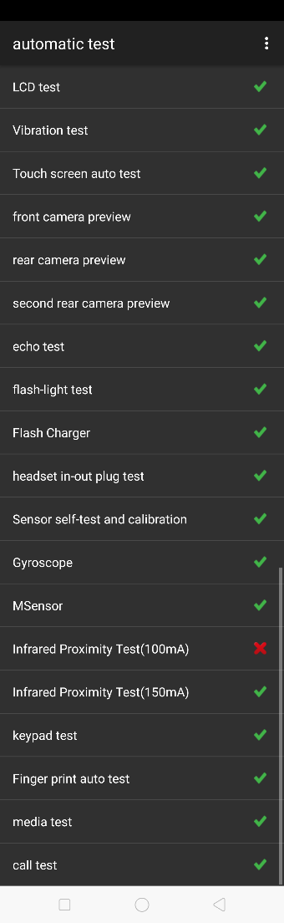

Figure 7-1 Figure 7-2

8. General Cautions
1. For Reno4 Standard Edition Disassembly Video Please visit:
Baidu network disk：https://pan.baidu.com/s/1gmM_2rwXxIgW0K7KVhe9Fg
Password :95mz
FTP: Overseas costumer service/OPPO technical service/product material/Reno4

Version | Date | Draft | Review | Approve | Modified content
V1.0 | 2020-07-14 | Max | benny | wong | 1.  2.

