Reno4 Service Manual -V1.0
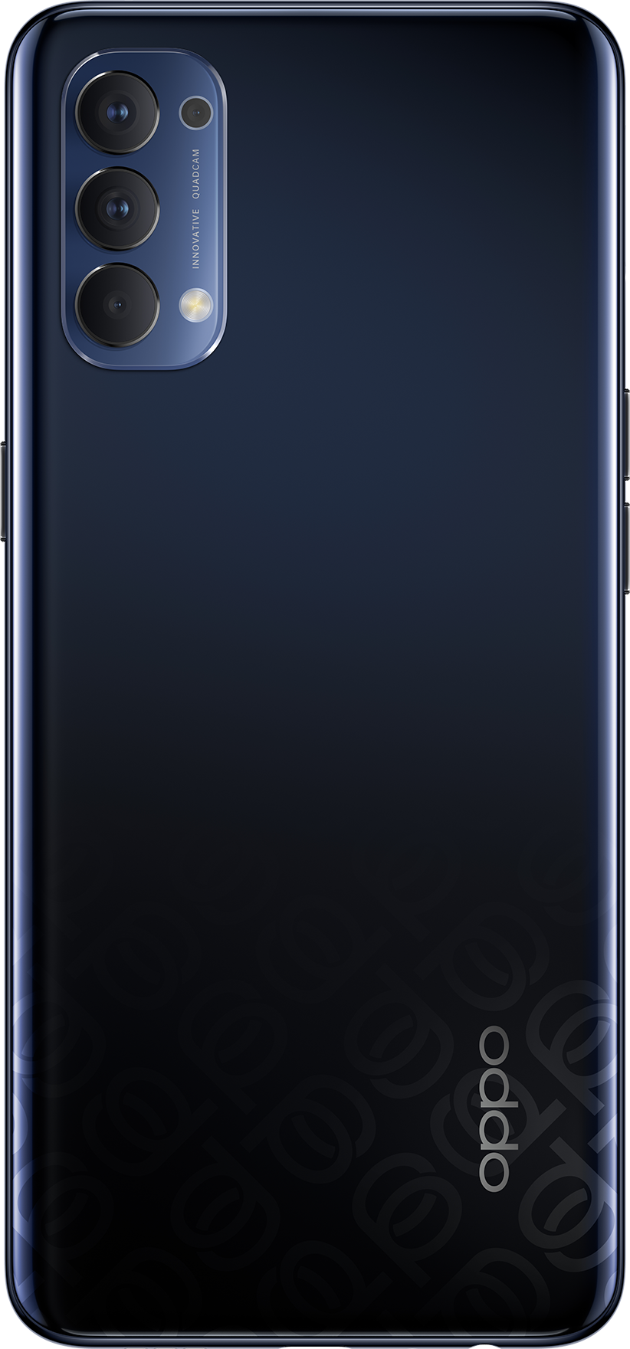
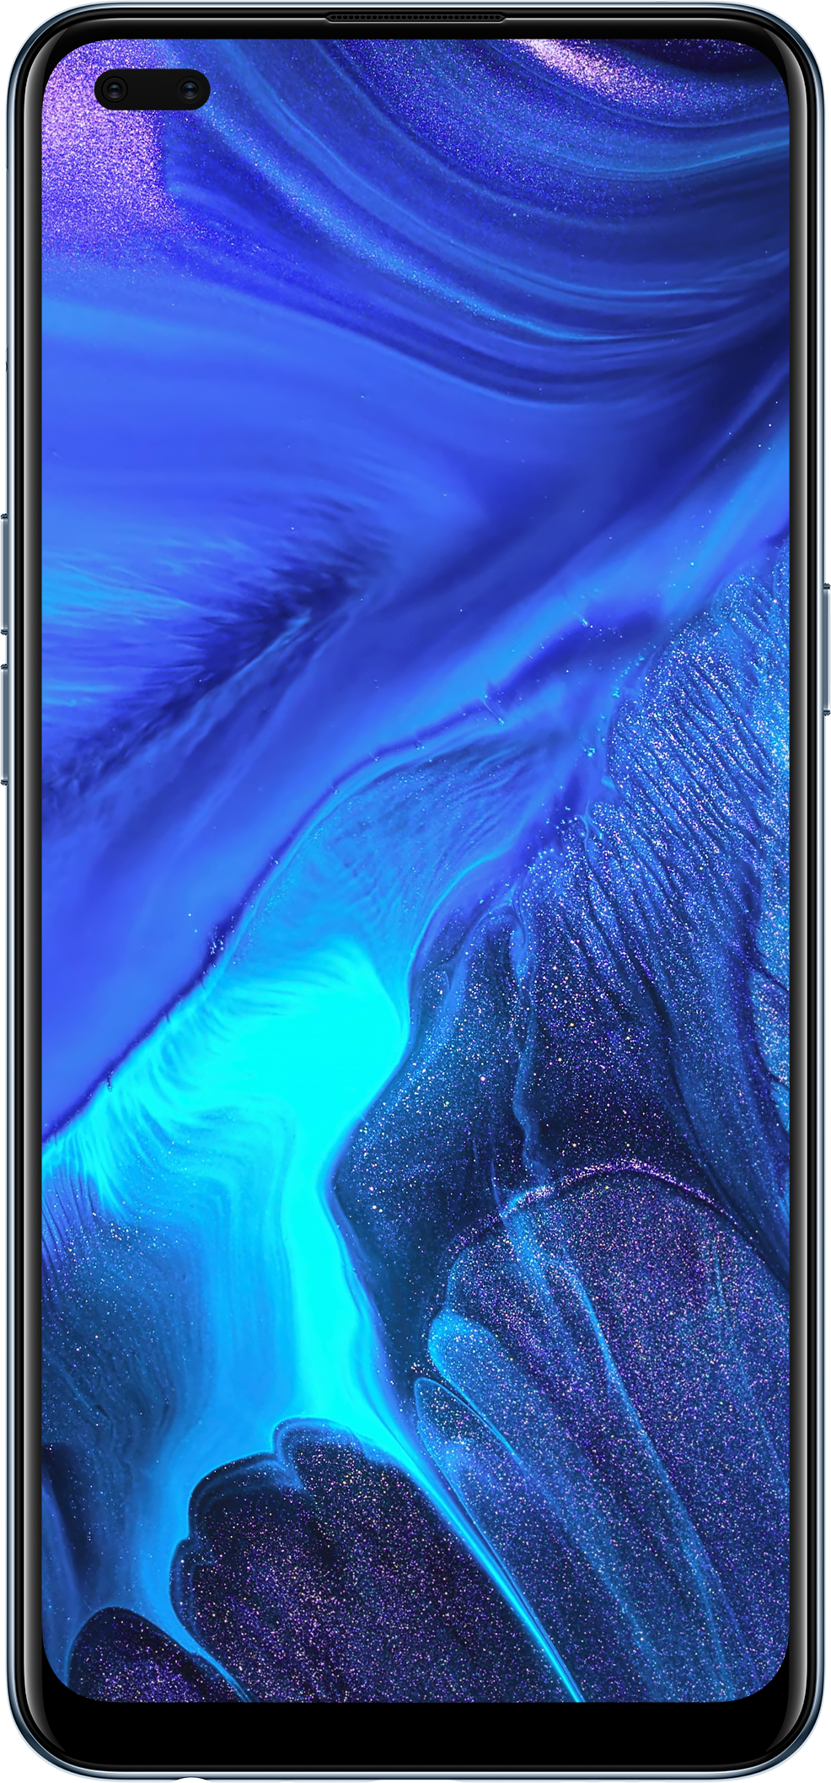

Confidential

Content

1. Guidance 3
1.1 Warnings 3
1.2 Cautions 3
2. General Repair Information 4
3. Phone Structure Diagram 5
3.1 Product Appearance 5
3.2 Phone Structure Explosive View 5
3.3 Explosive Map BOM 6
4. Disassembly Steps 9
4.1 Disassembly Tools 9
4.2 Preparation 9
4.3 Disassembly Steps 9
5. Assembly Steps 13
5.1 Bill of Must-Be-Replaced Materials 13
5.2 Assembly Steps 13
6. After-sale calibration 16
6.1 Leak Calibration 16
6.1.1 Calibration Scenario 16
6.1.2 Calibration Tool 16
6.1.3 Calibration Method 16
6.2 Fingerprint optical calibration 17
6.2.1 Calibration Scenario 17
6.2.2 Calibration Tool 17
6.2.3 Calibration Method 17
6.3 Dual Camera Calibration 17
6.3.1 Calibration Scenario 17
6.3.2 Calibration Tool 17
6.3.3 Calibration Method 17
7. Function Test 19
7.1 Test Path 20
7.2 Test Requirements 20
8. General Cautions 22

Guidance
The purpose of this document is only to guide OPPO technicians to carry out maintenance service to OPPO products. The content shall be keep in confidential, only avail be able to OPPO authorized service centers, and cannot be provided to third parties without authorization. Please follow the regulations and the guidance for maintenance service. For any problems, please contact China HQ in time.

1.1 Warnings
1. Care must be taken on installation in vehicles fitted with electronic engine management systems and ABS (Anti–skid Braking Systems). Under certain fault conditions, emitted RF energy can affect their operation. If necessary, consult the vehicle dealer/manufacturer to determine the immunity of vehicle electronic systems to RF energy.
2. Phones must not be operated in areas likely to contain potentially explosive atmospheres, e.g. petrol stations (service stations), blasting areas etc.
3. Operation of any radio transmitting equipment, including cellular telephones, may interfere with the functionality of inadequately protected medical devices. Consult a physician or the manufacturer of the medical device if you have any questions. Other electronic equipment may also be subject to interference

1.2 Cautions
1. Repair services and calibrations must be undertaken by qualified personnel only.
2. Use only approved components as specified in the parts list.
3. Ensure all components, modules screws and insulators are correctly re-fitted after servicing and alignment.
4. Electrostatic discharge is the main cause of damage to sensitive components of electronic products. Service centers must operate in accordance with OPPO's requirements for ESD protection. Ensure all work is carried out at an ESD workstation and that an ESD wristband is worn.

General Repair Information
- Ensure all work is carried out at an ESD workstation and that an ESD wristband is worn before starting maintenance.
- Wear ESD gloves to avoid oil stains and fingerprints.
- Use protective films to protect the display, camera, camera lens to prevent dust and scratches.
- Use a clean cloth, ESD brush and alcohol (Concentration above 95%) for appearance cleaning. Do not use other items (such as an eraser) for cleaning to prevent the protective layer from being scratched, which may lead to oxidation and corrosion.
- Faulty welded mechanical parts (except shield cover and shield frame parts) can only be replaced and not repairable.
- Use accessories provided by OPPO.
- Check the contacts or solder joints of devices that may cause simple faults (e.g. soldered interfaces or switches). Re-weld if necessary (only for service centers where lead-free soldering is available) and clean the flux remaining after soldering.
- Use the equipment provided by OPPO to test the phone (e.g. When the charging function of the device is abnormal, do use the original OPPO adapter to test to ensure the accuracy of the test results).
- Fill in the fault phenomenon code and fault reason code according to the actual situation, and accurately enter the replacement material code in the CRM system.
- For more information about products,
Mainland China please visit:
http://172.16.41.122:8888/kbaseui-dev/main.do
Regions except for Mainland China please visit:
ftp://ftpex.oppo.com:919/ or
https://oppo knowledge.custhelp.com/app/home/loc/zh_CN

3. Phone Structure Diagram

3.1 Product Appearance
As shown in Figure 3-1-1
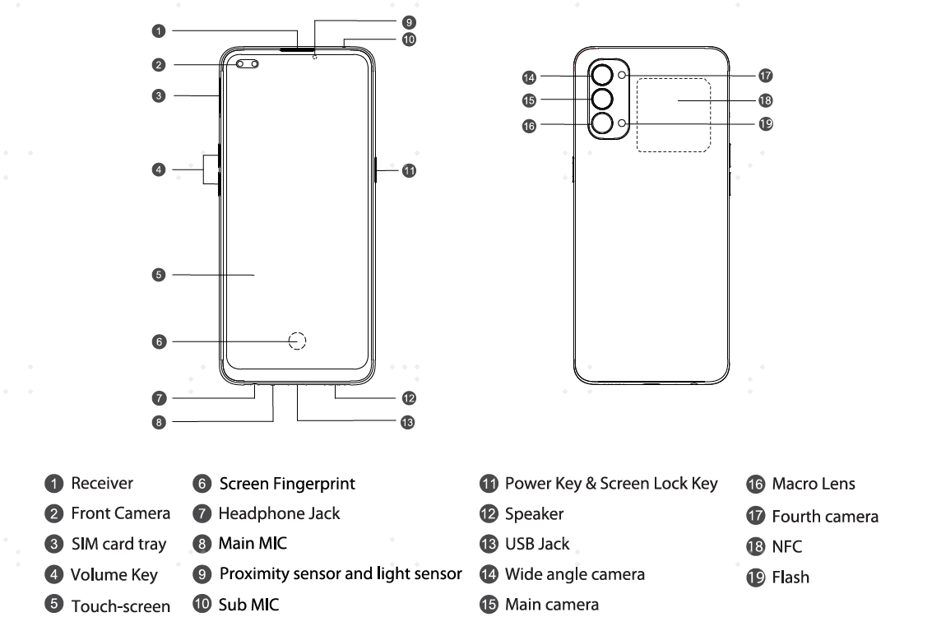

3.2 Phone Structure Explosive View
As shown in Figure 3-2-1

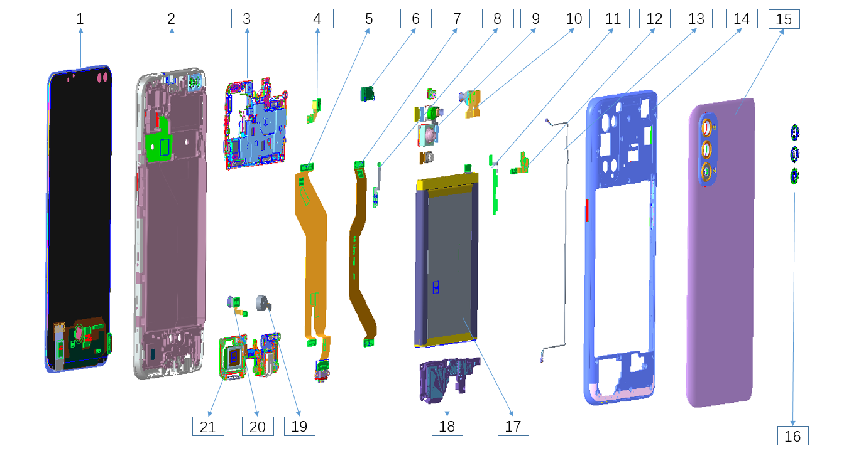
Figure 3-2-1

3.3 Explosive Map BOM
No. | Material Name(After-sales) | Physical Figure | Sub material | QTY | Unit
1 | Screen | 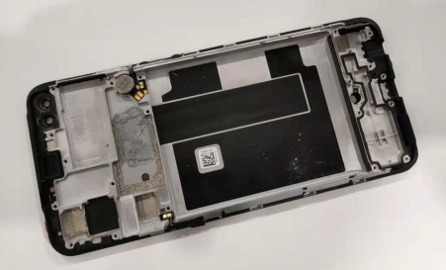 | (1) OLED Display Screen | 1 | PCS
1 | Screen |  | (2) Middle Frame | 1 | PCS
2 | Mainboard | 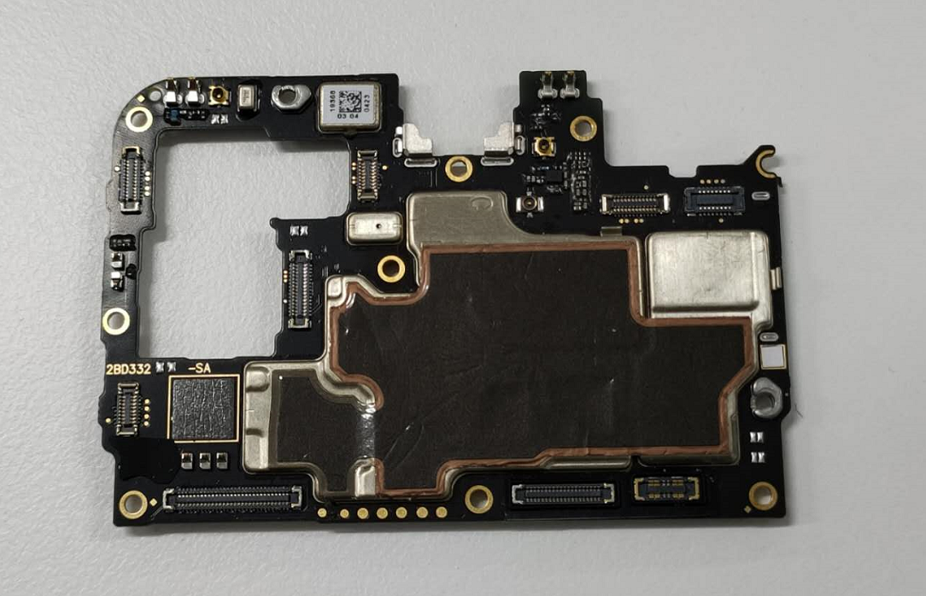 | Test point PET sheet 1 | 1 | PCS
2 | Mainboard |  | Test point PET sheet 2 | 1 | PCS
2 | Mainboard |  | (3) PCB semi-finished | 1 | PCS
2 | Mainboard |  | Waterproof paste | 1 | PCS
3 | Middle frame | 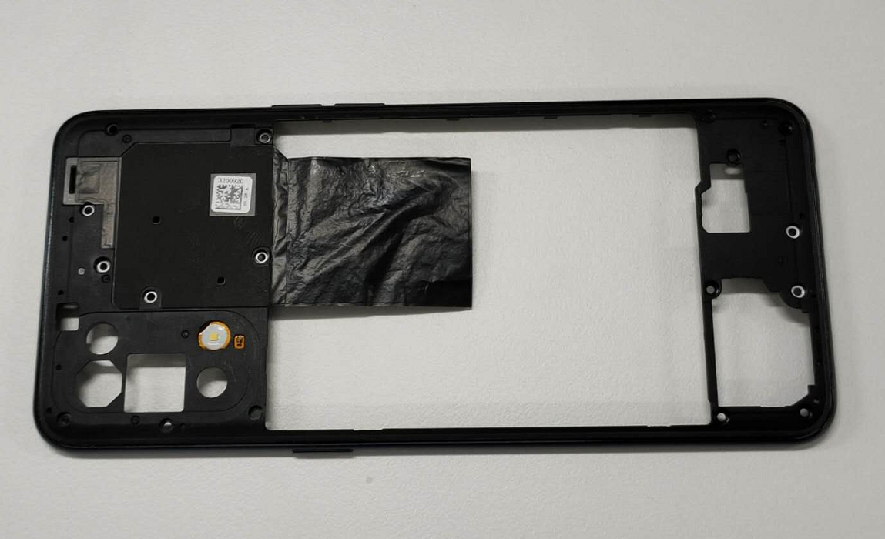 | (14) Middle frame | 1 | PCS
3 | Middle frame |  | (12) Flash FPC | 1 | PCS
4 | Front cameras | 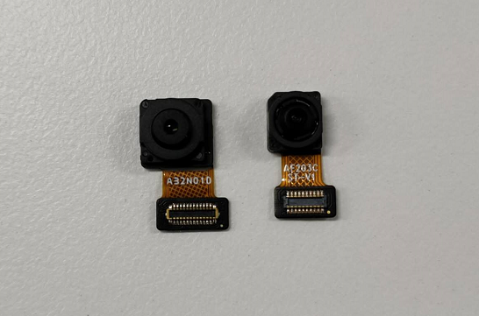 | (10) Cameras, the right one is the AON camera | 1 | PCS
5 | Main camera | 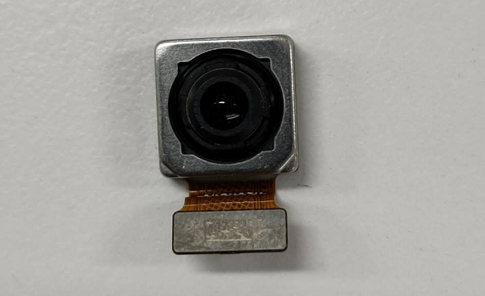 | (9) Rear main camera | 1 | PCS
5 | Main camera |  | Rear camera conductive cloth | 1 | PCS
6 | Wide angle | 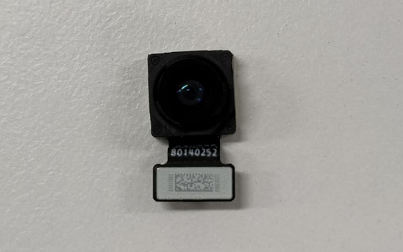 | (9) Rear wide-angle camera | 1 | PCS
6 | Wide angle |  | Rear camera conductive cloth | 1 | PCS
7 | Macro camera | 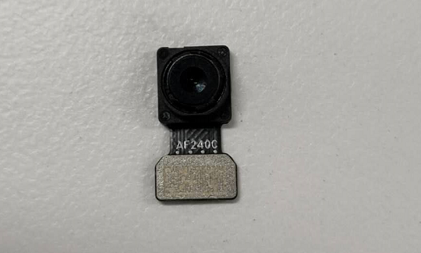 | (9) Rear macro camera | 1 | PCS
8 | B&W camera | 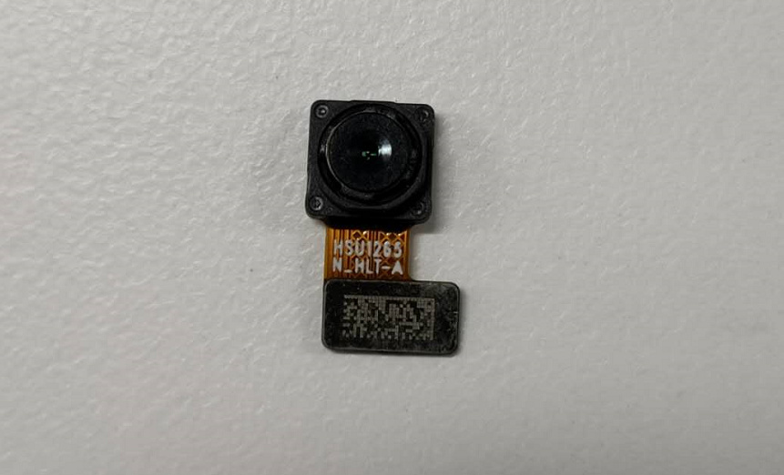 | (9) Rear filter camera | 1 | PCS
9 | USB FPC | 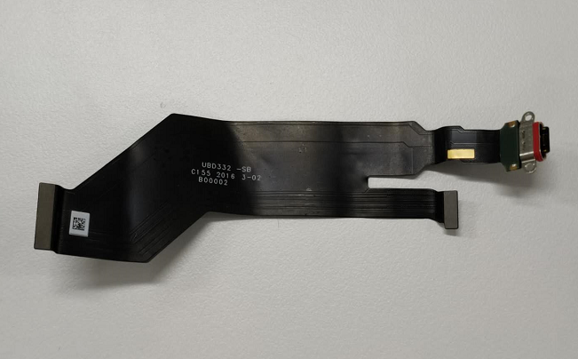 | (5) USB FPC | 1 | PCS
10 | Fingerprint sensor | 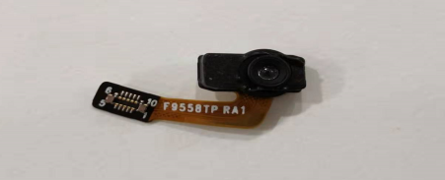 | (20) Fingerprint sensor | 1 | PCS
10 | RF cable | 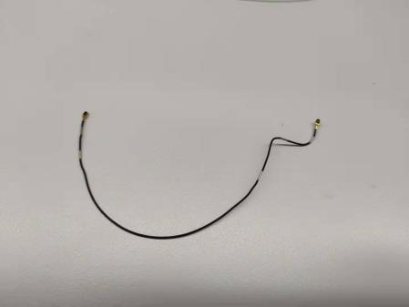 | (13) RF cable | 1 | PCS
13 | L-FPC | 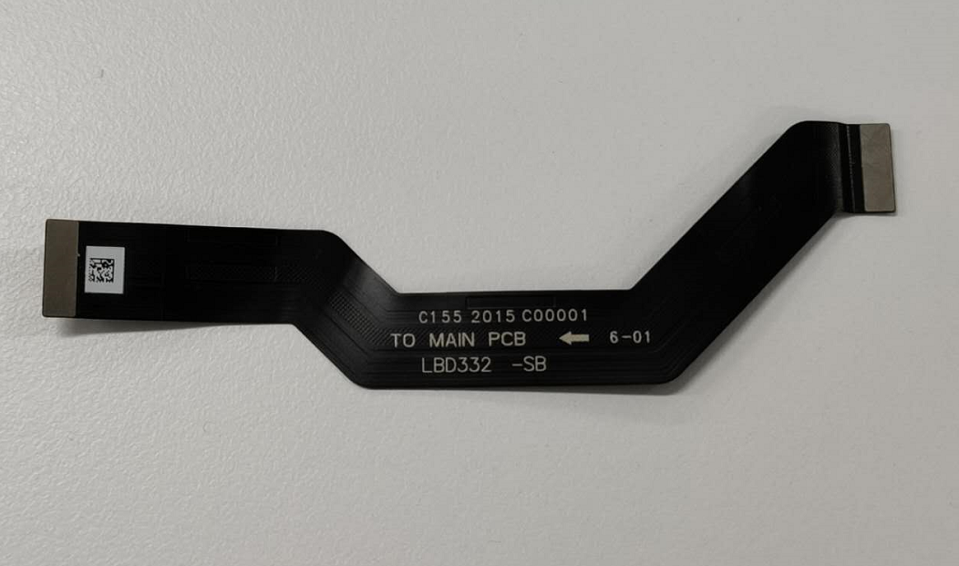 | (7) L-FPC | 1 | PCS
14 | BOX | 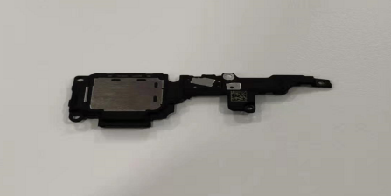 | (18) BOX | 1 | PCS
15 | Antenna board | 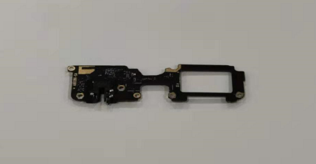 | (20) Antenna board | 1 | PCS
16 | Back cover | 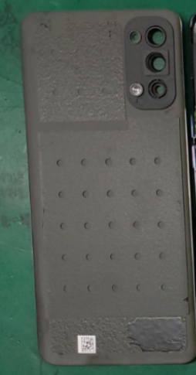 | (15) Back cover | 1 | PCS
16 | Back cover |  | (16) Camera lens | 1 | PCS
17 | Camera adapter FPC | 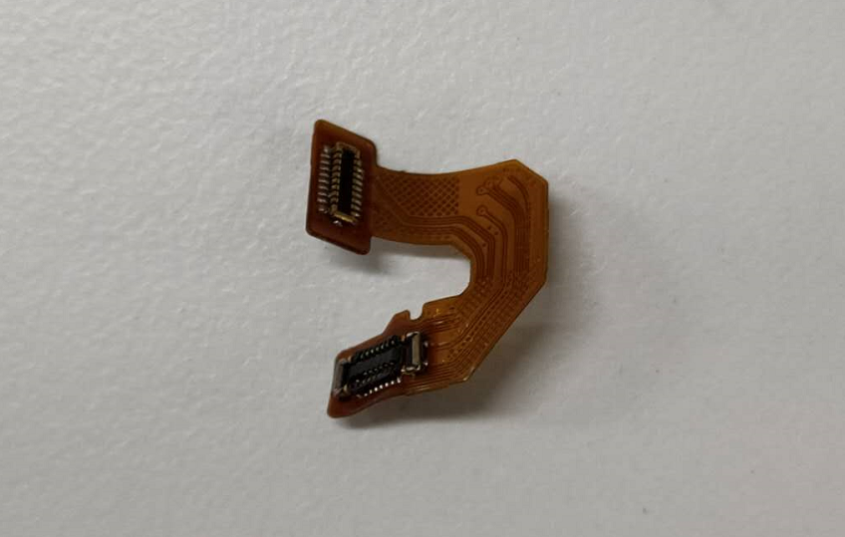 | (4) Camera adapter FPC | 1 | PCS
18 | Vibration motor | 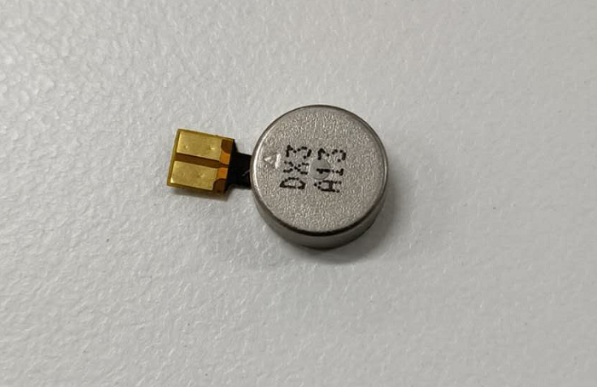 | (19) Vibration motor | 1 | PCS
19 | Receiver | 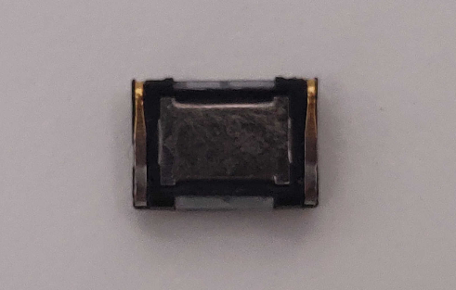 | (6) Receiver | 1 | PCS
20 | Keys FPC | 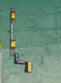 | (11) Volume-FPC | 1 | PCS
20 | Keys FPC | 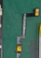 | (8) Power-FPC | 1 | PCS
21 | Battery | 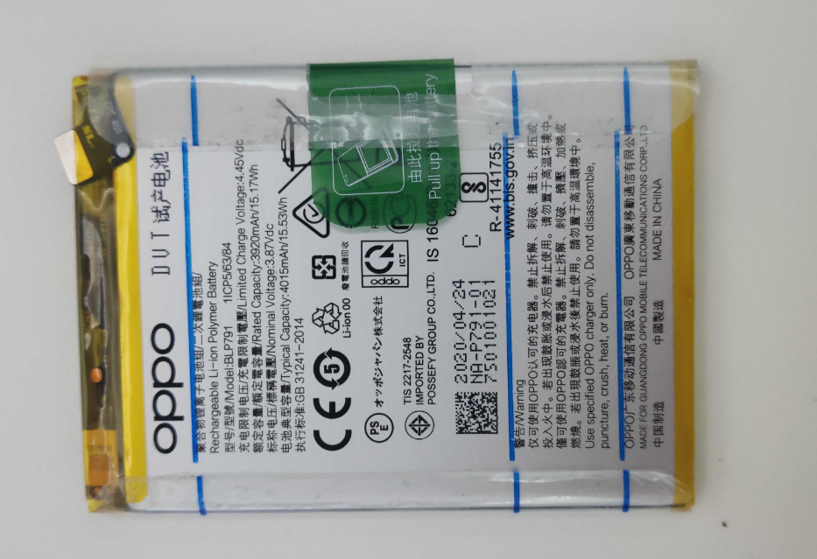 | (17) Battery | 1 | PCS

Note：This table is used only for the name of the annotation but not for the preparation of materials. Please refer to the Price List of OPPO Mobile Phone Original Accessories (for Mainland China)/Price List of Commonly-Used Materials and Accessories (Regions except for Mainland China) for the preparation.

4. Disassembly Steps

4.1 Disassembly Tools
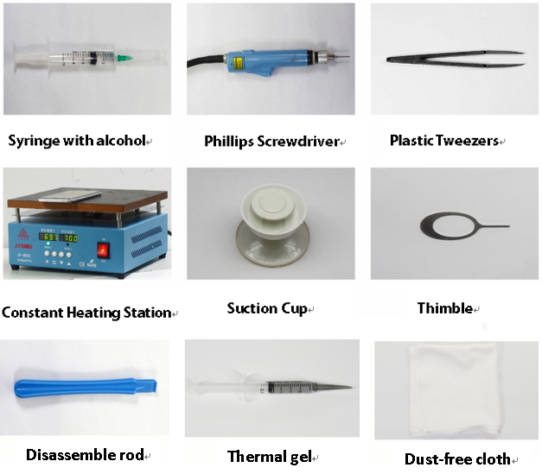

4.2 Preparation
1. The phone must be powered off before disassembly.
2. Way to Power Off:
System Power Off: Press the power key then slide to power off.
Forced Power Off: Long press the volume “+” key and power key for about 8 seconds until the display is off.

4.3 Disassembly Steps

Step | Content | Figure | Cautions
1 | Remove the SIM tray | 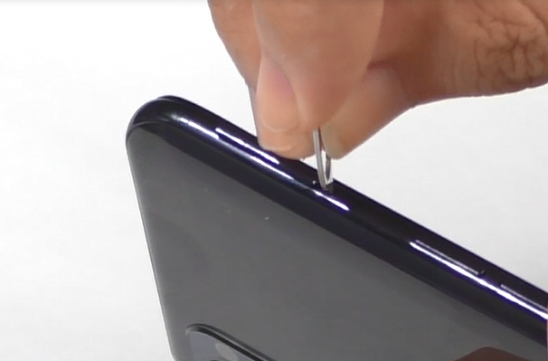 | Don't scratch the device
2 | Remove the back cover | 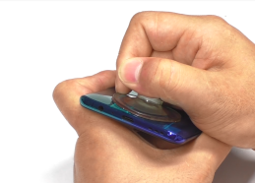  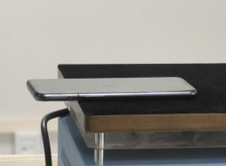 | Avoid heating the camera. Heating requirements: 70 ° C -80 ° C for 5-10 mins;  (2) Control the strength when the battery cover and the middle frame are separated.
3 | Clean Double-sided tape | 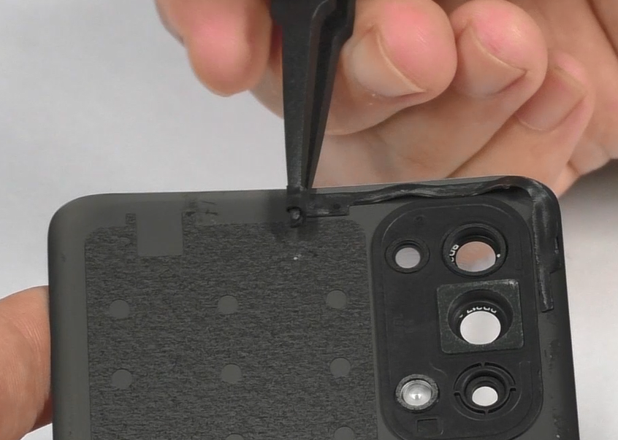 | Please confirm whether the rear decorative ring is degummed. If it is loose, replace the back glue (4882492) of the decorative part and press it hard.
4 | Remove the middle frame | 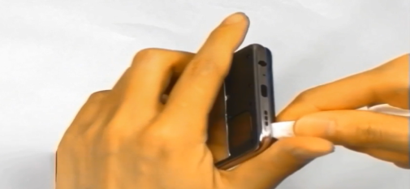  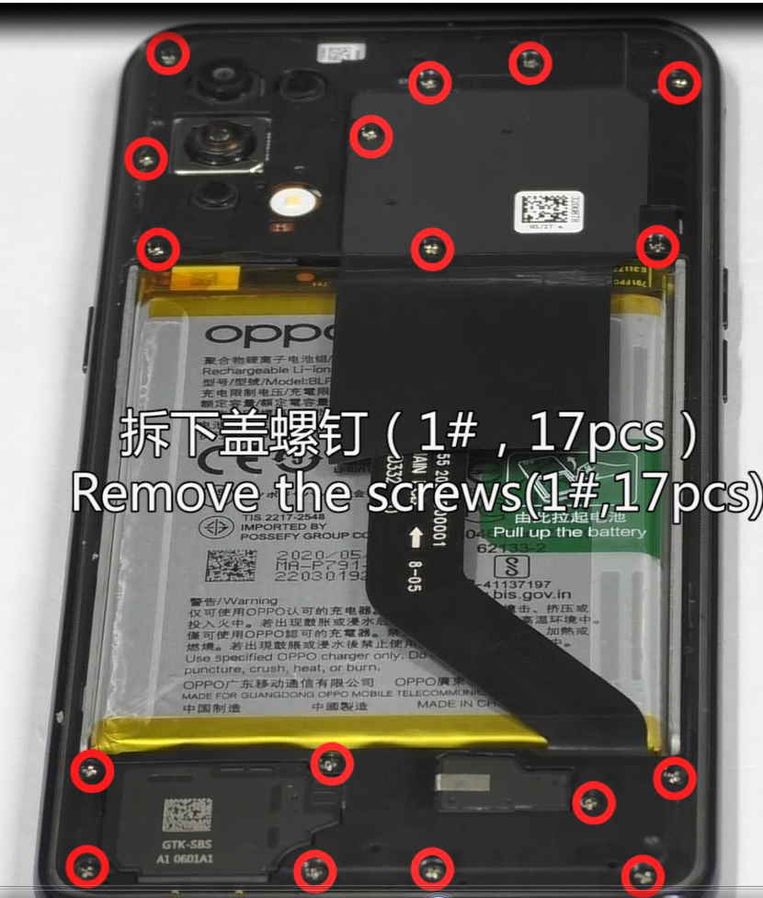 | Be careful not to damage the card tray
5 | Remove the battery | 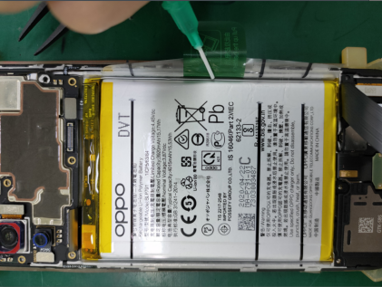  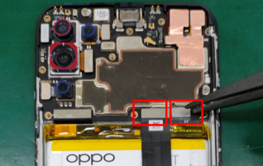  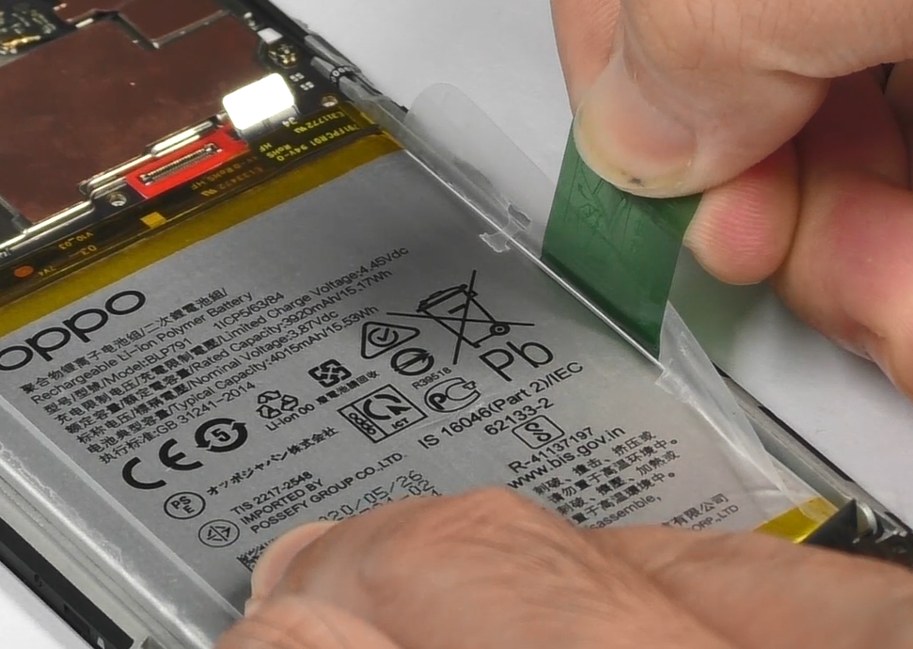 | Add 0.2ml of alcohol to the top and bottom of the handle, and stand the phone sideways for 15 seconds until the alcohol spreads;  Note: During disassembly of the battery, it is necessary to avoid bending and deformation of the middle part of the battery as much as possible.
7 | Uninstall the cameras | 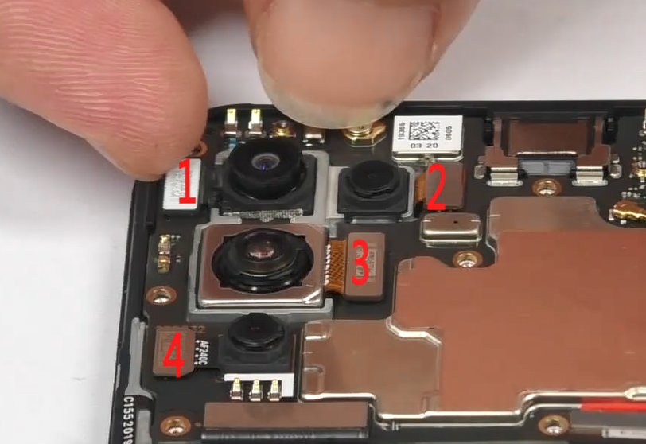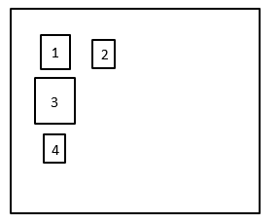 | Use your fingernail or plastic tweezers to disassemble the 4 BTB buttons of the rear camera, and gently take out the No.1 camera, No.3 camera and No.4 camera cameras respectively. The No.2 camera adapter plate BTB needs to be turned up to 90° with the whole machine;
8 | Remove the cameras | 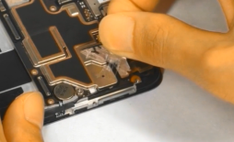  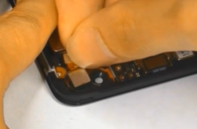 | The front graphite sheet must be disassembled and replaced to avoid dust entering through holes (if dust enters, please use air blowing, do not use brush)
9 | Remove RF cable, foam, mainboard fixing screws, mainboard | 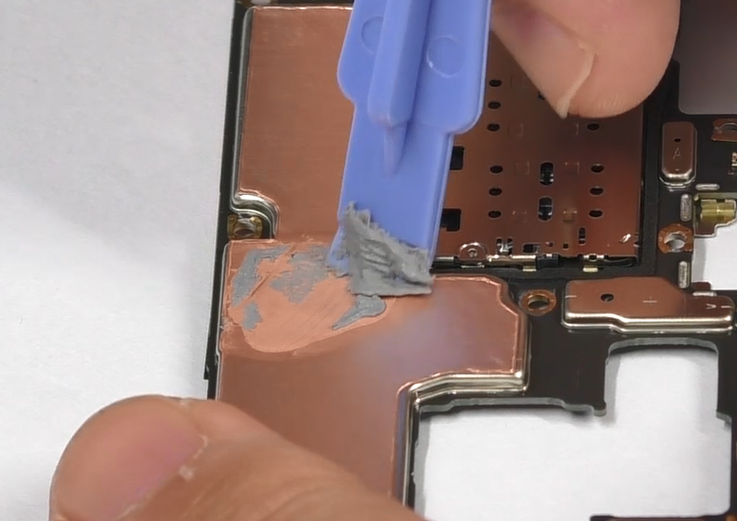  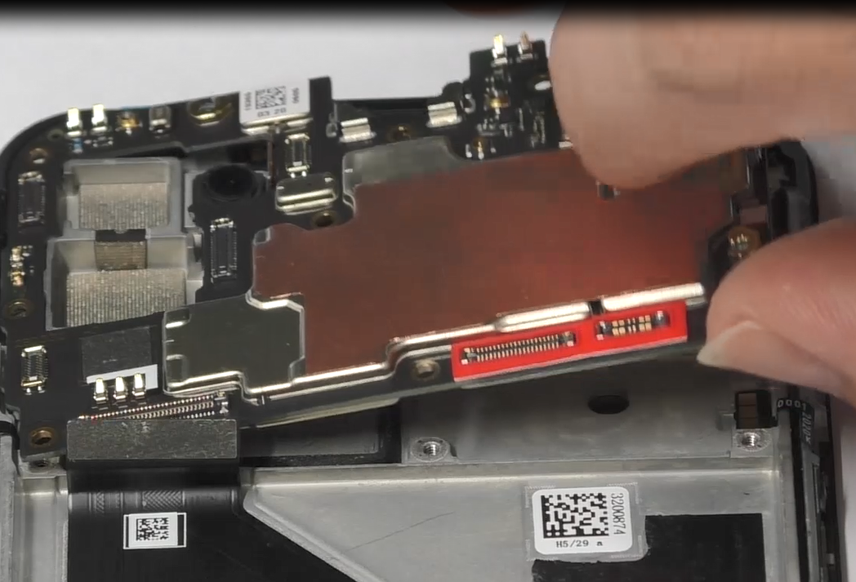  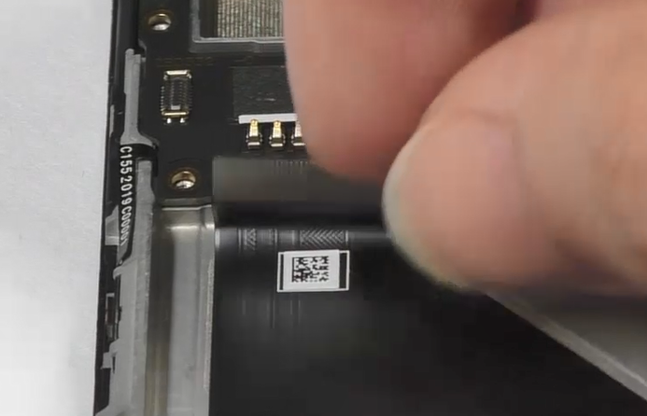  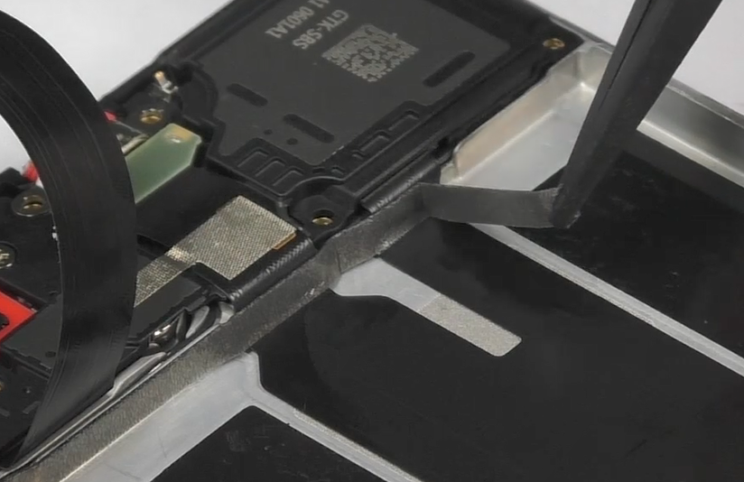  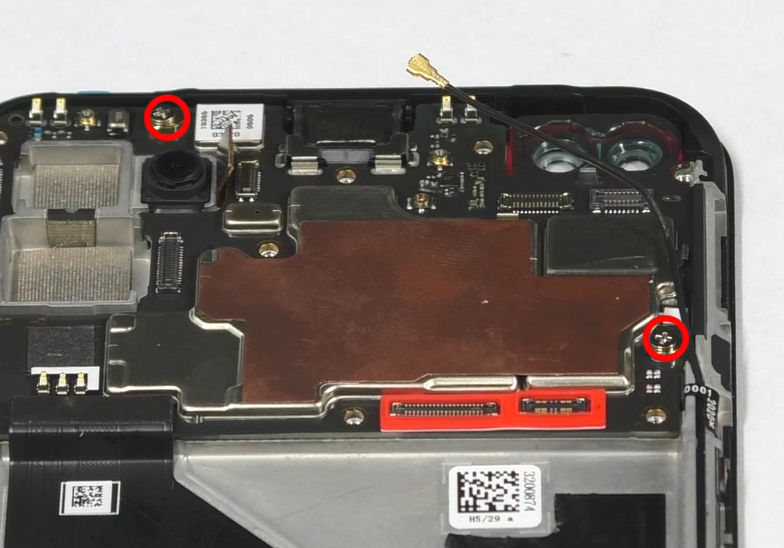  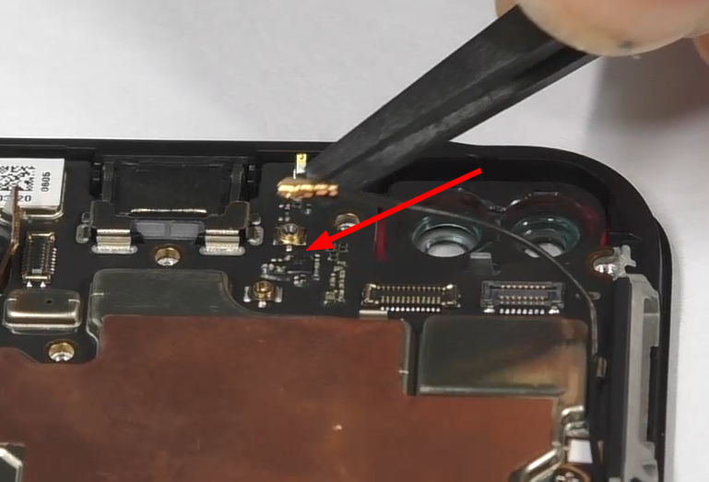 | Pick up the motherboard from the right
10 | Remove No.2 camera, receiver, light-sensitive PCB | 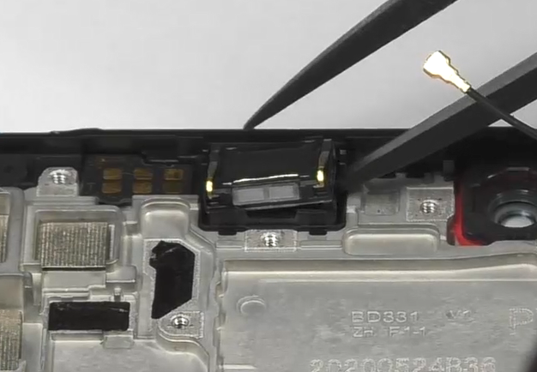  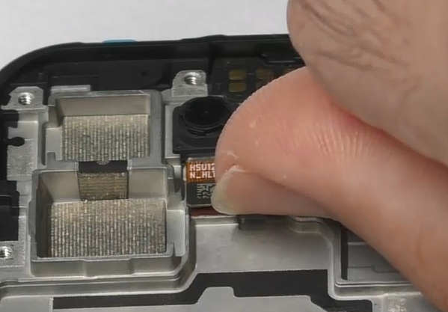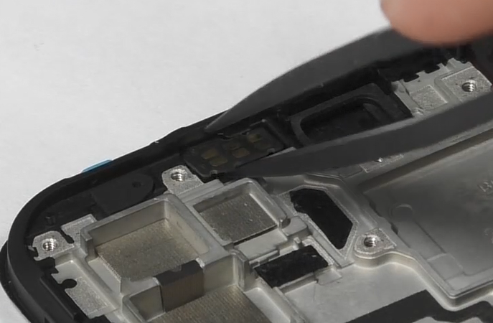 | /
11 | Remove the antenna board fixing screws | 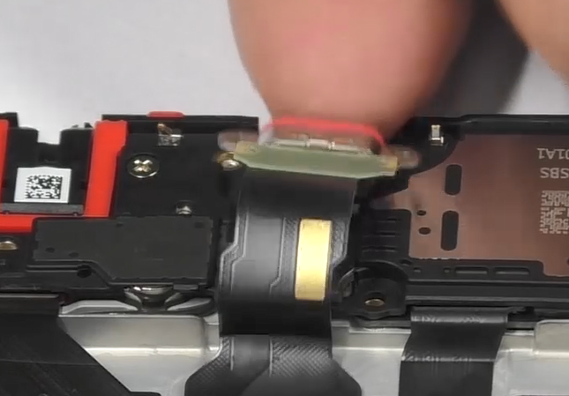  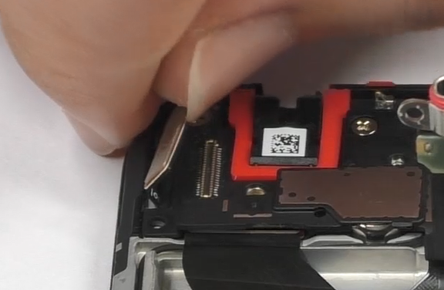  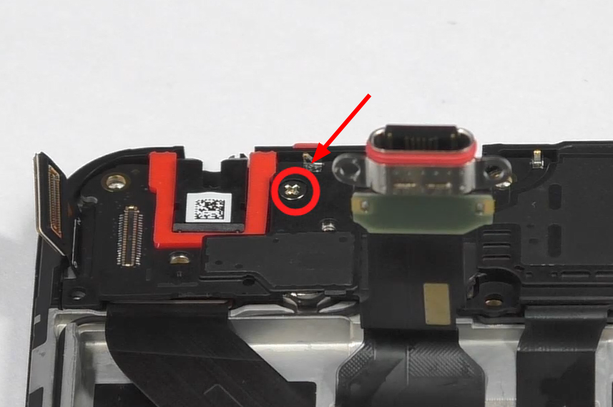  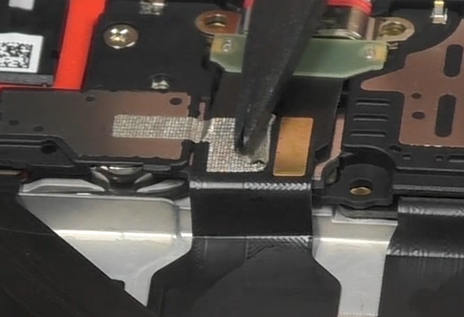 | /
12 | Remove USB | 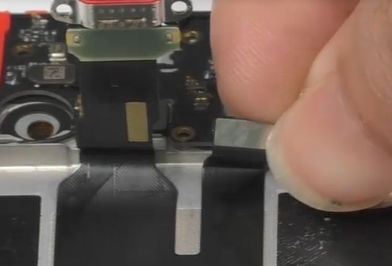  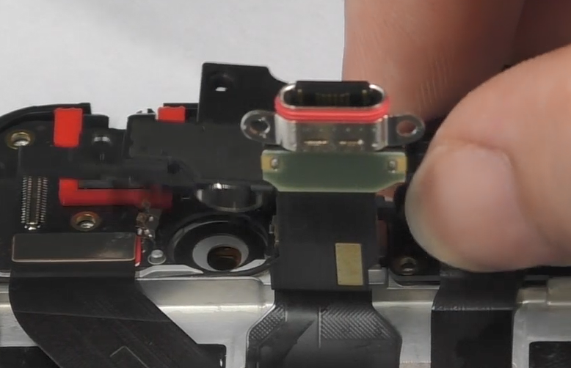 | /
13 | Remove the fingerprint sensor | 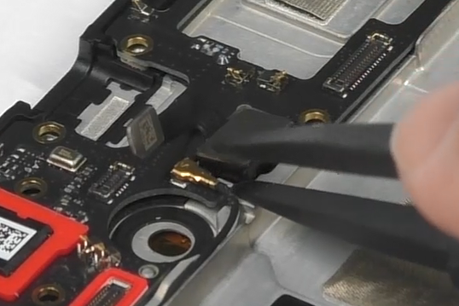  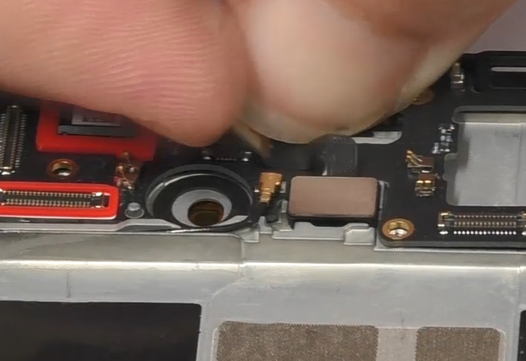 | /
14 | Remove RF cable、antenna board | 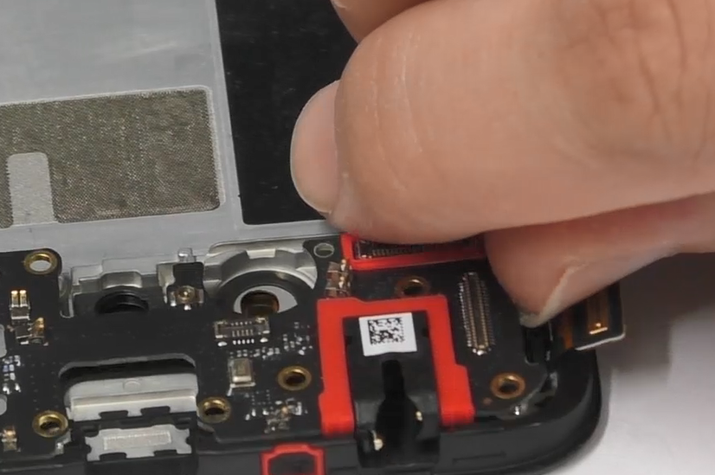  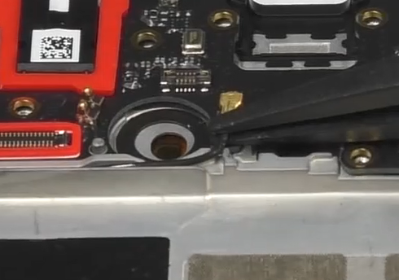 | /
15 | Remove FPC、RF cable | 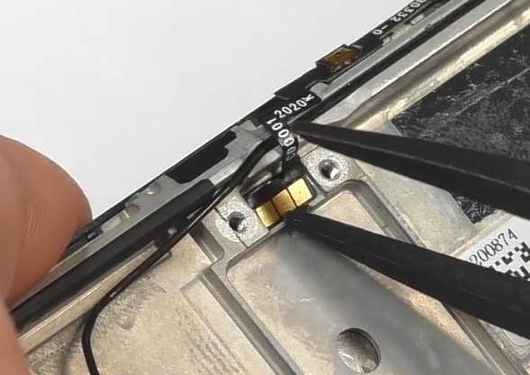  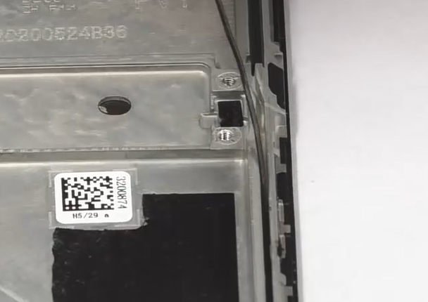  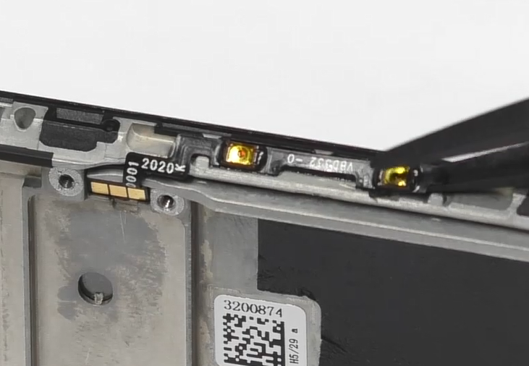  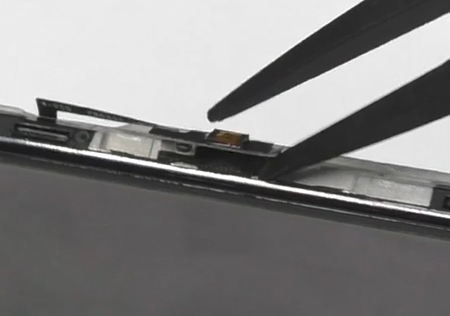 | /

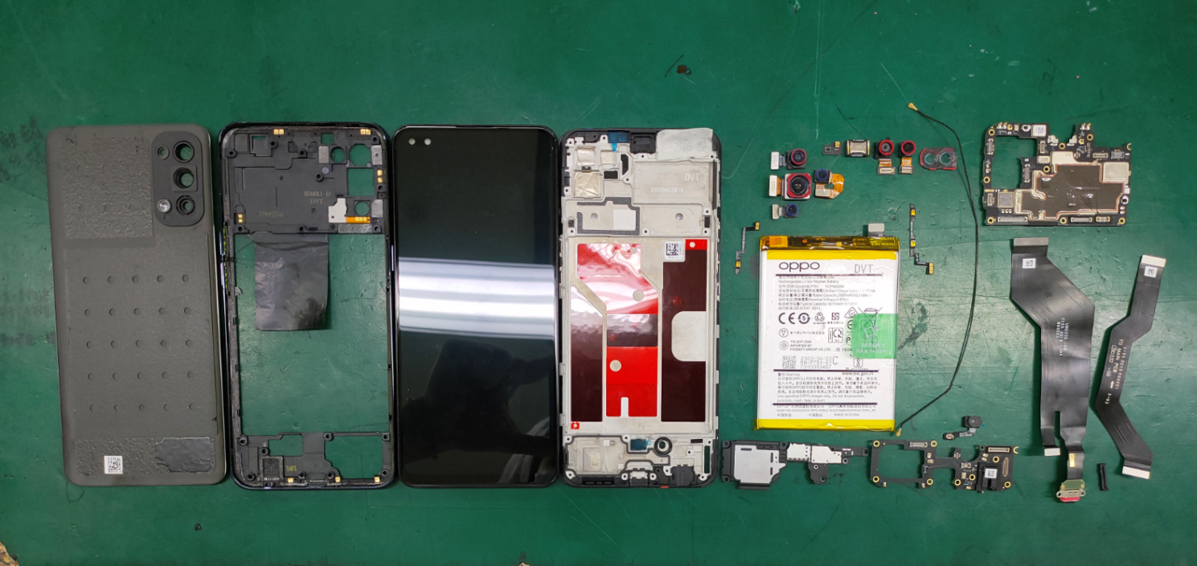
Figure 4.3 All Materials of the Phone

5. Assembly Steps

5.1 Bill of Must-Be-Replaced Materials
No. | Code | Material | SPEC. | QTY | Remark
1 | 4883010 | Battery pull tape | BLP791 transparent | 1 | Remove the battery must be replaced
2 | 4882366 | Front camera copper foil sticker | BD331 | 1 | Must be replaced after disassembly
3 | 4882492 | Camera decorative ring double-sided adhesive | BD331 | 1 | Must be replaced after disassembly
4 | 4881759 | Battery cover double-sided tape | BD331 | 1 | Must be replaced after disassembly

5.2 Assembly Steps
Step | Content | Figure | Cautions
1 | Install No.2 camera, power key FPC | 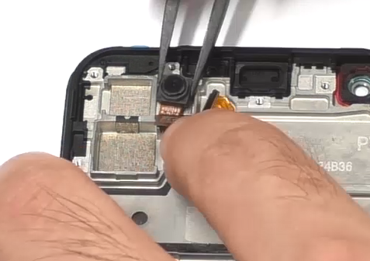  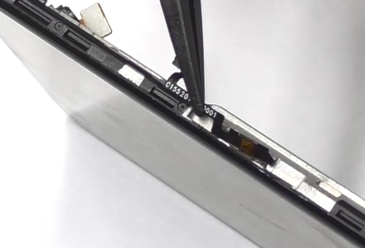 | Buckle up BTB of camera
2 | Install antenna board, Fingerprint sensor | 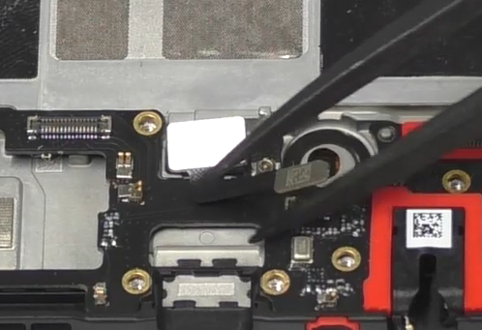  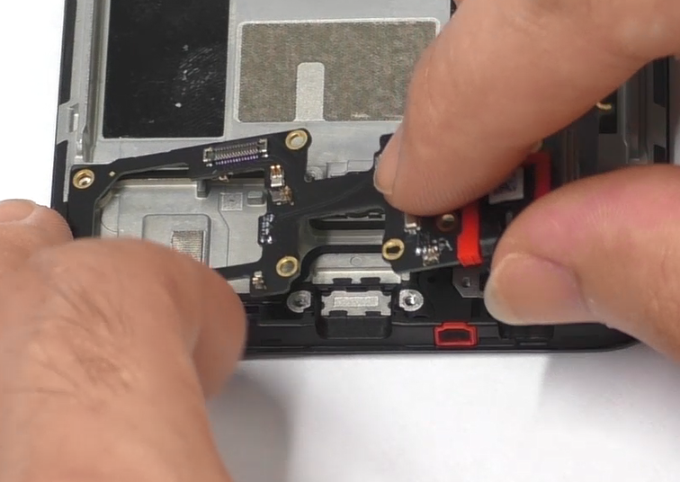 | Buckle up BTB of fingerprint
3 | Install volume key FPC, receiver | 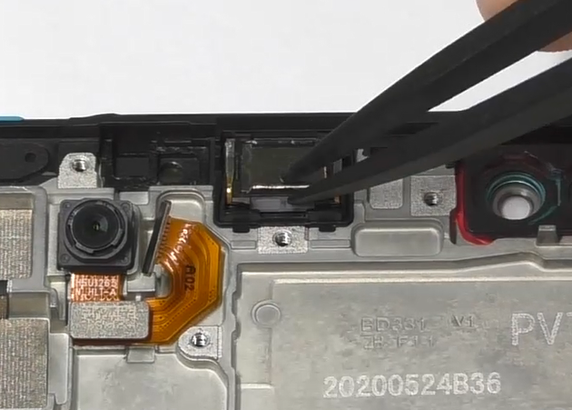  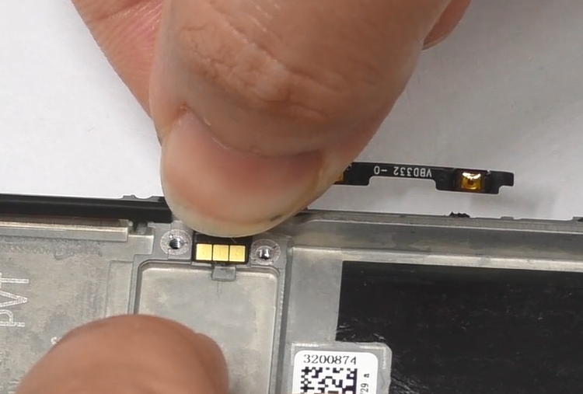 | Volume key FPC not installed outside
4 | Install light sense FPC，paste thermal gel | 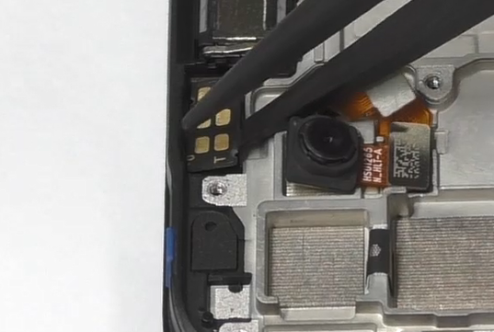  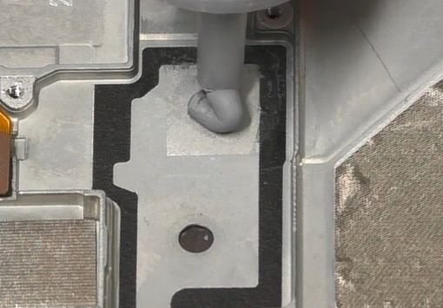 | /
5 | Install mainboard | 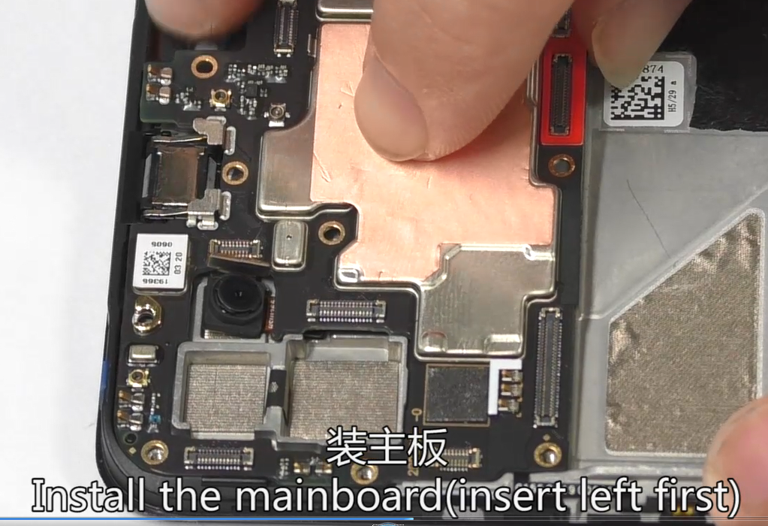  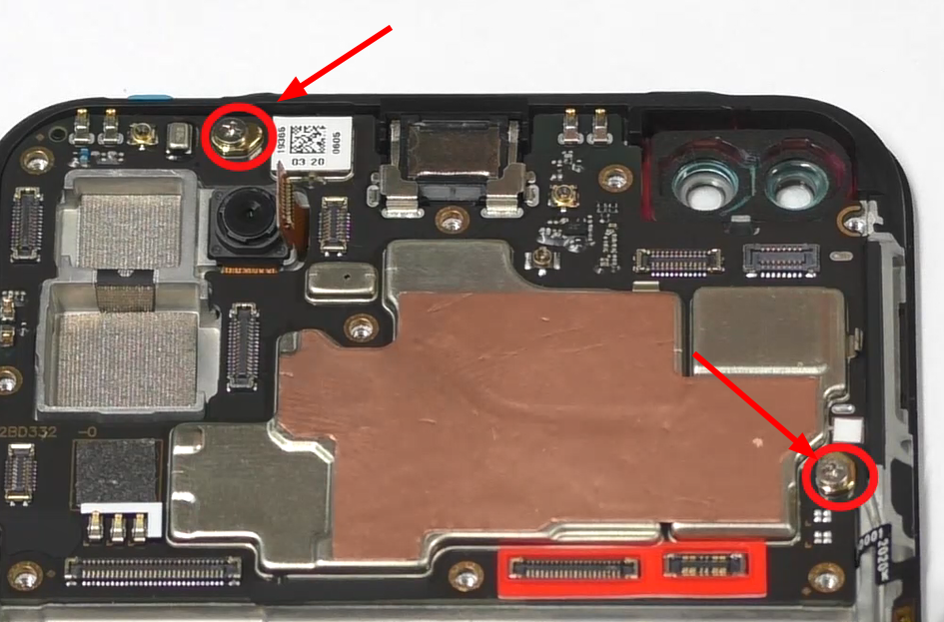 | Fix the mianboard screws after installation (2pcs)
6 | Install RF cable | 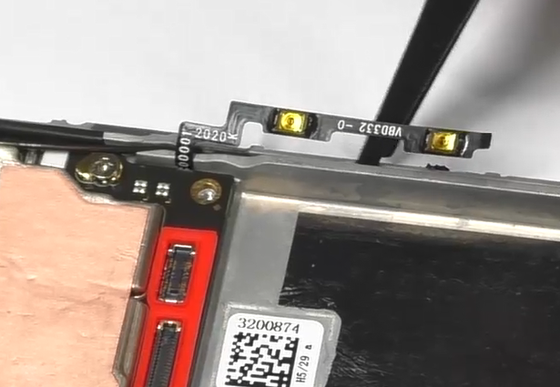  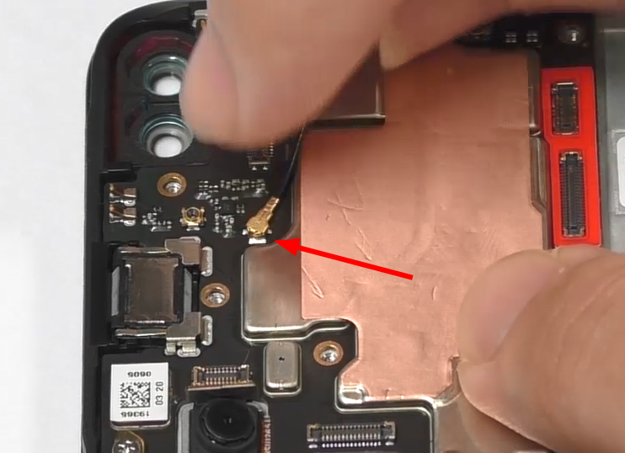 | Install the volume button FPC after installing the RF cable
7 | Install cameras | 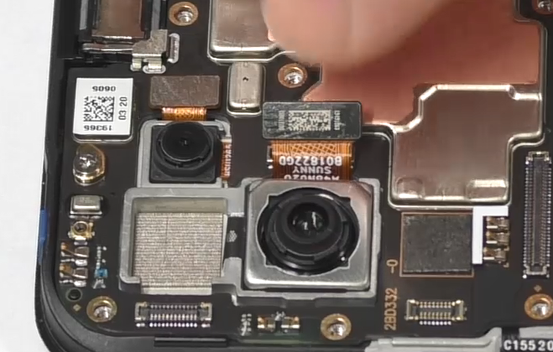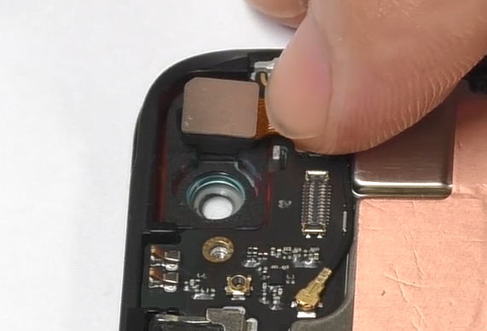 | /
8 | Install USB | 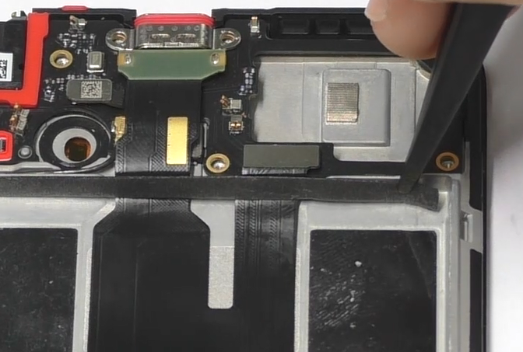  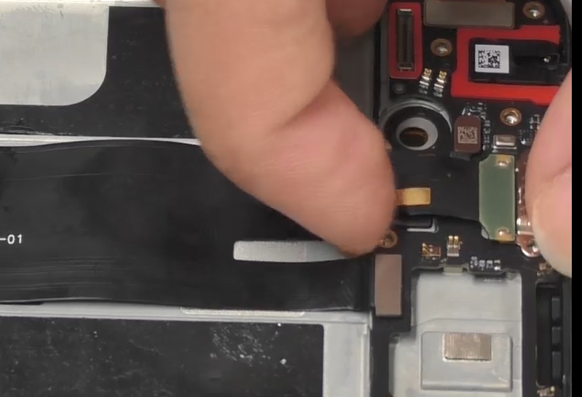 | /
9 | Install battery | 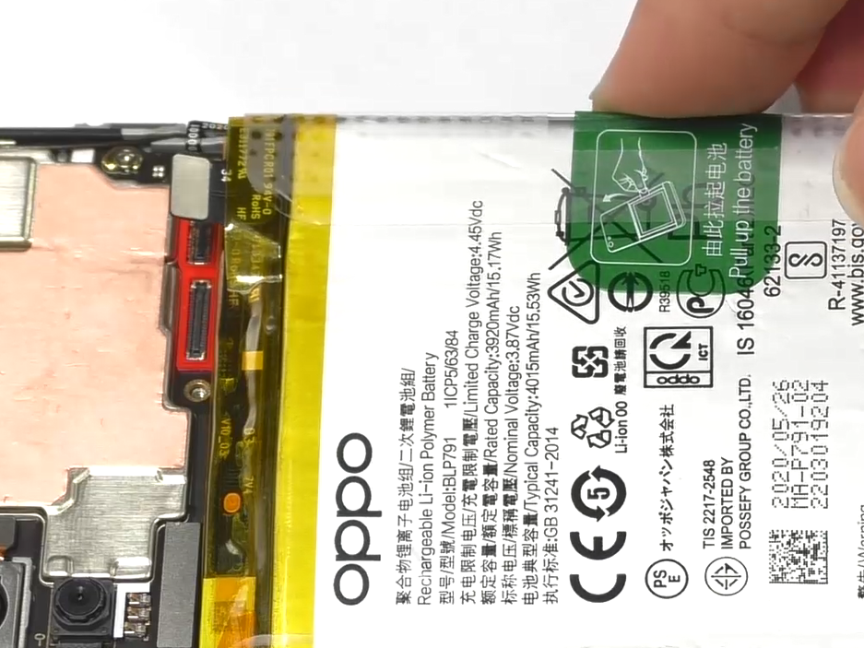  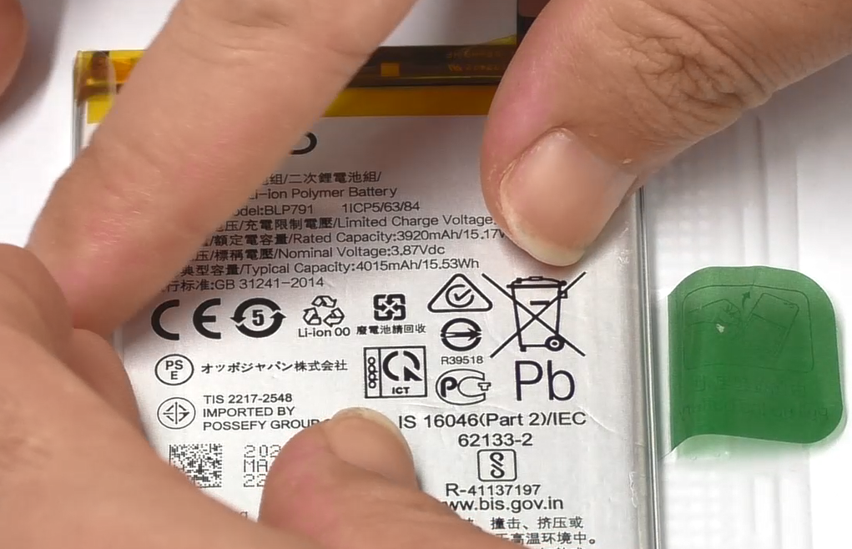 | Change easy to tear paper
10 | Install L-FPC, BOX, copper foil | 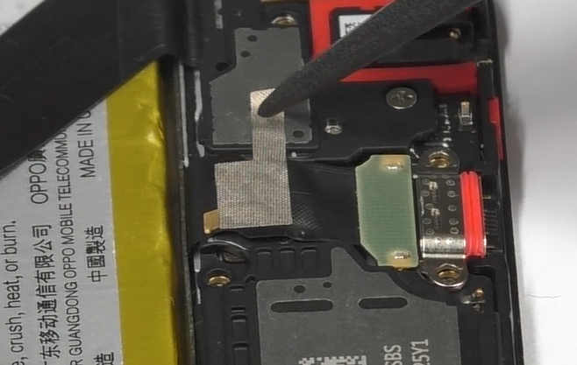  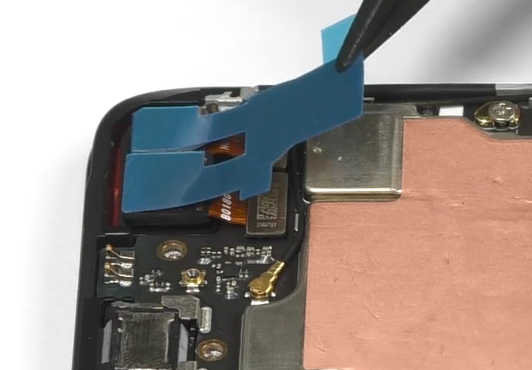  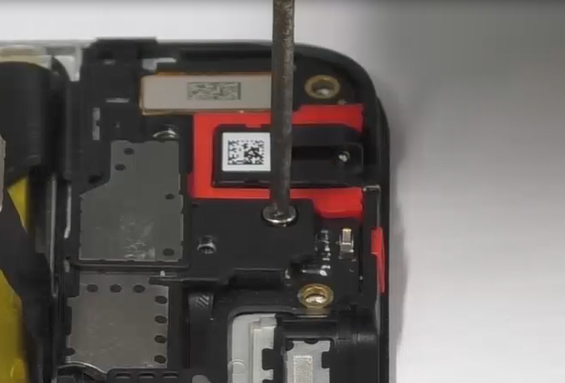  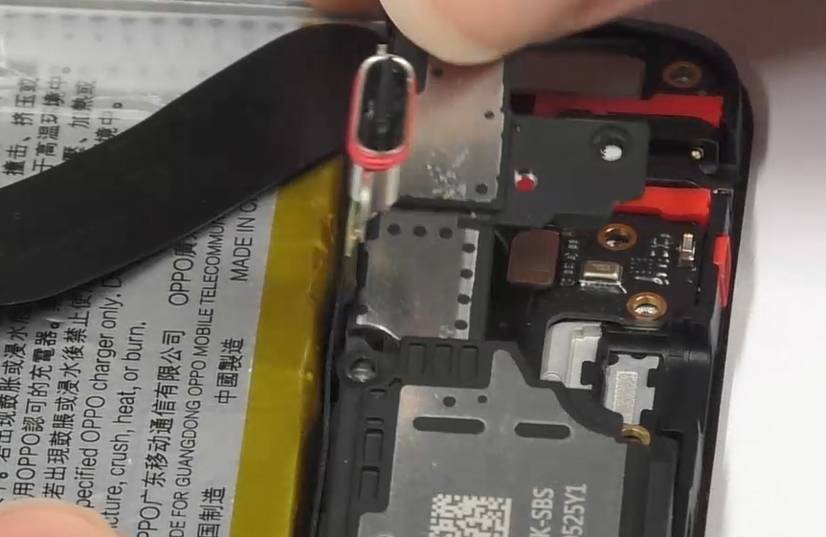 | /
11 | Install middle frame | 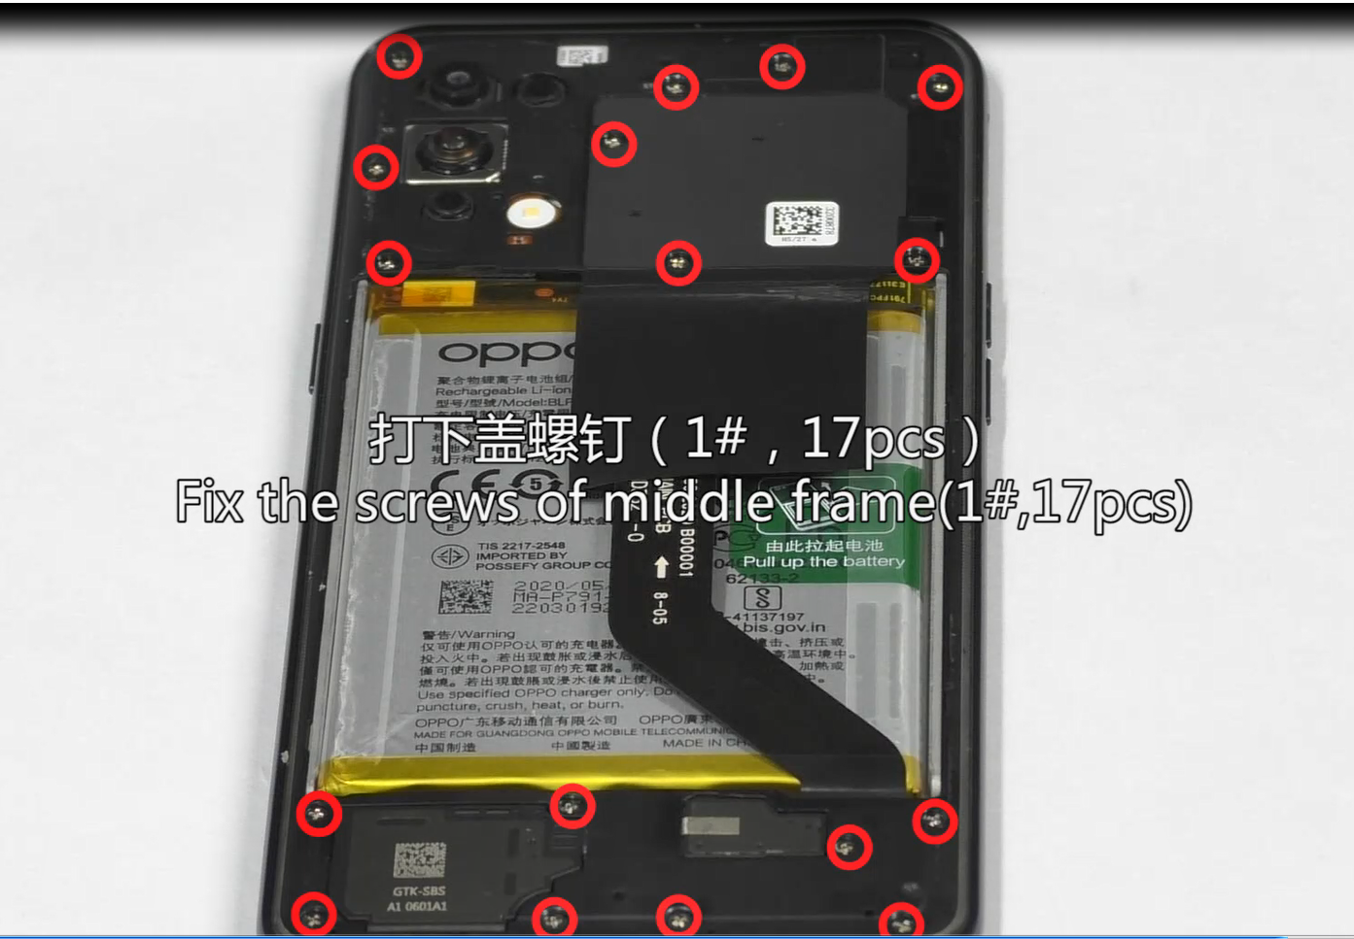  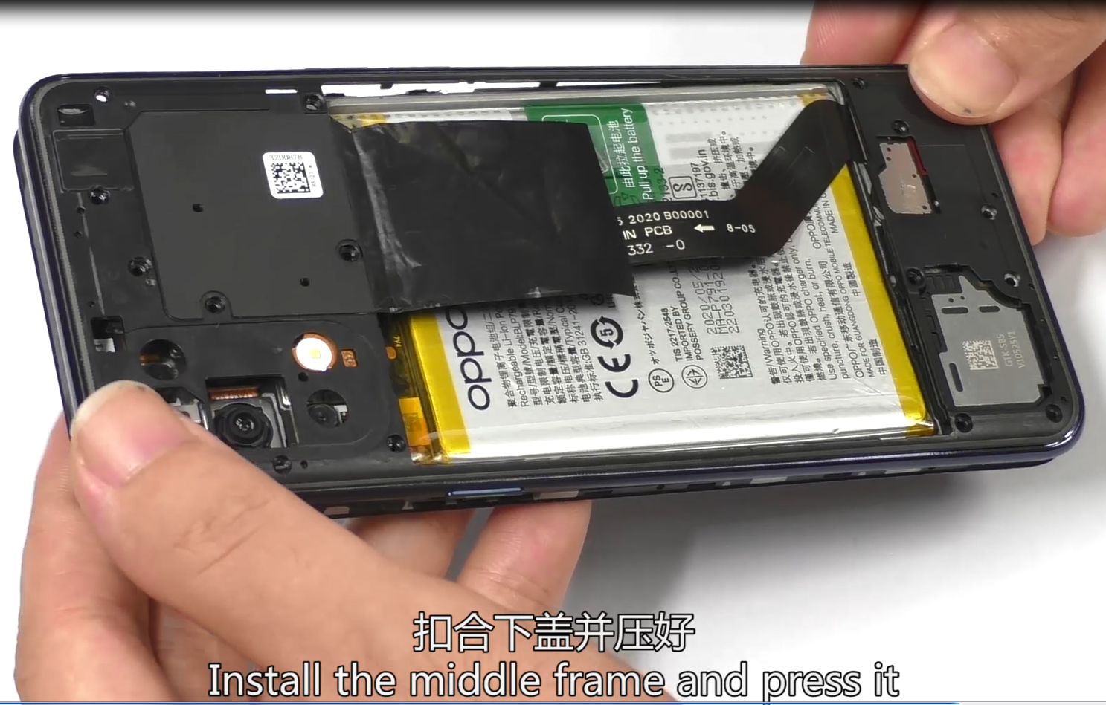 | Screw 17pcs
12 | Install back cover | 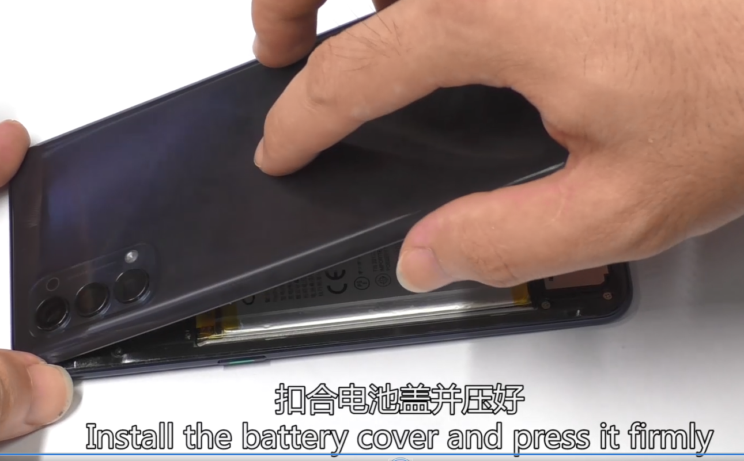  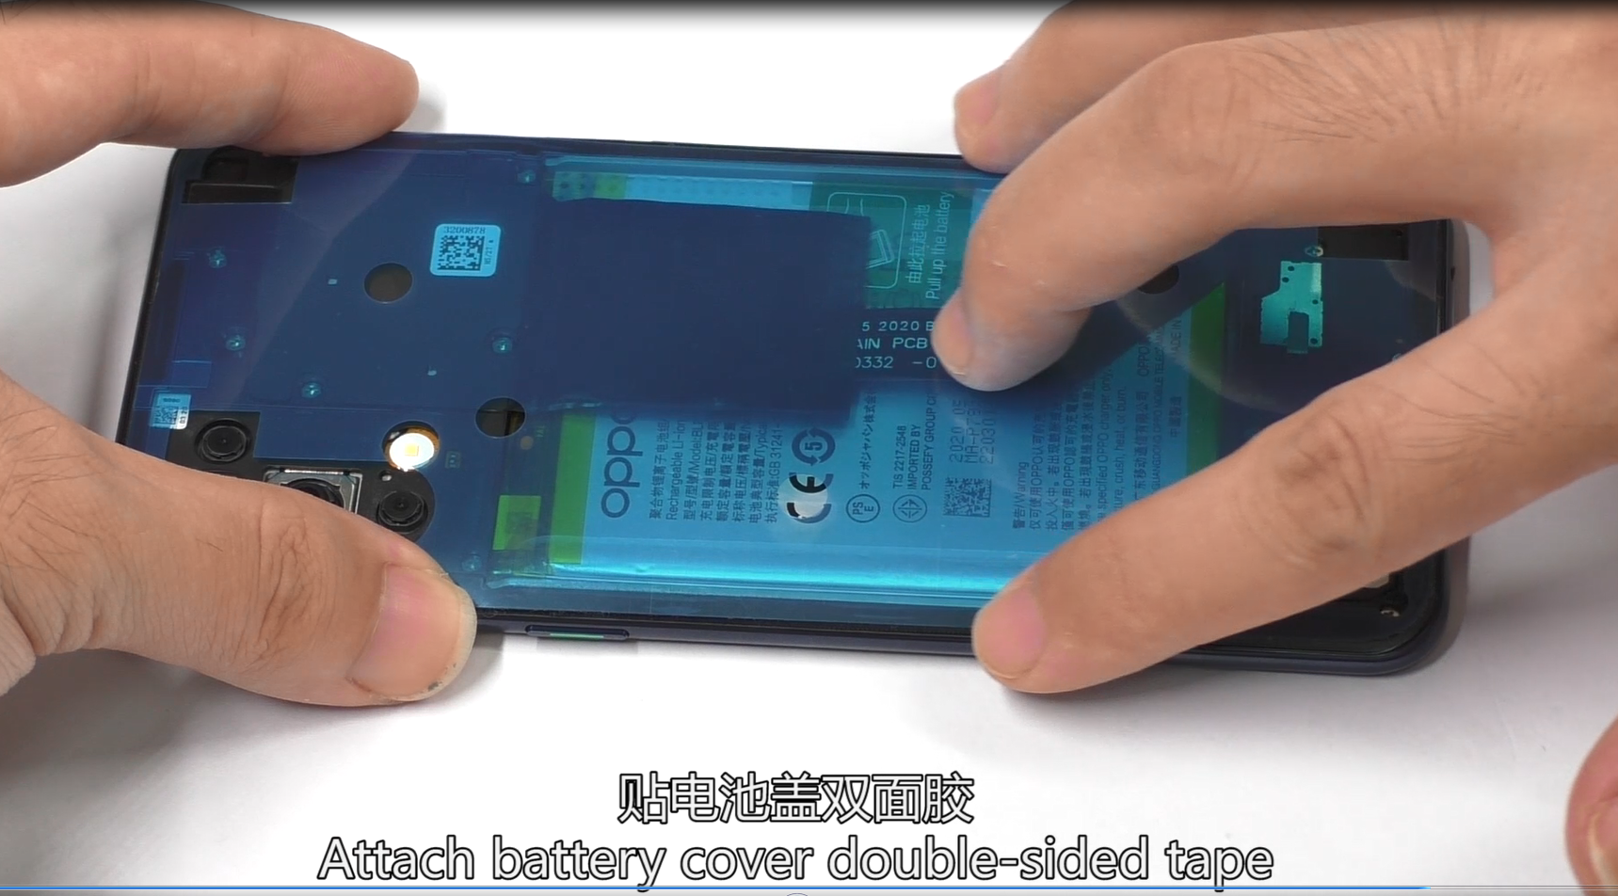 | After the back cover is installed, press hard to activate the adhesive
13 | Install card tray and check functions | 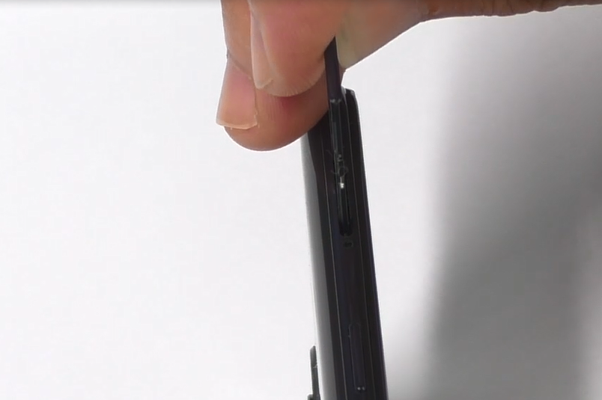  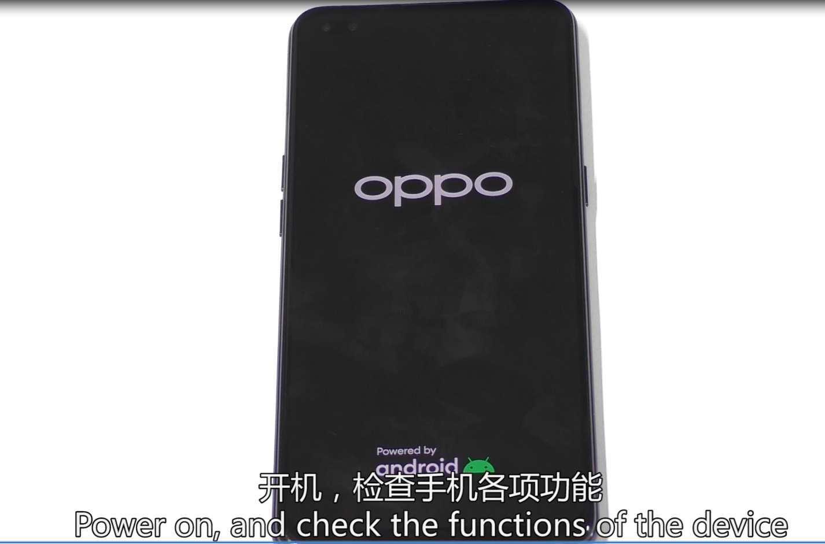 | /

6. Calibration
After the phone is disassembled and assembled, the aftersale devices calibration must be calibrated first. The calibration of this model includes(leak calibration--fingerprint optical calibration--aftersales calibration--smart power amplifier calibration.
Enter Password: 6776 | Click ”leak calibration ” |  | When the environment is completely black, click the "leak calibration" button; |  | 1.Click "START" to start calibration after it jumps into the fingerprint optical calibration
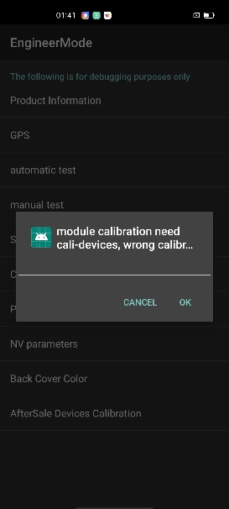 | 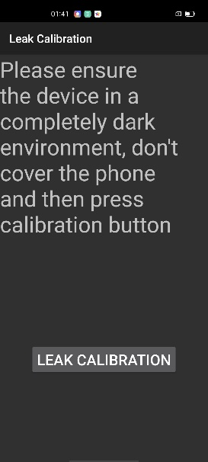 |  | 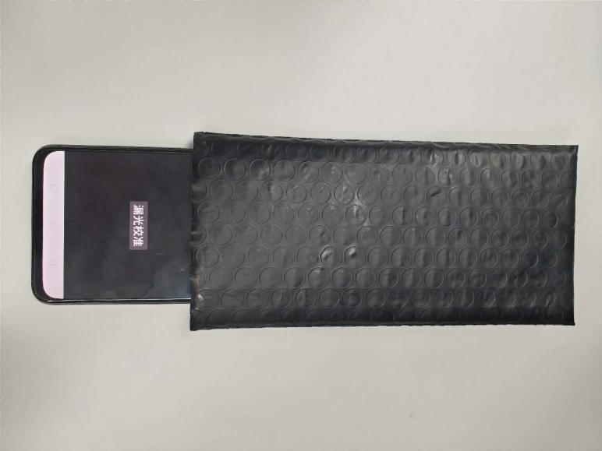 |  | 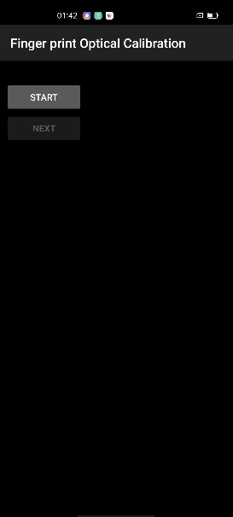
2. According to the prompt "please place the yellow rubber ", put the yellow rubber on the fingerprint spot area (the groove is facing down), and click "NEXT" until it prompts " please place the black rubber". |  | 3. According to the prompt "please place the black rubber head", put the black rubber on the fingerprint spot area (the groove is facing down), click "NEXT" until the "please place the yellow stripe rubber " prompts to remove the black rubber ; |  | 4. According to the prompt “Please place the yellow- striped rubber”, put the yellow stripe rubber (striped down) in the spot area, click “NEXT”;
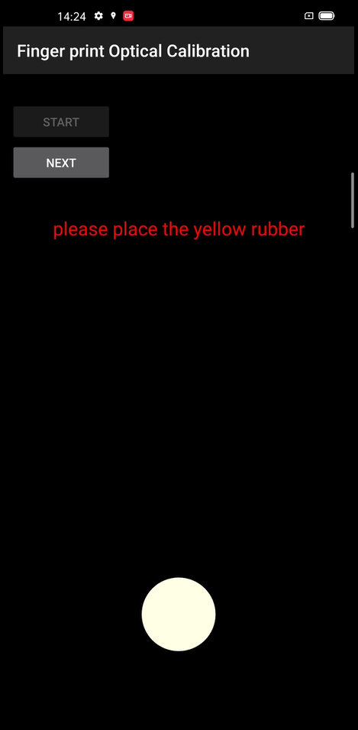 |  | 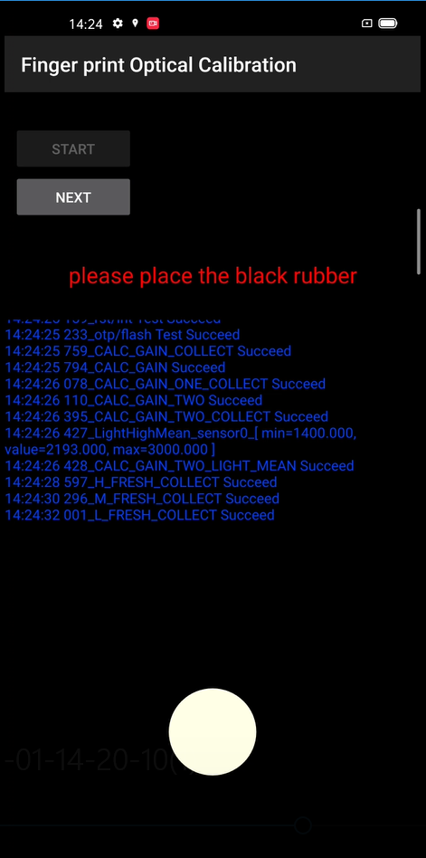 |  | 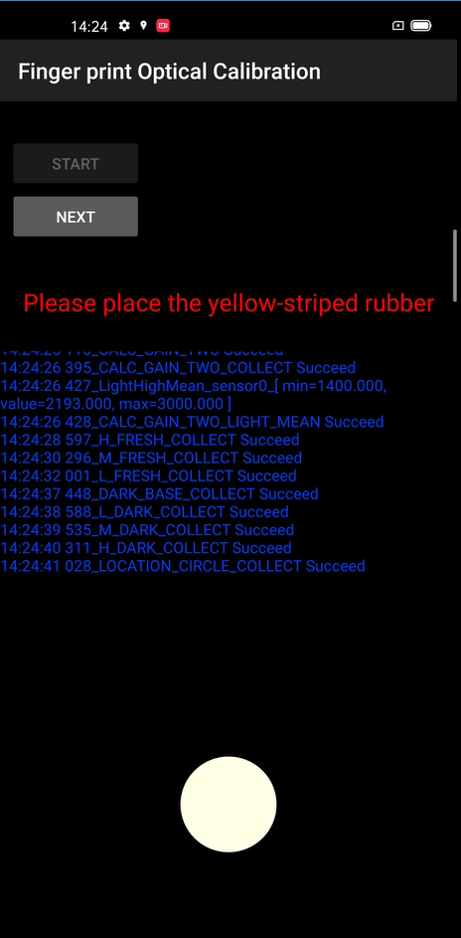
it jumps into the after sales calibration from fingerprint optical calibration |  | After the calibration is completed，it’s will jump into smart power amplifier calibration
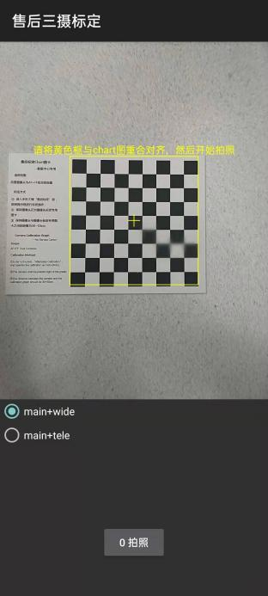 |  | 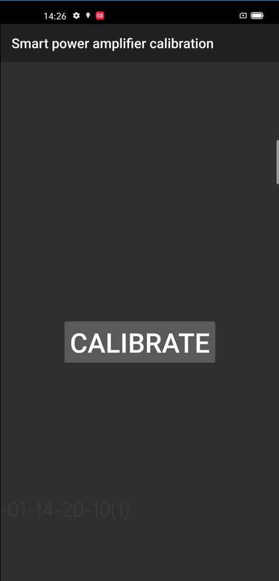
After the calibration is completed, restart the phone to make the calibration take effect, and guide the user to delete the original fingerprint and re-enter.

7. Function Test

7.1 Test Path
Dialing Interface>Enter*#899#>Enter automatic test； The "Confirm" dialog box will pop up after the test complete, if there is no problem choose “Pass”, otherwise choose “Fail”.

7.2 Test Requirements
No. | Test Items | Test Requirements
1 | LCD Test | Observe the red, green, blue, white, black, gray, grayscale and color interface successively; If there are black spots, bright spots and other anomalies, the function is good;
2 | Vibration Test | Get ear close to check the vibration from the motor for 3 seconds.  If the motor vibrates normally(No noises or weak vibration), the function is good;
3 | Touch Screen Auto Test | If the interface shows “PASS” and jumps to the next test, the function is good;
4 | Front Camera Preview | Align the camera with a white surface and a black surface. If there is no black dot, black line or blurred screen on the screen after aligning the white surface, and there is no bright spot on the screen after aligning the black surface, the camera is good;
5 | Second Front Camera Preview | Align the camera with a white surface and a black surface. If there is no black dot, black line or blurred screen on the screen after aligning the white surface, and there is no bright spot on the screen after aligning the black surface, the camera is good;
6 | Rear camera preview | Align the rear camera with a white surface, a black surface, and a surface with text. If there is no black dot, black line or blurred screen on the screen after aligning the white surface, there is no bright spot on the screen after aligning the black surface, white point or blurred screen, the camera is good;
7 | Second rear camera preview | Align the Second rear camera with a white surface, a black surface, and a surface with text. If there is no black dot, black line or blurred screen on the screen after aligning the white surface, there is no bright spot on the screen after aligning the black surface, white point or blurred screen, the camera is good;
8 | third rear camera preview | Align the third rear camera with a white surface, a black surface, and a surface with text. If there is no black dot, black line or blurred screen on the screen after aligning the white surface, there is no bright spot on the screen after aligning the black surface, white point or blurred screen, the camera is good;
9 | Fourth rear camera preview | Align the fourth rear camera with a white surface, a black surface, and a surface with text. If there is no black dot, black line or blurred screen on the screen after aligning the white surface, there is no bright spot on the screen after aligning the black surface, white point or blurred screen, the camera is good;
10 | Echo test | Testing Main MIC: Blow the air to the MIC hole on the bottom of the phone. If the receiver (earphone) sounds, the function of Main MIC is good;  Testing Sub MIC: Blow the air to the sub MIC hole on the top of the phone. If the speaker sounds, the function of Main MIC is good;
11 | Flashlight Test | Open the flashlight. If it can be opened normally with color deviations, the function is good;
12 | Charging Test(SuperVOOC) | Use the original OPPO adapter and USB cable to charge. If the interface shows “PASS” and jumps to the next test, the function is good;
13 | Headset in-out Plug test | Plug in and out the earphone with the OPPO earphone. If the interface shows “PASS” and jumps to the next test, the function is good;
14 | Sensor Self-test and Calibration | When the phone enters into the Sensor self-calibration interface, the phone must be placed on the desk flatly. Then click the first calibration item. After the test is passed, it will automatically jump to the next test item;
15 | Gyroscope Test | Take the mobile phone to draw the "8" word graphic. If the interface shows “PASS” and jumps to the next test, the function is good;
16 | M-Sensor Test | Shake the phone from the left to the right side. If the interface shows “PASS” and jumps to the next test, the function is good;
17 | Proximity-sensor Test | Use the palm to cover the light sensor hole, and the screen will turn green from black. If the interface shows “PASS” and jumps to the next test, the function is good;
18 | Keypad Test | Press the power key and volume key one by one. If keys can be pressed normally and the interface jumps to the next test, the function is good;
19 | Fingerprint Auto Test | If the interface shows “PASS” and jumps to the next test, the function is good;
20 | Media test | Click the “20-4K（-3db)signal” to test the sound of the media function for 5s. If there is no silence, weak sound, noises, and breaking sound, the interface shows “PASS” and jumps to the next test, the function is good;
21 | Call test | If the phone has been installed with the operator's SIM card, dial the corresponding operator's phone number. If no card is installed, call the 112 to test (Calling the Operator is recommended). If the call can be performed normally and the receiver is without noises or weak sounds, the function is good;
22 | NFC Test  Only RU/KZ/PL/TR support NFC | Close the phone of the rear camera area to the NFC card reader. If the signal light of the card reader changes from red to green with “Beep” sound, the interface shows “PASS” and jumps to the next test, the function is good.

8. General Cautions
1. When disassembling (front/rear) camera and fingerprint module, pay attention to protect the camera lens with low mucosa;
2. If it involves replacing the screen assembly, the main board or cleaning the original thermal gel, it is necessary to apply tShe thermal conductive gel according to the above installation steps;
3. Please confirm whether the rear decorative ring is degummed. If it is loose, replace the back glue (4882492) of the decorative part and press it hard.
For OPPO Reno3 Pro Disassembly Video Please visit:
FTP: Overseas Customer Service--- OPPO Technical Service--- Product Material---Reno4 (CPH2113).
Version | Date | Draft | Review | Approve | Modified content
V1.0 | 2020-07-25 | Jimi | Lin  binbin | Huang  guoxin | 1.First Edition

