Version No | Content Modified | Date of Modification | Modified by | Approved by
1.0 | Original version | 01/08/19 | Lerina Tong | /

I. General Demands 2
II. Systems 2
2.1 Call Systems 2
2.2 CRM System 3
2.3 Other Systems/Tools 4
III. Equipment & Servers 4
3.1 Equipment 4
3.2 Servers 5
IV. Office Infrastructure 5
4.1 Location & Environment 5
4.2 Furniture 7

General Requirements
As an official OPPO Contact Center, which provides service directly to OPPO customers, shall be equipped with systems, hardware & software infrastructure that is no lower than the standard required by HQ.

Systems

2.1 Call Systems
Applicable if no Call System is provided by HQ.
Call System applied in Contact Center shall include, but not limited to following features:
- ACD (Automatic Call Distribution):
System can distribute incoming calls to agents as per rules set
- CTI (Computer Telephone Integration):
Agents can use either IP phone or soft phone to perform calls.
- IVR:
IVR can be set and customized with various levels for each line as per business request; After call IVR survey shall be available to collect customer satisfaction
- Agent Monitor:
Collect service volume & status of each agent as well as each team
- Recording:
Calls shall be recorded for 100% on the system; The recordings can be listened to online or downloaded in batch, when needed
- Data & Reports:
Dashboard shall be available to monitor real-time Key Operation Data. Reports, including Ticket Management Report (By Agent/Team), Agent Status Report (By Agent/Team), Customer Survey Report etc., shall be available on the system.
Better to have more features like:
- QA:
QA module is expected if available to help monitor the service quality; Thus QA Report for the same.

2.2 CRM System
All regions are required to apply CRM system provided by HQ, which is Salesforce at the moment and will be WCSM in future.
CRM system is used to make documentations for enquiries of all channels. Meanwhile, CRM is connected with other systems/modules like KM, RV, E-Warranty Search, IMEI/PCB Search etc. for agents’ convenience while assisting customers.

2.3 Other Systems/Tools
- Chat
A Chat system has been available in HQ, which can be provided for local usage if needed.

Equipment & Servers
Cloud Call Center system can be selected when the Team size is within 20 agents. However, since customers’ data is being collected during our service, Data Safety will be a key point to confirm with system vendor to ensure all customer data will be saved as per Personal Data Protection Regulations.
If the size of the team is big with 20 agents above, or there is any special laws for customer data protection, local equipment & server will be needed to save the data collected and protect data from being disclosed.

3.1 Equipment
- Gateway:
As per amount of agents
- Junction Box:
As per amount of agents
- UPS Power Supply:
Can support for at least 1 day while needed
- Computers:
Single screen, screen size should be 19" and above, solution should be more than 1366X768
- IP phone and earphones:
Can be adjusted between left & right ears. Can support real-time monitoring

3.2 Servers
- CTI server
- IVR server
- Database server
- Recording server, can save recordings of at least 1 year

Office Infrastructure

4.1 Location & Environment
    - Location
There should be an exclusive office for CC Team, where there is no noise. Noise in CC team shall be no more than 65dbA.
    - CC Layout
- The overall layout of CC should be aligned with office design of local company, like training room, meeting room, Pantry etc.
- There should be at least 1 window in CC office.
- Height of the office shouldn’t be less than 300cm. Otherwise, a strong sense of pressure will be caused.
- Avoid pillars in CC office to produce a sense of ease.
- At least 1 dedicated training/meeting room for CC.
    - Office area:
As per size of CC Team; Minimum area should be 15m² and above. Generally speaking, average area covered per agent shall be no less than 2m^{2.}
    - Decoration
- Lights:
Reasonable lighting can reduce fatigue of agents. Natural ray of light is the best choice; Otherwise, RGB lighting shall be applied.
- Air conditioner:
Air conditioner is mandatory in CC office.
- Carpet
Carpet shall be used in CC office to reduce noise.
- Hue
Colorful decoration in agents’ desks and overall working space is appreciated. Flags, balloons are good for CC office decorations.
- OPPO Branding
OPPO logo and posters for OPPO Culture, Service Concept etc. are mandatory in CC office.

4.2 Furniture
Furniture applied in CC should be comfortable, simple and functional.
Here is the list of furniture which is mandatory for CC, with spec requirements for reference:
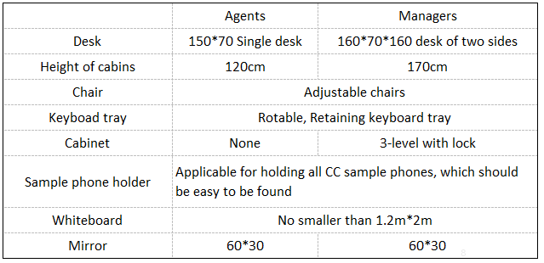

Besides the furniture for service demands, more are needed for agents’ life convenience, like water dispenser, cup holder on desk etc.

