Version No | Content Modified | Date of Modification | Modified by | Approved by
1.0 | Original version | 15/08/19 | Lerina Tong | /

1. Purpose 2
2. General Requirements 2
2.1 Channels: 2
2.2 Method： 3
2.3 Owner 3
2.4 Frequency: 3
3. Inbound Line Test 4
3.1 In-house Call Center 4
3.2 Outsourced Call Center 4
4. Email Test SOP 5
5. Outbound CallerID Test 6
5.1 CallerID Test SOP 6
5.2 Correcr CallerID 7
5.3 Vendors for CallerID Solution 7
6. Test Result Management 7
7. Attachment 7

Purpose
In order to ensure that all Service Channels are reachable with good quality.
Inbound Call: Line is reachable & clear
Email: Email is reachable
Outbound Call: Correct Caller ID is displayed; Line is clear

General Requirements

2.1 Channels:
Inbound Call, Email, Outbound Call

2.2 Method：
Mainly test whether the service channels are good in quality through test inbound calls, test Emails, test outbound calls etc.

2.3 Owner
Overseas Contact Center Team as below.
Business Zones | Owner
Europe | Elisa
Southeast Asia | Lerina
Asia Pacific & MO Markets | Lerina
South Asia | Camille
Middle East & Africa | Wendy

Frequency:
Once a month on 29-31, and will be conducted in advance if there is holiday.

Inbound Line Test

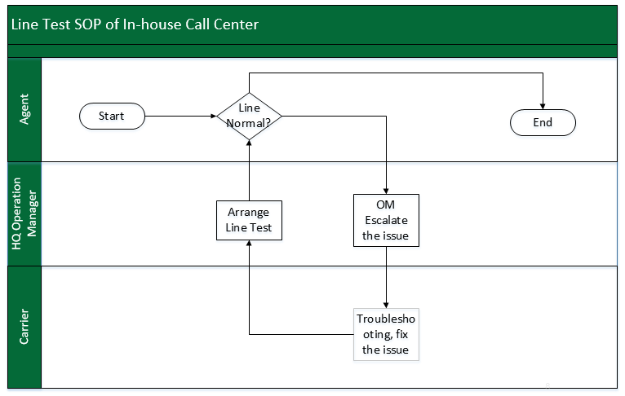
3.1 In-house Call Center

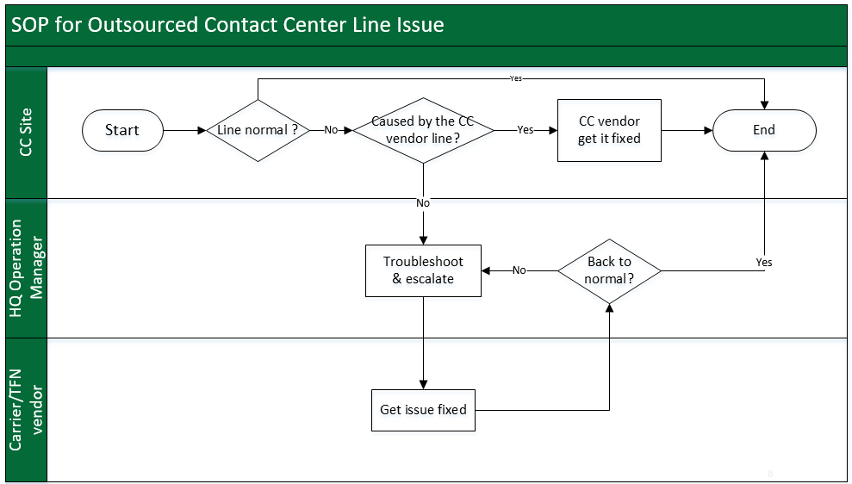
3.2 Outsourced Call Center

Email Test SOP
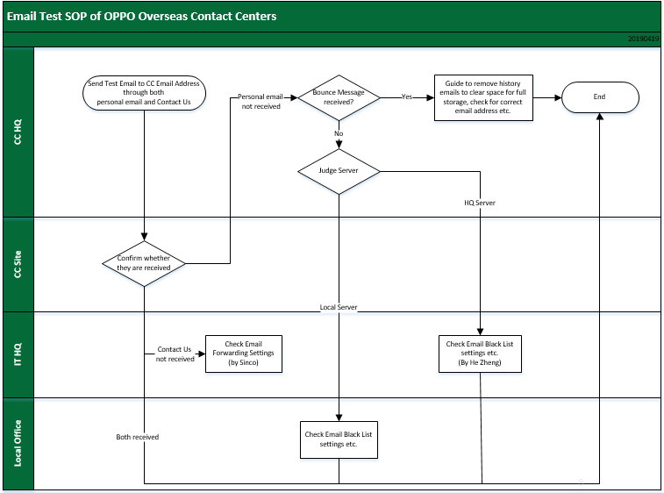

Refer to 2.10-1 Email List of OPPO Overseas Contact Centers.

5. Outbound Caller ID Test

5.1 Caller ID Test SOP

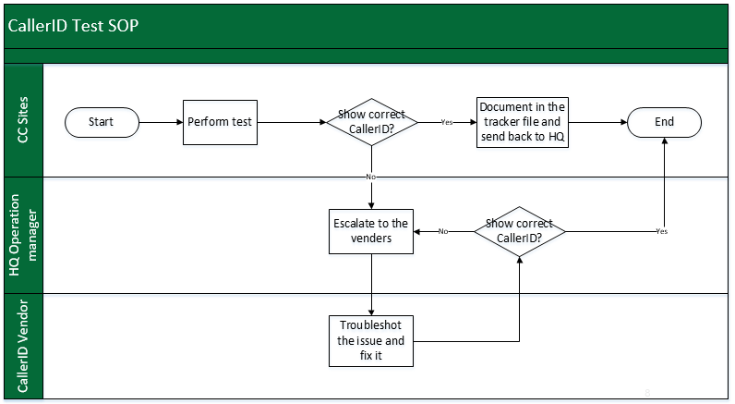

5.2 Correct Caller ID
Refer to 2.10-2 Display Table of All Region CallerID

5.3 Vendors for Caller ID Solution
GVM: noc@gvmhk.com.hk
Nexmo: support@nexmo.com
Both vendors are providing 7*24 service.

Test Result Management
All the test result shall be submitted immediately after the test is completed.
Refer to 2.10-3 Test Result Escalation Tracker.

Attachment
7.1 2.10-1 Email List of OPPO Overseas Contact Centers
7.2 2.10-2 Display Table of All Region CallerID
7.3 2.10-3 Test Result Escalation Tracker

