Version No | Content Modified | Date of Modification | Modified by | Approved by
1.0 | Original version | 30/06/19 | Lerina Tong | /

1. Origin of Enquiry Data 1
1.1. Inbound call 1
1.2. Email/Contact Us 2
1.3. Chat/Facebook/Twitter/Other social media channel 3
2. Enquiry Data Collection 3
3. Regular Enquiry Data Report 4
3.1. Daily Inquiry Monitoring 4
3.2. Weekly Review Report 4
4. Application of the Enquiry Data 4
5. Attachments 5

Origin of Enquiry Data

Inbound call
When Customers contact us by calling our hotline, agents will record the enquiry of the on the system.


Email/Contact Us
When customers reach us by sending the enquiry concern to our service email or send us email via our official service website with their personal email. (Please refer to the screenshot).
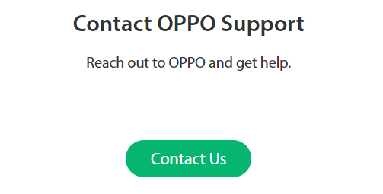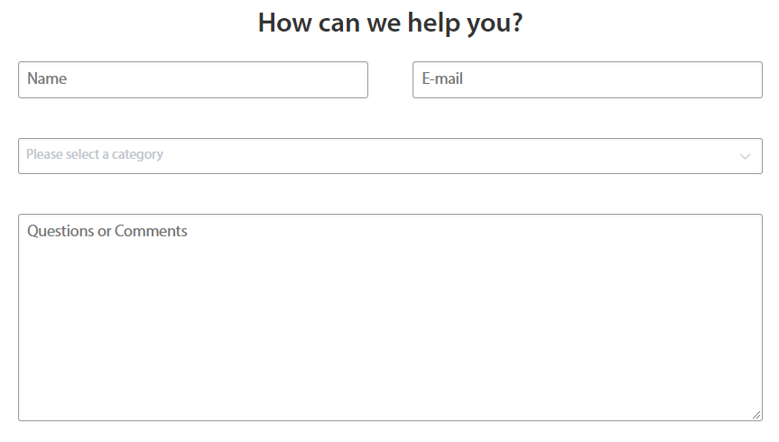

Chat/Facebook/Twitter/Other social media channel
When customers feedback the concern or try to reach us via Chat or other social media platforms, e.g. Facebook, Twitter, agents will record the enquiry of the on the system and generate the enquiry data on the system.

Enquiry Data Collection
Requirement
Completeness
Agents are required to record all the necessary information of the enquiry, for the purpose of 1) make follow-up with the case of the customer and 2) enquiry data analysis

Personal data protection
We are required to keep all the data we collected from customer confidential and protected. Never transfer or send customer’s personal information to anyone without customer’s permission even with the purpose of data analysis.

Timely escalation principle
If there is any abnormality found in the enquiry case, agent should escalate to the
Team leader at the same time and make close follow-up and monitoring.

Regular Enquiry Data Report

Daily Inquiry Monitoring
Unified format: (XX)CC Data Monitoring Report _YYYY. MM, DD
Take MM For example: (MM) Daily Inquiry Monitoring _2017.06,28
Notes: (XX) = country code _YYYY.MM, DD = sent date
Refer to the attachment 2.11-1 Daily Inquiry Monitoring template

Weekly Review Report
Please refer to the attachment 2.11-2 Weekly review report.

Application of the Enquiry Data
Quality issue analysis .
Contact center is one of the customer data collection windows which help to collect customer’s voice towards our product and service. It’s of great value to analyze the enquiry data.

Attachments
5.1 2.11-1 Daily Inquiry Monitoring template
5.2 2.11-2 Weekly review report

