Version No | Content Modified | Date of Modification | Modified by | Approved by
1.0 | Original version | 31/05/19 | Lerina Tong | /

1. Handling Standard of the Moment of Truth (MOT) 2
1.1 Opening 2
1.2 Check Contact History 3
1.3 Gather Customer Information 3
1.4 Paraphrase 4
1.5 Empathy & Apology 5
1.6 Willingness to Help 5
1.7 Probing 6
1.8 Hold 6
1.9 Provide Solution 7
1.10 Closing 8
1.11 Email Signature (Email Only) 10
2. Cautions during MOT 10
3. Documentation Standard 11
3.1 Customer/Product information 11
3.2 Description of customer’s concern 11
3.3 Agent’s reply 12
3.4 Tally 12
3.5 End 13
4. Escalation Standard 13
4.1 Cases to be escalated 13
4.2 Escalation Template 14
5. Attachments 15

Handling Standard of the Moment of Truth (MOT)
The Moment of Truth (MOT) refers to key service moments from customers being connected to Contact Center till the service being properly ended. Agents’ performance during Moment of Truth can cause customers’ satisfaction or dissatisfaction directly. Refer to 2.1-1 Enquiry Handling SOP.
During service, there are following Moment of Truth:

Opening
Requirement for Opening:
- Prompt: Respond to customers in 2 seconds
- Polite: Follow standard script and show gratitude for customers’ contact
- Enthusiastic & Energetic (Voice channel only): Talk in pleasant voice; Sounds friendly;
Voice should be clear and loud enough, with proper speed
- Standard Script:
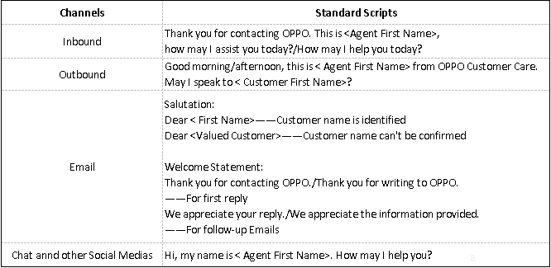

Check Contact History
Upon customer’s contact, agents shall check whether the customer contacted us before via all channels, which can greatly impress customers with a prompt & amiable service.

Gather Customer Information
Following rules shall be obeyed while gathering customer information:
- Gather as few information as possible.
As customer information is quite private, agents shall only collect information which is necessary for handling the concern. Information commonly collected can include, but not limited to following:
Customer name * (Mandatory)
Customer phone number * (Mandatory for IB)
Customer information Customer Email address * (Mandatory for Email & Chat)
Customer location
Social media account *(Mandatory for Facebook etc.)
Phone model * (Mandatory if purchase)
IMEI
Device information Android/ColorOS version
Purchase date
Repair history

Other information without * are needed for typical scenarios in order to replicate, investigate or solve the issues.
- Always let customer know the reason why the information is needed.
When customer information is collected, agents shall explain the reason why the information is needed in order to solve the issue so that the customer will easily understand the necessity and support for the same.
Besides, initiative explanation can shorten the service duration to some extent since customers won’t need ask why, which might takes time.
For example, location is needed when the customer is facing signal malfunction.
CORRECT: May I have your location please as we will need check the network coverage in this place and try to replicate the issue?
WRONG: May I have your location?
- Avoid collecting information which was provided in history contact.
While checking history contact of the customer, agents shall review all related records and avoid asking for information which was provided already.
- Avoid collecting information which can be deduced from other information.
Some information can be easily deduced from others. For example, if customers provide phone model, then agents shall not ask for Android version as agents shall be professional enough to know Android version of each model.

Paraphrase
Paraphrasing is to briefly summarize the relevant information given by the customer.
It is another way of conveying your messages correctly. It creates the notion that you are actively listening to your caller and it will allow good flow of the conversation.
- Paraphrase is not to repeat.
Following phrases can be used to paraphrase:
“As I understand….”
“Let me confirm….”
“I’d just like to check if I’ve got this correct”
“Let me make sure I understand your request/concern…”
“So if I hear you correctly…..”
“If I understand you correctly, you’re telling me that...”
- When paraphrase the concern, if there are more than one concerns, do paraphrase with all concerns addressed.

Empathy & Apology
Empathy means understanding another person so well that you identify with him/her, you feel like he/she does. The ability to empathize is directly dependent on your ability to feel your own feelings and identify them. In other words to put yourself in another’s shoes. Empathy doesn’t mean to give customers whatever they want, to agree with the customer, or to constantly apologize for yourself and the company.
We can apologize to customers for the poor experience with our products or service, for bad things they suffered etc.
Following wordings are popularly applied to show empathy & apology:
“I can imagine”
“I can understand why you’re upset”
“I know that can be upsetting”
“That must have been very irritating for you”
“We feel sorry to learn that”

Willingness to Help
Agents’ willingness to help can always let customers reassured and feel they and their concerns are cared! Always let customers know:
“We’re more than happy to assist you on this concern.”
“Rest assured…”

Probing
Asking probing questions can be helpful in providing your customers the best solution to their issues or concerns.
- Only ask questions related with the concern.
Avoid asking unrelated questions while probing. Only do probing which is helpful for agents to understand the detailed scenario of the concern and get it resolved. Probing can be done as per troubleshooting steps for each scenario.
- Avoid probing for what was provided already.
Similar to gathering information, agents shall not probe for what is clarified or
confirmed yet. Agents might easily omit information when there is a long history
record. Sometimes, probing has been done in previous contact, while agents ask
for same probing questions again, which is really annoying and easily makes
customers feel their concerns are not carefully treated.
- Never assume. When there is any doubt, ask and confirm with customer.
Refer to 2.1-2 Troubleshooting for Popular Scenarios and 2.1-3 SOP for Popular Cases.

1.8 Hold
Hold is allowed when agents need search on Knowledge Base, consult others etc. so as to provide customers with complete and accurate solution. Proper Hold is acceptable for customers, while unqualified Hold can be an unpleasant experience either.
Following rules shall be obeyed for Hold:
- Ask customer’s permission before putting customers on Hold.
- Provide the reason for hold and how long you will put the customer on hold.
- Hold Refresh – If agent needs more time to check for a resolution, get back to
the customer on the promised hold time and ask permission for an extension.
- Make sure to provide the reason for the extension and put the customer on
hold again if he agreed to give an extension.
- Always thank the customer once you get back to them.
- Only Voice Service and Chat need put customers on hold. Kindly check the Hold duration below for each channel:

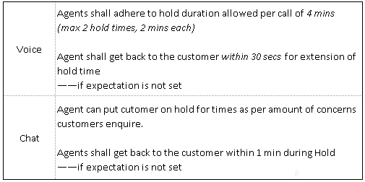

Provide Solution
- Solution provided should be complete.
Agents shall manage to provide the best possible alternatives/resolution steps that could either lead to resolution or completely resolve the customer specific issue.
- Solution provided should be correct.
All information provided should be accurate, no matter it is a key point for the concern or a reminder only.
- All of customer’s concerns should be addressed while providing solution.
- If customer is advised for Factory Data Reset, visiting SC etc., customers shall be reminded for data loss/accessory missing etc.
For Factory Data Reset:
“Your data and files saved on the phone might be removed after Factory Data Reset. Kindly make sure to backup all the data on the device to your SD, SIM card or other devices/tools before performing Factory Data Reset to avoid any data loss.”
For Visiting SC:
You may do the following before walking into the service center to avoid any data loss or accessory missing:
1) Bring warranty card or receipt of purchase
2) Backup all the important personal data to your SD card, Google Drive, PC or laptop
3) Keep personal accessories such as SD Card, SIM Card and others
4) You may refer to the link below to get the nearest service center < https://www.oppo.com/xx/supports//customer-service-center/ >” (xx=region code)

1.10 Closing
- Check with customers whether further assistance is needed before ending the service.
- Promote/guide customers to the OPPO website self-service/Chat service etc.
Inbound/Chat | Is there anything else that I can assist you with?
Email | [With Promotion Request]  Should there be any assistance required in the future, just click and Chat with us: https://oppo-au.custhelp.com/app/chat/chat_launch, or visit Support on our website: www.oppo.com to explore more fast & convenient instructions anytime.
Email | [No Promotion Request]  Should there be any assistance required in the future, please do not hesitate to reach us again!
as per HQ requirement.
- Survey invitation and ending.
Invite customers to participate in survey before the service is ended. Following script can be applied:

Inbound | Please stay online. I will now transfer this call to a short survey with 2 questions based only on our conversation. If you are satisfied with my service, kindly rate me a 5 and a Yes, this will mean a lot to me.  Thank you for contacting OPPO. Have a nice day!
Chat | We would greatly appreciate if you can participate to our short survey with two questions right after you have ended the chat. We value your feedback especially if I provided sufficient assistance to your concern today. Thank you for contacting OPPO and have a great day ahead!

1.11 Email Signature (Email Only)
Email signature is mandatory at the end of email reply to personalize support Email and disclose OPPO contact information. Refer to 2.1-4 OPPO Support Mail Signature_Template

2. Cautions
- Avoid interrupting/talking over customers during the call.
- Address customers by their names during service.
- Avoid dead air during service, especially for Voice services. Dead air shouldn’t exceed 3 seconds during voice service.
- Agents shall display friendly, warm, and pleasant approach throughout the call with suitable pace and volume.
- Agent shall display professionalism in language proficiency and refrained from use of jargon or slang during the call.
- Any inappropriate behaviors as below won’t be tolerated:
- Rude and unprofessional in their demeanor.
- Responded impolitely when the customer uses profanity (curse/vulgar words).
- Criticized the company or agree to the negative statement by the customer towards the company.
- Hang up the call without following proper and professional procedure.
- (For written services only.) All OPPO related brand names and technical terms should follow the correct case as per the OPPO website. Sentences should be grammatically correct.
- (For written services only.) Email was replied with correct spelling, a maximum of 2 spelling error can be allowed, provided the error(s) do (es) not change the meaning of the whole word/sentence.
- Address customers by name at least twice during call, Chat and other conversation type channels.
- (For voice services only.) Agent shall display the ability to steer the conversation to the resolution in the most direct way possible.
Refer to 2.1-5 Standard Script & Tips-Reference for more scripts.

Documentation Standard
All cases shall be recorded properly on Salesforce, on the module of [Cases].
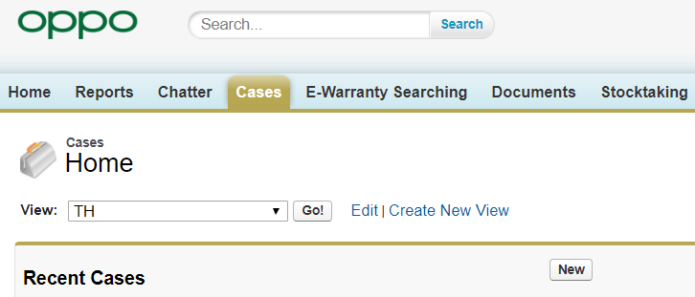

A complete documentation include:

Customer/Product information
All information gathered from customer should be documented on system.
When there are more than one models mentioned in the case, the agent can record the model which is closer to the enquiry itself;
When the models are of equal opportunities in the case, then create a new case for the model & concern.

Description of customer’s concern
Customer’s description should be as detailed as enough, including customer’s original description, information gathered from probing question.
Summary of service content with translation (only for Non-English service) is needed, if agents can write English. Refer to Table below for Description of popular cases:

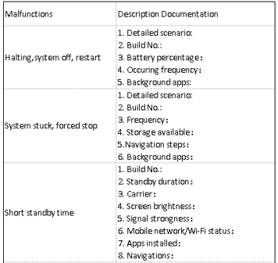

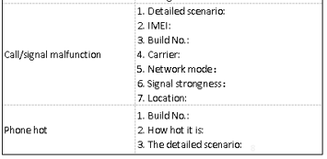

Agent’s reply
Agent’s reply should include the solution provided to the customer towards all concerns, if there are more than one.

Tally
- If the customer is enquiring different issues for SAME MODEL, agents can do as what they are doing now. Select the model, with different tally. While, if the customer is enquiring issues for DIFFERENT MODELS, agents should create a new case for different model mentioned on the call/email.
- Multiple Tally can be selected if there are more than one concerns enquired in the service.
- Tally which is closest to the concerns shall be selected when there is no exact tally on system.

End
Always select FINISH to close a case.

Escalation Standard
Some general enquiries might exceed CC business scope and need escalating for more complete and confirmed information. In this case, a standard escalation process need to be followed.

Cases to be escalated
Following cases might need be escalated:
- Repair related enquiries
In some regions, when customers enquire about repair/delivery status, requesting loan phones, requesting repair discount etc., agents will need seek advice or explore information from SC teams.
- Business related enquiries
Agents shall escalate cases for dealership request, pre-sales promotions or other activities, sponsorship proposal etc., if any.
- Technical related enquiries
For technical related concerns, if agents fail to resolve the concern via troubleshooting, while it is definitely not a hardware concern, then it is time to escalate for further investigations. Agents are encouraged to submit Quality Feedback cases for technical related enquiries and prizes are offered by HQ for the same.
Refer to 2.1-6 OPPO Quality Feedback Reward Regulations for Customer SC Staff V4.0.
- Complaints
Complaints shall be created on Salesforce system. Agents can also transfer Cases to be Complaints. Refer to 2.2 Complaint Handling Standard Handling Standard for details.
- Controversial & Sensitive information
Refer to 2.4 Controversial & Sensitive Information Handling Standard for details.
- Judicial related enquiries
Refer to 2.1-7 Handling Standard of Judicial related Enquiries

Escalation Template
Escalation Template shall be followed for all escalations:
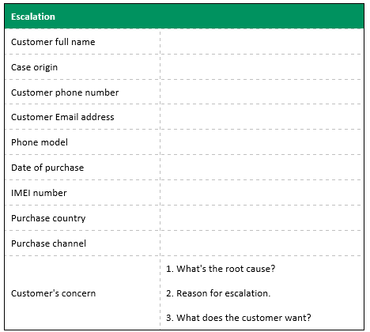

Refer to 2.12 Escalation Management Standard for more detailed regulations.

Attachments
5.1 2.1-1 Enquiry Handling SOP
5.2 2.1-2 Troubleshooting for Popular Scenarios
5.3 2.1-3 SOP for Popular Cases
5.4 2.1-4 OPPO Support Mail Signature_Template
5.5 2.1-5 Standard Script & Tips-Reference
5.6 2.1-6 OPPO Quality Feedback Reward Regulations for Customer SC Staff V4.0
5.7 2.1-7 Handling Standard of Judicial related Enquiries
5.8 2.1-8 Contact Window List of OPPO Overseas Contact Centers

