Version No | Content Modified | Date of Modification | Modified by | Approved by
1.0 | Original version | 31/05/19 | Camille Cheng | /

1. Definition and Scope of Complaint 2
1.1 Definition 2
1.2 Scope 3
2. Complaint Categories and Judgment Criterion 4
2.1 Complaint Categories 4
2.2 Judgment Criterion 6
3. Handling SOP & Principles of Complaint 6
3.1 Handling SOP of Complaint 6
3.2 Responsibilities of Related Business Units 7
3.3 Handling Principles of Complaint 9
3.4 Complaint Handling TAT 9
4. Documentation Requirement 10
5. Application of Complaint Data 10
5.1 Complaint Monthly Report 10
5.2 Case Sharing 10
5.3 Complaint Assessment 11
6. Attachments 12

Definition and Scope of Complaint

1.1 Definition
Complaint refers to the dissatisfaction caused by the difference between the company's products and services and the user's expectations. We can also simply define complaint as not being satisfied.
We can judge whether it is a complaint from three dimensions: user's demands, user's emotions and user’s feedback.
- When user's demands include the following situations, case should be documented as complaint.
- Request compensation: refund, replacement, compensation, discounts, gifts etc.
- Request apology: a verbal or written apology.
- Request escalation: users request talk to the superior, ask the superior to call back etc.
- Seeking third-party intervention such as exposure media, newspapers, radio stations; appeals, find consumer protection bureaus, etc.
- Request solution/explanation: E.g. due to product malfunction/spare part shortage, customer requests solution; Maintenance policy dispute/maintenance result dispute, customer requests reasonable explanation; bad service attitude/long repair duration, customer request improve service experience.
- When user’s emotions include the following situation, case should be documented as complaint.
- Emotions: unhappy, angry, manic, disappointed.
- Customer expression over phone (CC): blame, sneer, sigh, and increase volume, use uncivilized language etc.
- Customer expression when face to face (in SC): blame, sneer, sigh, use uncivilized language, refuse to talk, crease volume or suddenly silence, pat the table, throw things, and swear roaring and so on.
- Words used File a complaint/ frustrated/ unhappy/ dissatisfied/ disappointed/ angry/ upset/annoying etc.
- When the user does not show bad emotions or appeal as mentioned above, but the feedback of user does not meet the internal service standard or procedures, CC agent should also document complaint order. Refer to 2.2-1 Complaint Types and Scenarios.xlsx.

1.2 Complaint Case Origin

1.2.1 Common Channels
Complaints received from frontline staff, including IB, OB, Email, Chat, social medias, On-Site Reception etc.

1.2.2 External Channels
Customer complain directly to external organization, including but not limited to Consumer Protection Association, Administrative Organization and Public and Social Media (Facebook, twitter, YouTube), etc.

Complaint Categories and Judgment Criterion

2.1 Complaint Categories

2.1.1 Complaint Level
Bases on degree of impact, complaints can be divided into three levels: High, Middle and General.
Response: within 24 hours
Solution: within 72 hours
Response: within 8 hours
Solution: within 48 hours
Response: within 2 hours
Solution: within 24 hours

- Level III (General)
- Promises towards maintenance, repeated repair, replacement & refund are not fulfilled.
- Service staff is not able to solve customers’ problems or the service attitude is bad.
- Dissatisfied with product quality.
- Level II (Middle)
- Complaint has been or risks to be exposed on local general Medias.
- Batch of complaints appeared on Community regarding product quality.
- Customer intends to take radical actions which may case negative impact on company.
- Repeated complaint due to the complaint is not resolved at the first time.
- Complaint @local management team.
- Level I (High)
- Complaint published on the home page of local popular Social Medias or appeared on Press
or reported by local popular TV programs.
- Complaint under legal actions.
- Negative news widely reposted on Facebook/Twitter/other Social Medias.
- Complaints that matters to customer property loss and healthy or security.
- Company data or information is widespread due to disclosure.

2.1.2 Complaint Type
Based on complaint object, complaints can be divided into 6 types: Complaint towards SC, Complaint towards CC, Complaint towards Dealer, Complaint towards Concept Store, Complaint towards Product, and complaint towards company sales/marketing strategy.
Complaint Type | Complaint Target
Type A Complaint | - Complaint towards CC  - Complaint towards CC attitude  - Complaint towards CC skill  - Complaint towards SC  - Complaint towards SC attitude  - Complaint towards long repair duration  - Complaint towards repair quality of SC  - Complaint towards service policy of SC  - Complaint towards service process of SC  - Complaint towards SC charge
Type B Complaint | - Other customer service related complaint of CC  - Other customer service related complaint of SC
Type C Complaint | - Complaint towards dealer  - Complaint towards Concept Store  - Complaint towards product  - Complaint towards company sales/marketing strategy

2.2 Judgment Criterion
To judge a complaint is valid or not and for assessment, we divided those complaint as Type A, B & C. For Complaint judgment criterion, kindly refer to 2.2-2 OPPO Overseas Complaint Judgment Criteria 2.0.docx

Handling SOP & Principles of Complaint

Handling SOP of Complaint
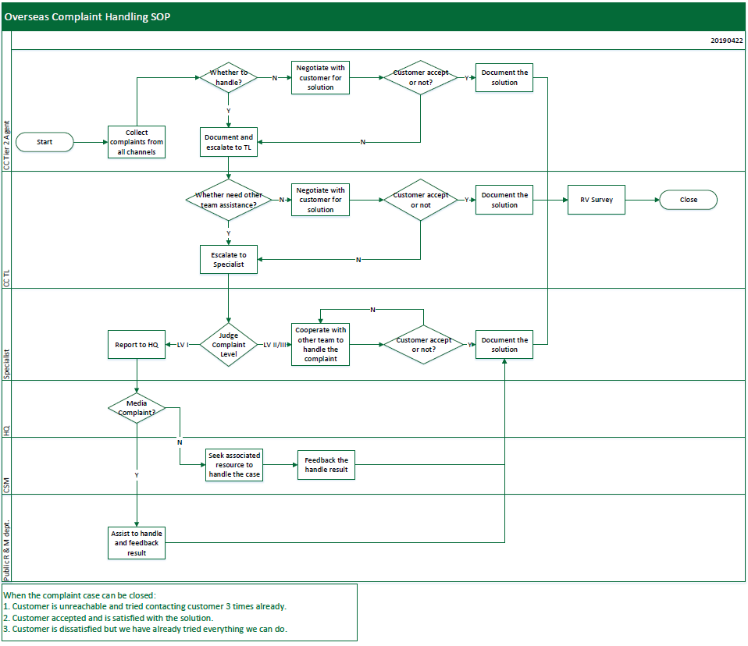

3.2 Responsibilities of Related Business Units

3.2.1 CC
- Ensure all the complaint channels are reachable, accept and hear complaint case.
- Ensure customer is appeased at the first place and the complaint information is recorded accurately.
- When necessary, escalate the complaint case to complaint handling specialist within due time.
- Be responsible for callback survey for CSAT within 48 hours after the case handled completed.

3.2.2 Complaint Handling Specialist
- Complaint contact windows of OPPO HQ.
- Confirm customer complaint target and request, coordinate with other department to provide customer one-time solution and ensure customer is satisfied with the solution.
- Report major complaint in time to supervisor/HQ.
- Summary complaint cases every month and submit Monthly Complaint Analysis Report to HQ before 6th of each month.
- Share complaint case story from daily work or by submitting Monthly Complaint Analysis Report.
- By summary complaint cases, find out the shortcomings and press for improvement.

3.2.3 SC
- SC Receptionist/Staff
- Receive complaint from on-site reception and IB, record customer complaint accurately and appease customer in the first time.
- Provide solution for complaint within extend of competence, or escalate complaint to Complaint Handling Specialist when it’s out of extend of competence.
- SC manager
- Coordinate with and provide necessary support to Complaint Handling Specialist to provide solution to customer when complaint target is SC. The main handler is Complaint Handling Specialist.
- Coach SC staff or maintenance engineer for improvement.

3.2.4 Customer Service Manager
- Be responsible for all the complaints in the region and give necessary support to complaint handling specialist.

3.2.5 HQ CC Team
- Provide complaint handling guidance and necessary support for local complaint handling specialist such as story experience sharing and knowledge sharing.
- Monitor global complaints by daily tracking to ensure the cases are handled properly and timely and monitor major complaint.
- Summary monthly complaint overview and share it to local customer service manager.

3.3 Handling Principles of Complaint
- Believe customer at the first place. Believe what customer said, then find proof to prove whether customer’s description is true or not.
- Solution should go before reason exploration. Provide solution to solve customer’s actual concern and then explore the cause of the complaint & claim the responsibility.
- Response fast to customer complaint to show our good faith and care to customer. Even no final conclusion, we should also contact customer to let them know they are cared and we are following up his case. (Response fast means contacting customer as earlier as possible in the due time )
- Devote to customer’s benefit and take company’s responsibility; we should take priority of customer’s benefit while handling complaints. Dissatisfaction from various customers are hidden behind every single complaint case, thus we should nip the bud while handling a complaint to ensure similar case won’t happen again.
- Escalate major/urgent complaints: Level I complaints should be escalated to senior supervisor/leader for further handling immediately, and the supervisor/leader should be responsible for monitoring & associating each dept. to solve the complaint properly. The complaint handling process shouldn’t be terminated due to lack of competence of each class’s personnel.

3.4 Complaint Handling TAT
Responder | Level I | Level II | Level III
Tier 2 Agent | Escalate within 10 minutes | Escalate within 30 minutes | Escalate within 30 minutes
TL | 30 minutes | 1H | 2 hours
Specialist | Response within 2H | Response within 8H | Response within 24H
Overall  Duration | Response within 2H, provide solution with 24H | Response within 8H, provide solution within 48H | Response within 24H, provide solution within 72H

Note: The TAT of agent and TL are working hours, the TAT of specialist is nature hours. OPPO HQ will daily track complaint case handling progress, local complaint contact windows are requested to cooperate to update daily.

4. Documentation Requirement
Refer to 2.2-3 Complaint Documentation Regulation.docx

5. Application of Complaint Data

5.1 Complaint Monthly Report
Those countries/regions are not using system should send complaint analysis report and complaint cases tracking list to HQ before 6th of each month. Refer to the Complaint Tracking List template, if you do have your own template, can also use your own template. 2.2-4 Complaint Tracking list.xlsx

5.2 Case Sharing
- Two-Way sharing mechanism:
- Local teams are requested to submit at least one Story Sharing per month to HQ before each 15th.
- HQ will choose and push the suitable story via WeChat official account every Wednesday to overseas Customer Service Manager and complaint handling specialists. The story been chosen will be rewarded. Refer to Complaint Assessment.
- Caution:
- For security reason, the complaint case story is not allowed to be reprinted or shared with non-OPPO staff.
- The complaint story pushed via WeChat official account is not allowed to be WOWed.

5.3 Complaint Assessment
The following assessment will be applied so as to strengthen the monitoring and assessment for complaint handling.
Objects | Reward/Penalty amount | Notes
Story Sharing | Reward 20 USD/case | Only for the chosen and published stories
TAT | Reward 30 USD | At least 20 complaints per month, (TAT<72H)%>70%
TAT | Reward 50 USD | At least 20 complaints per month, (TAT<72H)%>80%
TAT | Reward 100 USD | At least 20 complaints per month, (TAT<72H)%>90%
TAT | Penalty 50 USD | At least 20 complaints per month, (TAT<72H)%<60%
Hidden Complaint | Penalty 50 USD/Case
Level I complaint | Penalty 50 USD/Case | Only when the complaint is caused by after-sales team
Type A Complaint | Penalty 30 USD/Case
Type B Complaint | Penalty 20 USD/Case

TAT is based on system data, to ensure your region TAT is good, please update process in time. The complaint object can appeal in following situations.
TAT is more than 72 hours due to the following reasons:
1. Customer response slowly. Related proof such as email or call log should be provided when appeal.
2. Need to collect phone for assessment that takes a long time.
3. Due to public holiday or weekend.
Appendix: Complaint Contact Window
Refer to 2.2-5 Complaint Contact Window_20190822.xlsx

6. Attachment
6.1 2.2-1 Complaint Types and Scenarios.xlsx
6.2 2.2-2 OPPO Overseas Complaint Judgment Criteria 2.0
6.3 2.2-3 Complaint Documentation Regulation.docx
6.4 2.2-4 Complaint Tracking list.xlsx
6.5 2.2-5 Complaint Contact Window_20190822.xlsx

