Version No | Content Modified | Date of Modification | Modified by | Approved by
1.0 | Original version | 31/05/19 | Lerina Tong | /

1. Definition and Identification Standard 2
1.1 Definition 2
1.2. Identification Standard 2
2. Responsibilities of HQ teams 2
2.1 Contact Center 2
2.2 Technical Support team 3
2.3 Public Relations & Legal Team 3
3. Classification for Overseas Regions 3
4. Handling Process and Principles of Incidents 5
4.1 Handling Process and Principles of Incidents in Region A & B 5
4.2 Handling Process and Principles of Incidents in Region C 7
5. Cautions while Handling Incidents of each Overseas Region 9
5.1 Preparations when the Incident Occurs 9
5.2 On-site Investigation 9
5.3 Contact with Customers 10
6. Verification & Reimbursement Process 11
6.1 Clarification for Material Verification & Reimbursement 11
6.2 Clarification for Cash-related Expense 12

Definition and Identification Standard

1.1 Definition
Major incidents that handsets or accessories explode, smoke, burn, deform severely and other symptoms occur during customers’ usage of the devices, which may endanger or has already endangered personal and property safety.

1.2. Identification Standard
Refer to attachment 2.3-1 Incidents Identification Manual.pptx

Responsibilities of HQ teams

2.1 Contact Center
Monitor incidents across all channels.
- Master and update progress of incidents; Maintain “Overseas Incidents Tracking List”.
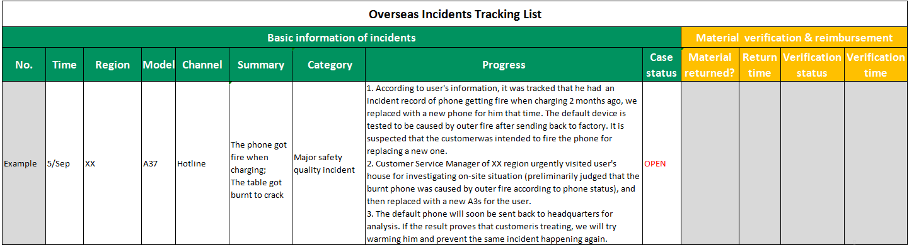
- Provide advice considering the condition of faulty device, suggestion from Technical Team and situation of local region.
- Start the public opinion monitoring mechanism when the incident occurs.
- Follow up with the legal process (if legal measures are taken).

2.2 Technical Support team
- Provide preliminary analysis result according to faulty device.
- Assist to find & maintain authoritative third-party identification institute, while needed.
- Follow up with cause analysis of the incidents and provide solutions for potential quality concerns.
- Confirm & proceed the verification & reimbursement incurred by the incidents.

2.3 Public Relations & Legal Team
When the incident has been exposed on website or has the potential risk to be exposed, Public Relations & Legal Team of HQ and the region will provide assistance. When legal actions are involved in the incidents, Legal Team of HQ & the region will provide advice & assistance.

Classification for Overseas Regions
Overseas regions are classified into A, B & C according to the integrated factors such as media environment, legal environment, political amity, violation penalty, international influence etc.:

Refer to the original excel: 2.3_2 Incidents Regional Classification.xlsx
Caption for the classification:
- “Incident handling process” shall be strictly applied to A/B regions.
- Existing solutions (including policy) can be applied to C regions.

Handling Process and Principles of Incidents

4.1 Handling Process and Principles of Incidents in Region A & B

4.1.1 Handling Process
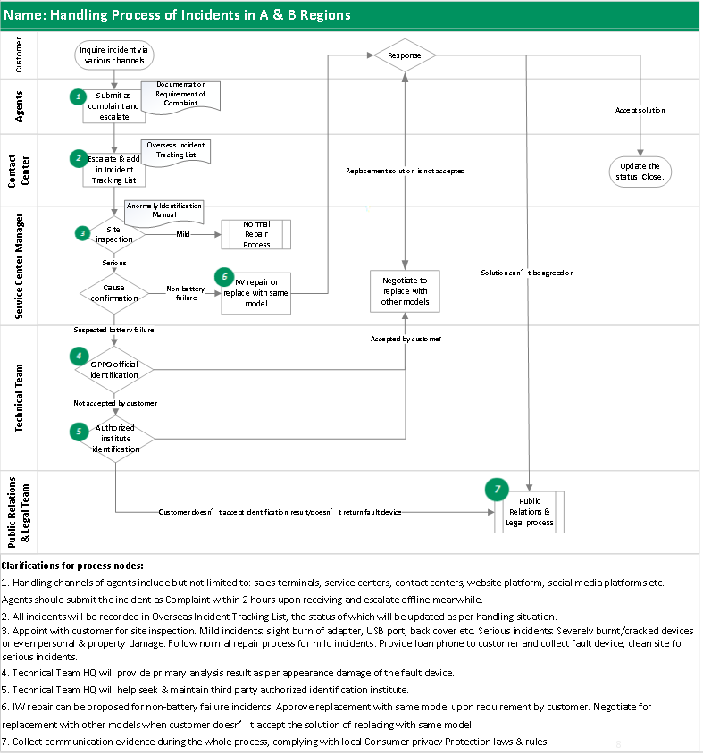

4.1.2 Handling Principles
4.1.2.1 Prompt Response: The “First Owner”
Customer Service Manager is responsible for the handling result of incident in the region, who will act as the First Owner.
- Each channel shall report to Customer Service Manager within 0.5 hour for further handling as soon as any incident is received.
- Agents shall respond to incidents immediately and escalate within 2 hours upon receiving.
- Overseas Customer Service Department shall report incidents immediately to Region
Supervisor and relative owners upon receiving.
4.1.2.2 Immediate Processing: Four Immediate Actions
- Get in contact with & pacify customer immediately and confirm the specific situation.
- Collect faulty device and clean the site immediately. Return the faulty device and
accessories to HQ immediately. It should be collected to local warehouse if can’t be returned to HQ, which will be verified by HQ.
- A solution shall be agreed on with customer immediately and delete relative videos, pictures and chat history immediately.
- Actions should be immediately taken to control media communication to avoid the event to be amplified to the government or medias, which might make the situation worse.
4.1.2.3 Stick to Bottom Line: Believe in Product Quality
- No cash compensation shall be provided. Follow normal IW process when it is within warranty period; Stick to IW process when warranty period has been expired.
- Collect communication evidence while handling the incidents. Never sign any Agreement with customer.
If customer rejects to accept the identification result by OPPO, the device can be delivered to authorized third party institute for further identification. If the customer would

4.2 Handling Process and Principles of Incidents in Region C

4.2.1 Handling Process
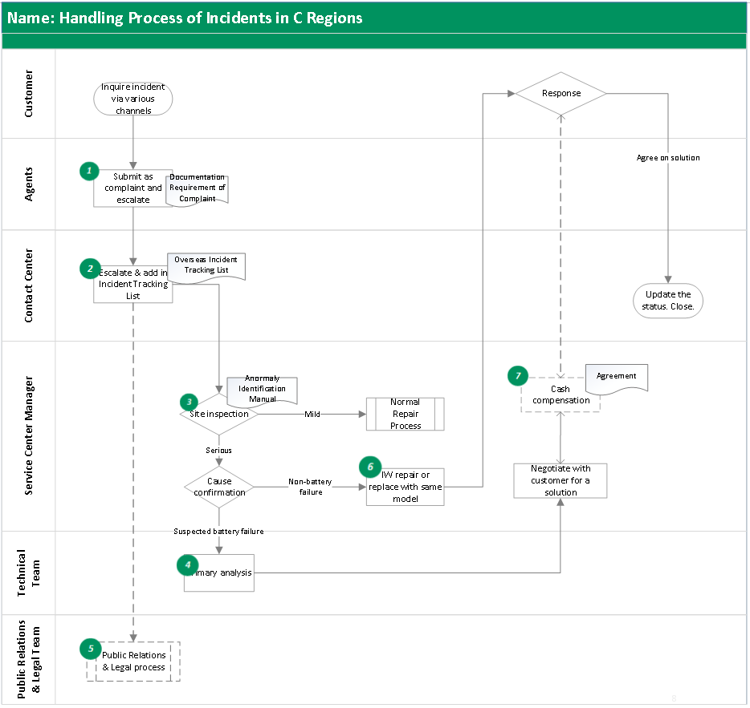

4.2.2 Handling Principles
4.2.2.1 Prompt Response: The “First Owner”
Customer Service Manager is responsible for the handling result of incident in the region, who will act as the First Owner.
- Each channel shall report to Customer Service Manager within 0.5 hour for further handling as soon as any incident is received.
- Agents shall respond to incidents immediately and escalate within 2 hours upon receiving.
- Overseas Customer Service Department shall report incidents immediately to Region Supervisor and relative owners upon receiving.
4.2.2.2 Immediate Processing: Four Immediate Actions
- Get in contact with & pacify customer immediately and confirm the specific situation.
- Collect faulty device and clean the site immediately. Return the faulty device and accessories to HQ immediately. It should be collected to local warehouse if can’t be returned to HQ, which will be verified by HQ.
- Reach an Agreement with customer immediately and delete relative videos, pictures and chat history immediately. (refer to 2.3-3 Agreement Template.docx)
- Actions should be immediately taken to control media communication to avoid the event to be amplified to the government or medias, which might make the situation worse.
4.2.2.3 Being Flexible: Prevent Incidents being escalated
- In principle, no cash compensation shall be provided when there is no personal injury or property damage; under special conditions, cash compensation can be released as per customer request & property damage, which should be equivalent with the damage caused.
- Collect communication evidence while handling the incident. An Agreement of 1 copy should be signed for cash compensation, which will be held by OPPO.
- Manage to get it solved on site. When it can’t be resolved on the site, pacify customer’s emotion first, promising that we will be responsible till the end.
- Provide loan phone, collect faulty device and clean the site.

Cautions while Handling Incidents of each Overseas Region

5.1 Preparations when the Incident Occurs
- The owner should get in touch with the customer to understand the general on-site situation, and appoint time & address for physical site visit.
- Bring along with the recording equipment. Record the entire handling process after being approved by the customer. No need to record if recordings can’t be taken as valid evidence as per local law. Customer Service Managers can deal with incidents flexibly according to local situations and collect evidence in advance on the premise of Consumer Privacy Protection laws and regulations.
- Bring along with same new handset or higher configured handset in case of need according to the preliminary assessment of the situation.

5.2 On-site Investigation
- Upon arrival, pacify the customer first and show sympathy.
- The authenticity of product model, production time, phone body, charger and other spare parts should be confirmed while performing site investigation. Check whether the using conditions are applied with Instructions; Take pictures of the site; learn the complete story how the incident happened & environment where the phone was used, and make documentation accordingly.
- Once the incidents are confirmed to be caused due to other reasons such as burning from electrical appliance/gas etc. or improper usage of customers, explain to the customer that it is not caused by product failure. Meanwhile, negotiate with the customer to take away the faulty device, which can also be replaced with a brand new phone, while necessary, so as to avoid false pictures/report.
- If the cause of the incidents can’t be confirmed on site, pacify the customer’s emotion, provide loan phone, and take pictures for both faulty device and site. The faulty device should be taken back to company for further inspection & analysis.

5.3 Contact with Customers
- Customers of serious incidents should be reached on the same day and site investigation should be appointed on the same day as well.
- Treat customers and their families with caution, regard them as related personnel upon negotiation.
- All incidents should be reported and handled on the same day. If it can’t be solved on the same day due to some reason, pacify customer’s emotion and collect faulty device & accessories immediately, which should be sealed up and dully signed by customer.
- Communicate with customers at the agreed place, avoid locations where there are third parties, such as office buildings and high traffic areas, also wear the normal dress while investigating and negotiating for compensation (Don’t wear clothes with any kind of OPPO Logo).
- Do avoid the media intervention during the entire process. If it goes to the media due to any reason, report to company immediately. Never spread incidents of competitors.

Verification & Reimbursement Process
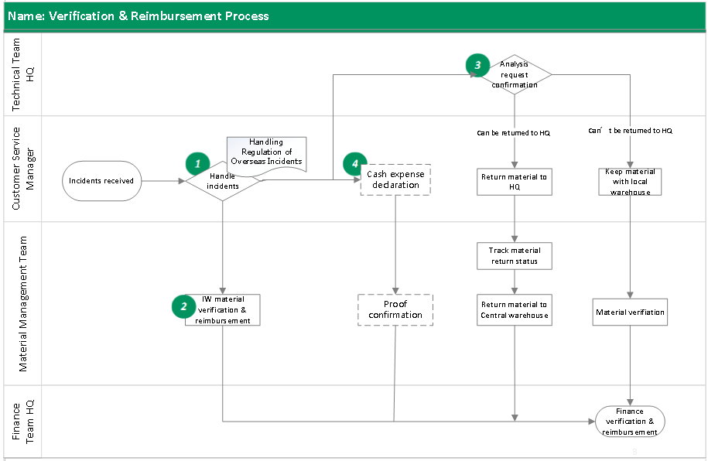
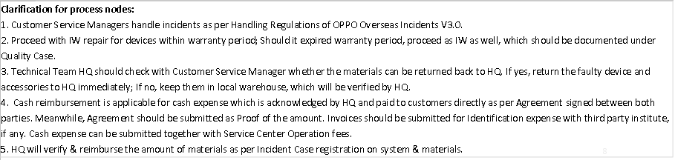

6.1 Clarification for Material Verification & Reimbursement
- Verification & reimbursement for mild incidents:
All mild incidents, no matter IW or OOW, should be documented as Special Quality Case as per Documentation Requirements of Special Quality Case. Accessory amount will be verified & reimbursed based on what is documented on system.
- Verification & reimbursement for serious incidents:
When materials are returned back to HQ: Verification & reimbursement will be completed within 10 working days upon receiving the materials.
When materials can’t be returned back to HQ: Materials should be kept in local warehouse, which will be verified by HQ (once a quarter). Verification & reimbursement will be completed within 10 working days after the verification.

6.2 Clarification for Cash-related Expense
- Cash reimbursement, undertaken by HQ, is applicable for cash expense which is acknowledged by HQ and paid to customers directly as per Agreement signed between both parties. Meanwhile, Agreement should be submitted as Proof of the amount.
- Invoices should be submitted for Identification expense with third party institute, if any, which will be undertaken by HQ.
- Cash expense can be submitted together with monthly Service Center Operation fees.

