Version No | Content Modified | Date of Modification | Modified by | Approved by
1.0 | Original version | 5/31/2019 | Lerina Tong | /

1. Definition and Scope of Controversial &Sensitive Information 1
1.1 Definition 1
1.2. Scope 2
2. Controversial and Sensitive Case Handling Principles and SOP 3
2.1. Handling Principles 3
2.2. Standard Handling SOP 4
2.3. Cautions 4
3. Controversial & Sensitive Case Handling Regulations 5
3.1 Political Risk 5
3.2 Religion/Culture/Custom 7
3.3 Morality/Law 9
3.4 Other discrimination 10
3.5 Celebrity endorsers 10
3.6 Involving personal, property and information security issues 11
3.7 The public security organ and other law enforcement departments call 12
3.8 Media call 13
4. Typical Cases Sharing 14
5. Appendix Taboos 14

1. Definition and Scope of Controversial &Sensitive Information

1.1 Definition
According to the importance and departments involved, controversial and sensitive information can be divided in to company level and department level.

1.2. Scope
Platform/Touch channels
Controversial & sensitive incidents involve modules connecting to customers, including but not limited to following types:
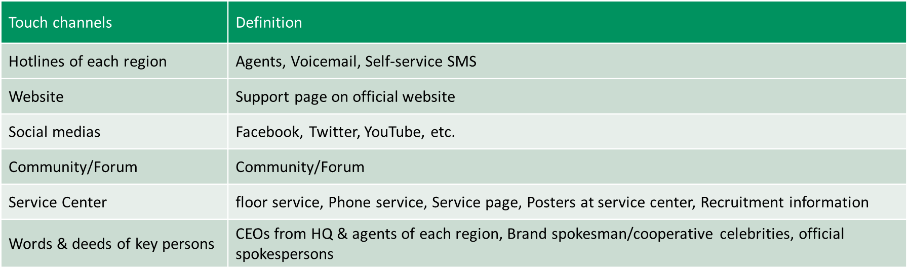

2. Controversial and Sensitive Case Handling Principles and SOP

2.1. Handling Principles
- Report incidents where personal & customer information security is involved immediately
- Do not easily respond to sensitive topics; Do not reply to uncertain incidents based on feelings (such as I think, I suppose…)
- Document media information accurately and report promptly
- Talk less and listen more during the interaction; Do not repeat.

2.2. Standard Handling SOP
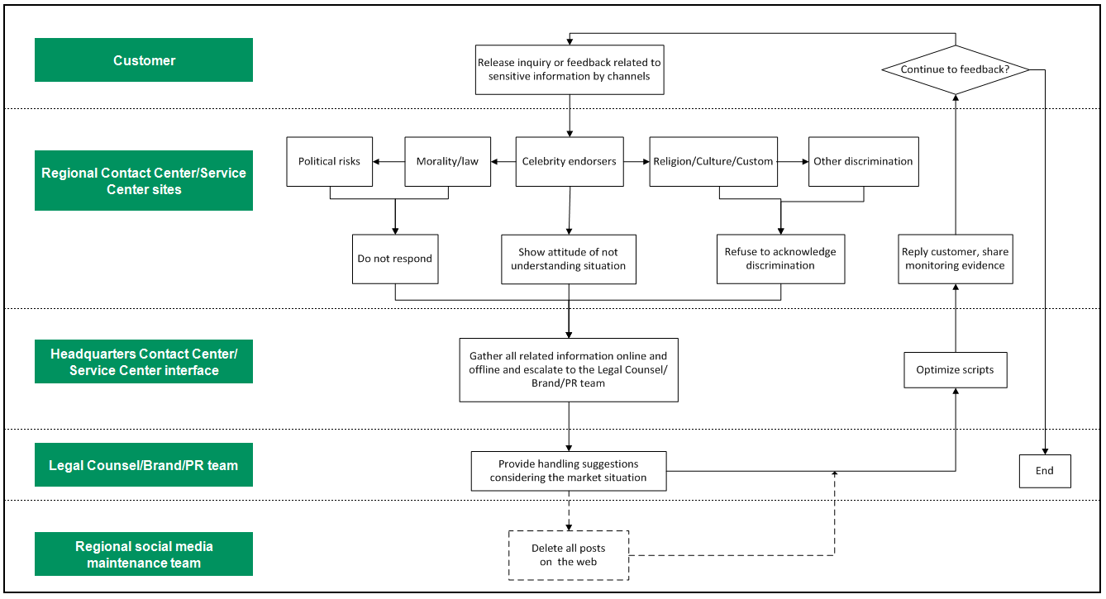

2.3. Cautions
2.3.1 Contact Center agents cannot help customers to check the contact information of other companies online. If customers inquire, reject it.
Referenced script: “We apologize that we won't be able to check the information for you as there is no network access allowed on my end. Hope you can understand it. Thank you!”
2.3.2 Contact center agents shall not disclose company internal information to customers, including but not limited to: internal process, rules and regulations, operating mode, organization structure, and judgment standards etc. which are limited to internal operation or use of the company.
2.3.3 While adjusting, planning or updating support page on OPPO overseas official website, forum, community and other OPPO official channels, it is necessary to get the approval of supervisor after reviewing controversial and sensitive information before the content is publicized.
2.3.4 For promotion posters, promotion display rack and other service support pages in service center, the Customer Service Manager shall report to Service Center Management Team for controversial information review and approval before the content is publicized.

3. Controversial & Sensitive Case Handling Regulations

3.1 Political Risk

3.1.1 National sovereignty and map labeling
- OPPO does not initiatively indicate political position to sensitive countries & regions (such as Japan, Taiwan, Vietnam, Philippines).
- Handling principle for Taiwan: unified as Taiwan, China.
- OPPO does not initiatively label the national flag, national emblem and map of controversial country or region.
- For sovereignty issue, if it is necessary to reply when customer inquiries, referenced script:
“We always adhere to the one-China principle; Taiwan, the South China Sea and other regions are inalienable parts of China.”

3.1.2 Political words and deeds
- OPPO does not mention, state or participate in any speech or activity that may involve sensitive political content (such as party and government meetings, territorial disputes, etc.), and does not express its own political opinions and demands.
- Once posts are found, report to the Social Media Operation Team so as to delete them immediately.
- OPPO does not sponsor or authorize any activity in the name of politics or with political background.
- OPPO Contact Center/Service Center does not initiatively reply to the topic. Referenced script: “Currently, the Contact Center/Service Center is mainly handling product related concerns.”

3.1.3 Distort History
- OPPO does not mention, state or participate in any speech or activity that may involve distorting history, including but not limited to World War II, the Nanjing Massacre, Nazi, militarism, the Great Proletarian Cultural Revolution, etc.
- Once posts are found on social medias, report to the Social Media Operation Team so as to delete them immediately.
- OPPO Contact Center/Service Center does not initiatively reply to the topic. Referenced script:
“Currently, the Contact Center/Service Center is mainly handling product related concerns.”

3.1.4 Supporting terrorism / IS's remarks
- OPPO does not mention, state or participate in terrorism or IS speeches and activities of any form.
- Once posts are found on social medias, report to the Social Media Operation Team so as to delete them immediately.

3.2 Religion/Culture/Custom

3.2.1 Religious discrimination
- OPPO does not mention or comment any religious belief, neither participate in nor destroy any religious group.
- Once posts are found, report to the Social Media Operation Team so as to delete them immediately.
- No restrictions on religious beliefs in recruitment information or other texts.
- Religious related concerns can't be mentioned, and religious restrictions or discrimination can't be shown in any profile of Service Center (design, decoration, and location), service case promotion, service process formulation & implementation.
- If customers inquire religious discrimination related concerns, they should be denied. Referenced script:
“We respect each person's religious beliefs and there is no religious discrimination in OPPO.”

3.2.2 Religious custom
- OPPO fully respect local religious culture and customs around the world and communicates in a way that is suitable for local customs.
*Refer to “Christian and Islamic Taboos" for Specific Taboos of Major Religions.

3.2.3 Racial discrimination
- OPPO does not mention or comment any speech or participate in activities that may involve risks of racial discrimination, including but not limited to the blacks, Filipino maids, refugees, etc.
- Once posts are found, report to the Social Media Operation Team so as to delete them immediately.
- No restrictions on race can be shown on recruitment information or other texts.
- Restrictions or discrimination on Race can't be shown in any profile of Service Center (design, decoration, and location), service case promotion, service process formulation & implementation.
- If customers inquire race discrimination issues, it should be denied. Referenced script:
“There is no racial discrimination in OPPO.”

3.2.4 Region discrimination
- OPPO does not mention or comment any speech or participate in activities that may involve region discrimination risks, such as discrimination against Northerners, Henan people, rural people, etc.
- Once posts are found, report to the Social Media Operation Team so as to delete them immediately.
- No region restrictions can be shown in recruitment information or other texts.
- Region discrimination can't be shown in the image of Service Center (design, decoration, and location), service case promotion, service process formulation & implementation.
- If customers inquire region discrimination issues, it should be denied. Referenced script:
“There is no regional discrimination in OPPO.”

3.3 Morality/Law

3.3.1 Violation of law
OPPO shall not be involved in any comments of violating law, which might incur negative impact for company, including but not limited to:
- Company tax evasion
- Key figures engaging in drug trafficking, drug abuse, prostitution, whoring, gambling, traffic offences, etc.
Referenced script: “Currently, the Contact Center/Service Center is mainly handling product related concerns.”

3.3.2 Violation of morality
OPPO does not involve any statements of negative impact caused by violating morality, including but not limited to:
- Key figures are obviously not honest, not orderly, not respecting the opposite sex, disloyal in marriage, alcoholic, abusive, aggressive, pornographic, scruffy, etc.
- OPPO does not involve any statements of negative impact caused by attacking competitors.
Referenced script: “Currently, the Contact Center/Service Center is mainly handling product related concerns.”

3.4 Other discrimination

3.4.1 Gender discrimination
- OPPO does not participate in any speeches or activities that may involve gender discrimination; for example, in the area where feminism is prevalent in Europe, in the external promotion screen, if there are women, there must be men.
- No gender specific requirements shall be shown in recruitment information on support page online and offline.
- If customer inquiries gender discrimination issues, it should be denied. Referenced script: There is no gender discrimination in OPPO.

3.4.2 Disability discrimination
- OPPO does not participate in any speeches or activities that may involve disability discrimination
- No disability specific restrictions shall be shown in recruitment information on support page online and offline.
- If customer inquiries disability discrimination issues, it should be denied. Referenced script: There is no disability discrimination in OPPO.

3.5 Celebrity endorsers

3.5.1 Comments on cooperative celebrity
- Do not comment on celebrity endorsers in any form.
- If customer inquiries celebrity issues, referenced script: “Sorry we have no idea about the issue you are mentioning. Currently, the Contact Center/Service Center is mainly handling product related concerns.”

3.5.2 Contract signing issue with cooperative celebrity
- If customer inquiries, show an attitude of not understanding situation.
- If customer inquiries celebrity’s contract signing issues, referenced script: “Sorry we have no idea about the issue you are mentioning. Currently, the Contact Center/Service Center is mainly handling product related concerns.”

3.5.3 Other issues related to cooperative celebrity
- If customer inquiries issues related to cooperative celebrity, referenced script: “Sorry we have no idea about the issue you are mentioning. Currently, the Contact Center/Service Center is mainly handling product related concerns.”

3.6 Involving personal, property and information security issues
In general, strictly execute according to “Handling Process for OPPO Overseas Incidents”.
- Taking customers’ personal safety as the first principle
- Timely feedback, follow up by handling people
Contact Center：
- Agent: Upon receiving issues above, document complete information and inform the customer that relevant staff will get in touch with him soon, and report to floor leader as soon as the call is finished(<5min once personal safety is concerned; 30min for non-personal safety concerns).
- Floor leader: After receiving feedback, if personal safety is concerned, the floor leader shall report the situation to the HQ POC within 10 minutes. If no personal safety is concerned, then normal escalation process should be followed.
- HQ POC: HQ POC shall track to handle the customer's concern. If it is necessary to call police, the HQ POC shall reach Customer Service Manager for further process.
Service Center:
Service Center staff shall report to Customer Service Manager for further handling as soon as any such concern is received.

3.7 The public security organ and other law enforcement departments call
- If not involving personal safety issues, decline to answer and inform the shift leader
- If involving personal safety or major incidents, do not agree or refuse
- Timely feedback, follow up by handling people
Contact Center:
- Agent：Upon receiving issues above, document complete information and inform the customer that relevant staff will get in touch with him soon, and report to floor leader as soon as the call is finished (<5min once personal safety is concerned; 30min for non-personal safety concerns).
- Floor leader：After receiving feedback, if personal safety is concerned, the floor leader shall report the situation to the HQ POC within 10 minutes. If no personal safety is concerned, then normal escalation process should be followed.
- HQ POC：HQ POC shall track to handle the customer's concern. If it is necessary to call police, the HQ POC shall reach Customer Service Manager for further process.
Service Center:
- Service Center staff shall report to Customer Service Manager for further handling as soon as any such concern is received.

3.8 Media call
- Talk less, listen more and show respect
- Feedback only, never promise reply
Contact Center:
- Agent: Document complete information and inform customer that his concern will be reported to relative department(do not promise reply) ; report to floor leader once the call is finished (<30min)
- Floor leader：After receiving feedback, the floor leader shall report the situation to the HQ POC within 10min.
- HQ POC: Ask for handling suggestions from brand, PR and legal counsel.
Service Center:
- If customer is calling to feedback customer issues, document relevant information, report to Service Center Supervisor who shall synchronize to Customer Service Manager to negotiate a solution.
- If customer is calling to ask for a telephone interview, reject; if the call has been cut into live broadcast, accept but do not answer anything regarding uncertain or sensitive information.
- If it is a live media interview, don't block or intercept shooting, guide media people to the resting area and report to Customer Service Manager immediately for further handling.

4. Typical Cases Sharing
Refer to 2.4-1 Typical Case Sharing.docx

5. Appendix
2.4-2 Appendix_Taboos.docx

