Version No | Content Modified | Date of Modification | Modified by | Approved by
1.0 | Original version | 31/05/19 | Lerina Tong | /

1. Categorizations of RV (Return Visit) 2
2. Customer Satisfaction Survey towards Service Centers 2
2.1 RV Rules and Scripts 2
2.2 RV Ratio Requirement 3
2.3 RV Data Sharing Mechanism 4
2.4 Cautions 5
3. Quality Related Outbound Survey 5
3.1 Survey Questionnaires for Popular Quality Concerns 5
3.2 Cautions 6
4. Attachments 6

Categorizations of RV (Return Visit)
Based on the content of RV survey tasks, there are mainly two types of outbound surveys for Contact Center: Customer Satisfaction Survey towards Service Centers, which is well known as RV, and Quality Related Outbound Survey.

Customer Satisfaction Survey towards Service Centers

RV Rules and Scripts
Same standard outbound survey questionnaires and rules provided by HQ are applied by all regions. The survey is composed of two sessions of questions: Sent by user and Non-sent by user.
Following rules shall be followed while assigning RV task:
- Assign RV task every 2 days.
- Filter Repair Orders of 3 days before for Sent by user and 5 days before for Non-sent by user.
- Set Deadline for the task to be 2 days since the Delivery Date.
- While assigning RV tasks for the region, stick to same RV task ratio for all SCs.
Once the ratio is set, do not adjust the amount manually for SCs with high volumes, which is allowed for balancing sample amount for SC of low repair volume only when needed.
(SCs with low repair volume refer to those which can't ensure 15 minimum sample request.
Reason for this, SC with low repair volumes didn't reach the 15 sample target when not all repair orders are called).
Example:
On 24th May, assign RV tasks for Repair Orders of 20th (Sent by user) and 18th (Non-sent by user), deadline of 26th
On 26th May, assign RV tasks for Repair Orders of 22nd (SBU) and 20th (NSBU), deadline of 28th
Refer to 2.5-1 Outbound Survey Questionnaires of All Languages &
2.5-2 RV Service Standard.

2.2 RV Ratio Requirement
RV ratio target varies among regions based on the repair amount per month. Refer to the table below for the ratio target of each region.
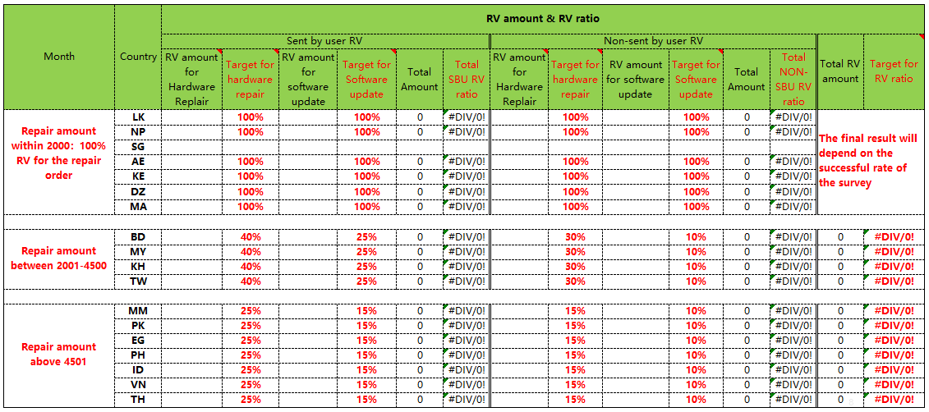

2.3 RV Data Sharing Mechanism
RV data is closely monitored for both QUANTITY and QUALITY in following format on a weekly basis to ensure that outbound volume can be properly balanced among weeks. In this case, if there is any anomaly in the data, Contact Center can have enough time to further investigate and calibrate.
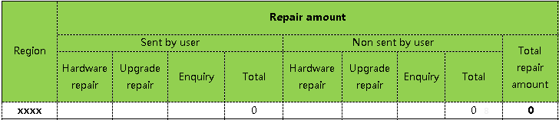

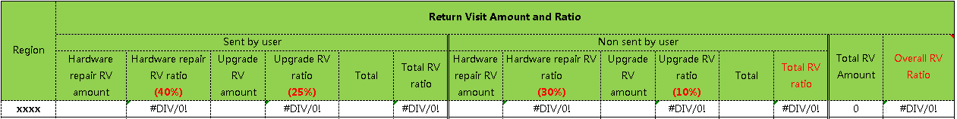

What’s more, HQ will share RV Report for each region on a monthly basis to keep local office updated for RV KPIs of the region as well as main findings through RV.
Refer to 2.13 RV Data Management Standard.

2.4 Cautions
- Local service language is required while performing outbound survey calls.
When there are more than 1 service languages in the region, local language will be prioritized. Such as for Philippines, the service languages are English & Tagalog, while Tagalog will be prioritized while calling to customers.
- When performing RV survey task, a balance among Service Centers is also required by local teams. A least of 15 samples are required for each Service Center, unless the repair amount is not enough to reach this target.
Refer to 2.5-4 WCSM RV Module Training Material.

Quality Related Outbound Survey

3.1 Survey Questionnaires for Popular Quality Concerns
Contact Center is always requested to help with Quality Surveys so as to gather more information for Technical Team or QT Team analyze, investigate and locate the concerns. Popular quality concerns include:
Signal Malfunction
Call Malfunction
Data Network Malfunction
Third Party App Malfunction
Speaker Malfunction

Refer to 2.5-5 Survey Questionnaires for Popular Quality Concerns.

3.2 Cautions
- When we performed Quality survey calls to customers, we are required to perform 3 rounds of calls in total. This is to say, if customers are not reachable once, we will call him/her for totally three times at different time. We will give up only when customers are unavailable after all three times.
- Since there is no system to support us with neither the questionnaire nor documentation for quality survey calls, agents shall be more careful while following the question list and recording customers’ reply to avoid any missing.

Attachments
  - 2.5-1 for Outbound Survey Questionnaires of All Languages.
  - 2.5-2 RV Service Standard
  - 2.5-3 RV Report_Reference
  - 2.5-4 WCSM RV Module Training Material
  - 2.5-5 Survey Questionnaires for Popular Quality Concerns.

