Version No | Content Modified | Date of Modification | Modified by | Approved by
1.0 | Original version | 12/02/20 | Lerina Tong | /

I. General 3
1. Purpose 3
2. Range of Application 3
II. Principles 3
III. Description of Service Quality Management Related Roles 5
1. Online Customer Service Manager (HQ) 5
2. QA Team of Contact Center Sites 5
3 Floor Operation Management Team 6
IV. Content of Service Quality Management 7
1. QA Scope & Business Target 7
2. Categorizations & Content 7
3. Sampling Size 8
4. Scoring Standard 8
5. QA Appeals 9
6. QA Accuracy Guarantee 10
7. QA Standard Update 12
V. Service Quality Management Means 13
1. Service Quality Management Meetings 13
2. Trainings 13
3. Assessment 14
4. Customized Quality Management Means 14
VI. Attachments 14

General

Purpose
Contact Center is one of the windows open to OPPO customers which represent OPPO brand image to public. In order to ensure excellent service perception, it is necessary for Contact Center to take measures to keep improving service quality, optimize service SOP, initiate to solve problems, and finally increase customers’ satisfaction. This Standard is worked out to guide Contact Centers sites to execute service quality management so as to ensure the overall service level.

Range of Application
All service channels of OPPO Overseas Contact Center Sites.

Principles
- Customer-oriented: Starting from customer perception, oriented by customer satisfaction, execute service quality management by means of solving problems. All work like drawing up Quality Management Standard, optimizing service SOP, shall follow the principle of customer-oriented.
- Clear on specific rules: Legend to each parameters shall be clear and specific, avoid any controversial or vague areas. All parameters shall be unified during execution.
- Critical focus: Focus on dominating customers, major business, key staff & accent SOP, consolidate all resources and improve service efficiency.
- Timely & efficient: Feedback the markdowns found in Quality Management to relative staff in time; Ensure the follow-up and solution of the issues are done with high efficiency.
- Closed-loop tracking: Formulate closed-loop Service Quality Management SOP through working on quality monitoring/improving plans, keeping continuous quality monitoring means, overall diagnostics & analysis of problems and following up for solutions so that service quality can be improved.

Description of Service Quality Management Related Roles

Online Customer Service Manager (HQ)
Work out and keep revising a basic standard version of Service Quality Management Standard of Contact Center and related materials as per company & online service strategies, with all key parameters included, which can be applied to those sites where no customized Standard is applied. Customized Standard of other sites need work with HQ parameters included.

QA Team of Contact Center Sites
  - Formulate Service Quality Management Standard: QA TL is responsible to formulate service quality management standard of the site based on HQ version.
  - Service Quality Monitoring: Consolidate service quality monitoring & management of all service channels, find out service markdowns of agents, business, SOP etc. in time.
  - Service Quality Improvement: Carry on QA & quality improvement related work, investigate the weak KPIs & business, find out the origin of the markdowns and organize for improvement.
  - Service Quality Data Analysis: Responsible to count and provide quality related data; Analyze and optimize daily quality KPI & data.

Floor Operation Management Team
Floor Operation Management Team includes all other agents’ above positions, like Operation Manager (OM), Team Leader (TL), Trainer, Smart Master Expert (SME) etc.
  - Work out service quality improvement action plans and implement for the same.
  - Monitor and ensure all actions to improve services are being done properly, like trainings, incentives etc.

Content of Service Quality Management

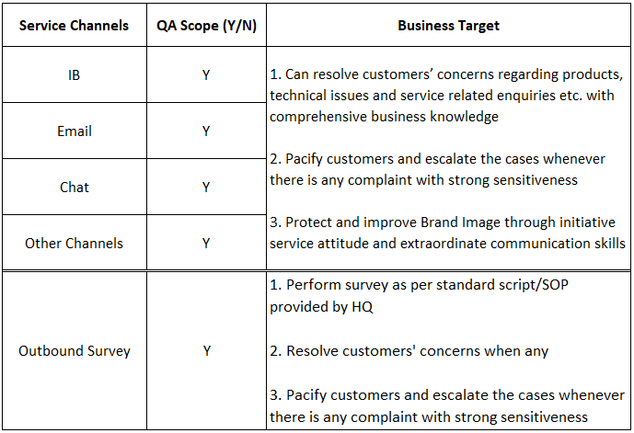
QA Scope & Business Target

Categorizations & Content
  - Regular QA: Perform QA as per QA plan & QA Standard, which is to evaluate agents’ performance in service skills/attitude/service standard etc.
  - Typical QA: Perform QA towards typical samples as per business development, operation demands or agents’ markdowns, like for New Product, Audit of Information Security etc.

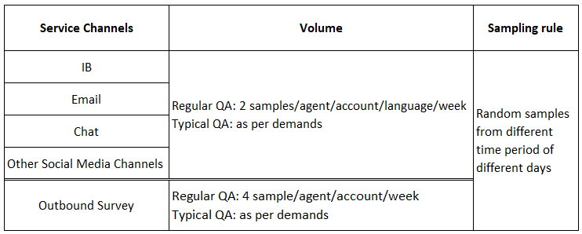
Sampling Size

Scoring Standard
  - Scoring rules are set as per Service Standard of each channel, which include
Opening, Paraphrasing, Hold Process, Resolution, Closing, Communication Skills, Documentation & OPPO Core Value.
  - QA parameters are divided into Fatal & Non-fatal, CTP (Critical to Performance)
& CTQ (Critical to Quality).
  - Each parameter can be judged as Yes, No, N/A.
  - Agents’ QA score of the period of time will be counted as Average score of all samples monitored.
  - Refer to 2.6-1 OPPO Phone Monitoring Score Sheet, 2.6-2 OPPO Email
Monitoring Score Sheet, 2.6-3 OPPO Chat Monitoring Score Sheet for Scoring
parameters as well as Legend for each specific parameter.

QA Appeals
Should there be any question/disagreeing towards QA result they can raise their concerns and QA Team should review for the second time.
Refer to following SOP for handling QA appeals:
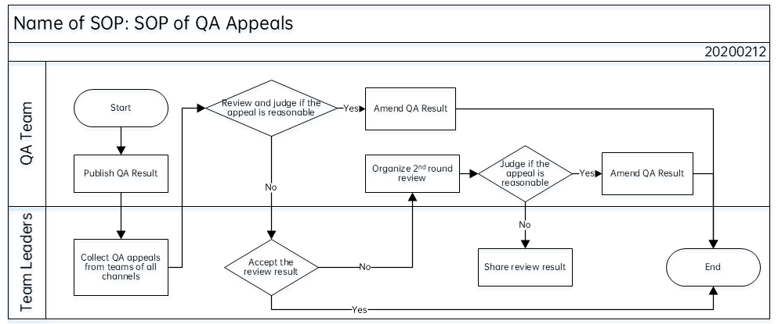

  - Agents shall raise their appeals within 2 days since the QA result is published. The time can be delayed if there is any absence of agent during the time. TL shall collect and share appeals from all agents to QA Team by the coming Mondays for review.
  - QA will only review and amend the points where agents have concerns, but no longer add more markdowns on the sample.
  - 2nd round review: 2nd round review shall be done with TL, OM & QA Team all involved.

QA Accuracy Guarantee
  - QA Certification
QA personnel shall be certified before they are appointed as QA.
    - Certification Requirement: Monitor 10 samples (for channels involved) within certain period of time. Certification is passed if the QA accuracy is ≥80%. One time make-up test can be provided if fails. However, if fails in 2nd round again, the personnel shall be re-evaluated for the position.
    - Should there be more than 10% valid appeals among all samples in each period of time, the QA shall be re-certified.
6.2 Calibration
Calibration should be done within the team to ensure all members hold same understanding towards each QA parameter.
- Frequency: Twice a month.
- Sampling size: 2 samples/channel.
Output: Variance Report should be shared after Calibration Meeting.
Refer to following SOP for QA Calibration Process.
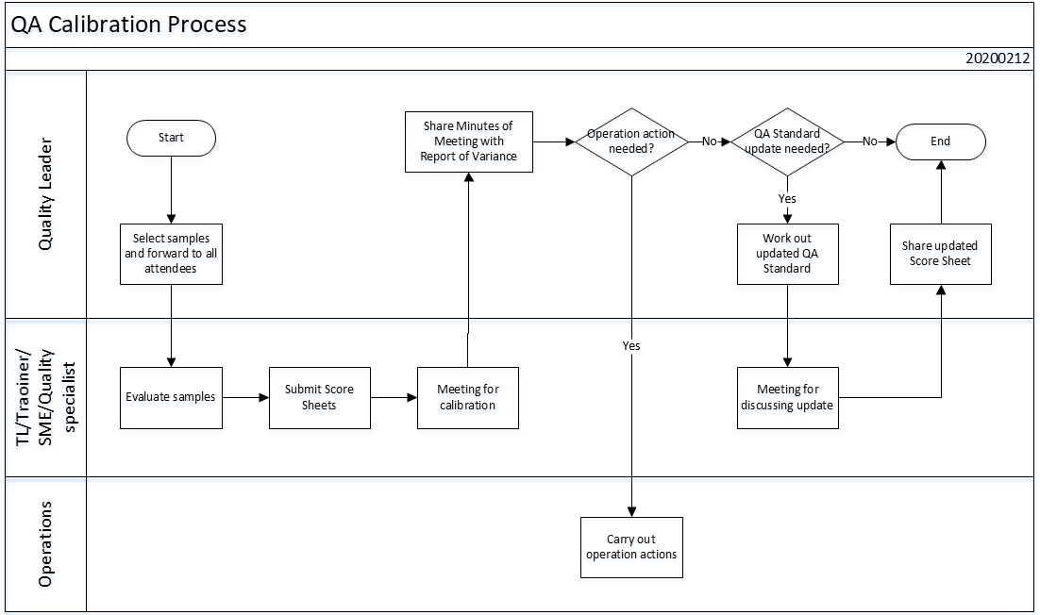

QA Standard Update
7.1 When to Update
Whenever there is a service/bonus/penalty missing in the existing QA standard, or when there is any knowledge gap which existed for more than 3 times after calibrations, then QA Standard shall be updated to optimize the understanding from all members.
7.2 How to Update
Whenever there is a request to update QA Standard, it shall be raised among all members, Quality Leader/Manager being the owner. A meeting shall be held especially to discuss the request in details.
Once the new standard is confirmed, the owner shall send an official Email to publish the updated QA Standard to all personnel related, stating when to start.

Service Quality Management Means

Service Quality Management Meetings
  - Weekly QA Meeting:
Organize QA team meeting every week, to report QA status of previous week, summarize the QA markdowns & findings, analyze the weakness and provide action plans for improvement.
  - Calibration Meeting:
As per Calibration requirements, twice a month, to regulate QA legend.
  - Quality Discussion Meeting:
Schedule Quality Discussion Meeting with all agents’ above positions involved, to discuss the existing problems and solutions, to push the executions on floor.

Trainings
QA Team shall collect common markdown found in QA and share to Trainer. Trainer shall organize trainings for the topics and host quizzes for the same. All relative materials shall be saved for future reference.

Assessment
CSAT, FCR, QA scores, complaint shall be included in agents’ assessment.

Customized Quality Management Means
All Contact Center Sites can take customized service quality management measures as per local situation.

Attachments

2.6-1 OPPO Phone Monitoring Score Sheet

2.6-2 OPPO Email Monitoring Score Sheet

2.6-3 OPPO Chat Monitoring Score Sheet

