Version No | Content Modified | Date of Modification | Modified by | Approved by
1.0 | Original version | 16/08/19 | Lerina Tong | /

1. New Hired Training 2
1.1 General Requirement 2
1.2 Basic SOP for New Hired Training 2
1.3 Training Schedule & Topics 3
2. New Knowledge Training 3
2.1 Types of New Knowledge Training 3
2.2 New Knowledge Training SOP 3
3. Attachment 4

New Hired Training

1.1 General Requirement
- Onboard:
Go through hiring process and be onboard on due date.
- Training:
Be educated as per New Hired Training SOP and cover all topics.
- Assessment:
Assessment is mandatory for each new hire.
- Duration :
At least 2-week training before going alive

1.2 Basic SOP for New Hired Training
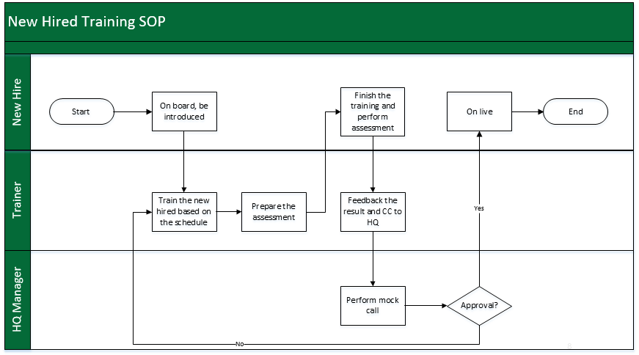

1.3 Training Schedule & Topics
Refer to 3.1-1 New Hired Training Plotter and 3.1-2 Assessment Table.

New Knowledge Training

2.1 Types of New Knowledge Training
- New Product training:
While there are new models released, agents need to be trained for the new models information and features
- New system training (Android, ColorOS): While there is new system released or available for update, agents need to be trained for the update features
- New business SOP training:
While there is new working operation process (e.g, new return visit process update, new system module online/modified), agents need to be trained for better understanding for the working process.

2.2 New Knowledge Training SOP

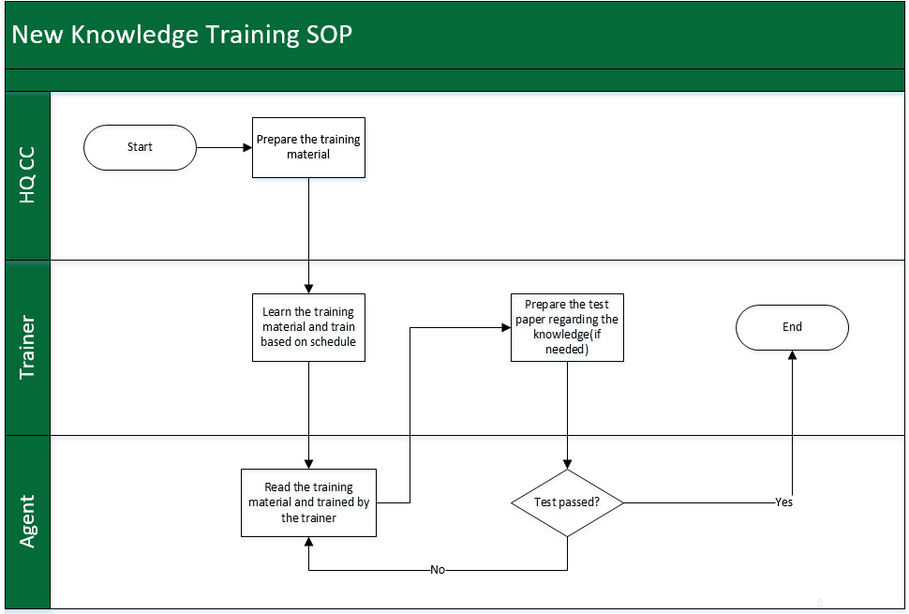

Attachment
3.1 3.1-1 New Hired Training Plotter
3.2 3.1-2 Assessment Table_Reference

