Version No | Content Modified | Date of Modification | Modified by | Approved by
1.0 | Original version | 12/08/19 | Lerina Tong | /

I. Categorization of Fixed Asset in CC 2
II. Management of Sample Devices 2
2.1 Owner 2
2.2 Application & Management of Sample Phones 2
2.3 Cost Verification & Reimbursement 3
2.4 Sample Phone Management 4
III. Attachment 5

Categorization of Fixed Asset in CC
Fixed asset included, but not limited to following items:
Computers/laptops
Earphones
Desk & Charis
TV
Sample devices
All the other assets are provided and managed by Local Office only, while cost of sample devices is included into clearance & reimbursement with HQ.

Management of Sample Devices

2.1 Owner
Contact Center Managers.

2.2 Application & Management of Sample Phones
    - When to Apply
Principally speaking, sample phones shall be applied 3 weeks and delivered to Contact Centers 1 week before official Launch Event. It can still depend on actual situation as of sample phone availability and application process.

    - Quantity to Apply
1 phone per language, based on languages for Enquiry Services, which can be adjusted as per FTE size and operation status of the site.

    - Application SOP
- Regional Contact Center Hubs
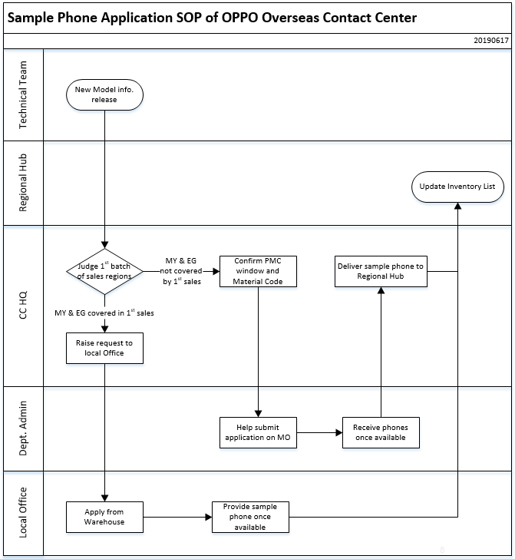

Notes: Application from PMC HQ is prioritized, local office being backup.
  - Local CC: Refer to internal process of Local Offices.

2.3 Cost Verification & Reimbursement
2.3.1 Regional Contact Center Hubs
Phones provided to regional hubs will be fully reimbursed. CC HQ will claim the Sample Phone amount together with Regional Hub Operation Cost monthly; It will be verified and reimbursed as per ex-works price.

2.3.2 Local Contact Center Sites
Submit sample phone amount to SC Management Team together with CC Operation Cost, CC
receipt being attached with consistent information. Same will be submitted to Audit & Finance
HQ for reimbursement.

2.3.3 Following information shall be included while submitting the amount:
From | To | Date | Quantity | Model | Storage | Color | IMEI
Refer to 4.5-1 Verification Table for Sample Devices.

Sample Phone Management
2.4.1 Inventory List Update
All phones delivered to Regional Hub belong to fixed assets of OPPO HQ; Those of Local Contact Centers belong to Local Offices. Contact Center Managers shall update the Inventory List including following information:
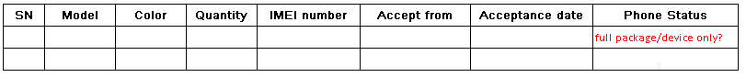

Refer to 4.5-2 Inventory List_Reference.

2.4.2 Compensation for Phone Damage/Lost
Sample phones shall be managed by Contact Centers. Service cycle of the phones is 2 years after the model is discontinued. Once there is any loss/damage, compensation will be incurred. Compensation quotation will be based on ex-works price of the model by Audit Team of OPPO HQ.

Attachment
  - 4.5-1 Verification Table for Sample Devices
  - 4.5-2 Inventory List_Reference

