Version No | Content Modified | Date of Modification | Modified by | Approved by
1.0 | Original version | 12/08/19 | Lerina Tong | /

I. Clarification 1
II. Billing & Payment SOP 2
III. Timeline Highlight 4

Clarification
For Regional Hubs, billings shall be released before 10th every month; And for local CC, just follow the HQ policy & SOP for verification & reimbursement.
What will be mentioned below will be Billing Management Policy & SOP for Regional Hubs, while local CC can take it for reference while managing local billings.

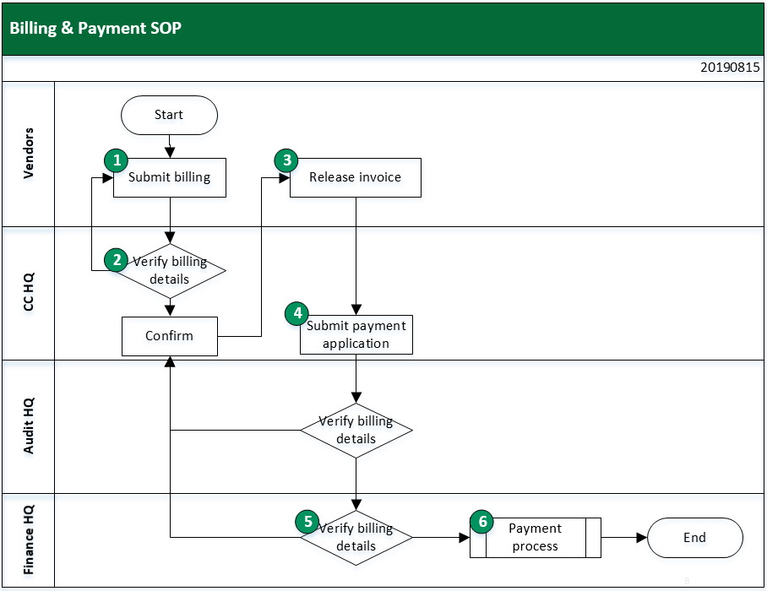
Billing & Payment SOP

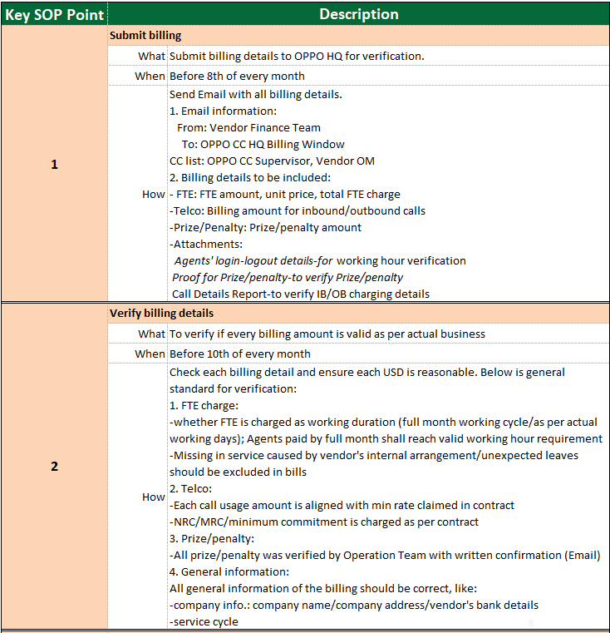

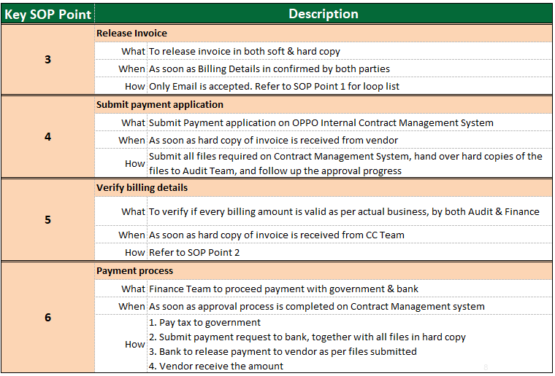

Timeline Highlight

