Version No | Content Modified | Date of Modification | Modified by | Approved by
1.0 | Original version | 25/06/19 | Lerina Tong | /

I. Purpose 2
II. Owners 2
III. Frequency 2
IV. General Audit SOP 2
V. Scope 4
VI. Result 4
VII. Attachments 5

Purpose
Audit is performed so as to learn how the Contact Center is performing, through Spot Check, SOP/Handbook Inspection and Performance Monitoring.

Owners
Initiator: Contact Center HQ.
Collaborator: QA Leader of Local CC Team.

Frequency
Once half a year.

General Audit SOP

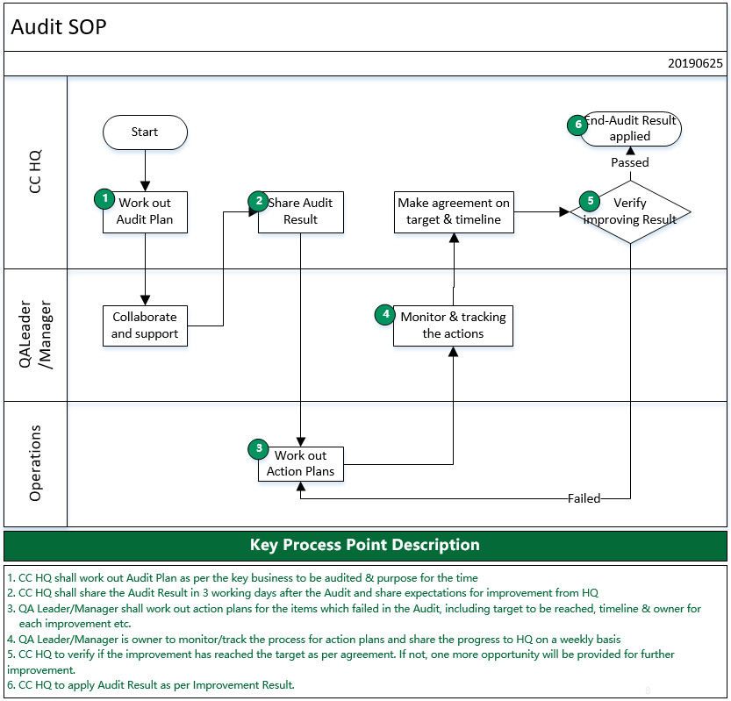

Refer to 2.9-1 Audit SOP.

Scope
Audit mainly covers following business aspects, with overall weight being 100.

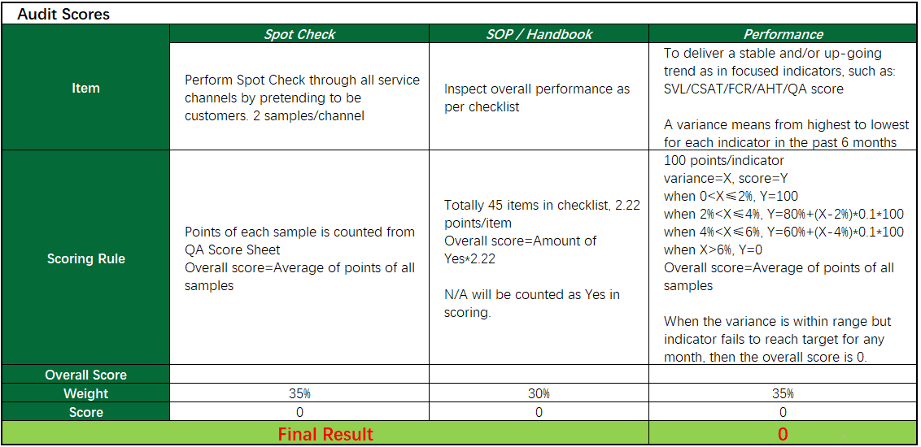

Refer to 2.9-2 Audit Form_Template.

Result
- Excellent: 80 Above
To make action plans for items which failed and keep Excellent in next Audit cycle.
- Passed: 60-80
To make out a action plans for items which failed, with target to reach in next Audit cycle.
- Failed: 60 below
To make out a systematic action plan with target to reach in limited timeline. Once failed by the deadline, CC plan will be considered
Notes: As per Audit SOP, one more opportunity will be provided once the site failed in the Audit. If the site fails again in next cycle, then the final result will be applied to evaluate the CC Service Module.

Attachments

7.1 2.9-1 Audit SOP

7.2 2.9-2 Audit Form_Template

