Version No | Content Modified | Date of Modification | Modified by | Approved by
1.0 | Original version | 31/05/19 | Camille Cheng | /

1. What should be documented? 1
1.1 Customer Information 1
1.2 Product Information 1
1.3 Complaint Information 2
1.4 Handling 3
1.5 Return Visit 4

1. What should be documented?
Document principle: Record should be completed and accuracy, the content should be clear and specific.

1.1 Customer Information
(1). Name and Gender: Mrs. / Mr., First & Last name (should write note if customer is unwilling to provide first or last name.)
(2). Contact Info: Phone number, email address or social media account (Facebook or Twitter account if case original is from FB or Twitter), etc., location (postal address).

1.2 Product Information
(1). Phone model: need to confirm the specific model, like R9 should distinguish R9s and R9 Plus.
(2). IMEI number: IMEI number is needed in case that the complaint is related to Repair. (Should write note if customer cannot provide IMEI)
(3). Purchase data: if customer can provide detailed purchase data, then record detailed date. If not, record the approximate time such as 2018-01-01.
(4). Repair history/relative record: if customer has contacted us before, should record the case ID; if customer has repaired the device before, then record repair ID.

1.3 Complaint Information
(1). Complaint Level:
Select the correct complaint level according to customer complaint content.
- General complaint: Enterprise or individual users are dissatisfied with OPPO product or service, such complaints involve individual users or internal management system, with less impact. (For example, users ‘demands for product quality, customer service, dealers, and primary dissatisfaction with relevant systems.)
- Major complaint: complaints with hidden danger or existing security problems: leakage, abnormal high temperature, explosion, battery dissolution, physical injury, etc; User complaints are spread in the local media or have proliferation risks; large-volume quality complaints, etc.
- Crisis complaint: The content of the complaint is published on social media or local mainstream radio/newspapers. TV stations, radio stations, related media or public security law enforcement agencies call for requests for processing procedures or documents.
(2). Complaint Target
Select what customer complained. If there are multiple complaint target in customer description, the priority is as follow:
Company level>Incident>SC > CC > Product Related > Concept Store > Dealer
- SC: service attitude, repair quality, repair duration, service policy etc.
- CC: service attitude, service skill etc.
- Concept Store: service attitude, service policy, concept store appearance etc.
- Dealer: service attitude, service policy (refuse customer reasonable request), activities related etc.
- Product Related: product function and performance dissatisfaction
- Incidents: product security concern such as leakage, abnormal high temperature, explosion, and battery dissolution, physical injury etc.
- Company level: complaint about media conferences, official news, fan activities, marketing strategies, etc.

(3). Complaint Description
Refer to the Documentation Requirements for Complaint Description.

1.4 Handling
(1). Update process daily: Since the handling process may take a few days, to ensure other related team (CC, HQ) to be informed about the latest process, the documentation of handling is required to update daily no matter the case is solved or not. If cannot update process daily, a note is necessary to explain the reason.
(2). Process records need to be logically clear and complete, the following content should be included in handling documentation.
- Clarify if the complaint description recorded by CC agents is true. If not, record the real situation and upload related proof if there is any.
- (For users) The measure that we have taken and the final solution given to customer, and the result.
- (For internal) How to avoid such complaint happen again?
(3). Complaint handling plan format requires:
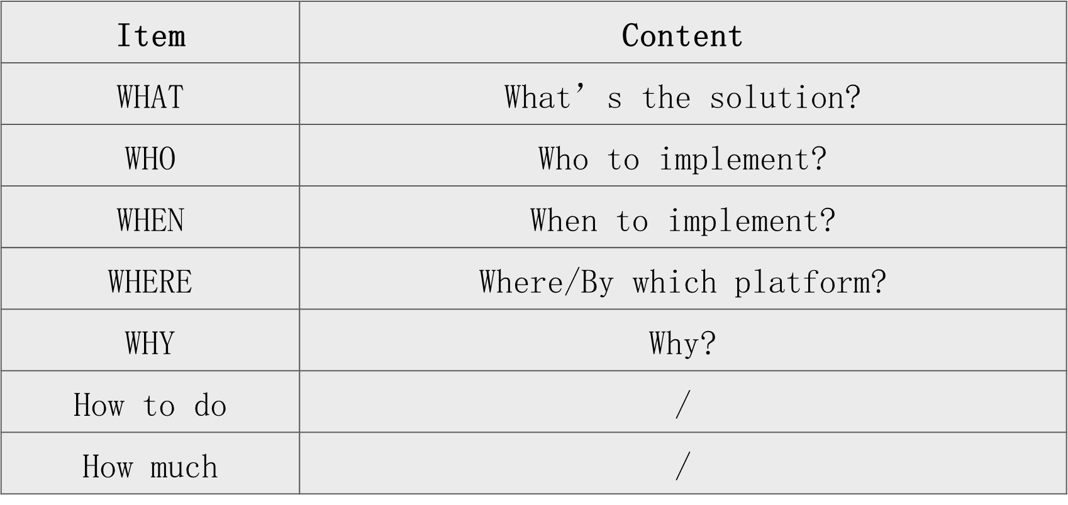

Example:

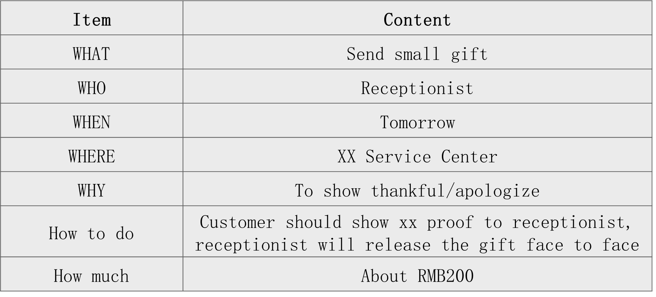

Complaint handling process and result example:
8/9，received the complaint order. After investigation, there is misunderstanding between customer and engineer. The real story is . I called customer 3 times, no answer, will contact customer tomorrow. To avoid such misunderstanding happen again, we will .
8/10, I called the customer to explain the misunderstanding and we negotiated the solution , customer accepted.
The solution is that send customer a free phone case (about 20RMB) to comfort customer. (Who) will pack the earphone and mail to customer this afternoon.

1.5 Return Visit
After complaint handling specialist handled the case, CC TL should arrange agent to do CSAT survey within 48 hours.
Here is the documentation requirement of RV:
1. Record CSAT according to customer feedback; if the result is dissatisfied or general, the reason should be recorded also.
2. If customer phone cannot be reached/no answer, can select ‘callback failed” after calling customer 3 times in 3 days.
3. If no RV needed, just select “callback failed” and note down the situation “no RV needed”.

