- Background
There might be some phone related enquiries from police or other judicial institutions for detecting/judging criminal cases. Contact Center shall handle judicial related enquiries as advised in this document.

- Scope
All enquiries related with Judicial, including but not limited to following scenarios:
- Checking phone information
Like E-warranty status, checking specifications, checking authenticity etc.
- Checking repair related information
Like repair history, SC surveillance video etc.
- Repairing evidence devices
- Request data stored in the phone
Like pictures, videos, App data record etc.
- Seeking owner for lost phones
- Request to get in contact with personnel from Legal Team

- Target
Applicable for OPPO Overseas Contact Centers.

- Handling SOP

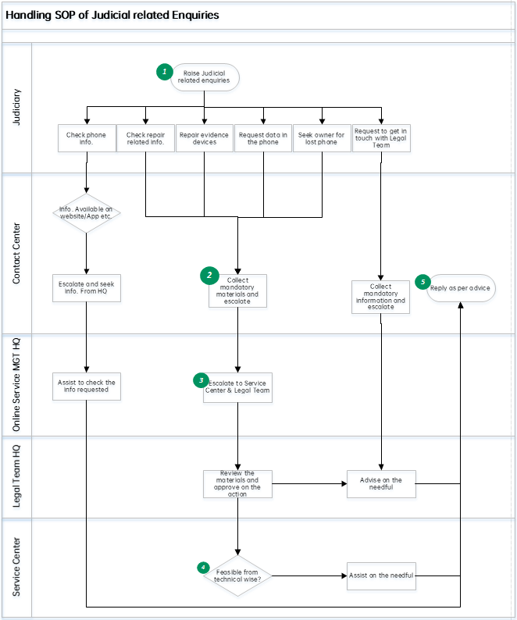

Clarifications for key nodes:
- Judicial related enquiries might be raised from all Contact Center channels, including but not limited to inbound call, Email, Chat, Facebook, WhatsApp, Twitter, Line etc.
- Materials normally requested for those scenarios:
- The filled table for Government/Law Enforcement Information Request.
Refer to Attachment for the Table.
- Scanned copy for Investigation Order.
- Scanned copy for Police Offer Card.
Once the materials are properly collected, escalate the case to HQ.
- Escalate the case to Legal Team by sending Email to law.enforcement@oppo.com or advise customer to send email directly to the email once all materials are ready. Legal Team is responsible to review the materials and check on reasonability of the request. All after-sales actions shall be approved by Legal Team.
Contact window from Legal Team: Liu Wenyuan.
TAT of the Email response: 3 working days
- Quality Feedback & VOC Team shall work with Service Center to check on the feasibility of the action from technical wise and advise on how to reply/proceed.
- All contact center reply shall be approved by Legal Team

- Handling Standard and Reference Scripts
- Checking phone information
Scenarios | Check on E-warranty status, checking specifications, checking authenticity etc. with the IMEI provided
Solution | - Advise customer to check on OPPO website, OPPO Service App, CRM system etc. for the information requested  - If the information is not available on the channels above, escalate to HQ for further check
Judicial materials needed | N/A
Reference Script | For E-warranty Status available on the channels:  You may check the E-warranty Status directly on our website www.oppo.com, under Support>Warranty Status.  For specifications beyond CC knowledge:  We will double check on the specification requested and get back to you soon. (Double check with HQ)  For authenticity:  (Record available by CC from CRM)  Upon checking, the phone is properly existing on our system, which is originally produced by OPPO.  (No record found by CC)  Upon checking, we didn’t find any record of this phone on our system for the while. However, we will double check on this and get back to you soon.  (Double check with Quality Feedback & VOC Team for confirmed information)
- Checking repair related information/Repairing evidence devices/Request data stored in the phone/Seek owner for lost phone etc.
Scenarios | Seek assistance for following scenarios:  - Check repair history, SC surveillance video etc.  - Repairing evidence devices involved in criminal cases  - Request to check pictures/videos saved in the phone  - Request to provide customer information of the phone
Solution | - Collect the materials required  - Escalate to Legal Team by sending email to law.enforcement@oppo.com or advise customer to send email directly to the email with all materials requested
Judicial materials needed | - The filled table for Government/Law Enforcement Information Request.
Reference Script | Kindly fill in the table for Government/Law Enforcement Information Request as attached then send Email to law.enforcement@oppo.com.  Or  We will forward your request to related department once the materials requested are provided.  (The following reply shall be based on Legal Team’s instruction after the solution is provided.)

- Request to get in contact with personnel from Legal Team
Scenarios | Request to get in contact with personnel from Legal Team directly
Solution | - Collect information:  Name, Company, Mobile number, Email address, reason for the request  - Escalate to Legal Team by sending email to law.enforcement@oppo.com or advise customer to send email directly to the email with all information requested
Judicial materials needed | N/A
Reference Script | You may send your request to law.enforcement@oppo.com to reach Legal Team directlt.  Or  We have forwarded your request to related personnel.  (Never promise whether Legal Team will contact the customer or not)

V. Attachment
Government / Law Enforcement Information Request
Law Enforcement Officers should transmit requests to law.enforcement@oppo.com.
OPPO will not process a Government or Law Enforcement Information Request unless it is received from the requesting officer’s official government or law enforcement email address.
Government or Law Enforcement Agency | Country/Region
Government or Law Enforcement Agency | City/State/Province
Government or Law Enforcement Agency | Agency Name
Requesting Officer | Name & Title Rank
Requesting Officer | Official Government or Law Enforcement Email Address
Requesting Officer | Phone
Case Context | Case Date & Location
Case Context | Case Type, Number & Overview
Case Context | Information supporting request (Examples: IMEI number, Email address; phone number; MAC )
Case Context | Information requested from OPPO(Note: information requested should be as narrow as possible relative to the case context)
Case Context | Legal Basis for request：(Responding officer should indicate a specific provision in their domestic law, for example the relevant article or section of an Act such as Criminal Procedure Act or Criminal Evidence Act, which authorizes the collection of information from a third party entity such as OPPO for the purpose of prevention, detection or investigation of the offences; or the relevant article or section of an Act such as Data Protection Act or Privacy Act which provides an exemption for such purposes.)

