OPPO Enco X True Wireless Noise Cancelling Earphones Service Manual

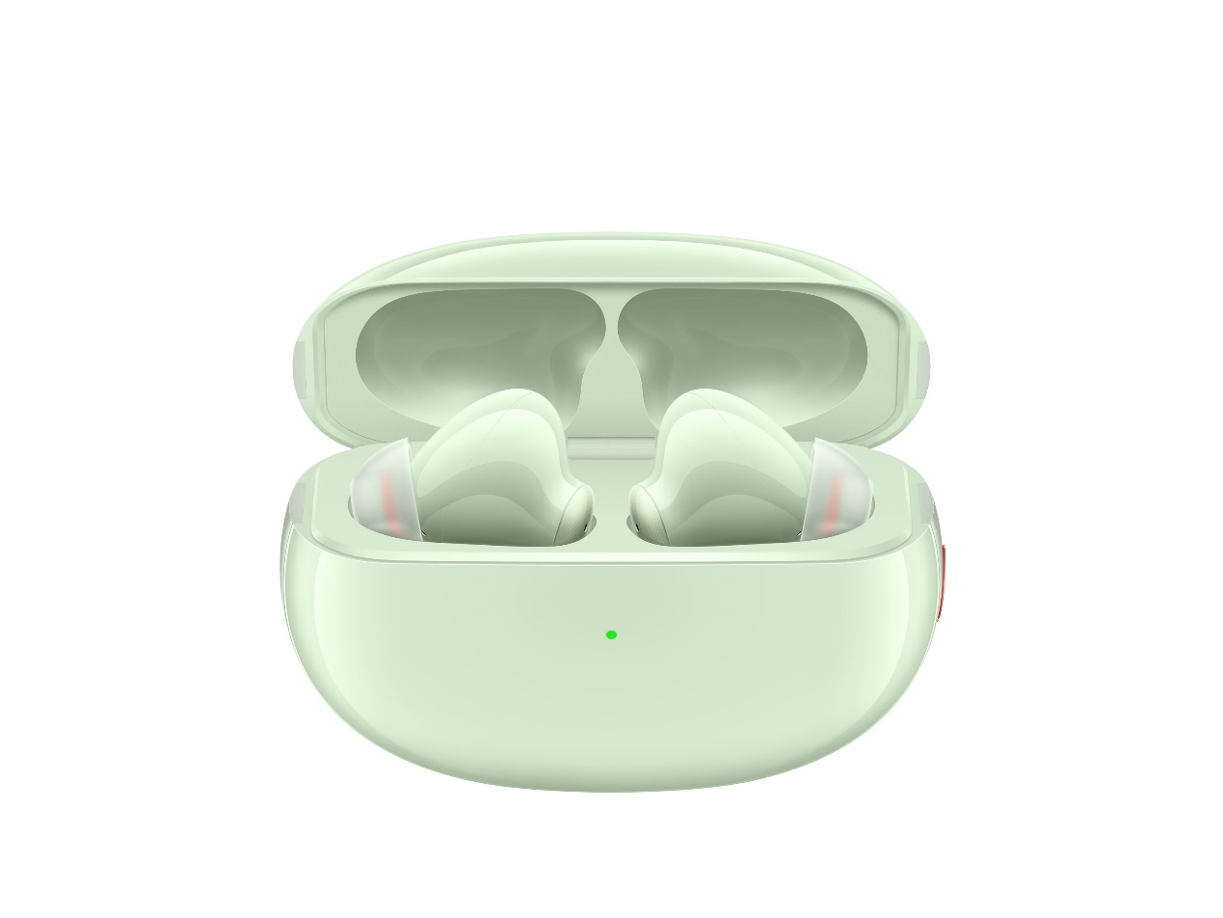

请勿外传
目录
一、Purpose and requirements 3
1.1 Purpose 3
1.2 Requirements 3
二、Product Introduction 3
2.1Product parameter 3
2.2 Product Image 3
2.3 Product SN code 4
三、After-sales policy 5
3.1 After-sales warranty policy 5
3.2 Warranty Program 5
3.3 Warranty Program 5
3.4 Maintenance time specification 6
四、Instructions 6
4.1 Bluetooth pairing 6
4.3Connect other devices 7
4.4Detect headset wearing status 7
4.5Choose earplug silicone sleeve 7
4.6 Touch function 8
4.7Noise control 8
4. Charging function 9
4.9Reset headset 10

一、Purpose and requirements

1.1 Purpose
This article introduces OPPO Enco X True Wireless Noise Cancelling Earphones product parameters, instructions for use, and after-sales policies, which are used to guide the customer service center to correctly handle product after-sales work.

1.2 Requirements
Customer service personnel must strictly follow the policy requirements

二、Product Introduction

2.1Product parameter
Refer to 《OPPO Enco X True Wireless Noise Cancelling Earphones Parameters Table》 for details

2.2 Product Image
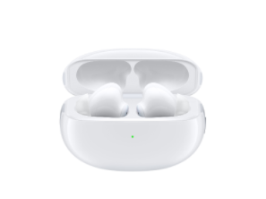
（1）White

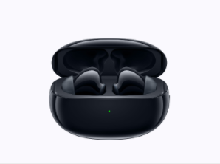
（2）Black
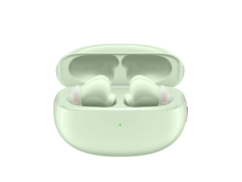
（3）Green

2.3 Product SN code
OPPO Enco X True Wireless Noise Cancelling Earphones product SN code information is printed on the packaging box and Charging Case. The SN code information is consistent, as shown in the red area in the picture:
（1）packaging box
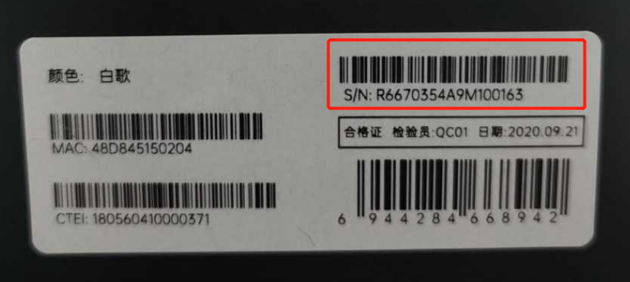
（2）Charging Case
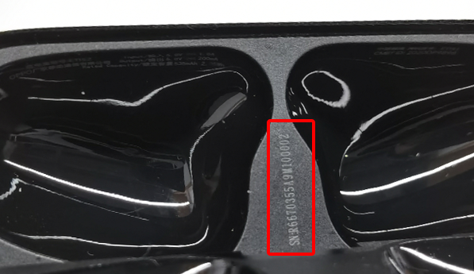

三、After-sales policy

3.1 After-sales warranty policy
After-sales warranty policy is implemented in accordance with local laws and regulations

3.2 Warranty Program
①During the warranty period, if the true wireless headset L has product quality problems, the true wireless headset L can be replaced separately；
②During the warranty period, if the true wireless headset R has product quality problems, the true wireless headset R can be replaced separately
③During the warranty period, if the charging box has quality problems of the product itself, the charging box accessories can be replaced separately；
④During the warranty period, if the USB charging cable has quality problems of the product itself, the USB charging cable accessories can be replaced separately；
⑤During the warranty period, if the earplug silicone sleeve has quality problems of the product itself, the earplug silicone sleeve accessories can be replaced separately；

3.3 Warranty Program
①If the true wireless headset L is damaged or lost, you can pay to replace the true wireless headset L separately；
②If the true wireless headset R is damaged or lost, you can pay to replace the true wireless headset R separately；
③If the charging box is damaged or lost, the charging box accessories can be replaced at a separate fee；
④If the USB charging cable is damaged or lost, the USB charging cable accessories can be replaced at a separate fee；
⑤If the earplug silicone sleeve is damaged or lost, the earplug silicone sleeve accessories can be replaced at a separate fee.

3.4 Maintenance time specification
（1）Online e-commerce purchase
With proof of purchase: calculate the warranty period based on the purchase date on the purchase invoice.
No proof of purchase:Provide the packaging box and the whole headset and identify the consistency of the SN code, calculate the warranty date based on the SN barcode information, and calculate the warranty date based on 90 days after the factory date identified by the SN barcode.
（2）In-store purchase
With proof of purchase: calculate the warranty period based on the purchase date on the purchase invoice.

No proof of purchase:Provide the packaging box and the whole headset and identify the consistency of the SN code, calculate the warranty date based on the SN barcode information, and calculate the warranty date based on 90 days after the factory date identified by the SN barcode.
（3）In the case that invoices, warranty cards, packaging boxes, online purchase records, and SN barcode information query and calculation of the warranty date cannot be provided, the product has not been damaged by third-party factors (such as liquid leakage, private disassembly, etc.), and can be sold by region Time, calculate the warranty period.

四、Instructions

4.1 Bluetooth pairing
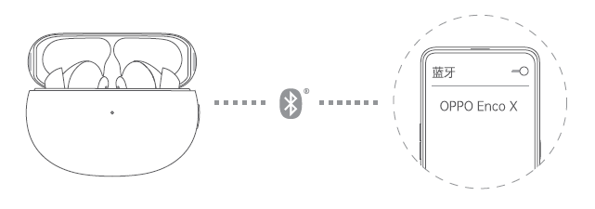
1. When using for the first time, open the charging box and keep the headset in the charging box, the headset will automatically enter the pairing state (the white indicator light of the charging box flashes quickly)。
2. Turn on the phone's Bluetooth:
Regular pairing: Search for "OPPO Enco X" via Bluetooth, select and complete pairing.
Quick pairing: When you are close to an OPPO phone that supports quick pairing, when the Bluetooth is turned on, the phone will automatically pop up a quick pairing prompt. Please follow the on-screen instructions to complete the pairing.
*Only some models support quick pairing.4.2自动重新连接
已有配对记录后，耳机在充电盒中时打开充电盒，将自动回连最近连接过的一台设备。

4.3Connect other devices
1. Keep the headset in the charging box and open the cover, press and hold the function button for 2 seconds until the indicator light flashes white, the headset enters the pairing state;
2. Complete the new device pairing on the Bluetooth interface of the mobile phone.

4.4Detect headset wearing status
When using OPPO Enco X to listen to music, the music will automatically pause after you take off any earphone, and it will automatically play when you put it on again.

4.5Choose earplug silicone sleeve
Appropriately sized earplug silicone sleeves are very important for noise reduction experience, sound quality and comfort. Please try on earplug silicone sleeves of different sizes to choose from. Please note that your left and right ears may need to use earplug silicone sleeves of different sizes.
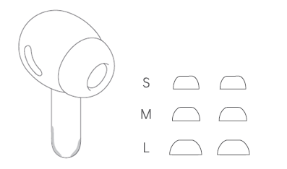

4.6 Touch function
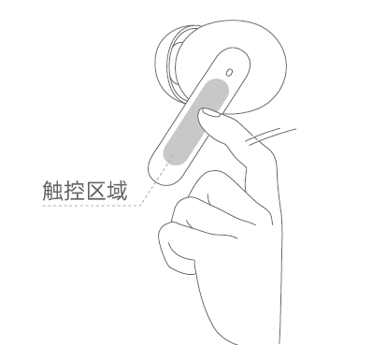

• Switch to the next song: double-click any headset
• Strong noise reduction/transparency mode switching: long press any earphone for 1 second
• Increase/decrease volume: any headphone handle slides up/down
• Answer/hang up a call: double click any headset
Custom settings
You can customize the tap function of the left and right earphones on the OPPO mobile phone, such as turning on the voice assistant, customizing the touch function, etc. Some OPPO models may not support the above functions due to the software version. For details, please refer to the official website: www.oppo.com.
※ The support of voice assistants may vary depending on the phone brand and model.

On the Bluetooth interface of the OPPO mobile phone, click "OPPO Enco X> Headphone Function" to customize the headset.
※ Only supports ColorOS 7.0 and above mobile phones.
Android system
In the app store, search for the "Huanlu" App. After the download and installation are complete, you can customize the headset in the App.
※ Only supports Android 6.0 and above mobile phones.
※ For a list of app stores that support downloading the "Huanlu" App, please check the product details page on the official website.

4.7Noise control
OPPO Enco X headset supports the following 4 noise control modes. You can check the mode you need in the headset custom settings (the default is strong noise reduction and transparent mode). The selected mode can be pressed on the headset side for 1 second Any headset switching.
• Transparent mode: In the transparent mode, the earphone allows external sounds to enter, and the surrounding human voices and other environmental sounds can be clearly heard when wearing
• Strong noise reduction mode: shielding the noise in subways, high-speed rails, airplanes, etc., to provide clearer and more immersive audio effects.
• Weak noise reduction mode: suitable for low-noise daily environments (offices, coffee shops, etc.), balanced ear pressure, and more comfortable listening.
• Noise reduction off mode: no noise reduction effect.
Principle of Noise Reduction
The noise reduction circuit collects external noise through the built-in microphone and sends the opposite signal through the earphone speaker to reduce noise.
The noise reduction function can reduce unwanted noise and provide clearer and more immersive audio performance.
Note:
• The noise reduction effect may not be obvious in a very quiet environment;
• The noise reduction function is mainly effective for low-frequency noise;
• The noise reduction function can reduce noise, but it cannot eliminate it completely.

4.8 Charging function
Power display
• When the headset is in the charging box, the indicator light indicates the power of the headset; when both headsets are removed, the indicator light indicates the power of the charging box.
• The color of the indicator light indicates the power, red means low power (<20%), yellow means medium power (20%-80%), and green means high power (greater than 80%).
Headphone charging
After the headset is placed in the charging box, the indicator light will display the power status of the headset and charge the headset at the same time.
Charging box charging
When the charging box is charging, the color of the indicator light indicates the charging status, yellow means charging, and green means fully charged.
• Wired charging:
Use the supplied Type-c charging cable to charge the charging box.
• Wireless charging:
Use a wireless charger compatible with Qi wireless charging protocol to charge the charging box. When charging, place the charging box with the front face up. At the same time, you can use a mobile phone that supports wireless reverse charging to charge the charging box.
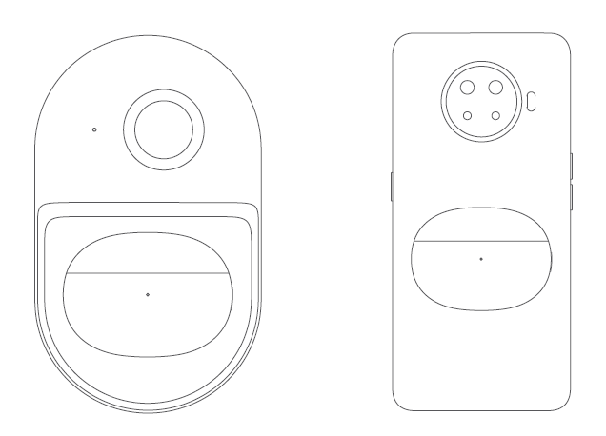

4.9Reset headset
1. Put the headset in the charging box and keep the charging box cover open.
2. Press and hold the function button for 15 seconds until the indicator light flashes red three times and then release it. At this time, the headset has been restored to factory settings.

