OPPO Enco W51 True Wireless Headphones Service Manual

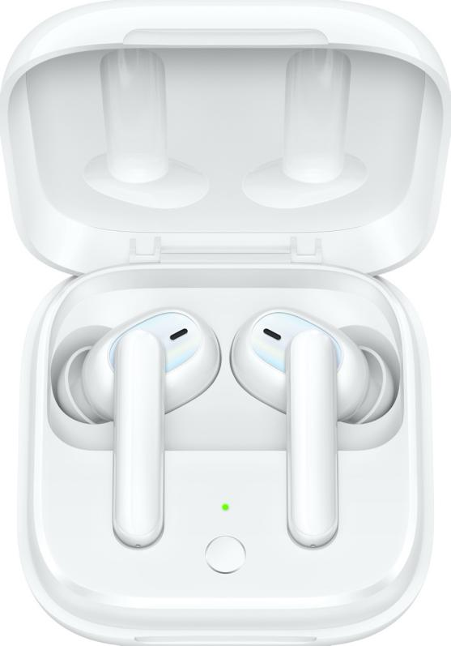

INTERNAL ONLY
Contents
1. Purpose and Requirements 1
1.1 Purpose 1
1.2 Requirements 1
2.Product Introduction 1
2.1 Product Parameters 1
2.2 Product Color and Picture 2
2.3 SN Code Identification 3
3. After-sales Guide 3
3.1After-sales policy 3
3.2 Warranty Instruction 3
3.3 Maintenance Instruction 4
3.4 Warranty Time Specification 5
4.Instruction 6
4.1 Bluetooth Pairing 6
4.2 Automatic Connection 7
4.3 Pairing with Other Devices 8
4.4 Replace the Ear Tips 8
4.5 Touch Control 8
4.6 Charging 9
4.7 Resetting 10
4.8 Noise Cancellation 10
5.Function Test 11
5.1 Bluetooth Connection Test 11
5.2 Headphones Listening Function Test 11
5.3 Headphones Call Function Test 12
5.4 Charging Function Test 13
5.5 Voice Assistant 14

1. Purpose and Requirements
1.1 Purpose
This article introduces the product parameters, instructions for use, and after-sales policies of the OPPO Enco W51 true wireless headphones to guide the customer service center to properly handle the after-sales work of the product.
1.2 Requirements
The customer service center must operate in strict accordance with after-sales policies and order specifications.

2.Product Introduction

2.1 Product Parameters
Name | OPPO Enco W51 True Wireless Headphones
Model | ETI21
Charging Case model | ETI22
Driver | 7mm dynamic driver
Frequency response range | 20 Hz- 20 kHz
Microphone sensitivity | -38 dBV/Pa
Bluetooth codec | AAC/SBC
Bluetooth version | 5.0
Bluetooth range | 10 m
Battery type | Rechargeable Lithium-ion battery
Battery capacity | 25 mAh (Earbuds)  480 mAh (Charging Case)
Music play time (50% volume) | 3.5 h(single charge)  20 h(with Charging Case)
Charging time | 80 min(Earbuds)  80 min( Earbuds +Charging Case)
Input (Charging Case) | 5V----2A
Charging Port | USB Type-C
Color | White 、Black

2.2 Product Color and Picture（换图）
White | Black
 | 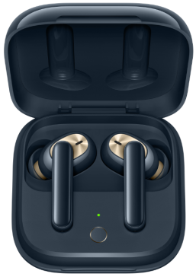

2.3 SN Code Identification
The SN code information of OPPO Enco W51 true wireless headphones products is printed on the packing box and the charging case. The SN code is the same, as shown in the red area in the figure:

Packaging box | Charging case
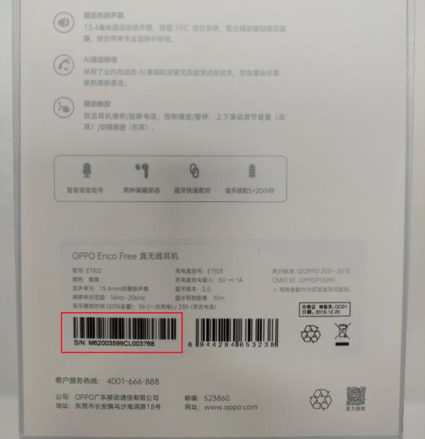 | 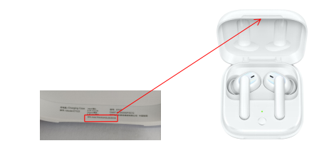

3. After-sales Guide

3.1 After-sales policy
The After-sales policy is implemented in accordance with local regulations.

3.2 Warranty Instruction
1. In warranty period, if the left earphone has non-artificial damage and the quality of the product itself, the left earphone accessories can be replaced separately;
2 In warranty period, if the right earphone has non-artificial damage and the quality of the product itself, the right earphone accessories can be replaced separately;
3. In warranty period, if the charging case has non-artificial damage and the quality of the product itself, the charging case should be replaced separately.
4. In warranty period, if the USB charging cable is not artificially damaged and the quality of the product itself, the USB charging cable accessories can be replaced separately.
5. In warranty period, if the ear tips has non-artificial damage and the quality of the product itself, the ear tips can be replaced separately.
Remarks: OPPO Enco W51 true wireless headphones are shipped as a complete set, and then disassembled to replace it for users. The sluggish materials subsequently generated are written off by the spare parts team with agents.

3.3 Maintenance Instruction
1. If the left earphone is faulty or missing, the customer can pay for the replacement of the left earphone accessory separately.
2. If the right earphone is faulty or missing, the customer can pay for the replacement of the right earphone accessory separately.
3. If the charging case is faulty or missing, the customer can pay for the charging case accessory , and the charging case should be replaced separately.
4. If the USB charging cable is faulty or missing, the customer can pay for the replacement of the USB charging cable accessory separately.
5. If the ear tips is faulty or missing, the customer can pay for the replacement of the ear tips accessories separately.
Remarks: OPPO Enco W51 true wireless headphones are shipped as a complete set, and then disassembled to replace it for users. The sluggish materials subsequently generated are written off by the spare parts team with agents.

3.4 Warranty Time Specification
1. Having proof of purchase: calculate the warranty time with the purchase invoice and warranty card;
2. No proof of purchase: provide the box and identify the SN code, and use the SN code information to query and calculate the warranty date.
3. In the case where the invoice, warranty card, packing box, online purchase record, SN code information query and calculation of the warranty date cannot be provided, No warranty is provided.

4.Instruction

4.1 Bluetooth Pairing
How to connect Bluetooth :
- When using for the first time, make sure that the headphones is in the charging case. Open the charging case and the headphones will automatically enter the pairing state.
- Non-first use , need to connect a new phone, there are two ways to enter pairing status
1) Turn off the Bluetooth function of the original mobile phone , the headphones will automatically enter the pairing state , the headphones sounds a pairing prompt; go to step 3
2) Ensure that the headphones in the charging case, press the right headphone 5s until the charging case red indicator flashes three times and then turn to green light breathing , the headphones enters the pairing state. Go to step 3
- Turn on the phone Bluetooth
1) Conventional pairing: find Bluetooth name: OPPO Enco W51, click to connect.
2) Quick pairing: Close to the OPPO mobile phone that supports quick pairing, and when Bluetooth is turned on , the phone will pop up a quick pairing prompt, and follow the on-screen prompts to complete the pairing.
How to disconnect:
- Put the two headphones into the charging case and close the case cover 5s to automatically disconnect.
- Click the Bluetooth name after the device is connected, select Unpair to disconnect.
- Click the Bluetooth name after the device is connected and choose to disconnect this connection.
- Turn off the Bluetooth switch of the device to disconnect.

4.2 Automatic Connection(to paired phone) :
If the mobile phone to be connected is the last mobile phone connected to the headphones, open the case and the earphones will re-connect to the phone automatically.
note:
1. The mobile phone needs to be within the transmission distance of the Bluetooth, and ensure that Bluetooth function is turned on.
2. Due to the characteristics of the Bluetooth, the electromagnetic waves in your area may interfere with the Bluetooth connection, which could cause the headphones don’t play or disconnected.

4.3 Pairing with Other Devices
Disable Bluetooth feature on your device,the headphones will start pairing automatically, the headphones then are available for pairing with a new device.

4.4 Replace the Ear Tips
OPPO Enco W51 True Wireless Headphones are equipped with 4 types of Ear Tips (the Size M Ear Tips are pre-installed on the headphones). Choose the right Ear Tips for the most comfortable feel.

4.5 Touch Control
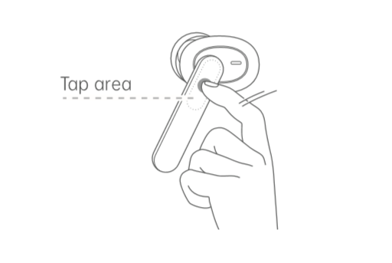
Function | L | R
Next Track |  | • •
Answer/End a call |  | • •
Noise cancellation | • •
Voice Assistant | • • • | • • •

※”• ”means touch it once.
※ Whether voice assistant is supported depends on the brand and model of the device.

4.6Charging
1.Check charge status
• The Indicator shows charge status of the headphones when they are in Charging Case. Otherwise, the Indicator shows charge status of the Charging Case.
• The indicator color indicates the battery level, red indicates low battery, yellow indicates medium power, and green indicates high battery.
• When the remaining battery charge of the Charging Case is low (the indicator lights red), the Charging Case can only complete one full charge of the headphones at most. Please charge the Charging Case in time.
2.Charge the Headphones
• The headphones charge while in the Charging Case.
3.Charge the Charging Case
• Use the USB-C Cable to charge the Charging Case. The Indicator will light up when charging.
※ If the device is left to lie idle for long periods, charge it every two months; otherwise, the headphones may not work properly.
※ The headphones and the Charging Contacts, clean them before charging. Otherwise corrosion and damage may occur.

4.7 Resetting
1. With the headphones in the Charging Case and lid open,and disconnect the headphones with the device.
2. Press and hold the right/R headphone (15S) until the Indicator flashes red three times. Then the headphone have been restored to factory settings.

4.8 Noise Cancellation
OPPO Enco W51 Ture Wireless Headphones detect ambient noise through the built-in microphones,and generate an equal-but-opposite signal through the speakers to reduce the ambient noise. Noise cancellation reduces unwanted noise and offers you a clear and more immersive audio experience.
Note:
The noise cancellation effects may not be pronounced in very quite environments.
The noise cancellation feature works better for low frequency noise.
The noise cancellation feature reduces noise but does not completely cancel it out.

5.Function Test

5.1 Bluetooth Connection Test
1. With connected mobile phones, you can quickly connect after opening the charging case (most connect within 5s, and a few connect within 10s)
2. Put the headphones back on the charging case. After closing the lid of the charging case, the Bluetooth connection will be disconnected within 5s. If you turn it on again, it will automatically reconnect.
3. An headphone can be connected separately. At this time, the mobile phone only displays the power of the worn headphone .
4. Bluetooth signal test: The mobile phone is placed on the desktop, the headphones is worn, music is played or a call is made, and the distance between the headphones and the mobile phone (no obstruction in the middle) ≤ 10m indicates that the signal is abnormal.
Note: There is an obstruction between the mobile phone and the headphones(when the object or the human body is stuck, the phenomenon of jamming may occur during the distance)

5.2 Headphones Listening Function Test
1. Play music, long press the right ear touch area , and adjust the volume to the maximum. Pay attention to the volume adjustment evenly, and the volume cannot suddenly increase.
Note: The volume of the headphones and mobile phone cannot be adjusted automatically.
2. Play the music, wear the headphones well, and listen to whether the volume of the left and right ears is the same (it is important to measure this after replacing the single headphone separately for the user, it is best to confirm with the user when the user picks up the machine)
3. Play music, touch the left headphone twice to switch to the previous song, touch the right headphone twice to switch to the next song, touch the left/right headphone once to pause and play music.
4. Play the music, wear the left and right ears, the left and right ears are normal at this time, then remove the left ear, the music is paused, then wear the left ear music to continue playing; remove the right ear, the music is paused, and then wear the right ear to continue to play the music.

5.3 Headphones Call Function Test
1. Wear the headphones, make a call, pay attention to whether the sound is low in the first 10s, and then normal.
2. Make a call, test whether the other party hears noise, electric current, or broken sound.
3. Wear the headphones, double-click to access the phone, listen to the other party's voice and whether the other party's listening is normal, double-click to hang up the phone

5.4 Charging Function Test
1. When the headphones is placed in the charging case, the indicator will flash twice, indicating that the headphones has been placed in the charging case.
Note: Failure of the headphones in-box detection will directly affect charging (the headphones does not charge)
2. Put the headphones in the charging case, close the charging case cover, and then open the charging case cover. At this time, the charging case indicator light indicates that the Hall switch function of the charging case switch is normal, and the color of the indicator light at this time represents the power of the Headphones (if two headphones’ battery is inconsistent, the lower battery status is displayed), red indicates low battery (<20%), yellow indicates medium battery (20% -80%), and green indicates high battery (greater than 80%).
3. Use the Type-C charging cable to charge the charging case. The indicator light will turn on when charging, indicating that the charging case has entered the charging state.
Note: If the user feedback that the headphones is not charging, first check whether the charging contacts of the headphones(located on both sides of the mic hole at the bottom of the headphones) are dirty and corroded. If the corrosion is severe, remind the user to put the headphones back when using the headphones. If there is more sweat before charging the box, wipe the contact sweat with a tissue or cloth.
Check whether the charging shrapnel of the charging case headphones can expand and contract normally, if it is blocked by foreign objects. If the shrapnel fails to stretch normally (perhaps the sweat crystal may affect the normal expansion and contraction of the shrapnel), you can repeatedly press the shrapnel with a cotton swab moistened with water, and then blow it with a wind gun at 60°C for two minutes.

5.5 Voice Assistant
1. Touch the left/right headphone three times to wake up the voice assistant. (OPPO phones will wake up Breeno, other voice assistants depend on the model brand).
2. Execute an instruction, such as asking the weather of the day.

