Version No | Content Modified | Date of Modification | Modified by | Approved by
1.0 | Original version | 25/06/19 | Lerina Tong | /

I. Purpose 2
II. Data Cycle & Frequency 2
III. Owner 2
IV. Data Template 2
4.1 Data Origin 2
4.2 Weekly RV Status Update Table 3
4.3 Monthly RV Report 3
V. Attachments 4
5.1 2.13-1 Weekly RV Status Update Table_Template 4
5.2 2.13-2 OPPO RV Report_ID_June 4

Purpose
RV Data shall be monitored and shared regularly to ensure both quantity and quality of RV task are properly fulfilled either on a weekly basis or on a monthly whole. Besides, it can also explore the performance of the region as a whole and in SC wise so that local office can have a better understanding of their service quality.

Data Cycle & Frequency
- Weekly RV Status Update Table, data of previous week by every Monday
- Monthly RV Report, report of previous month by every 10th

Owner
RV Team Leader

Data Template

Data Origin
All RV Data can be generated from Salesforce system, under the report named [Return Visit (Non-sent by user(201903)].

Weekly RV Status Update Table
    - Scope
Main focus of Weekly RV Status Update is to show the RV amount & ration on a weekly basis so as to ensure the monthly target can be reached and RV amount of each type is properly balanced.

    - Template
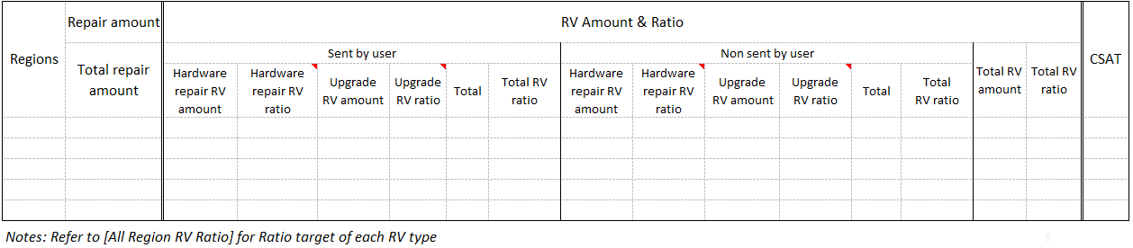

Refer to 2.13-1 Weekly RV Status Update Table_Template

Monthly RV Report
    - Scope
Monthly RV Report is mainly showing the general performance of the region in key KPI wise as well as SC wise then both HQ and Local Office can have a better understanding of how SCs are working so that proper actions can be taken to improve the service.

    - Structure of RV Report
RV Report include following parts:
Overall Performance
Key KPI Trend
SC Wise Performance
Refer to 2.13-2 OPPO RV Report_ID_June for reference.

Attachments

2.13-1 Weekly RV Status Update Table_Template

2.13-2 OPPO RV Report_ID_June

