I. Definition & Purpose 1
II. Scope 2
III. Owner 2
IV. How to Perform Real-time Management 2
1. Monitor Agent Status in Real-time 2
2. Monitor and Analyze Key Performance Indicators 2
3. Track and Compare Forecasted and Actual Center Statistics 3
4. Evaluate Adherence and Take Actions to Improve Performance 5
V. Real-time Management Report/Dashboard 5
VI. Owners for Real-time Management on Floor 6

Definition & Purpose
Real-time management is proactively managing the contacts and queues “on the day” to
ensure service levels and business targets are met. This means taking the resource plan and
forecasts and monitoring volumes throughout the day, acting if thresholds are transgressed
and enabling service recovery plans if required.
An effective real-time management process and governance is critical for workforce
optimization and it provides the opportunity for the planning team to really show their worth
by reacting to changes as they unfold in a positive way and without compromising on
service.

Scope
Applicable for all Contact Center service channels.

Owner
Team Leaders are the main owners for real-time management of each service channels, while Operation Manager is the owner for overall performance on floor.

How to Perform Real-time Management

Monitor Agent Status in Real-time
This shows each agent’s status (Available, Busy, Away, Offline etc.).
When using this metric along with the “calls in queue” metric, managers can more effectively assign tasks to their team. For example, having a few available agents isn’t a problem if your team is only receiving a few calls. Managers can then assign agents to work on other tasks.

Monitor and Analyze Key Performance Indicators
2.1 Answer Rate (ANS %) & Service Level (SVL %)
Service level can be a quality indicator for Contact Center and is defined as the percentage of calls answered within x seconds (x=20s as per OPPO current target).
OPPO target for ANS%/SVL% is 90%/80%.

2.2 Average Waiting Time and Average Time of Abandonment
These indicators reflect recent trends and provide context to the number of calls in the queue and longest waiting time. Supervisors can compare current metrics against historical data and easily identify trends.

2.3 Number of Calls in Queue
This displays the current backlog. It is the metric that is most sensitive to changes and trends. Managers should decide what action should take place when this metric reaches a predefined cutoff. For example, when agents notice that this metric exceeds a predetermined threshold, they can place their current caller on hold, or expedite their current call to accommodate a caller in the queue.

2.4 Longest Waiting Time
This is the length of time that the longest waiting caller has been in the queue. Agents can use this metric as an indicator that they should expedite the call, or spend more time with the current customer. Managers can use this metric along with the calls in queue metric to anticipate a critical time for them to engage in preventative action. For example, if there are far more calls in queue than normal but the longest waiting time is short, the team is starting a downward trend and service level will decrease. This is an important time to engage in preventive action.

Track and Compare Forecasted and Actual Center Statistics
  - What is Forecast Accuracy
Forecast accuracy can be defined as the difference between the amount of work per time period projected to be presented and the amount of work that is actually presented. This work can include all channels where agents are engaged, like inbound calls, outbound/RV calls, Emails, Chats and social media enquiries etc. They can all be included into “calls” in following calculations.

  - How to Calculate Forecast Accuracy
Following formulas can be applied to calculate Forecast Accuracy:
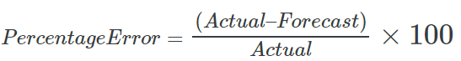

Wherein, Actual volume is “calls offered”.
Instead of breaking percent difference up across the day, it is better to include the results across intervals in the calculations, for a more reliable result. An interval is a fixed unit of time, sometimes referred to as a “reporting period”. It can be 1 hour or 0.5 hour for daily forecasting and monitoring.

  - How to Perform Forecasting
3.3.1 Define Forecasting Formulas
Contact centers can predict call volumes for the period to come ahead by finding an average from the previous two or three periods.
For example, if this is to forecast service volume for each day of the coming month, history data of previous two or three months can be applied, which shall be broken down into days:
Moving Average (April)= $\frac{1}{3}$ Jan volume+ $\frac{1}{3}$ Feb volume + $\frac{1}{3}$ Mar volume
    - Use Excel for Forecasting
The first stage of creating Excel-based forecasts is to analyze historical call data and look out for recurring patterns. This can be done by pulling data from the contact center’s CTI or ACD system. Failing that, checking the Call Detail Records (CDR) is the next-best option, and contacting the telephone company would be a final resort.
If done through an ACD system, the contact center will be able to see the percentage of the day’s incoming calls, broken down to match each reporting period, usually up to 30 minutes.
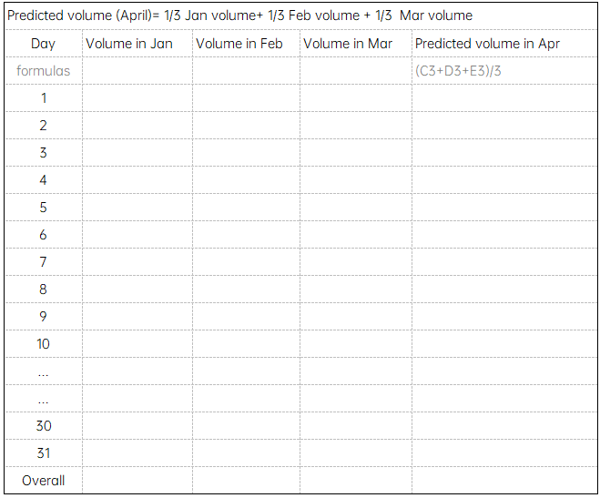
  - Tips for Forecasting
3.4.1 Use recurring and non-recurring events to create a prevision forecast.
Forecasting best practices suggest that more accurate forecasts enable more effective scheduling.

3.4.2 Be prepared for frequent changes to your staffing plan.
Agents call in sick, will be late, will need to leave early, won’t leave or return from meals and breaks on time for a variety of reasons.
Streamline the schedule-change process to reduce administrative overhead (and associated costs!) and ensure key metrics continue to be met.

3.4.3 Consider overstaffing and understaffing impacts independently.
Have a keen understanding of what factors drive the business. Since customer satisfaction is our top priority, little overstaffing can be desirable.
3.4.4 Watch out for regular typical events
Many factors affect the demand presented to the average contact center. The number of factors can be virtually unlimited, but includes regular events like:
- Day of week (volumes may be higher on Mondays than they are on Wednesdays)
- Day of month (volumes may be higher on the 1st, 15th or 30th)
- Season (holidays, anyone?)

Evaluate Adherence and Take Actions to Improve Performance
Real-time adherence is a logistical metric that indicates whether agents are where they're supposed to be, when they're supposed to be there, according to their scheduled queues and skill groups. This is one of the first metrics managers should check when service levels aren't being met. More and more, real-time adherence will not only be monitored in the call queue but also across other near real-time channels. There would always be enough appropriately skilled agents to handle each call as it arrived to satisfy service level, customer satisfaction, cost and revenue objectives. It is important to match the right agents to the projected work based on these factors.

Real-time Management Report/Dashboard
Real-time Management Report/Dashboard can be available on Call Systems, which is developed by system vendors. Contact Center is responsible to check whether the metrics included in the report are to our demands.
A complete Real-time Management report shall include, but not limited to metrics below:
Agents’ status:
- Available, Busy, Away, Offline etc.
- Service queue of all channels:
including how many customers are waiting with each channel, how many calls offered, how many answered, how many abandoned, how long each customer has been waiting on the queue etc.
- Key Performance Indicators:
ANS%, SVL%, AHT, ATT, Average Hold Time, FCR, CSAT etc.
The Real-time Management Report/Dashboard shall be refreshed every 15 seconds as long as the page is active.

