Version No | Content Modified | Date of Modification | Modified by | Approved by
1.0 | Original version | 30/06/19 | Camille Cheng | /

1. Spot Check Process 1
2. Detailed Process Description 2
3. Control Points 5
4. List of Artifacts/Documents 5

1. Spot Check Process
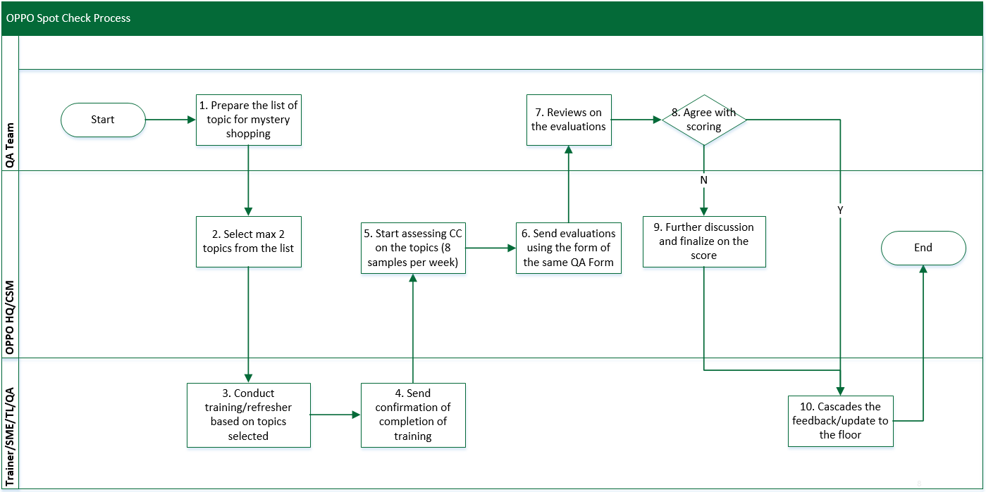

2. Detailed Process Description

3. Control Points

4. Attachment
2.7_1 OPPO_QA Spot Check Score Sheet_Template

