Case 1 National sovereignty and map labeling 1
Case 2 Gender discrimination 2
Case 3 Religion/Culture/Custom 2

Case 1 National sovereignty and map labeling
In response to a number of foreign airline websites listing Taiwan as "country", the Civil Aviation Administration of China wrote to 44 foreign airlines on April 25 requesting changes to the designation of Taiwan, including American Airlines, Delta Airlines, and United Airlines 3 major U.S. airlines. China's initial deadline is 30 days, with 18 airlines revised on schedule. The duration of the other 26 airlines was subsequently extended to July 25.
However, Delta Airlines and United Airlines’ websites still list "Taiwan", "Hong Kong" and "China" in the "Country/region" column. As for American Airlines, they still list “Hong Kong" with "China" in the country/region column.

Taiwan, Hong Kong, Macao do not parallel with the country. If need to do so, it is important to note them under "countries and regions" as well as use “Hong Kong, China”, “Macao, China”, “Taiwan, China” or “Taiwan area”.

Case 2 Gender discrimination


The picture is a screen-lock magazine for Australia OPPO phone. Customer sued OPPO for materializing women because the picture says beautiful lady.

Case 3 Religion/Culture/Custom
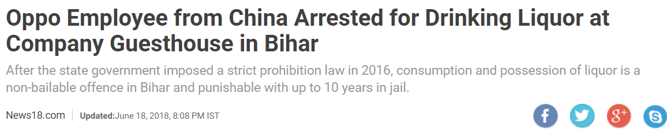
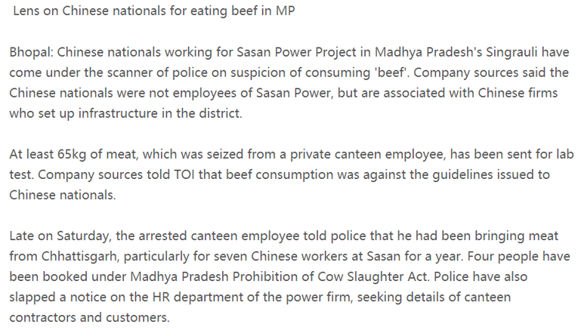

In some areas of India, consumption and possession of liquor is a non-bailable offence in Bihar and punishable with up to 10 years in jail.

Indians respect cows as gods, eating beef is not allowed

