Version No | Content Modified | Date of Modification | Modified by | Approved by
1.0 | Original version | 30/06/19 | Wenhong Tan | /

1. Definition of VOC 2
2. VOC report management 3
3. VOC feedback and tracking mechanism 4
4. Application of VOC Report .......……………………………………………………….5

Definition of VOC
- VOC is the short term for the “voice of the customer” which is a process used to capture the requirements/feedback from the customer (internal or external) to provide the customers with the best in class service/product quality. This process is all about being proactive and constantly innovative to capture the changing requirements of the customers with time.
- The “voice of the customer” is the term used to describe the stated and unstated needs or requirements of the customer. The voice of the customer can be captured in a variety of ways: Direct discussion or interviews, surveys, focus groups, customer specifications, observation, warranty data, field reports, complaint logs, etc.
- This data is used to identify the quality attributes needed for a supplied component or material to incorporate in the process or product.

VOC report management
To better analysis the quality issue based on the enquiry data, contact center is responsible for the 1) customer enquiry data collection 2) analyzing the raw data and make it in a report to present the main feedback of the week, which we call it VOC report

2.1 Enquiry data category (Tally Report)
The following is what we have for Tally 1
Tally 1
Function (Setting) inquiry
Product specification/parameter inquiry
Business enquiry
Complaint/Suggestion/Compliment
Malfunction for hardware/software
Repair/after-sale enquiry
Pre-sales enquiry
Other

Refer to the attachment 2.14-1 Contact Center 6-Tally Report

VOC feedback and tracking mechanism
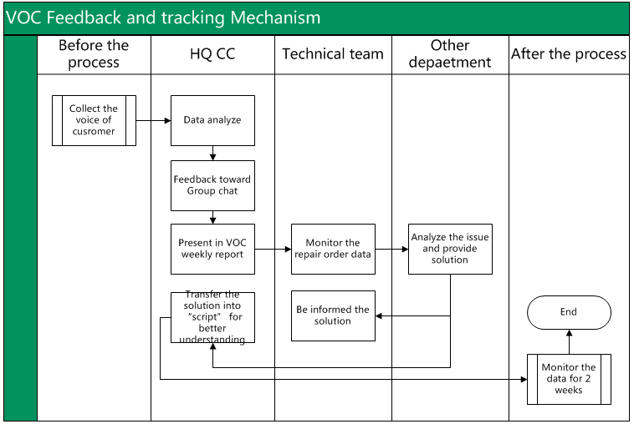

Application of VOC Report .
- Quality issue alert
To highlight the quality issue of the week for quality related department to analyze
- Customer suggestion collection
To analyze customer’s need regarding our product.

