OPPO Watch 41mm (Wi-Fi) Service Manual

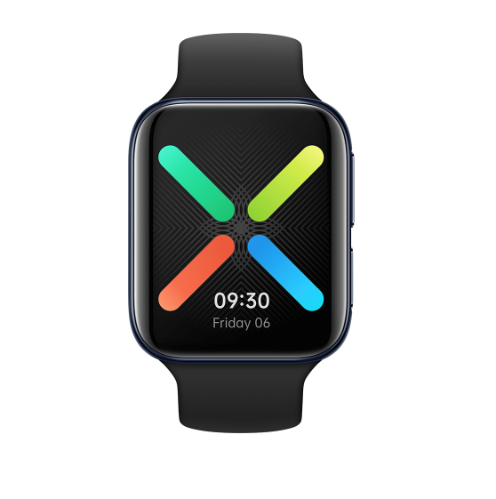
Confidencial

Contents
1 Purpose and requirements 2
1.1 Purpose 2
1.2 Requirements 2
2 Product Introduction 3
2.1 Product parameter 3
2.2 Product color, picture 4
2.3 Product DC code identification 5
3 After-sales policy 6
3.1 After-sales warranty policy 6
3.2 Warranty policy 6
3.3Maintenance Proposal 6
3.4 Maintenance time 7
4 Instructions 7
4.1 Product overview 7
4.2 Buttons 8
4.3 Operations 8
4.3 Charge OPPO Watch 9
4.4 Pair OPPO Watch 9
4.5 Manage OPPO Watch 10
4.6 Change the watch strap 10
5 Function test 10
5.1 Test path 10
5.2 Testing requirements 11

1 Purpose and requirements

1.1 Purpose
This article introduces the OPPO Watch 41mm (Wi-Fi) product parameters, instructions for use, and after-sales policy to guide the customer service center to correctly handle the after-sales work of the product.

1.2 Requirements
The customer service center must operate in strict accordance with the after-sales policy and order recording specifications.

2 Product Introduction

2.1 Product parameter
Market Name | OPPO Watch 41mm (Wi-Fi)
Colour | Black/Pink Gold/Silver Mist
Size | 41.45×36.37×11.4mm (13mm including heart rate sensor)
Watch frame | Aluminum alloy
Strap | Fluororubber
Bottom case | PC
Weight | About 30.1g (without straps)
Buttons | Home button, Multifunction button
Screen | Rigid AMOLED Screen
Screen size | 1.6"
Resolution | 320×360
Battery capacity | 300mAh (Typical value)/289mAh (Rated value)
Adapter power requirements | Rated output 5V⎓1.5A or above
Charging mode | Magnetic Charging
Theoretical battery life in Smart mode | Up to 24 hours
Theoretical battery life in Power Saver mode | Up to 14 days
Flash Charging | Watch VOOC Flash Charging
Processor | Qualcomm® Snapdragon Wear™ 3100 & Ambiq Micro Apollo3 Wireless SoC
Operating system | Wear OS by Google™
Capacity | 1GB+8GB
Wi-Fi | WLAN 2.4G
Bluetooth® | BT4.2，BLE
Sensor | Tri-axial acceleration sensor/Gyroscope sensor/Geomagnetic sensor/Barometric sensor/Optical heartbeat sensor/Capacitance sensor/Ambient light sensor
Workout modes | Fitness Run/5-Min Workouts/Fat Burn Run/Outdoor Walk/Outdoor Cycling/Swimming
Fitness functions | Heart rate monitoring/Sleep monitoring/Get Up Reminder/Guided breathing exercises
Water resistance | 3ATM
GPS | With Built-in GPS. Supports A-GPS and GLONASS.
NFC | Support
Voice assistant | Google Assistant
App | Wear OS by Google & HeyTap Health App
Packing list | Watch body (without strap)×1  Fluororubber strap×1  Charging base×1  Quick Start Guide×1  Safety Guide×1

*Battery capacity, battery life, etc. are measured under OPPO laboratory room temperature (25°C) using OPPO standard chargers. The measured data may vary due to factors such as the use environment and individual differences in the charger.
* Specifications are all laboratory test data.

2.2 Product color, picture
（1）Black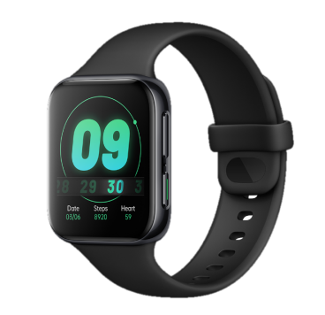

（2）Pink Gold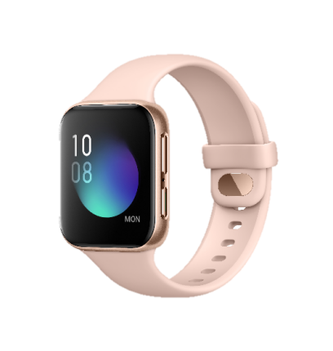

（3）Silver Mist 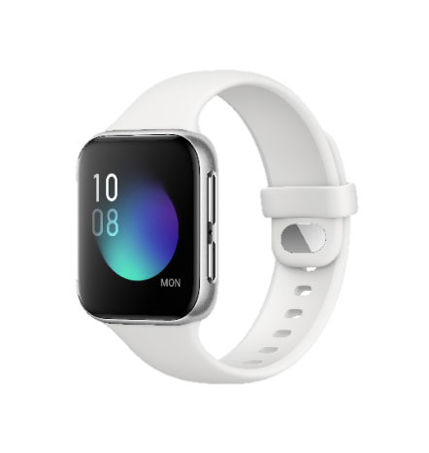

2.3 Product Device code identification
DC code (device code) is the identification code used by OPPO watches for non-LTE versions. The function is similar to IMEI. It can be used to query the watch E-warranty card in the system (Path：WCSM-Basic data-E-warranty card search -IMEI/SN) and other information. The DC code information of OPPO Watch 41mm (Wi-Fi) is include in the box, warranty card and watch settings. As shown in the red area in the figure:
（1）Box
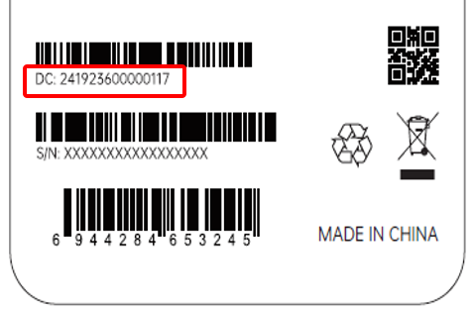
（2）Warranty card
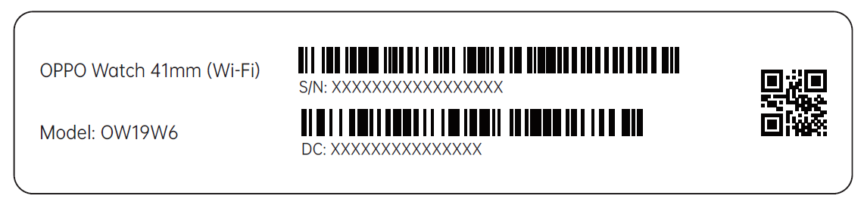
（3）Watch settings.
Path: Settings>System>About>Device code
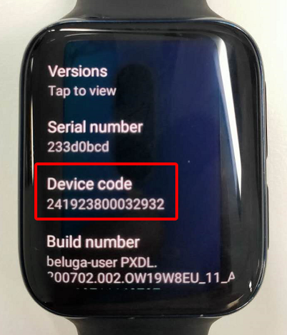

3 After-sales policy

3.1 After-sales warranty policy
After-sales warranty policy is implemented in accordance with local laws and regulations.

3.2 Fault phenomenon and cause
Since there is no maintenance condition for the watch overseas, it will be replaced by replacement. According to the following table, select and enter the failure phenomenon and cause.
Fault phenomenon | cause
Refer to the mobile phone and enter the fault phenomenon code with the actual fault | 1.Smart watch with good appearance but abnormal functions(SPF12）  2.Smart watch with defective appearance but good functions(SPF13)  3.Smart watch with defective appearance & abnormal functions(SPF14)

Note:
Defective appearance: Refers to the defective appearance of the watch screen, middle frame, physical buttons and back cover. If one part of the appearance is damaged, it is defective appearance, such as defective display dots, glass breakage/falling, large seam/warping/degumming, etc.; The body screen + rear case + middle frame + buttons can be judged as good appearance only if they are all intact.
Abnormal functions: no power on, no charging, abnormal built-in application function, slow response, Bluetooth incompatibility (not connecting, pairing failure, disconnection after connecting) and other problems that affect the functional experience, excluding user consultation, user active request for upgrade, forget password.
If the screen cannot be displayed, but it will vibrate when you press the power button,deal with it as functional malfunction.

3.3 Warranty policy
① During the warranty period, if the watch is not damaged by humans and has quality problems of the product itself, the watch can be replaced ;
② During the warranty period, if the strap is not damaged by humans and the quality of the product itself, the strap accessories can be replaced separately;
③During the warranty period, if the charging stand is not damaged by humans and the product itself is quality problems, the charging stand accessories can be replaced separately;
④ During the warranty period, if the strap ring is not damaged by humans and the quality of the product itself, the strap ring accessories can be replaced separately.
Inspection order record:
Select "Special replacement" for delivery type, "IoT" for work order type, and "Replacement for repair" as reason for replacement.
Charge information:
The maintenance type selects the warranty, and the material code is entered according to "OPPO Watch X19W6&W8&W12 after-sales BOM and failure phenomenon_self-research_V2.0_20200824".

3.3 Maintenance Proposal
① In the case of watch failure or loss, the whole set of watch accessories can be replaced separately for a separate fee;
② In the event of a failure or loss of the strap, the strap accessories can be replaced at a separate fee;
③ In the case of malfunction or loss of the charging stand, the accessories of the charging stand can be replaced at a separate fee;
④ In the case of failure or loss of the strap ring, the strap ring accessories can be replaced at a separate fee.
Inspection order record :
Select "Special replacement" for delivery type, "IoT" for work order type, and "Replacement for repair" as reason for replacement.
Charge information:
Select the Maintenance type and enter the material code according to "X19W6&W8&W12 after-sales BOM and failure phenomenon_self-research_V2.0_20200824".

3.4 Maintenance time
(1) With invoice of purchase: calculate the warranty time with the purchase invoice and warranty card;
(2) No invoice of purchase: Check the DC code in customers watch\packing box, query path from watch: settings—system—about—DC code, use the DC code to query the electronic warranty card registration time in the system to start calculating the warranty time;
(3) If the invoice, warranty card, packaging box, online purchase record, and the warranty date calculated by querying the DC code information cannot be provided, Take the first sale time as the warranty start date.

4 Instructions

4.1 Product overview
1. When using the watch for the first time, charging and then press and hold the function key to turn it on, and follow the onscreen instructions to perform pairing operations.
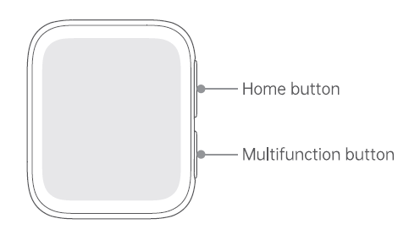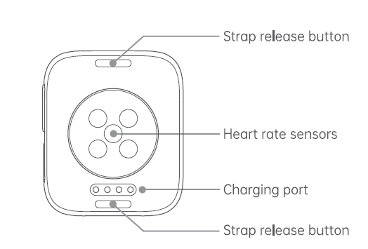

4.2 Buttons
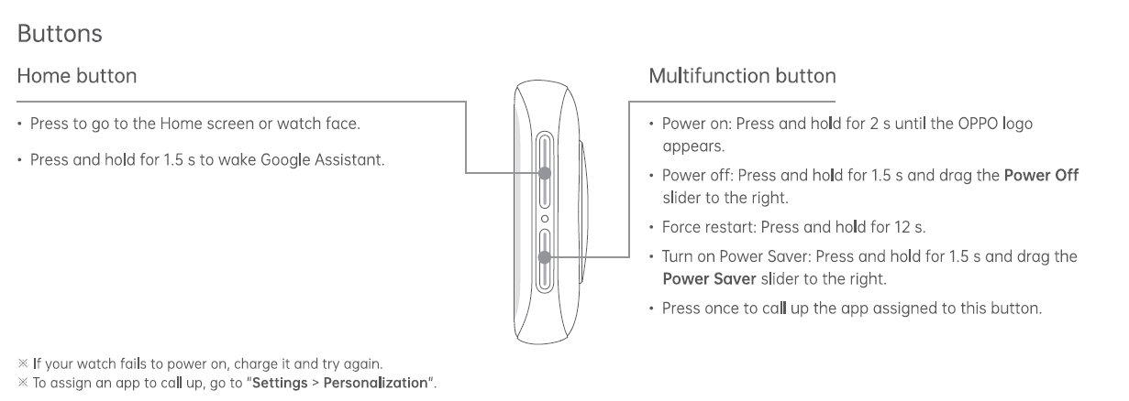

4.3 Operations
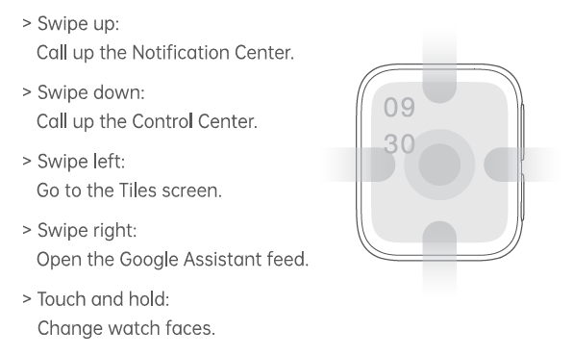

4.3 Charge OPPO Watch
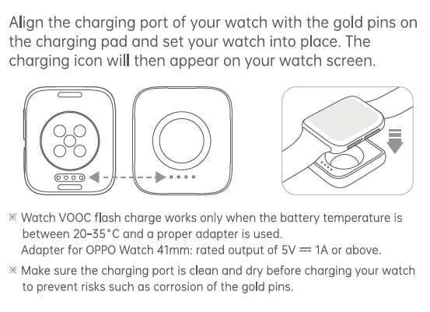

4.4 Pair OPPO Watch
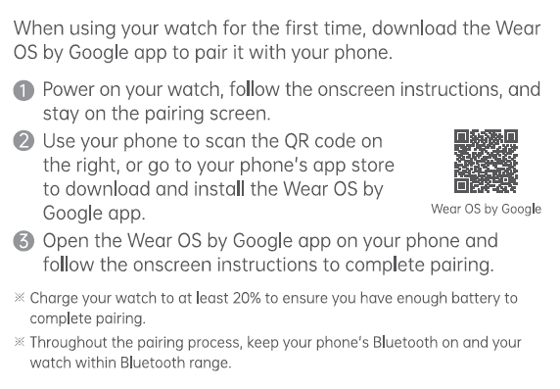

4.5 Manage OPPO Watch
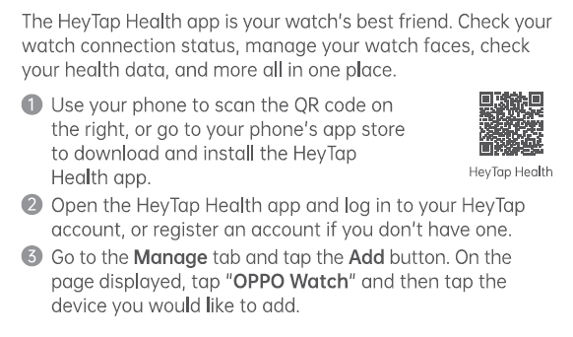

4.6 Change the watch strap
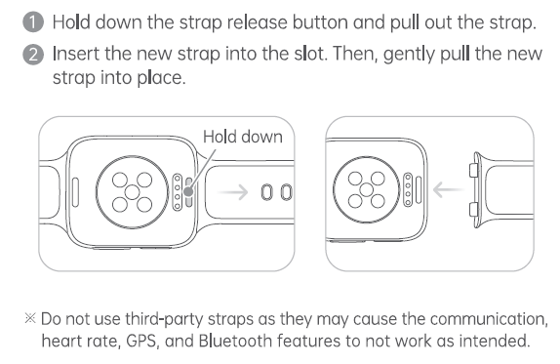

5 Function test

5.1 Test path
1.In Settings>System>About> Click "Serial number" 8 times
2. Back to Settings>Quick commands>*#899#>Automatic test
The "Confirm" dialog box will pop up after the test complete, if there is no problem choose “Pass”, otherwise choose “Fail”.

5.2 Testing requirements
SN | Test Items | Test Requirements
1 | Vibration Test | Get ear close to check the vibration from the motor for 3 seconds.  If the motor vibrates normally(No noises or weak vibration), the function is good;
2 | Touch Screen Auto Test | If the interface shows “PASS” and jumps to the next test, the function is good;
3 | Adjust Screen Brightness | Swipe the brightness bar/click +1.-1 to adjust the screen brightness ratio, if the screen brightness changes with the adjustment, the test is PASS
4 | Flash test | Click test, the test will show pass
5 | Proximity-sensor Test | Use the palm to approaching or away from the capacitive sensor (at the bottom of the watch), there is a proximity signal feedback, it will shows pass and automatic jumps to the next test
6 | Keypad test | Press the Home button and multifunction button one by one. If keys can be pressed normally and the interface jumps to the next test, the function is good;
7 | NFC test | Close the watch to the NFC card reader. If the signal light of the card reader changes from red to green with “Beep” sound, the interface shows “PASS” and jumps to the next test, the function is good.
8 | G-sensor | Take the watch to draw the "8" word graphic. If the interface shows “PASS” and jumps to the next test, the function is good;
9 | Gyroscope self test | Lay the watch flat, it will automatically judge whether it is PASS
10 | Msensor | Shake the phone from the left to the right side. If the interface shows “PASS” and jumps to the next test, the function is good;
10 | Generic Charger | Use the original OPPO adapter to charge. If the interface shows charging, the function is good;
11 | Single MIC recording test | After entering the interface, click on the MAIN MIC RECORDING, and blow air into the main MIC hole. The value can go up to 6000 and then drop back, which can be judged as a successful test
12 | Media test | Click the “20-4K（-3db)signal” to test the sound of the media function for 5s. If there is no silence, weak sound, noises, and breaking sound , the function is good;
13 | MIC test | Click to start recording, about 5s then stop recording; play to confirm whether there is sound, if it can play normally, the test is pass
14 | LCD test | Observe the red, green, blue, white, black, gray, grayscale and color interface successively; If there aren't black spots, bright spots and other anomalies, the function is good;
15 | LightSensor | In a dark environment, if the light perception value is less than 10, it is judged as PASS.
16 | LCD small core test | Tap the screen to change the color. During the process, If there aren't black spots, bright spots and other anomalies, the function is good;
17 | Search Bluetooth device | After entering the interface, the Bluetooth will search automatically. After the search is completed, the Bluetooth list pops up, and the search is completed. If the search can be completed, then the test is PASS
18 | Wi-Fi test | After entering the test interface, pull down to view and you can search for Bluetooth normally, then the test is PASS
19 | Motor calibration | Click to start calibration, enter”6776”>ok, it will shows “Test succeeded”, then the test is pass
20 | Small core TP test | Click "TEST", the touch screen will automatically test the feedback result Pass/Fail
21 | Pressure sensor | Use a normal watch as a comparison to test the current ambient air pressure intensity, enter it on the test machine-air pressure standard column and click to confirm-test result feedback: PASS and observe whether the test value error is within ±0.78hPa
22 | Call test | call the 112 to test (Calling the Operator is recommended). If the call can be performed normally and the receiver is without noises or weak sounds, the function is good;

After the above 22 items are tested, they will prompt to the test result interface. If the test PASS, project will show “√”; If the test FAIL, project will show “×” .

